Section 1A.5: Reporting Accidents, Incidents, Near Misses or Property Damage

- Reference: (Specific Division Policy)– Injury Reporting System

- Definitions:

  - Accidents
An unwanted, unplanned event that results in a loss (production, property or human).

  - Incidents
An unwanted, unplanned event that results in or could have resulted in a loss (production, property or human).

  - Near Miss
An unwanted, unplanned event that didn’t but could have resulted in a loss (production, property or human)

- Reporting Accidents/Incidents/Near Misses or Property Damage

General Reporting:
  - Complete Incident Report Form and submit to the Foreman or designate.

  - Participate in the follow up investigation of incident, near miss, accident or property damage.

  - Obtain the name and plate number of any other person involved in the motor vehicle accident.

  - Consult the Transportation Foreman before the bus is moved from the accident scene.

  - Complete a Student Report Form, if applicable and ensure a copy is given directly to the Principal/Vice Principal by the driver and a scanned copy is sent to the Foreman from the school scanner.

  - Report any damages to the Transportation Foreman or designate. Complete and submit incident report form to the Foreman.

  - When able to do so, contact the Principal particularly if the accident, incident or student behavior results in an alteration to the regular schedule or other circumstances that might impact school operations.

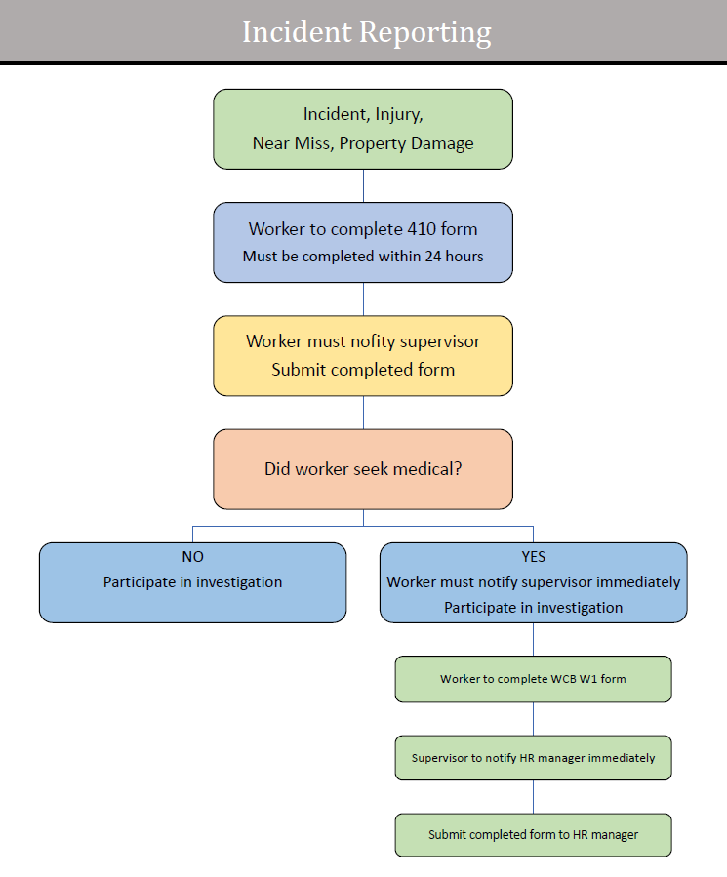

- Traffic/Criminal Code Violations
Under The Traffic Safety Act, bus drivers must report the following situations to the Manager of Facilities & Transportation or designate:

  - Any ticket violations received while driving any type of school division vehicle.

  - Any type of Criminal Code Violations received whether it be in a school division vehicle or personal vehicle must be reported to the Director of Education of the charges. (Specific Division Policy)
  - Drug or alcohol related incidents.

- Fines
The following applies to situations where a traffic violation summons, or ticket has been issued to a bus driver:

  - Bus drivers who are cited for any type of violation must pay fines with their own funds.

  - Traffic violations become part of the National Safety Code (This document is for internal use by the Transportation Sector staff only). In this document, the driving record of all employees is summarized, and demerits are assigned.

