Chapter 2A: Job Safety Analysis, Safety Procedures, Safety Memos

Section 2A.1: Job Safety Analysis (JSA)

Job/position/work type: Bus Diver |  |  |  |  |  | Date Completed:
Assessment Team: |  |  |  |  |  | Reviewed/revised:
Tasks  (List all tasks/activities of the job/position) | Hazards  (List all existing and potential health and safety hazards) | Severity | Probability | Risk | Controls  (List the controls for each hazard:  Elimination, Engineering, Administrative, Personal Protective Equipment) | Comments
 |  | S x P = R
Pre-Trip Inspection:  - Open / close hood  - Check fluids  - Bleeding air lines  - Walk around  - Entering bus | Slips, trips, falls  Pinch fingers  Shoulder strain  Back strain  Getting down on hands & knees |  |  |  | Wear appropriate footwear(identified in driver handbook)  Hold hand rails when entering/ exiting bus  Wear gloves  Follow bus driver ergonomic and safe body mechanics | Requires orientation to:  - Transportation Manual  - Bus driver self-assessment  - Bus driver safe body mechanics
Working alone | Potential harm, entrapment/ no assistance, medical emergency |  |  |  | Follow working alone process/communication plan
Pick up /drop off students (Route)  - Driving  - Parking at school  - Leaving school  - Placing / removing “empty” sign at back of bus  - Students on bus  - Scents | Road / weather conditions  Other drivers  Watching students, foot traffic  Distracted driving (student behavior, noise)  Reaction to scents |  |  |  | Practice defensive driving skills  Communicate rules to ride the bus  Be aware of your surroundings at all times  Proper clothing for winter weather | Transportation Manual -Student responsibilities (rules)
Fuelling the bus | Spilling fuel |  |  |  | Attention to task/monitor fuel | Follow WHMIS 2015 education and training
Washing the bus | Slip, trip  Back strain  Shoulder strain |  |  |  | Wear appropriate footwear(identified in driver handbook)  Practice proper body mechanics  Wear safety glasses  Read Safety Data Sheet | Follow WHMIS 2015 education and training
Biological exposure (mouse droppings, insect bites, blood, body fluids) | Mouse droppings on bus  Blood & body spill (vomit, blood, urine) |  |  |  | Wear PPE (gloves, masks) as identified in safe work procedure. Clean rodent droppings up following safe work procedure for Hantavirus.  Refer to Exposure Control Plan and Communicable Disease Handbook.
Rural driving | Passing/meeting farm equipment  Wildlife |  |  |  | Practice defensive driving  Aware of surroundings at all times
Handling hazardous products, chemical exposure (WHMIS 2015).  -fuelling  -checking fluids | Chemical burns, respiratory problems, infections, illness, serious condition, death. |  |  |  | WHMIS training/education and current SDS sheets for hazardous products. Wear PPE (gloves, masks) as identified in SDS/safe work procedure. | Handling hazardous products, chemical exposure (WHMIS 2015).

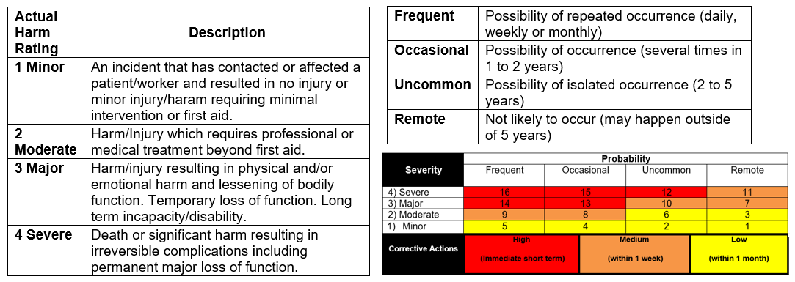
Risk Matrix

