Article 2A.2.4: WHMIS 2015 / Safety Data Sheets (SDS)

Transportation Sector WHMIS 2015 Process
Worker must have completed WHMIS 2015 Education and Training.
All Hazardous Products in or on the worksite must have a Safety Data Sheet (SDS).
NOTE: Consumer Products (which are materials intended for consumer use, and provided in volume, such as cleaners, adhesives, lubricants, etc.) are not subject to WHMIS 2015 requirements. However, if product is brought into the workplace a SDS must accompany the product. In many cases, SDSs are available from the product supplier.
Only Safety Data Sheets SDS are acceptable. Material Safety Data Sheets MSDS are not acceptable.
Transportation Bus Garages:

Worker purchases a hazardous product that is new to the WHMIS 2015 inventory, worker must:
- Provide SDS (this can be provided by supplier)
- SDS to be added to inventory database (internal facility drive), binder in the shop, binder in work truck, binder in buses; communicate with supervisor.
- If unable to locate/acquire SDS notify shop foreman immediately
Hazardous Products used in Buses:
- No products are to be left in buses unless the product is required for the operation of the bus (ex: fuel, washer fluid, fuel additive, etc.)
  - The above mentioned products must have a SDS in the bus, SDS’s are provided to bus driver to include in Transportation Manual.
Hazardous Product no longer used or available or supplier change
- SDS must be removed from database, binder(s) shop, truck, buses
Supervisor:
- To support worker locating SDS, maintain index, database, binder(s)
- Any identified change in SDS information must be communicated to worker
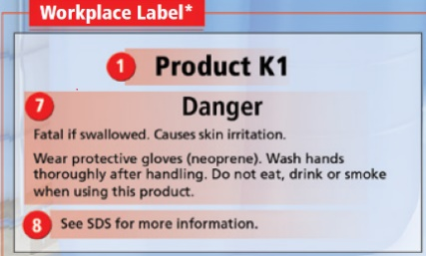
- Provide new SDS if applicable
Availability of Safety Data Sheets:
- To workers who may be exposed to the hazardous product
- To the Occupational Health Committee
Workplace Label required:
- A hazardous product is decanted into another container (ex: transferred or poured)
- A supplier label is lost or no longer illegible (unable to read)

