Section 3.12: Safety Memos
Safety Memo

Safety is everyone’s responsibility!

Extension Ladder

Extension Ladder Selection:
- Select a ladder that is the proper length to reach the working height and inspect it before use. The ladder must be long enough to be set up at a safe angle and extend 90 centimeters (three feet) beyond the top landing.
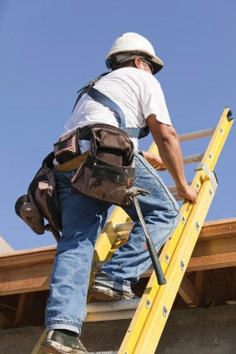
- Do not use metal or wood ladders near live power lines.
- Use fiberglass ladders when working around electrical conductors.
Set Up:
- Set the ladder on firm ground. Do not use on ice, snow or slippery surfaces without non-skid devices or securing footing.
- Set the ladder up at a safe angle. Position the feet one foot back for every three or four feet up, depending on length.
- Extend ladder three feet above the roof line and tie the top at support points.
- Secure the base when raising.
- Protect the base of ladder from any activity that could bang it.
- Do not overextend the ladder section. Maintain the minimum overlap of sections.
- Securely engage ladder locks before climbing.
- When working from a ladder more than three metres or 10 feet up, wear a safety harness and tie off to a well anchored lifeline or other support—not to the ladder.

Safe Climbing and Use:
- Do not place the ladder in front of doorways or on movable surfaces.
- Face the ladder and maintain 3-point contact when climbing up or down. Ensure boots are free of mud, snow or other substances before climbing.
- Do not carry tools, equipment or materials in your hands while climbing.
- Keep body centered between side rails.
- Do not overreach or stand higher than the fourth rung from the top.
- If possible, use extension ladders only for access and not as work platforms.
- Do not use the ladder in high winds unless secured properly.
- Keep the areas at the top and bottom of the ladder clear of debris, materials and other obstructions.

Inspection Checklist:
- Are any parts broken, cracked or splintered?
- Are there any defects in the side rails, rungs or other parts?
- Are their makeshift repairs on the ladder?
- Are there any worn, damaged or unworkable extension ladder locks, pulley or other fittings?

- Is the ladder twisted, warped or bowed?
If any answer is yes to any of the above, the ladder should be tagged and taken out of service.

Source:
CSA Standards Information Sheet - Portable Ladders, www.ccohs.ca
The Occupational Health and Safety Regulations, 2020
Be Accountable: Choose safety - work safe - and go home injury free!

Safety Memo

Safety is everyone’s responsibility!

Stepladder Safety

Ladders come in all shapes, sizes and lengths. There are a variety of types; however, the most common is the stepladder. By definition a stepladder is self-supporting, portable, is non-adjustable in length, having flat steps and a hinged back. Stepladders are useful, versatile and at times hazardous. Falls from stepladders are very common. Knowledge of safety guidelines can prevent stepladder incidents from happening.

What should you do when using a stepladder?
- Use a stepladder that is about 1 m (3 ft) shorter than the highest point you have to reach. This gives a wider, more stable base and places the shelf at a convenient working height.
- Open the stepladder spreaders and shelf fully.
- Check stability. Ensure that all ladder feet are on a firm, level and non-slippery surface.
- Place a stepladder at right angles to the work, with either the front or back of the steps facing the work.
- Keep the stepladder close to the work.
- Avoid pushing or pulling stepladders from the side. Repeated sideways movement can make ladders wobbly since they are weaker or less stable in those directions.
- Face the stepladder when climbing up or down. Keep your body centered between side rails. You have climbed too high if your knees are above top of the stepladder or if you cannot maintain a handhold on the ladder.
- Maintain a firm grip. Use both hands when climbing.

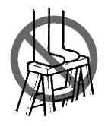
What should you avoid when using a stepladder?
- Do not overreach. Move a stepladder when needed.
- Do not "shift" or "walk" a stepladder when standing on it.
- Do not stand, climb, or sit on the stepladder top or pail shelf.
- Do not overload. Stepladders are meant for one person.
- Do not use a stepladder as a brace or as a support for a work platform or plank.
- Do not climb a stepladder that is leaning against a wall. Use a straight ladder instead.
- Do not use stepladders on slippery surfaces.
- Do not use stepladders on soft ground where one leg may sink farther into the ground than others.
- Do not place stepladders on boxes, unstable bases or on scaffolds to gain additional height.
- Do not climb the back of a stepladder.
- Do not push or pull stepladders sideways.
- Do not use ladders in passageways, doorways, driveways or other locations where a person or vehicle can hit it. Set up suitable barriers or lock doors shut.

Ladders
- An employer, contractor or supplier shall ensure that every ladder is designed, constructed, used and maintained to perform its function safely.
- An employer, contractor or supplier shall ensure that:
- no wooden ladder or stepladder is painted with any substance other than a transparent coating; and
- no ladder is made by fastening cleats across a single rail or post.

Portable ladders
- In this section and section 254, “portable ladder” means any ladder that is not fixed in place and includes a stepladder.
- An employer or contractor shall ensure that:
- a portable ladder is equipped with non-slip feet;
- a portable ladder is secured against accidental movement during use;
- a metal or wire-bound portable ladder is not used where the ladder or a worker handling or using the ladder may come into contact with an exposed energized electrical conductor; and
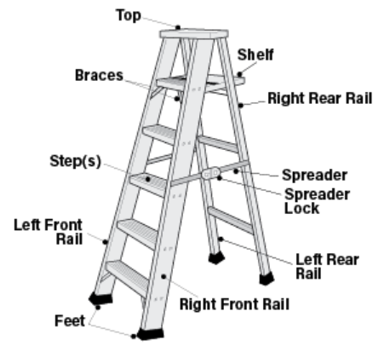
- a portable ladder extends at least one metre above any platform, roof or other landing to which the ladder is used as a means of access.
- An employer or contractor shall ensure that each worker who handles or uses a portable ladder is instructed in the requirements of this section.
- An employer or contractor shall ensure that a stepladder:
- is not more than six metres high when set for use;
- has legs that are securely held in position by means of metal braces or an equivalent rigid support; and
- when in use, has a front section slope at an angle of one horizontal to six vertical.
- An employer or contractor shall ensure that:
- an extension ladder is equipped with locks that securely hold the sections of the ladder in the extended position;
- where a section of an extension ladder is extended, the section that is extended overlaps another section for at least one metre;
- an extension ladder consisting of two sections does not exceed 14.6 metres in length; and
- an extension ladder consisting of more than two sections does not
exceed 20 metres in length.
- An employer or contractor shall ensure that no single portable ladder and no section of an extension ladder exceeds nine metres in length.

Be Accountable: Choose safety - work safe - and go home injury free!
Safety Memo

Safety is everyone’s responsibility!

Personal Protective Products – (PPE)

The school division will ensure that in any circumstance requiring PPE that they are readily available, up to standard and appropriately used.
Gloves
- Glove use is NOT a substitution for proper hand hygiene.
- Remove gloves after each procedure has been completed.
- Discard gloves and then perform hand hygiene.
- Never use the same gloves for more than one individual or procedure.
- Gloves shall be used:
- To provide a protective barrier and prevent contamination of hands.
- When there is potential to be exposed to blood, body fluids, secretions, excretions, mucous membranes, and non-intact skin.
- Selection of gloves should be based on:
- proper fit for the worker;
- the type of procedure being done; and,
- the likelihood of exposure to body fluid.
Note: The employer will ensure that latex-free options are made available for employees with latex allergies.
- Gloves shall be changed:
- When task or procedure is complete.
- If a leak is suspected or a glove tears.

- Gloves shall be worn:
- When exposure to potentially infectious material such as blood, body fluids, secretions, excretions, mucous membranes, and non-intact skin is anticipated.
- For handling hazardous products that require them per the Safety Data Sheet (SDS)
- By workers who have cuts, scratches, or other breaks in the skin.
- Single-use Disposable Gloves:
- Single-use disposable gloves must not be washed or reused.
- Procedure for Removing Soiled Gloves:
- The outside of gloves is considered contaminated.
- Grasp outside of glove with opposite gloved hand and peel off.
- Hold removed glove in gloved hand.
- Slide fingers of un-gloved hand under remaining glove at wrist.
- Peel glove off over first glove.
- Discard gloves in appropriate waste container.

Eye Protection
- Eye protection includes such items as:
- eye goggles
- a face shield
- safety glasses
- Eye protection must be worn during procedures in which it is required per the Safety Data Sheet (SDS) of the chemical.

- Respiratory Protection/High Efficiency (95%) Particulate Respirators - N95 Masks
- Where a worker is likely to be exposed to dust, fumes, gas, mist, aerosol, vapours, or any contaminant that may be present in amounts that are harmful or offensive to the worker, the employer will provide the worker with suitable, approved, and adequate respiratory protection.
- The worker must use the respiratory protective equipment provided.
- The use of a respiratory mask is recommended to prevent the worker from being infected by micro-organisms that are transmitted through the air. Masks protect the wearer from inhaling both large particle aerosols (droplets) that are transmitted by close contact and generally travel short distances (1 meter or 3 feet) or small particle aerosols (droplet nuclei) that remain suspended in the air and thus travel longer distances.
In general:
- Masks are for single use only.
- Masks must completely cover the nose and mouth.
- Do not touch the mask when in use.
- Change the mask when wet.
- Discard all used masks into the wastebasket immediately after proper removal.
- Masks must not dangle around the neck.
- Wash hands after proper removal.
- Masks should be worn with nose piece on top, pleats open downward with the nose piece being formed around the nose to provide thorough protection.
- N95 masks:
- Have the ability to filter particles 1 micron in size and are required for protection against diseases transmitted through the air.
- Must be worn by employees attending to an infectious participant as determined by infection control standards.
- To be effective, the N95 mask must be fitted to the wearer to determine which respirator provides the most amount of protection for each worker.
- Removal of Disposable Mask/Respirator
- Front of mask/respirator is considered contaminated.
- Grasp bottom, then top ties or elastics and remove.
- Discard in waste container.
- Wash hands.

©WorkSafeBC. Used with permission from A Clean Sweep.
Be Accountable: Choose safety - work safe - and go home injury free

