Caretaking Procedure: CP-110
Section 3.6: Safety Procedures
Caretaking Work Procedures for
[enter division name]
Facilities & Transportation Department

Work Procedure: Caretaking – Broken Glass

Sector::  Caretaking | Reviewed By: | Approved By: | Date Created: | Date of Last Revision:

Purpose: The purpose of this procedure is to explain the step-by-step instructions for cleaning, removal, and disposal of broken glass.

PROCEDURE:
Personal Protective Equipment:
- Protective gloves
- Eye protection
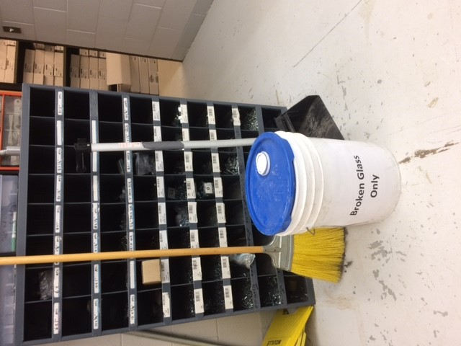
Tools / Materials Required:
- Broken glass container
- Dust pan
- Broom

Instructions:
- Do pre-visual inspection of equipment before beginning.
- Pick up large pieces of glass and place them in a box, bin or on several sheets of newspaper.
- Sweep the smaller pieces of glass in towards the center of the area.
- Once you have gathered all the glass shards, use a dust pan or other suitable object to sweep the glass onto and place it with the large pieces already collected.
Example: Broken glass container labelled with broom & dust pan
- Small glass fragments can be very effectively cleaned off smooth surfaces by using some wet paper towel.
- Vacuuming the area, if appropriate, is also very effective.
- Once cleanup is complete the collected glass needs to be sealed in a container; Box for larger pieces of glass.
- Clearly label the box as containing broken glass and place it in a caretaker room or directly into the school dumpster.

Responsibilities, Completion and Review:
All staff members are required to adhere to Department policies & procedures at all times while employed with the school division as it relates to day to day operation of the Department. Supervisors are also required to ensure that staff members are following Department policies at all times and to take the necessary steps to inform staff who fail to follow policies and report all matters to management immediately. Employees who fail to follow Department policies will be subject to disciplinary action.

