**Safety Memo**

***Safety is everyone’s responsibility!***

**Auto Scrubbers – Self-Propelled and Pad Assist**

Operating auto scrubbers requires skill and experience. There are many different styles of auto scrubbers. Follow all operating procedures per user manual when using any piece of equipment.

**General Safety Instructions**:

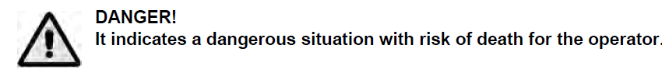

**IMPORTANT SAFETY INSTRUCTIONS: READ AND UNDERSTAND ALL**

**INSTRUCTIONS BEFORE OPERATING OR SERVICING MACHINE**

**Failure to Observe These Instructions Can Cause Personal Injury to Machine Operator,   
By-standers or Possible Machine Damage.**

* Disconnect the batteries before performing any maintenance/repair procedure.
* This machine must be used by properly trained and authorized personnel only.
* Keep the battery far from sparks, flames and incandescent material. During the normal operation explosive gases are released.
* Do not wear jewelry when working near electrical components (battery).
* Do not work under the lifted machine without supporting it with safety stands.
* Do not operate the machine near toxic, dangerous, flammable and/or explosive powders, liquids or vapors.
* Battery charging produces highly explosive hydrogen gas. Keep the tanks open during battery charging and perform this procedure in well-ventilated areas and away from bare flames.
* **NEVER** attempt to operate this machine unless you have been trained in its operation.
* **NEVER** allow an untrained person to operate this machine.
* **NEVER** attempt to operate this machine if it is not working properly or has been damaged in any manner.
* **NEVER** disconnect or modify any switch or safety device (circuit breaker) on this machine.
* **ALWAYS** operate this machine from the rear control panel, not from the side.
* **NEVER** operate this machine with any air opening blocked. Keep all air openings free of dust, lint, hair etc.
* **NEVER** allow the vacuum motor or battery charging plug to get wet. The vacuum motor and battery charging plug will short out if wet.
* **NEVER** operate this machine when battery charger is plugged in.
* **NEVER** operate this machine in an explosive atmosphere (grain dust, flammable liquids or fumes).
* **NEVER** use flammable liquids (gas, kerosene, solvents or thinners) to clean floor.
* **ALWAYS** turn the brush switch OFF when attaching pads or brushes.
* **ALWAYS** store this machine indoors in a dry, cool area.

**Operating Auto Scrubbers**

* Make sure the batteries are sufficiently charged
* Check pad driver that pad is properly installed per operator’s manual
* Turn power on the machine via button or key
* Set controls to the limits you require, as per operators manual
* Maintain a neutral spine position
* Grip machine with neutral wrist posture
* Use in area as required per operating procedures

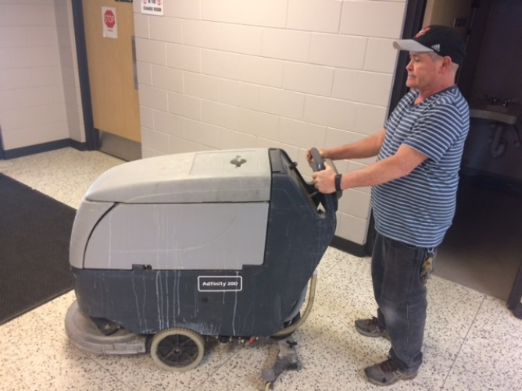 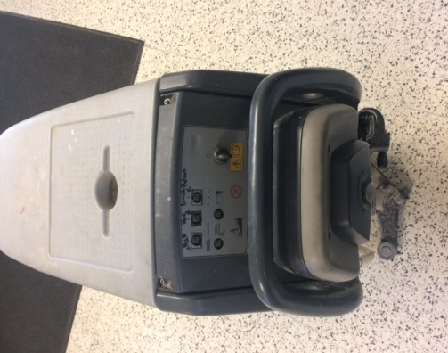

**Make sure controls are set in proper place for use.**

**Maintain a neutral spine with neutral wrist position.**

**Changing the Pads**

1. With pad driver up, manually remove by following operator’s manual instructions. Some units will have a release button on machine to drop pad driver.
2. Release center lock and remove old pad.
3. Replace with new pad and replace center lock.

©WorkSafeBC. Used with permission from *A Clean Sweep.*

**Be Accountable: Choose safety - work safe - and go home injury free!**

**Safety Memo**

***Safety is everyone’s responsibility!***

**Broken Glass**

Inside schools/facilities or outside/playgrounds broken glass can be a common occurrence. Inside or outside, whatever the broken glass is it needs to be cleaned up quickly and safely and disposed of properly.

**All schools/facilities will have a designated container with lid, dustpan and broom.**

**Procedure (Refer to CP-110)**

Secure the area so that no one cannot approach the broken glass. Then, while wearing appropriate shoes, gloves and safety glasses, if applicable:

* Pick up large pieces of glass and place them in a box, bin or on several sheets of newspaper.
* Sweep the smaller pieces of glass in towards the center of the area.
* Once you have gathered all the glass shards, use a dust pan or other suitable object to sweep the glass onto and place it with the large pieces already collected.
* Small glass fragments can be very effectively cleaned off smooth surfaces by using some wet paper towel.
* Vacuuming the area, if appropriate, is also very effective.
* Once cleanup is complete the collected glass needs to be sealed in a container; box for larger pieces of glass.
* Clearly label the box as containing broken glass and place it in a caretaker room or directly into the school dumpster.

**Issues to Note**

* Examine the area closely so that you are sure just how far the broken glass has scattered.
* Broken glass tends to stick/embed into sheet flooring and can be difficult to clean up. Be very thorough.
* Carpets can be particularly difficult to clean glass out of as it can get tangled in the carpet pile.
* If the broken glass was a container with material or residue in it then you should determine the need to consult an SDS prior to attempting cleanup. It may be a hazardous material.

©WorkSafeBC. Used with permission from *A Clean Sweep.*

**Be Accountable: Choose safety - work safe - and go home injury free!**

**Safety Memo**

***Safety is everyone’s responsibility!***

**Burnisher**

Operating a Burnisher requires skill and experience. It operates at high speeds to maintain floors.

**Operating a Burnisher (Refer to Caretaking Procedure: CP-103)**

* Visual pre inspection of equipment, initial & date on equipment sheet(form)
* Maintain a neutral spine position.
* High starting torque. Hold machine firmly with both hands. Feet planted shoulder width apart.
* **Do not** pull/run machine over cord. **Keep** cord away from heated surfaces.
* Operational hazard may occur when running the machine over the supply cord.
* Let the machine do the movement by moving with it as a unit back and forth over desired area.
* The burnisher has been designed for use with pads specified by the manufacturer. The fitting of other pads may affect safe operating.
* Ensure centre lock is secure, unplug to check and tighten centre lock.
* Dry mop area when complete.

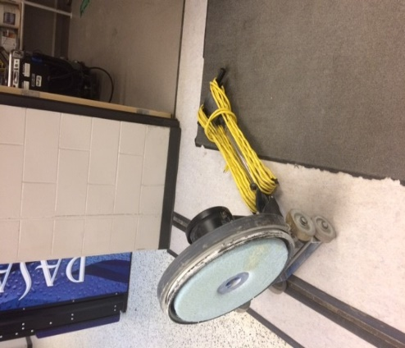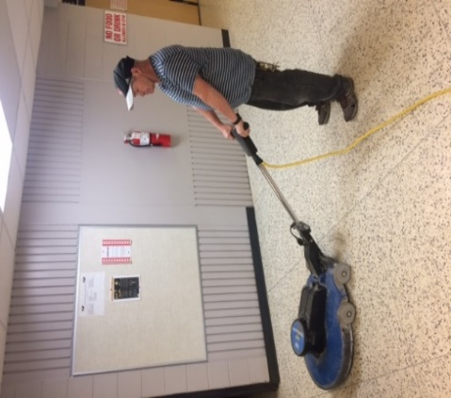

**Remove the center lock to replace the pads**

**Maintain a neutral spine position**

**Changing the Pads**

1. Unplug the burnisher.
2. Lay machine back, exposing the underside.
3. Remove center lock as per operator’s manual.
4. Ensure pad is centered on pad driver. Pull pad to edge of pad to edge of pad driver in several directions to check for proper engagement.
5. Replace center lock by as per operator’s manual.

©WorkSafeBC. Used with permission from *A Clean Sweep*

**Be Accountable: Choose safety - work safe - and go home injury free!**

**Safety Memo**

***Safety is everyone’s responsibility!***

**Cleaning Walls**

* Stand upright and use a lightweight long-handled mop or squeegee
* Adjust the length of a telescopic handle to minimize awkward bending and overreaching
* Alternate lead hands to avoid fatigue
* Use your legs, not just your arms, to generate force

**Using Telescopic Wall Washing Tools**

* Keep your hands in front of you and between your shoulders
* Work in a small area of the wall and try to keep your elbows below shoulder level
* Face the wall and move the tool up and down while:
* Using a combination of small arm movements while walking sideways

***or***

* Holding the tool across your body while walking forward to minimize arm movements
* Extend your washing range by walking forward to wash higher and walking back to wash lower

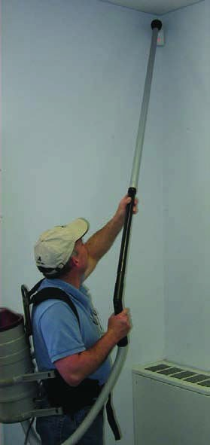

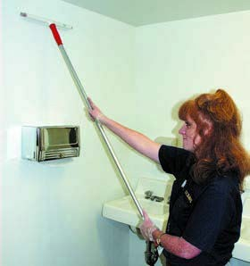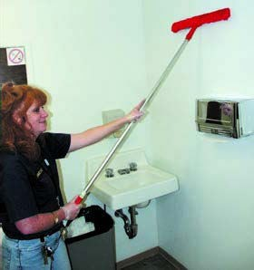

**Use lightweight plastic extension when vacuuming** **walls**

**Attach a long handled pole to mop or squeegee**

©WorkSafeBC. Used with permission from *A Clean Sweep.*

**Be Accountable: Choose safety - work safe - and go home injury free!**

**Safety Memo**

***Safety is everyone’s responsibility!***

**Garbage – Managing Containers and Bags**

Don't assume that garbage cans weigh the same each time Injuries can occur when lifting an unexpectedly heavy can.

**The risks of injury are related to:**

* Size of the garbage can
* Trying to predict the weight
* Suction holding the bag in place (see *Safety Talk: Garbage - Pulling Bags*)
* Ability to replace lifting with pulling
* Controlling the weight of bag
* Method of transporting bag to dumpster (see Safety Talk: Garbage - Transporting-Lifting- Dumpsters)
* Mechanics of lifting bag into dumpster (see Safety Talk: Garbage - Transporting-Lifting- Dumpsters)

**Container Size**

The right capacity for the container is based on the size and weight of the items placed in it.

When collecting heavy articles (wet paper, books, food waste):

* Use a smaller container
* Put in a false bottom to reduce the available space

**Controlling Bag Size**

Ensure the garbage bags are not overfilled

* Place a false bottom (styrofoam blocks or cardboard box) in the container to "use up some of the capacity"
* Tie off the bag when it's 1/2 (one-half) full and start a new bag on top of the first
* Tie off the second bag when it reaches the top of the container at 1/2 (one-half) full

**Predicting the Weight**

Often the person filling the container is not the person emptying it, so the containers may be overfilled.

* Test the load before lifting it, especially when a heavy load would be unusual

**Times when garbage bags may be heavier than usual:**

* Room set-up time
* Room clean-up time
* Special events

**Garbage – Transporting, Lifting and Dumpsters**

The dumping of garbage bags requires repeated high force and high shoulder lifts to toss in bags.

|  |  |
| --- | --- |
| **Common problems** | **Possible solutions** |
| * Heavy lids with stiff hinges * Overhead push of lids for shorter workers * Need to hold lid open with one arm while throwing bag in with the other | * Step stool - for better working height to throw in bags * Locking hinge lid - to allow two-handed handling of bags |

**Transporting to Dumpster**

* Always transport garbage bags to the dumpster with a cart
* Keep bags compact and light if no carts are available

**Lifting to Dumpster**

* Always wear gloves
* Roll barrels and other equipment containing trash bags as close to the dumpster as possible
* If the bag is too heavy, get help
* Use a step up platform next to the dumpster
* Avoid twisting and tossing side ways

**Garbage – Pulling Bags**

Repeated heavy lifting is more difficult when the contents of the bag have been pushed down to avoid extra trips to the dumpster. A strong suction is generated and extra force is needed to pull the bag out.

**Suction Effect**

Garbage bags fit tightly against the walls of the container and create a suction effect. This makes it difficult to remove the bags by increasing the force required. In order to remove the bag, air must enter the space between the bag and container.

**To reduce the suction**

Place a loosely fitting false bottom in the container (i.e., a light piece of foam, empty box placed upside down)

**Maintaining Garbage Cans**

* Empty cans before they are half full
* Do not overfill or compact trash in the barrel
* Ask for help when the bag is overfilled and too heavy

**Tilt and Pull**

Put the container on its side and use a pulling motion to get the bag out to avoid awkward lifts above your shoulder.

**Garbage – Emptying Cans**

Always wear gloves.

Check the weight of the can by tilting or pushing it.

Look over the contents of the can for sharp points or protrusions.

Grasp the lip around the rim of the can; use two hands if the can is heavy and avoid bending your wrists.

Change hands to pick up and lower trash cans.

Empty trash cans frequently to avoid accumulating heavy loads.

©WorkSafeBC. Used with permission from *A Clean Sweep.*

**Be Accountable: Choose safety - work safe - and go home injury free!**



**Safety Memo**

***Safety is everyone’s responsibility!***

**Wiping and Dusting**

A wet mop can weigh up to 25 pounds when fully saturated. Wet mopping can cause significant contact stress over the hand and wrist. It also adds strain to the low back.

**Wringing a mop**

* Bend your knees and keep your back straight as you push the mop wringer down
* Face the wringer lever with a straight elbow
* Use your body weight to press down on the lever
* Use a mop bucket raised off the floor to reduce the bending force required to wring out the water
* While squeezing the mop, place your foot in front of the wheel to prevent the bucket from moving

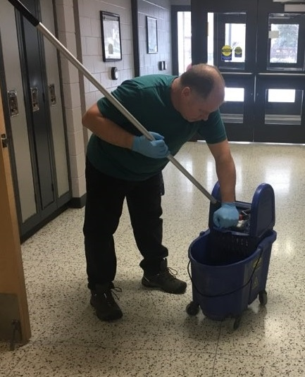

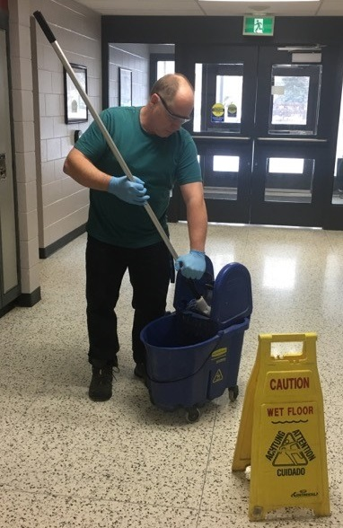

**Wear applicable PPE**

**Do not bend your back to squeeze out water**

©WorkSafeBC. Used with permission from *A Clean Sweep.*

**Be Accountable: Choose safety - work safe - and go home injury free!**

**Safety Memo**

***Safety is everyone’s responsibility!***

**Personal Protective Products – (PPE)**

[enter division name] will ensure that in any circumstance requiring PPE that they are readily available, up to standard and appropriately used.

1. **Gloves**
2. Glove use is NOT a substitution for proper hand hygiene.

* Remove gloves after each procedure has been completed.
* Discard gloves and then perform hand hygiene.
* Never use the same gloves for more than one individual or procedure.

1. Gloves shall be used:

* To provide a protective barrier and prevent contamination of hands.
* When there is potential to be exposed to blood, body fluids, secretions, excretions, mucous membranes, and non-intact skin.
* Selection of gloves should be based on:
* proper fit for the worker;
* the type of procedure being done; and,
* the likelihood of exposure to body fluid.

**Note: The employer will ensure that latex-free options are made available for employees with latex allergies.**

1. Gloves shall be changed:

* When task or procedure is complete.
* If a leak is suspected or a glove tears.

1. Gloves shall be worn:

* When exposure to potentially infectious material such as blood, body fluids, secretions, excretions, mucous membranes, and non-intact skin is anticipated.
* For handling cleaning products that require them per the Safety Data Sheet (SDS)
* By caretakers who have cuts, scratches, or other breaks in the skin.

1. Single-use Disposable Gloves:

* Single-use disposable gloves must not be washed or reused.

1. Procedure for Removing Soiled Gloves:

* The outside of gloves is considered contaminated.
* Grasp outside of glove with opposite gloved hand and peel off.
* Hold removed glove in gloved hand.
* Slide fingers of un-gloved hand under remaining glove at wrist.
* Peel glove off over first glove.
* Discard gloves in appropriate waste container.

1. **Eye Protection**
2. Eye protection includes such items as:

* eyegoggles.
* a face shield.
* safety glasses

1. Eye protection must be worn during procedures in which it is required per the Safety Data Sheet (SDS) of the chemical.
2. **Respiratory Protection/ High Efficiency (95%) Particulate Respirators - N95 Masks**
3. Where a worker is likely to be exposed to dust, fumes, gas, mist, aerosol, vapours, or any contaminant that may be present in amounts that are harmful or offensive to the worker, the employer will provide the worker with suitable, approved, and adequate respiratory protection.
4. The worker must use the respiratory protective equipment provided.
5. The use of a respiratory mask is recommended to prevent the worker from being infected by micro-organisms that are transmitted through the air. Masks protect the wearer from inhaling both large particle aerosols (droplets) that are transmitted by close contact and generally travel short distances (1 meter or 3 feet) or small particle aerosols (droplet nuclei) that remain suspended in the air and thus travel longer distances.
6. In general:

* Masks are for single use only.
* Masks must completely cover the nose and mouth.
* Do not touch the mask when in use.
* Change the mask when wet.
* Discard all used masks into the wastebasket immediately after proper removal.
* Masks must not dangle around the neck.
* Wash hands after proper removal.
* Masks should be worn with nose piece on top, pleats open downward with the nose piece being formed around the nose to provide thorough protection.

1. N95 masks:

* Have the ability to filter particles 1 micron in size and are required for protection against diseases transmitted through the air.
* Must be worn by employees attending to an infectious participant as determined by infection control standards.
* To be effective, the N95 mask must be fitted to the wearer to determine which respirator provides the most amount of protection for each worker

1. Removal of Disposable Mask/Respirator

* Front of mask/respirator is considered contaminated.
* Grasp bottom, then top ties or elastics and remove.
* Discard in waste container.
* Wash hands.

©WorkSafeBC. Used with permission from *A Clean Sweep.*

**Be Accountable: Choose safety - work safe - and go home injury free!**

**Safety Memo**

***Safety is everyone’s responsibility!***

**Swing Machines**

Operating swing machines requires skill and experience. Very small motions can produce sudden, extreme direction changes.

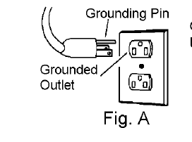

**Grounding Instructions:**

**This appliance must be grounded. See figure A.** If it should malfunction or break down, grounding provides a path of least resistance for electric current to reduce the risk of electric shock. This appliance is equipped with a cord having an equipment-grounding conductor and grounding plug. The plug must be inserted into an appropriate outlet that is properly installed and grounded in accordance with all local codes and ordinances.

**Daily Maintenance**

* Inspect power cord for wear. To prevent electrical shock replace cords with frayed or cracked insulation immediately
* Place machine in the storage position
* Check pad condition. Change if soiled or torn

**Operating Floor Machines**

* Visual pre inspection of equipment, initial & date on equipment sheet(form)
* Maintain a neutral spine position
* High starting torque. Hold machine firmly with both hands. Feet planted shoulder width apart
* **Do not** pull/run machine over cord. **Keep** cord away from heated surfaces
* Operational hazard may occur when running the machine over the supply cord
* Ensure that handle is locked in position before starting machine
* Let the machine do the movement by moving with it as a unit
* Grip machine with neutral wrist posture
* Control direction by raising and lowering the handles
* Do not let machine rest on pad. When finished with the machine, return handle to the storage position

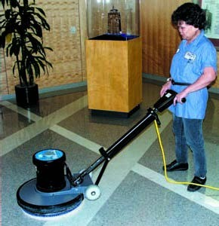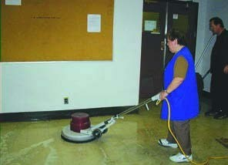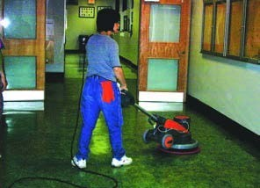

**Train workers in safe work procedures**

**Spread feet apart to maintain wide base & stability**

**Maintain a neutral spine position**

**Changing the Pads**

1. Unplug swing machine
2. Lock the handle in an upright position
3. Tilt the machine to place it on the floor
4. Place the pad on the floor near the machine and lower the machine onto the pad

**Storage:**

**Pad Driver/ Brush Installation and Removal**

1. Unplug swing machine
2. Lock the handle in an upright position
3. Lay machine back, exposing the underside
4. Place pad driver on the motor lug and rotate counter-clockwise until engaged. To remove, turn clockwise

©WorkSafeBC. Used with permission from *A Clean Sweep.*

**Be Accountable: Choose safety - work safe - and go home injury free!**

**Safety Memo**

***Safety is everyone’s Responsibility!***

**Vacuum Cleaner**

**Procedure for Vacuum Cleaners (Refer to Caretaking Procedure: CP-111)**

**IMPORTANT SAFETY INSTRUCTIONS**

When using an electrical appliance, basic precautions must always be followed, including the following. READ ALL INSTRUCTIONS BEFORE USING THIS MACHINE WARNING: To reduce the risk of fire, electric shock, or injury:

* Do not leave appliance when plugged in. Unplug from outlet when not in use and before servicing.
* Do not use outdoors or on wet surfaces.
* Use only as described in this manual. Use only manufacturer’s recommended attachments.
* Do not use with damaged cord or plug. If appliance is not working as it should or has been dropped, damaged, left outdoors, or dropped into water, notify your supervisor.
* Do not pull or carry by cord, use cord as a handle, close a door on cord, or pull cord around sharp edges or corners. Do not run appliance over cord. Keep cord away from heated surfaces.
* To unplug, grasp the plug, not the cord. Do not unplug by pulling on cord.
* Do not handle plug or appliance with wet hands.
* Do not put any object into openings. Do not use with any opening blocked; keep free of dust, lint, hair, and anything that may reduce air flow.
* Keep hair, loose clothing, fingers, and all parts of body away from openings and moving parts. Do not place fingers or other body parts under vacuum unless unplugged.
* Do not pick up anything that is burning or smoking, such as cigarettes, matches, or hot ashes.
* Do not use without dust bag and/or filters in place.
* Turn off all controls before unplugging.
* Do not use to pick up flammable or combustible liquids such as gasoline or use in areas where they may be present.
* Machines can cause a fire when operated near flammable vapors or materials. Do not operate this machine near flammable fluids, dust or vapors.
* Maintenance and repairs must be done by qualified personnel.
* Use only identical replacement parts. See instructions for Servicing of Appliances.
* If used on plush carpet or carpet with thick padding, do not leave machine in one place with machine turned on.
* Do not use the handle in the dust bag housing cover to carry the machine.
* Always turn off this appliance before connecting or disconnecting motorized nozzle.
* Brush may unexpectedly restart. To reduce the risk of injury from moving parts – Unplug before servicing. (Refer to Lock Out/Tag Out Procedure)
* The vacuum has a manual reset thermal protector. The protector is reset by switching off the vacuum. The thermal protector needs some time to cool down after switching off! Check the vacuum for air blockages or mechanical failures before switching on.
* Store the vacuum in a dry place at room temperature. When the vacuum is not in use, you should wrap the cord on the cable hooks.
* Any other servicing should be put in as a service request.

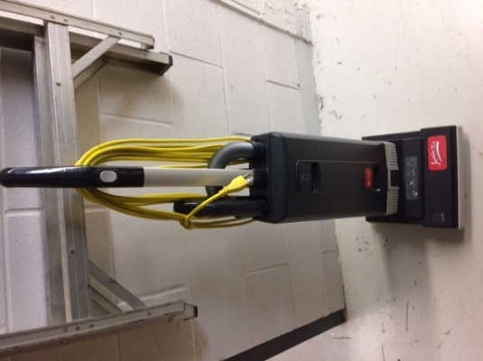

**Store Vacuum with cords wrapped around cable hooks**

©WorkSafeBC. Used with permission from *A Clean Sweep.*

**Be Accountable: Choose safety - work safe - and go home injury free!**



**Safety Memo**

***Safety is everyone’s responsibility!***

**Wiping and Dusting**

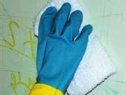Extending the shoulder and arm to wipe forcefully with the whole hand for long periods of time is tiring. Wringing wet wash cloths produces forceful and repetitious twisting and bending of the wrist.

**Cloth selection-size**

Cloths should be large enough to be efficient but small enough to squeeze out excess water with no more than two squeezing motions.

**Wringing**

The twisting force of the wringing action gets out more water than a simple squeeze, but this can cause wrist injury when done repetitively.

* To avoid injury, hold one hand above the other to produce a squeeze action – this allows both wrist joints to be in a straight neutral position

**Wiping Horizontal/ Vertical Surfaces**

* Use effective cleaning products and let the cleaning products do the work
* Divide work into sections to allow task rotation
* Alternate arms to reduce muscle fatigue
* Use well designed tools that match your height, strength and endurance

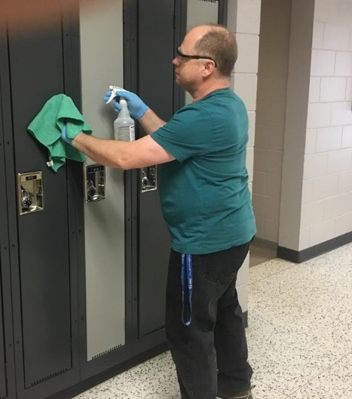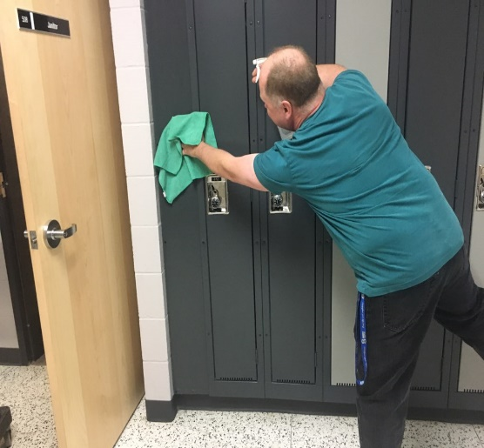

**Do not over reach to avoid injury**

**Wear applicable PPE**

©WorkSafeBC. Used with permission from *A Clean Sweep.*

**Be Accountable: Choose safety - work safe - and go home injury free!**