Section 3.8: Hantavirus

    - Hantavirus (rodent droppings)
What is Hantavirus?
Hantavirus infection is caused by a virus that is found in some field rodents, especially deer mice in Canada and the United States. The virus is rarely transmitted to people; when it is, the virus can cause severe illness-even death.
People can contract the disease when they breathe the virus that is found in the urine, saliva, or droppings of infected rodents. Hantavirus infections usually occur in rural or semirural areas where workers are more likely to contact infected rodents or their droppings. Those infected with the virus have shown flu-like symptoms that turn to dangerous, pneumonia-like condition after two or three days.
How is Hantavirus transmitted?
Hantavirus is not transmitted from person to person, only from deer mice to humans.
The virus is found in the droppings, urine, or saliva of the mouse and can spread to humans when particles of the infected saliva, urine or droppings are inhaled. Inhalation may occur through direct contact with the rodent, or from breathing airborne dust particles that are generated when rodent droppings or urine are disturbed. The virus can also be spread if an infected rodent bites you or if infected materials contact broken skin or the membrane of the eyes.
Hantaviruses do not survive for long outside of their hosts-usually less than a week indoors, and only a few hours when exposed to direct sunlight. The viruses can also be killed by most household disinfectants (e.g., 10% bleach).
What are the symptoms of Hantavirus?
Hantavirus is rarely transmitted to humans, but when it is it can cause severe illness including death. Early symptoms include fatigue, fever, and muscle aches (especially the large muscles, hips, back, thighs, shoulders). Some people will also experience, headaches, dizziness, chills, vomiting and abdominal pain. Later symptoms may include coughing and trouble breathing. If you experience any of these symptoms see your doctor as soon as possible and make sure the doctor is aware of any possible exposure you may have had to rodents or their droppings.

How can it be prevented?
There are no vaccines against Hantavirus. The only protection is to keep your home or workplace as free of deer mice as possible, and to safely clean up any mouse droppings or urine that you see. Regular inspections for rodents should be conducted to determine if active rodent control is necessary. Make sure your building is rodent proof by closing openings where rodents can gain entry. Ensure proper sanitation and elimination of food sources by storage in rodent proof containers.
General Clean up Procedure:
- Clear all unnecessary persons from the area.
- Ventilate area, open doors and windows, if possible.
- Disinfectant solution:
- diluted bleach (100ml/1litre water) to be used on rodent carcasses, nesting materials, droppings, surfaces, and materials contaminated with droppings or urine; or to decontaminate rubber gloves and boots.

- Cover any broken skin that may be exposed to infection prior to beginning clean-up of rodent contamination.
- Wear disposable gloves (nitrile, latex, etc.).
- Put on protective eyewear before starting clean-up of contaminated area.
- Wear a NIOSH approved respirator with a high efficiency P-100 filter (Note: All caretaking staff has been fit tested and issued ½ mask respirators equipped with these filters). If the area is heavily infested, workers should also wear disposable coveralls, rubber boots or disposable shoe covers.
Respirator Selection:
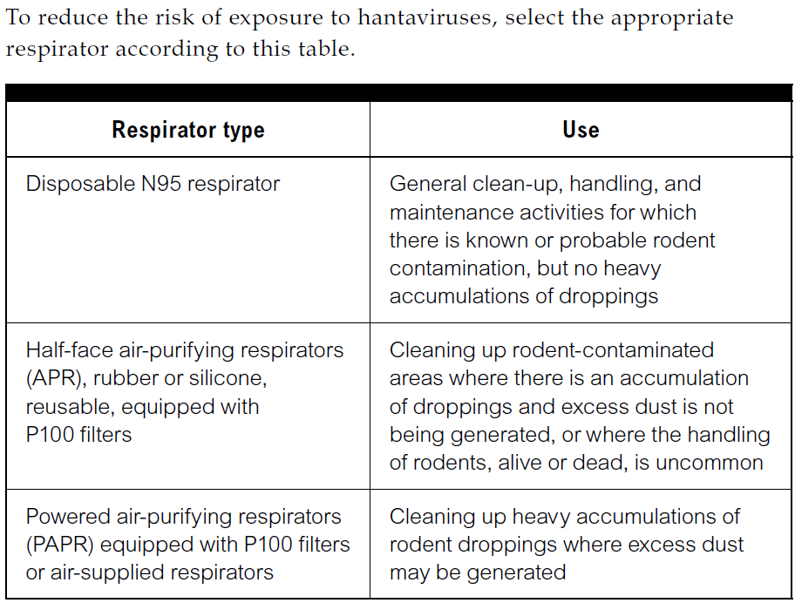
- Do not stir up dust by sweeping up or vacuuming up dry droppings, urine or nesting materials.
- Note: A high efficiency vacuum equipped with a HEPA filter is would be acceptable in hard to reach areas.
- To kill the virus lightly wet down the droppings or dead mouse with a solution of bleach. This should be mixed fresh daily because the quality of the bleach solution deteriorates after 24 hours.
- Clean up the contaminated materials with a damp towel. Put the droppings and towels in double plastic bags, label the bag contents, seal the bag and place in the outdoor garbage bin (out of reach of children).
- Dispose of any food or liquid that mice may have come into contact with. If you encounter a dead mouse wet the mouse down with the disinfectant solution. Wearing rubber gloves, put your hand inside a plastic bag, pick up the mouse, then turn the bag inside out so that the mouse is inside the bag and you haven’t touched it.
- Wipe or mop the surfaces and any equipment used with a solution of the disinfectant.
- Prior to removing your eye, hand and respiratory protection, remove coveralls, if applicable, (preferably outdoors) and disposable booties and place in a double plastic bag.
- Wet-wipe outer surface of the eyewear, respirator and footwear with a disposable towel.
- Rinse gloves in the disinfectant solution and place along with other disposable items in the double plastic bag.
- Wash your hands and any exposed skin areas well after the clean-up.

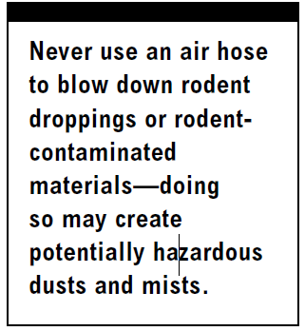
Clean carpets, clothing, upholstery or hard surfaces?
Remove droppings and contaminated materials following similar procedures as above, but do not use the bleach solution. Wet the area first with hot water; remove the mouse or droppings, then shampoo (do not use bleach on carpets or upholstery). Make sure you use a commercial rug shampoo to which you have added a disinfectant. It should not stain the carpet or upholstery. For small spot cleaning, spray the area with a disinfectant solution (not bleach), and wipe the droppings as above. Use the disinfectant on hardwood floors, and the bleach solution on linoleum floors, counters and appliances. Take bedding or clothing outside and either gently roll the droppings off or pick them off with rubber gloves: do not shake them off! Then wash them as regular laundry and dry them in a dryer or hang them outside in the bright sunlight.

Section 3.9: Histoplasmosis or Cryptococcosis

- Histoplasmosis or Cryptococcosis (Bird and Bat Droppings)

What are the Dangers?
When working around areas contaminated with bird and bat droppings, workers can be exposed to fungi that can cause serious infections called Histoplasmosis or Cryptococcosis. While fresh bird droppings are not expected to contain the fungi, fresh bat droppings may be contaminated. Disturbing the droppings or contaminated soil may release tiny particles into the air called “spores”. The spores can be inhaled and infect a worker’s lungs. Most people who become infected with the fungi experience no symptoms, but some may experience mild flu-like symptoms. For some people, especially those with weakened immune systems, the disease can be life threatening because it can spread to other areas of the body, become severe, and eventually cause death.
Identify Controls
Always assume droppings are contaminated. Take the following precautions to reduce your risk of infection:
- If you have a weakened immune system, you should consult your doctor before working in the area.
- When removing large amounts of droppings, use the following types of personal protective equipment (PPE):
    - rubber boots
    - disposable gloves under work gloves
    - disposable coveralls
    - respiratory protection

- Respirators should always be worn when working around bird or bat droppings. Appropriate respirators could range from an N95 filtering face piece for low-risk tasks to a full face piece air-purifying respirator or powered air-purifying respirator for high-risk tasks. Follow these additional procedures to minimize the risk of infection:
  - Eliminate the roost (nest) if the building is not going to be demolished and seal entry points if possible.
  - Avoid disturbing material that could be contaminated to prevent the generation of dust and inhalation of spores.
  - Never dry-sweep or dry-shovel material. Soak the material with water or a wetting agent to keep dust and spores down.
  - Use a HEPA vacuum to clean up the contaminated material (if available).
  - Dispose of the waste in 6-ml disposal bags and follow the disposal procedures outlined in your company’s health and safety policy.
  - For larger contamination, a disinfectant may be used. For these applications, consult the manufacturer’s directions.

