

**CARETAKING SECTOR MANUAL**

[ENTER DIVISION NAME]

march 2020

**Table of Contents**

Preface 4

Chapter 1: Duties, Roles and Responsibilities of Caretakers 5

Section 1.1: CARETAKER Job Description 6

Section 1.2: Absence Reporting 10

Section 1.3: Absence Reporting Sub-Caretaker Call-In Procedure 10

Section 1.4: Appearance, Safety, Conduct & Relationships 10

Section 1.5: Reporting Accidents, Incidents, Near Misses or Property Damage 12

Section 1.6: Roles & Responsibilities of the Worker 13

Chapter 2: Employment: Conditions, Safety Rules, and Health and Safety Policy 14

Section 2.1: Conditions of Employment 15

Section 2.2: Safety Rules 16

Section 2.3: Health & Safety Policy 17

Chapter 3: Job Safety Analysis, TLR-Object Moving, Proper Body Mechanics, Safety Procedures and Safety Memos 19

Section 3.1: Job Safety Analysis (JSA) 20

Section 3.2: TLR-Object Moving 29

Section 3.3: Proper Body Mechanics 31

Section 3.4: Hantavirus 33

Section 3.5: Histoplasmosis or Cryptococcosis 35

Section 3.6: Safety Procedures 37

Section 3.7: Safety Memos 61

Chapter 4: Security and Emergency Preparedness 79

Section 4.1: Security 80

Section 4.2: Emergency Preparedness 80

Chapter 5: Training, Communication & Ordering for Caretakers 81

Section 5.1: Training 82

Section 5.2: Department In-Service 82

Section 5.3: Communication 82

Section 5.4: Ordering Supplies & Keeping Inventory 84

Section 5.5: Orientation Checklist 85

Section 5.6: Online Leave Entry 88

Chapter 6: Appendices 89

Appendix A: Quick Reference Guide 90

Appendix B: Administrative Procedures (listed but not limited to) 91

Responsible use of Technology and the Internet 91

Exposure Control Plan (Blood, Body Fluids) 91

Tobacco Free Environment 91

Video Surveillance 91

Confidentiality 91

Emergency Water Situations 91

Social Media Guidelines 91

Student Welfare 91

Student Discipline 91

Damage to Property by Students 92

Service Dogs in Schools 92

Criminal Record and Vulnerable Sector Checks 92

Reporting of Criminal Charges 92

Harassment 92

Violence 92

Injury Reporting 92

Caretaker Supervision 92

Employee Use of Drugs and Alcohol 92

Mobile Devices 92

Hazard Identification and Control- Workplace Hazardous Materials Information System WHMIS 2015 92

Buildings and Grounds Security 93

Use of Division Vehicles 93

Appendix C: Key References 94

Chapter 7: Forms 95

Section 7.1: Caretaking Sector Forms (listed but not limited to) 96

Incident Report Form 96

Expense Reimbursement Form 96

Equipment Inventory - Yearly 96

Chemicals on Hand – Quarterly Inventory 96

Caretaker Performance Review Form 96

Snow/Ice Removal Log 96

Playground Inspection 96

Tri-Annual Reports 97

Yearly Inventory List 97

Working Alone 97

# Preface

[Enter division name] provides caretaking staff at all facilities in the division. Caretakers assist in the cleaning and minor maintenance of their assigned facility to ensure its clean and safe operation.

This manual provides caretakers with information they require to provide the best possible service to our students and staff.

The school division has approximately (division specific) full and part time caretakers that ensure clean and safe operations of facilities for approximately ## students daily, covering over ## facilities. The safety of students and staff is of highest priority.

“Success and achievement for every student in every school”



**Facilities & Transportation Department**

**[Enter division name]**



**1**

# Chapter 1: Duties, Roles and Responsibilities of Caretakers

**[ENTER DIVISION NAME]**

## Section 1.1: CARETAKER Job Description

**Position Profile:** The Caretaker assists in the cleaning and minor maintenance of the assigned facility to ensure its clean and safe operation.

**Directly Reports To:** Manager of Facilities and Transportation/Caretaking Supervisor or Designate

**Indirectly Reports To:** Administrator or Designate

**Required Education, Knowledge, Qualifications and Experience:**

* Valid Fireman’s Certificate is preferred
* Valid Driver’s License
* If required to operate a Division owned vehicle must provide copy of driver’s license
* Direct experience in the caretaking field would be considered an asset
* Demonstrated understanding of cleaning procedures, cleaning processes, products and equipment is preferred
* Knowledge of computers and applicable software
* Completed education of the Workplace Hazardous Materials Information System 2015 (WHMIS)

**Required Skills and Abilities:**

* Ability to work with minimal supervision
* Ability to work as a team player
* Ability to prioritize multiple demands and effectively manage time
* Ability to execute written and oral instructions for the safe, competent use of caretaking supplies and operation of equipment
* Ability to execute the school caretaking procedures as outlined in the caretaking manual
* Work in varied climates and conditions which may include: dust, vapors, fumes or slippery floors for example
* Ability to do Medium Load Work which includes:
* exerting up to 50 lbs. of force occasionally (lifting and/or carrying)
* exerting up to 20 lbs. of force frequently
* exerting up to 10 lbs. of force constantly to move objects
* Employees must be physically fit and able to handle various tasks involving lifting, bending, twisting, turning, and climbing
* Ability to perform minor maintenance functions
* Display a positive attitude

**Supervision of Staff:**

This position does not involve the supervision of staff

Duties and Responsibilities:

Without restricting the generality of the general description above, the Caretaker shall perform such duties and responsibilities as may be assigned including but not restricted to the following:

* Assist in the operation and checks of building mechanical systems (i.e., boiler system)
* Steam boilers checked by worker with valid Fireman’s Certificate
* Lock and secure facility
* Change light bulbs as required
* Steam boilers to be checked by worker with valid Firemen’s Certificate (Locations: _____)
* Perform minor maintenance and repair duties; similar in nature expected in the maintenance of a residence, which includes plumbing repairs, basic carpentry and minor painting.
* Dust and polish as required
* Be cognizant of the need to be proactive in energy management (i.e., turning off lights, HVAC systems when not required)
* Be willing to participate in training, education and department in-services
* Conduct oneself in a manner appropriate to an educational institution that provides services to children
* Deal tactfully with staff, students and the public
* Be knowledgeable and supportive of applicable administrative procedures
* Practice safe work habits at all times
* Participate in scheduled in-service pertaining to the performance of facility caretaking
* Maintain up to date Playground Inspection Sheets, where required
* Maintain up to date ice/snow log as required
* Maintain Safety Data Sheets (SDS) binders for all caretaking products that require this documentation

**Opening Duties**

* Ensure school is opened and lights turned on daily as arranged with the Principal
* Open all access gates
* Raise Canadian Flag as directed by school administration
* Visual check furnaces/air handling units to ensure they are operating
* Vacuum all entrance rugs

**Daily Duties**

* Disinfect all high touch areas regularly & thoroughly as schedule permits (doorways, light switches, door knobs, phones, computers, fountains/coolers etc.)
* Disinfect tables & furniture in pre-k & kindergarten rooms & other pertinent areas
* Clean & disinfect washroom toilets, sinks, fountains, mirrors, counters, etc.
* Dry mop all rooms, hallways, gymnasium and stage areas
* Wet mop any/all spills
* Damp mop/vacuum entrances & entrance mats
* Vacuum all carpets/rugs
* Empty all garbage cans & replace bags in all rooms & haul to garbage bin
* Wipe/wash down boot racks
* Clean common areas which includes washing all tables & dry or wet mopping floors
* Wipe off all stains/mud etc. on walls as required
* Wash & polish interior windows, entrance door glass and side light glass panels
* Check and refill all paper towel, toilet paper and soap dispensers regularly

**Closing Duties**

* Lower & remove Canadian Flag as directed by school administration
* Ensure school is locked (inside & outside) and all windows are closed and locked
* Ensure all lights are turned off as arranged with the Principal
* Shut off fans as directed
* Turn on all exterior lighting, as directed by school administration

**Weekly Duties (in addition to daily duties)**

* Thoroughly disinfect washroom/change room stalls, walls & showers
* Wash all desks, tables, ledges etc. as arranged with the teachers in all areas & offices
* Wash down whiteboards/blackboards, ledges & clean chalkboard brushes
* Complete thorough sweeping/mopping of facility
* Wash hallways and other high traffic areas with floor scrubber every 2- 3 days or as required
* Wash down water coolers, counters etc.
* Wash gymnasium floor
* Vacuum & tidy up stage areas, equipment rooms etc.
* Clean sinks in labs, art rooms, etc.
* Wipe down teachers’ desks if they are cleared off
* Sweep & wash down floors/counters in canteen areas (if applicable)
* Create or close Asset Planner service requests relative to the facility (if applicable)

**Monthly Duties (in addition to weekly duties)**

* Thorough washing of hallway walls, doorways, entrances & any soiled areas
* Polish or burnish all floors with available equipment
* Spot clean walls – around garbage cans, microwaves, doorways, lockers, etc.
* Dust trophy cases and clean glass
* Vacuum/wipe down student, teachers and staff room chairs
* Clean all electronic equipment – DVD players, TVs, CD players, laptops, etc.
* Wash fronts and tops of lockers
* Wash down windows and window coverings
* Thoroughly clean & organize caretaker rooms, supply areas & furnace/boiler rooms
* Order supplies (every three months or as directed by facilities management)
* Replace burnt out light bulbs as required
* Do minor maintenance repairs/projects, paint touch ups as required

**Exterior Duties**

* Maintain the outside perimeter of the school (grass cutting, weeds, debris, etc.)
* Ensure entrances & sidewalks are cleared and free of debris/snow/ice; complete log sheet
* Apply ice melt as needed; complete log sheet
* Inspect or assist in the inspection of playground equipment and surfaces; complete log sheet
* Pick up debris and garbage from school grounds
* Collect garbage from exterior collection areas

**Duties during weekly school breaks**

* Deep scrub and refinish floors as directed by your supervisor
* Thorough cleaning of all ceiling diffusers and light fixtures
* Thorough cleaning & disinfecting of washrooms & change rooms
* Shampoo/steam clean carpets/rugs as required
* Clean under & behind fridges, stoves, etc.
* Arrangements with vendors is required prior to moving vending machine(s) for any purpose

**Duties during Summer Break Period (in addition to regular duties)**

* Prior to summer break arrangements with administration to be made to ensure items are stored or removed for cleaning purposes
* Thorough wash down of entire school surfaces (this list includes, but not limited to walls, doors, lockers, cupboards, desks, furniture, including inside and outside of all surfaces)
* Touch up painting on shelving, cupboards, under chalkboards as required
* Scrub and refinish floors as directed by supervisor
* Light cleaning as needed the week before school
* Thorough cleaning & organizing of furnace, caretaker & storage rooms/areas

**Judgment, Independence and Client/Peer Contact**

**Confidentiality:** (Reference applicable policy)

At no time should a Caretaker discuss, in public, information pertaining to a student or staff. The Caretaker is expected to respect the confidential nature of the position by avoiding the discussion about any topics that are not formally communicated to the public by the administration of the schools or the school division. Breaching confidentiality is a serious violation of acceptable conduct.

**Independence:**

The Caretaker is expected to work independently and as a team member of the Facilities Department, all schools and the division office as required.

**Client/Peer Contact:**

This employee works collegially with school staff, school-based administration and other school division staff. Contact with other employees and outside agencies is regular and frequent.

**Responsibility for Quality of Assigned Work**

The employee is under direct supervision and is responsible to achieve the quality of work as assigned by the supervisor.

## Section 1.2: Absence Reporting

In any occasion of absence the Employee who will be absent is responsible to notify their respective Caretaking Supervisor or Assistant Caretaking Supervisor. Whenever possible, they should report this daily no later than one hour prior to the start of their scheduled shift.

Employees that will be absent from work must remain in contact daily with School Administration until able to return to work.

## Section 1.3: Absence Reporting Sub-Caretaker Call-In Procedure

**Absence Reporting**

The caretaker is to call and notify their Supervisor an hour (minimum notice) prior to their shift start time (earlier if possible)

* The Supervisor is to arrange a sub if required and available
* The Supervisor is to notify the school administration of the absence and verify the name of sub filling the position or if no sub is available
* The Supervisor (if possible) or administration will be available with keys and required time to direct the sub of their duties

**Leave Request Procedure for Caretaking**

* Leave requests are required seven (7) days prior to the day in question, unless unforeseen absences occur
* After the Supervisor receives the leave the foreman would confer with the school administration if for any reason the leave should be denied
* The Supervisor is to wait for a response before approving the leave
* The Supervisor will arrange for a sub if required and possible (caretakers do **NOT** arrange for their own subs)
* The Supervisor will notify the school administration of all arrangements that have been made
* The Supervisor will notify the caretaker of the leave approval or denial

**Medical Leave Procedure - Proof of Illness**

* An employee who is ill or absence due to medical for more than two consecutive days may be required to provide a certificate from a health care professional (medical note)

## Section 1.4: Appearance, Safety, Conduct & Relationships

**Appearance:**

Caretaking staff should be courteous at all times to students, school staff, and the public. Personal neatness and cleanliness must always be kept in mind.

Clothing should be in good repair. Clothing and hats with derogatory slogans (e.g., alcohol or drugs) are not permitted.

**Safety:**

Wear only an enclosed heel and toe footwear with flexible slip resistance soles (see picture for approved footwear).





Heavy Duty Stretch Rubber Overshoes Shoe Protector with Traction Sole for Stripping Floors is mandatory and can be purchased utilizing the Clothing Allowance (see picture below).

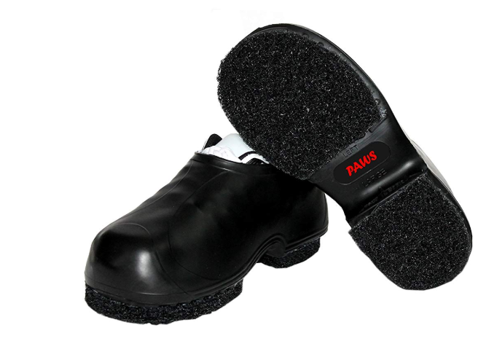

Long pants/long sleeves must be worn when performing the following tasks:

* Handling any hazardous products
* Yard maintenance (weed whipping, mowing [this includes push mower and non-enclosed tractors] and weed spray).

Always refer to the Safety Data Sheet for hazardous products

Always refer to operating procedures in Caretaker Sector Manual

**Conduct:**

Caretaking staff should always be available to offer assistance during their shift.

All caretaker rooms have hazardous products in them. The door must be shut and locked when you are not in the room. Caretaking carts must be within visual distance of caretakers at all times. If cart is not within visual distance the cart must be in a locked an unoccupied room due to hazardous products contained on the cart. All carts must be stored in caretaking room at end of shift.

Occupied classrooms or washrooms are not to be entered except when absolutely necessary. If it is necessary to go into these rooms, it is to be done in a manner to avoid disturbance. Caretaking staff must ensure washrooms are completely unoccupied prior to entering for cleaning purposes. When cleaning washrooms use “closed for cleaning” signs at the washroom entrance.

Caretaking staff should never discuss with the public what goes on around the school, nor criticize fellow workers, teachers, the principals or the administrative staff. The primary effort in public relations by the caretaking staff must be carried out with the public itself.

No employee of theschool division shall have the authority to make public or private statements on behalf of the school division without prior approval of the Director of Education. All employees shall conduct themselves publicly or privately in such a manner as shall bring credit to the school division.

**Relationships**

**Between Caretakers, School Staff, Students and the Public**

Caretakers must be reasonably tolerant of all individuals during their scheduled shift.

* Caretakers will report all occurrences of violence or potential of violence to the administration or their immediate supervisor.
* Behavior of any employee which may affect the safety and wellbeing of other employees of the school division or subcontractor, or to personnel served by the school division or subcontractor, shall be cause for disciplinary action, whether or not such behavior relates to proper performance of the employee’s job.

## Section 1.5: Reporting Accidents, Incidents, Near Misses or Property Damage

1. **Reference:** (Specific Division Policy)**– Injury Reporting System**
2. **Definitions:**
   1. **Accidents**

An unwanted, unplanned event that results in a loss (production, property or human)

* 1. **Incidents**

An unwanted, unplanned event that results in or could have resulted in a loss (production, property or human)

* 1. **Near Miss**

An unwanted, unplanned event that didn’t but could have resulted in a loss (production, property or human)

1. **Reporting Accidents/Incidents/Near Misses or Property Damage**

**General reporting**

* 1. Complete Incident Report Form and submit to the Supervisor or designate
  2. Participate in follow up investigation of incident, near miss, accident or property damage

**Off school property or while driving**

1. Obtain as much information as possible
2. Obtain the name and plate number of any other person involved in the accident
3. Report to your supervisor or designate immediately
4. Complete Incident Report Form and submit to the Supervisor or designate
5. Participate in follow up investigation of incident, near miss, accident or property damage

1. **Traffic/Criminal Code Violations**

Under *The Traffic Safety Act*, caretakers must report the following situations to the Manager of Facilities & Transportation or designate:

* 1. Any ticket violations received while driving any type of school division vehicle
  2. Any school division employee charged with a criminal offense, whether indictable or summary, federal or provincial, shall, **within two (2) working days**, inform the Director of Education of the charges. The initial contact may be verbal, but the employee is expected to provide the Director written confirmation within this timeframe. **Reference** (Specific Division Policy)

1. **Fines**

The following applies to situations where a traffic violation summons, or ticket has been issued to a caretaker while operating a school division vehicle:

* 1. Caretakers who are cited for any type of violation must pay fines with their own funds.

## Section 1.6: Roles & Responsibilities of the Worker

**Roles & Responsibilities of the Worker**

The *Act*, section 3-1(1)(gg), defines a “**worker**” as:

“an individual, including a supervisor, who is engaged in the service of an employer.”

A worker has three rights under the OH&S legislation; namely to:

1. Right to **Know** about hazards in the workplace.
2. Right to **Participate** in OH&S activities.
3. Right to **Refuse** work if the work is unusually dangerous.

***Worker***

A worker has responsibilities under the legislation to:

1. take reasonable care to protect his or her health and safety and that of others in the workplace;
2. refrain from causing or participating in harassment;
3. co-operate with any person exercising a duty under the legislation;
4. understand and follow legislative requirements;
5. use safety equipment, machine guards, safety devices, and Personal Protective Equipment (PPE) as required by the legislation, and as required and provided by the employer;
6. report all unsafe acts and workplace hazards to his or her supervisor;
7. take initiative to resolve unsafe situations within the scope of his or her responsibility;
8. follow safe work practices and procedures;
9. report all work related incidents, dangerous occurrences, injuries, or illnesses to his or her immediate supervisor;
10. participate in Occupational Health Committee (OHC) activities; and
11. co-operate with the OHC and others on health and safety issues

**\*\*\* Failure to comply may result in discipline and/or termination\*\*\***

***Reference: Saskatchewan Employment Act***

***The Occupational Health and Safety Regulations, 2020***



**2**

# Chapter 2: Employment: Conditions, Safety Rules, and Health and Safety Policy

**[ENTER DIVISION NAME]**

## Section 2.1: Conditions of Employment

1. General Terms of Employment

[](http://www.google.com/url?sa=i&rct=j&q=&esrc=s&source=images&cd=&ved=2ahUKEwjRqt7oyN_jAhXlRd8KHQcLCwEQjRx6BAgBEAU&url=http://www.evh.org.uk/hr-support/terms-and-conditions-of-employment&psig=AOvVaw0RJgi0f4y8ZnnasUK3Xn3v&ust=1564676614985708)Caretakers are employed under the conditions of their applicable collective agreement.

1. Required Documentation

All caretakers are required to produce the following documentation:

* 1. A valid Class 5 Driver’s License, if applicable.
  2. A Criminal Record Check of good standing, which includes a Vulnerable Sector Check.
* Caretaking Sector will review the prospective caretaker’s criminal record check. Regarding this review:
* A positive result allows the hiring process to continue.
* Criminal Record Checks that cite a conviction will be assessed by the Director or designate.
  1. Completed education of WHMIS 2015

1. Hours of Work

Allowable working hours from September to June will be Monday through Friday 6:00 a.m. – 8:00 p.m.*

Regular scheduled shifts will not begin prior to 6:00 a.m. and must be completed by 8:00 p.m.*

\**Exception of staffing shifts apply at _____________________*

Allowable working hours for July and August will be Monday through Friday 5:00 a.m. – 12:00 midnight

All scheduled hours must be pre-approved by Supervisor

All overtime hours must be pre-approved by Supervisor

Hours of work will align with ***The Saskatchewan Employment Act***

***The Occupational Health and Safety Regulations, 2020***

***Section 3-24– Working alone or isolated place of employment***

1. Ongoing Evaluation

Caretakers are evaluated a minimum of once every 3 years through a performance review completed by their supervisor.

## Section 2.2: Safety Rules

***We are all accountable for our actions and are expected to comply with the provisions***

***of the school division’s policies, procedures, practices and code of conduct.***

* 1. Accidents, injuries, unsafe conditions and near misses shall be reported promptly to your supervisors, must complete Incident Report Form as well. All forms must be filled out within 24 hrs.
  2. Have an awareness of your surroundings at all times.
  3. Always check with your supervisor before carrying out any task or operation if you feel your personal safety or the safety of others may be at risk.
  4. Inspect your equipment and tools before using them and report any defects and problems immediately.
  5. Ensure complete read/review of all Safety Data Sheets applicable to product being used.
* Ensure applicable Personal Protective Equipment (PPE) is worn and precautions are followed.
  1. Use the TLR Object Moving principles of good body mechanics when moving objects.
  2. Wear closed toe, closed heal and supportive footwear that is appropriate to the risks associated with the job.
  3. Use the PPE, safeguards and safety appliances/equipment provided to protect your health and safety.
  4. Review the Job Safety Analysis (JSA) frequently.
  5. Wear clothing that is appropriate to the risks associated with the elements.

**\*\*\* Failure to comply may result in discipline and/or termination \*\*\***

***Reference: The Saskatchewan Employment Act***

***The Occupational Health and Safety Regulations, 2020***

## Section 2.3: Health & Safety Policy

**______**

**STATEMENT OF COMMITMENT TO HEALTH & SAFETY**

**Background**

In Saskatchewan the employer is required by law to promote and protect the safety of workers in the workplace. This document provides the [enter school division] public declaration of its commitment to safety.

Statement of Commitment to Health and Safety will be posted in a location visible to all employees, such as the OHC bulletin board.

**Commitment**

The [enter school division] is committed to providing a safe and healthy work environment for all individuals (employees, students, visitors, contractors and volunteers).

The [enter school division] recognizes the duties, rights and responsibilities of all workers and will ensure that all workers are aware of these and other conditions embodied in provincial legislation. The [enter school division] declaration does not preclude all employees’ responsibilities and accountabilities in achieving a safe work environment for all.

The [enter school division] will establish and maintain an occupational health and safety program as part of its Safety Management System to ensure the goals of this policy and the right of participation of all workers. The [enter school division] will support safe work procedures through the funding of adequate equipment, programs, training and through the establishment of standards for safe work practices.

The [school division] will adopt and preserve the following safety philosophy statements:

* The safety of workers is as important as the safety of students, visitors and contractors.
* Workers have a right to work in a safe and healthy workplace.
* Health and safety is everyone’s responsibility based on the workplace responsibility system (WRS).
* Working in a healthy and safe way is a condition of employment.
* All hazards will be identified and controlled through regular formal and information workplace inspections.
* Health and safety education and training will be consistent and ongoing.
* Health and safety meetings will be held regularly, with worker input encouraged.
* All incidents and dangerous occurrences will be reported and investigated.
* Safety applies to all employers, supervisors, workers, volunteers, students, contractors, self-employed resources and suppliers in their dealings with the [enter school division].

This policy shall be reviewed every three years by the [enter school division] as part of the safety program review and/or whenever there is a change of circumstances that may affect the health and safety of workers, or a change in OHS legislation.

***References***

*The Saskatchewan Employment Act,* Part III, Section 3-20.

*The Occupational Health and Safety Regulations, 2020,* Section 3-11.



**3**

# Chapter 3: Job Safety Analysis, TLR-Object Moving, Proper Body Mechanics, Safety Procedures and Safety Memos

**[ENTER DIVISION NAME]**

## Section 3.1: Job Safety Analysis (JSA)

Job Safety Analysis (JSA)

| Job/position/work type: **Caretaker** | | | | | | Date Completed: |
| --- | --- | --- | --- | --- | --- | --- |
| Assessment Team: | | | | | | Reviewed/revised: |
| Tasks  (List **all** tasks/activities of the job/position) | Hazards  (List **all** existing and potential health and safety hazards) | Severity | Probability | Risk | Controls  (List the controls for each hazard:  Elimination, Engineering, Administrative, Personal Protective Equipment) | Comments: |
| **S x P = R** | | |
| Maintain floors:   * sweeping * mopping * stripping * waxing * scrubbing polishing | Falls  Slipping  Tripping  Repetitive movements  Airborne Particles (dust)  Lifting water buckets, brooms, mops, heavy floor machines.  Moving heavy items/furniture.  Chemical exposure to cleaners, strippers, waxes.  Electrical hazards, forceful grasping, noise, hand/arm vibration;  Physical injury from awkward postures (bending, twisting, pushing, pulling, bent wrists; kneeling on hard floors) Improperly inspected/maintained machines.  Working alone |  |  |  | TLR Object Moving Training, Good body mechanics, Never twist or turn without positioning feet in direction of movement  Vary your tasks  Appropriate footwear (as per caretaker manual),  Be aware of surroundings  Avoid forceful pressing handles into palms.  Ensure your equipment is strategically placed to reduce carrying/lifting distances.  Working alone procedures in place.  Approved personal protective equipment provided and used by worker (e.g., gloves, chemical cartridge respirator, dust masks, eye and hearing protection).  Refer to Safety Data Sheet SDS  Applicable PPE (refer to respirator sheet) |  |
| Remove garbage  and recyclables | Strains/Pulls  Pulling bags out of bins  Throwing bags into dumpsters  Hazardous Items (broken glass, used needles, etc.)  Overloaded waste bins  Blood and Body Fluids  Working Alone |  |  |  | TLR Object Moving Training, Good body mechanics, Never twist or turn without positioning feet in direction of movement  Vary your tasks  Appropriate footwear (as per caretaker manual),  Be aware of surroundings  Applicable PPE (refer to respirator sheet), Ensure air seal is broken in garbage bin, Smaller garbage container options  Ensure garbage is not overfilled  Communicate to staff to not overfill garbage. Manage weight loads to waste bin.  Follow Working Alone procedure  Follow exposure plan procedures |  |
| Clean and disinfect washrooms | Blood/body fluids  Slips/Trips  Muscle strains  Awkward positions  Push/Pull  Chemical exposures  Poor ventilation  Repetitive strains |  |  |  | TLR Object Moving Training, Good body mechanics, Never twist or turn without positioning feet in direction of movement  Vary your tasks  Appropriate footwear (as per caretaker manual),  Be aware of surroundings  Applicable PPE (refer to respirator sheet & SDS)  Follow exposure plan procedures  Refer to caretaking manual (pictures) |  |
| Hazardous spill clean-up (e.g., blood/body fluids, mouse/bird/bat droppings) | Exposure to bacteria/viruses/ chemicals |  |  |  | Follow expose control plan procedures  For Hantavirus and Blood and Body  Applicable PPE (refer to respirator sheet & SDS)  Practice hand hygiene |  |
| Move furniture and equipment (Tables, benches, desks, cabinets, TVs, entrance mats, floor machines, etc.) | Injury from awkward postures; heavy lifting, overexertion, repetitive motions, bending, twisting, carrying up and down stairs;  foot/hand injury |  |  |  | Adhere to TLR Object Moving Training, Good body mechanics, Never twist or turn without positioning feet in direction of movement  Use carts, dollies whenever possible  Vary your tasks  Appropriate footwear (as per caretaker manual)  Be aware of surroundings |  |
| Snow Removal | Shovels, snow blowers; heavy snow;  Flammable materials.  Heavy repetitive lifting; bending/ awkward postures.  Pushing, pulling equipment over uneven terrain.  Injury from flying debris,  moving machinery parts.  Fatigue and time constraints;  Slips/falls;  Extreme temperatures  Windchill  Weather conditions |  |  |  | Safe work procedures: Snow blowers, tractor snow blower  Follow Safety Memo for Snow Shoveling  Adhere to TLR Object Moving Training, Good body mechanics, Never twist or turn without positioning feet in direction of movement  Be aware of your surroundings  Vary your tasks  Appropriate footwear (as per caretaker manual)  Appropriate protection from the elements.  Refer to SDS  Gasoline stored outdoors in approved shed/ containers. |  |
| Boiler checks | Hot steam/water burn  Chemical exposure  Slip/trip/fall  Working alone  Lifting |  |  |  | TLR Object Moving Training, Good body mechanics, Never twist or turn.  Refer to SDS  Applicable PPE (glasses, gloves)  Be aware of your surroundings  Working alone procedures  Appropriate footwear (as per caretaker manual) | Boiler checks |
| Grounds Maintenance | Lawn mower, noise exposure pesticides, sun exposure, insects;  Stooping, bending,  Kneeling;  Hand/foot hazards from contact with moving parts.  Trips/ falls  Electric shock |  |  |  | Safe work procedures: Lawnmower, weed-whipper, leaf blower, riding lawnmowers, hedge trimmers,  Safe practices for rakes, shovels  Gasoline stored outdoors in approved shed/ containers.  TLR Object Moving Training, Good body mechanics, Never twist or turn without positioning feet in direction of movement  Vary your tasks  Appropriate footwear (as per caretaker manual)  Be aware of surroundings  Appropriate protection from the elements. | Grounds Maintenance |
| Auto Scrubber- Checking the battery fluids/filling the fluids | Splash  Overfill of battery fluid |  |  |  | Refer SDS  Utilize battery fill jug  Applicable PPE (gloves, eye protection, proper clothing) |  |
| Maintain carpets:   * Vacuum/Clean * Spot clean | Repetitive Movements  Trips/Falls  Push/Pull  Exposure to dust, noise |  |  |  | Be aware of surroundings  TLR Object Moving Training, Good body mechanics, Never twist or turn without positioning feet in direction of movement  Vary your tasks  Appropriate footwear (as per caretaker manual)  Applicable PPE (refer to respirator sheet)  Refer to SDS |  |
| Prior to use, visual inspection of equipment | Electrical shock  Trips/Falls  Rotating Equipment  Equipment Failure |  |  |  | Complete inspection prior to use  Be aware of surroundings  Appropriate footwear (as per caretaker manual) Good body mechanics  Vary your tasks  Applicable PPE (refer to respirator sheet) Reference manufacturers guidelines  Refer to SDS |  |
| General cleaning: desks, walls, chalk/whiteboards; windows/glass etc. | Repetitive movements  Strains  Awkward positions  Chemical handling  Push/Pull  Slips/Trips  Working from heights |  |  |  | TLR Object Moving Training, Good body mechanics, Never twist or turn without positioning feet in direction of movement  Vary your tasks  Appropriate footwear (as per caretaker manual),  Be aware of surroundings  Applicable PPE (refer to respirator sheet)  Refer to SDS  Refer to ladder safety in caretaker manual |  |
| Plunge clogged toilet | Biohazard  Splash  Slips/Trips  Muscle strains  Push/Pull  Chemical exposures  Repetitive strains |  |  |  | TLR Object Moving Training, Good body mechanics, Never twist or turn without positioning feet in direction of movement  Vary your tasks  Appropriate footwear (as per caretaker manual)  Be aware of surroundings  Applicable PPE (refer to respirator sheet & SDS)  Follow expose control plan procedures  Keep mechanical snake, used to unclog toilet in its own separate container (drum auger, closet snake)  Ensure equipment is cleaned and contained - (Plunger)  Practice hand hygiene |  |
| Expose to hazardous products/ spill clean-up (Chemical) | Exposure to chemicals |  |  |  | Read and follow SDS  Applicable PPE  Refer to WHMIS 2015 education and training  Practice hand hygiene |  |
| Inspect and clean-up of buildings and grounds | Broken glass  Cuts/Lacerations  Blood/body fluids  Insect bites  Animal feces  Working alone |  |  |  | Be aware of your surroundings. Follow exposure plan- applicable PPE to be worn.  Working alone procedures  Follow broken glass procedure  Vary tasks, insect may be worse sundown (bug spray) |  |
| Order stock and maintain supplies | Stock shelves with supplies  Exposure to hazardous products |  |  |  | TLR Object Moving Training, Good body mechanics, Never twist or turn without positioning feet in direction of movement  Always keep heavier items on lower shelves  Never store liquids above shoulders  Always keep lighter items higher  Vary your tasks  Refer to SDS  Appropriate footwear (as per caretaker manual) |  |
| Change/replace lights, ceiling tiles | Working from heights;  Ladders, scissor lifts/Geni-lifts.  Awkward postures  Risk of shock  Broken glass  Falls |  |  |  | TLR Object Moving Training, Good body mechanics, Never twist or turn.  Vary your tasks  Refer to ladder safety in caretaker manual  Safe work procedures: Scissor lifts/Geni lifts  Fall protection procedures  Be aware of your surroundings  Follow broken glass procedure  Applicable PPE to be worn  Appropriate footwear (as per caretaker manual) |  |
| Inspect/ change filter on furnace | Moving parts/rotating equipment,  Dust exposure  Hand injury  Slips/trips/falls  Working alone |  |  |  | Follow proper maintenance safe work procedures.  Wear appropriate PPE  Never wear loose clothing, long hair to be tied back and no loose hanging jewelry  Increased caution to be used around moving equipment.  Use lockout/tag out procedures  Working alone procedures  Be aware of your surroundings |  |
| Record/monitor mechanical room checks | Risk of shock  Slips/trips/falls  Working alone |  |  |  | Working alone procedures  Be aware of your surroundings  Wear appropriate PPE  Appropriate footwear (as per caretaker manual)  Ensure handrails are used if applicable |  |
| Working at heights   * Scissor lift/Geni lift * Ladder * Roof | Falls  Awkward postures  Other people around (students/staff)  Carry, pushing, pulling  Working alone |  |  |  | TLR Object Moving Training, Good body mechanics, Never twist or turn.  Fall protection procedure  Vary your tasks  Refer to ladder safety in caretaker manual  Safe work procedures: Scissor lifts/Geni lifts  Be aware of your surroundings in control zone  Working alone procedures  Appropriate footwear (as per caretaker manual) |  |
| Ear buds, headphones, excessive volume (radios, stereos, TVs, phones, etc.) | Unable to hear people around you  Unable to hear emergency announcements |  |  |  | Ear buds, headphones are prohibited. |  |
| Operating Truck | Road hazards  Other drivers  Students, pedestrians  Regular maintenance (fueling, check oil, general housekeeping) |  |  |  | Be aware of your surroundings at all times  Ensure circle check is complete prior to moving truck  Refer to the SDS  Appropriate footwear (as per caretaker manual) Appropriate protection from the elements. |  |

Risk Matrix:

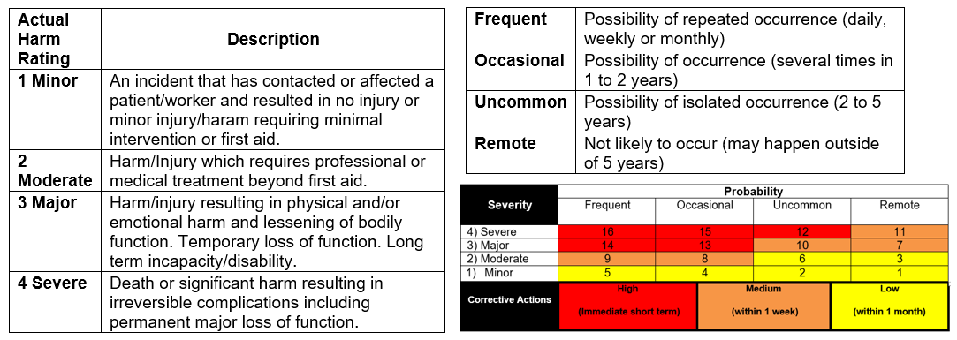

## Section 3.2: TLR-Object Moving

**Steps to a Moving Task**

* Assess: complete a risk assessment of self, environment, equipment, object, not just once, but also In the moment the task is being performed
* Select: the safest moving technique will be determined through the risk assessment process
* Prepare: footwear, personal protective equipment (PPE), equipment, assistance, roles clarified, command established, route, second location, pathway, clear visibility
* Move: In the Moment Assessment
* Evaluate: ask yourself questions
* Communicate: verbal and written

**Good Posture**

**Standing Posture:**

* tighten core
* flex the knees often
* work at an appropriate height for the task
* wear comfortable shoes that have support and are appropriate for the task
* stand on a cushioned or anti-fatigue mat when standing for extended periods of time
* to assist in relieving the static posture of standing, place one foot up on an elevated ledge
* (e.g., 10-15 cm or 4-6” high)

**Sitting Posture:**

* sit in alignment with ears over shoulders and shoulders over hips. Position reading material to avoid looking up or down for prolonged periods of time
* use a chair appropriate for the task that provides good lumbar support
* sit with feet flat on the floor, thighs at approximately a 90 degree angle, and knees slightly lower than the hips
* place both feet on appropriate foot rests when necessary
* sit close to the work
* stretch frequently

**TLR-Object Moving Checkpoints to Safe Body Mechanics**

**Safe Stance**

* Feet shoulder width apart (parallel or stride stance)

**For the Top**

* Ears over shoulders
* Shoulders over hips

**For the Bottom**

* Bend at the knees (e.g., soft knees)
* Bend at the hips
* “sit” into it (buttocks move down and back)
* Tighten core (i.e., abdominal muscles)

**Safe effective grip**

* Wrists in neutral position (wrists aligned with forearm)
* Elbows close to your sides
* Thumbs up or out

**Comfort Zone**

* Vertical zone: area between the shoulders and thighs (where the fingertips touch the thighs when standing in an upright posture); and
* Horizontal zone: area in front of you when your elbows are at or near a 90 degrees angle and are close to your sides
* Keep the load close

**Weight Transfer**

* Side to side
* Front to back

**TLR-Object Moving Safe Work Practice – TLR-Object Moving in the Moment Risk Assessment**

For each object moving task:

**Verify** before performing a moving technique. Find out:

* what you need to know about the object through labeling, co-workers
* what may be new or has changed since the last move, last shift
* is the moving technique a lift or reposition and what equipment is needed

**Assess** for risks:

* assess yourself before, during and even after the moving task: ask yourself questions such as “How am I feeling?”, “What is my attitude like today?”
* assess the environment: clutter, noise, lighting, aggression/violence
* assess the equipment: ensure appropriate assistance and equipment is available in quantity, capacity and quality
* assess the object: hot, cold, heavy, awkward

**Select** the moving technique:

* ensure it is the safest technique if it is already identified
* the technique may need to change if the assessment has identified a change

**Prepare** for the move:

* appropriate footwear
* the plan is in place (equipment, assistance, route)
* clear visibility

**Move** the object:

* duties are assigned
* use safe body mechanics (stance, grip, weight transfer)
* use the appropriate steps for the moving task

**Evaluate**

* Did you feel that the move compromised your own safe body mechanics?
* At any time did you feel the load was too heavy, awkward or unstable?

**Communicate**

* what went well
* what the recommended moving technique should be
* how risks were eliminated or managed
* what needs to be documented

## Section 3.3: Proper Body Mechanics

  **TIPS**

Correct Incorrect

**Plunging a Toilet**

|  |  |  |
| --- | --- | --- |
| image1.jpeg | image2.jpeg | * Wear your PPE when unclogging toilets. * Do not bend over toilet while plunging to avoid back injury * Use short pushes with your legs, shoulders and arms |

  **TIPS**

Correct Incorrect

**Wiping and Dusting**

|  |  |  |
| --- | --- | --- |
|  | image4.jpeg | * Wear required PPE per the Safety Data Sheets when using chemicals * When wringing cloths, to avoid injury, hold one hand above the other to produce a squeeze action – this allows both wrist joints to be in a straight neutral position * Do not overreach or stretch to wipe or clean |

**Wringing a Mop**

|  |  |  |
| --- | --- | --- |
|  |  | * Wear required PPE per the Safety Data Sheets when using chemicals * Use your arms and legs to press down on mop wringer * Do not bend over to push wringer down * Make sure you are using the correct size of mop for you |

## Section 3.4: Hantavirus

1. **Hantavirus (rodent droppings)**

**What is Hantavirus?**

Hantavirus infection is caused by a virus that is found in some field rodents, especially deer mice in Canada and the United States. The virus is rarely transmitted to people; when it is, the virus can cause severe illness-even death.

People can contract the disease when they breathe the virus that is found in the urine, saliva, or droppings of infected rodents. Hantavirus infections usually occur in rural or semirural areas where workers are more likely to contact infected rodents or their droppings. Those infected with the virus have shown flu-like symptoms that turn to dangerous, pneumonia-like condition after two or three days.

**How is Hantavirus transmitted?**

Hantavirus is not transmitted from person to person, only from deer mice to humans.

The virus is found in the droppings, urine, or saliva of the mouse and can spread to humans when particles of the infected saliva, urine or droppings are inhaled. Inhalation may occur through direct contact with the rodent, or from breathing airborne dust particles that are generated when rodent droppings or urine are disturbed. The virus can also be spread if an infected rodent bites you or if infected materials contact broken skin or the membrane of the eyes.

Hantaviruses do not survive for long outside of their hosts-usually less than a week indoors, and only a few hours when exposed to direct sunlight. The viruses can also be killed by most household disinfectants (e.g., 10% bleach)

**What are the symptoms of Hantavirus?**

Hantavirus is rarely transmitted to humans, but when it is it can cause severe illness including death. Early symptoms include fatigue, fever, and muscle aches (especially the large muscles, hips, back, thighs, shoulders). Some people will also experience, headaches, dizziness, chills, vomiting and abdominal pain. Later symptoms may include coughing and trouble breathing. If you experience any of these symptoms see your doctor as soon as possible and make sure the doctor is aware of any possible exposure you may have had to rodents or their droppings.

**How can it be prevented?**

There are no vaccines against Hantavirus. The only protection is to keep your home or workplace as free of deer mice as possible, and to safely clean up any mouse droppings or urine that you see. Regular inspections for rodents should be conducted to determine if active rodent control is necessary. Make sure your building is rodent proof by closing openings where rodents can gain entry. Ensure proper sanitation and elimination of food sources by storage in rodent proof containers.

**General Clean up Procedure:**

1. Clear all unnecessary persons from the area.
2. Ventilate area, open doors and windows, if possible.
3. Disinfectant solution:
   * Diluted bleach (100ml/1litre water) to be used on rodent carcasses, nesting materials, droppings, surfaces, and materials contaminated with droppings or urine; or to decontaminate rubber gloves and boots.
4. Cover any broken skin that may be exposed to infection prior to beginning clean-up of rodent contamination.
5. Wear disposable gloves (nitrile, latex, etc.).
6. Put on protective eyewear before starting clean-up of contaminated area.
7. Wear a NIOSH approved respirator with a high efficiency P-100 filter (Note: All caretaking staff has been fit tested and issued ½ mask respirators equipped with these filters). If the area is heavily infested, workers should also wear disposable coveralls, rubber boots or disposable shoe covers.

**Respirator Selection:**

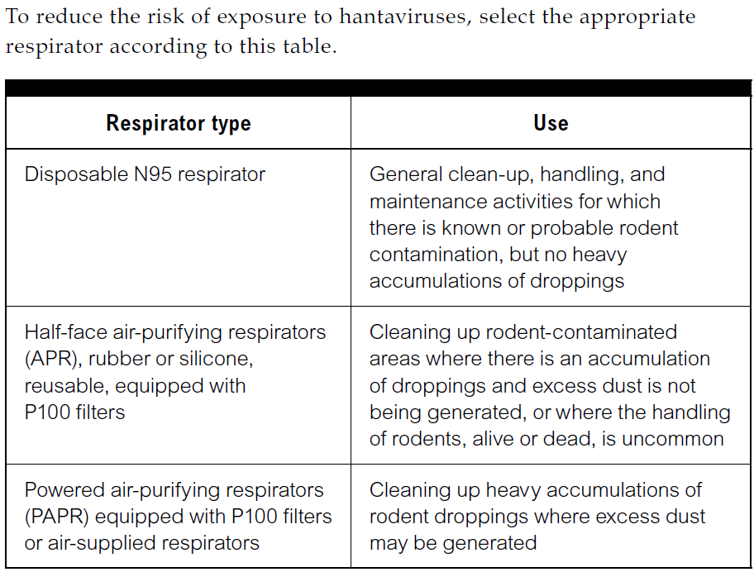

1. **Do not** stir up dust by sweeping up or vacuuming up dry droppings, urine or nesting materials. *Note:* A high efficiency vacuum equipped with a HEPA filter is would be acceptable in hard to reach areas.
2. To kill the virus lightly wet down the droppings or dead mouse with a solution of bleach. This should be mixed fresh daily because the quality of the bleach solution deteriorates after 24 hours.
3. Clean up the contaminated materials with a damp towel. Put the droppings and towels in double plastic bags, label the bag contents, seal the bag and place in the outdoor garbage bin (out of reach of children).
4. Dispose of any food or liquid that mice may have come into contact with. If you encounter a dead mouse wet the mouse down with the disinfectant solution. Wearing rubber gloves, put your hand inside a plastic bag, pick up the mouse, then turn the bag inside out so that the mouse is inside the bag and you haven’t touched it.
5. Wipe or mop the surfaces and any equipment used with a solution of the disinfectant.
6. Prior to removing your eye, hand and respiratory protection, remove coveralls, **if applicable,** (preferably outdoors) and disposable booties and place in a double plastic bag.
7. Wet-wipe outer surface of the eyewear, respirator and footwear with a disposable towel.
8. Rinse gloves in the disinfectant solution and place along with other disposable items in the double plastic bag.
9. Wash your hands and any exposed skin areas well after the clean-up.

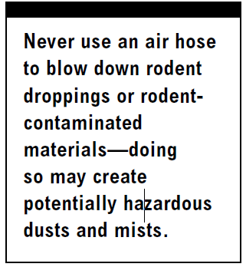

**Clean carpets, clothing, upholstery or hard surfaces?**

Remove droppings and contaminated materials following similar procedures as above, but do not use the bleach solution. Wet the area first with hot water; remove the mouse or droppings, then shampoo (do not use bleach on carpets or upholstery). Make sure you use a commercial rug shampoo to which you have added a disinfectant. It should not stain the carpet or upholstery. For small spot cleaning, spray the area with a disinfectant solution (not bleach), and wipe the droppings as above. Use the disinfectant on hardwood floors, and the bleach solution on linoleum floors, counters and appliances. Take bedding or clothing outside and either gently roll the droppings off or pick them off with rubber gloves: do not shake them off! Then wash them as regular laundry and dry them in a dryer or hang them outside in the bright sunlight.

## Section 3.5: Histoplasmosis or Cryptococcosis

1. **Histoplasmosis or Cryptococcosis (Bird and Bat Droppings)**

**What are the Dangers?**

When working around areas contaminated with bird and bat droppings, workers can be exposed to fungi that can cause serious infections called **Histoplasmosis** or **Cryptococcosis.** While fresh bird droppings are not expected to contain the fungi, fresh bat droppings may be contaminated. Disturbing the droppings or contaminated soil may release tiny particles into the air called “spores”. The spores can be inhaled and infect a worker’s lungs. Most people who become infected with the fungi experience no symptoms, but some may experience mild flu-like symptoms. For some people, especially those with weakened immune systems, the disease can be life threatening because it can spread to other areas of the body, become severe, and eventually cause death.

**Identify Controls**

Always assume droppings are contaminated. Take the following precautions to reduce your risk of infection:

* If you have a weakened immune system, you should consult your doctor before working in the area.
* When removing large amounts of droppings, use the following types of personal protective equipment (PPE):
  + - rubber boots
    - disposable gloves under work gloves
    - disposable coveralls
    - respiratory protection
* Respirators should always be worn when working around bird or bat droppings. Appropriate respirators could range from a N95 filtering face piece for low-risk tasks to a full face piece air-purifying respirator or powered air-purifying respirator for high-risk tasks. Follow these additional procedures to minimize the risk of infection:
* Eliminate the roost (nest) if the building is not going to be demolished and seal entry points if possible.
* Avoid disturbing material that could be contaminated to prevent the generation of dust and inhalation of spores.
* Never dry-sweep or dry-shovel material. Soak the material with water or a wetting agent to keep dust and spores down.
* Use a HEPA vacuum to clean up the contaminated material (if available).
* Dispose of the waste in 6-ml disposal bags and follow the disposal procedures outlined in your company’s health and safety policy.
* For larger contamination, a disinfectant may be used. For these applications, consult the manufacturer’s directions.



## Section 3.6: Safety Procedures

**Caretaking Work Procedures for  
[enter division name]**

**Facilities & Transportation Department**

|  |
| --- |
| **Work Procedure: Caretaking – Broken Glass** |

|  |  |  |  |  |
| --- | --- | --- | --- | --- |
| Sector::  **Caretaking** | Reviewed By:  **Caretaking Supervisor** | Approved By:  **Manager of Facilities & Transportation** | Date Created:  **January 2020** | Date of Last Revision:  **January 2020** |

|  |
| --- |
| **Purpose: The purpose of this procedure is to explain the step-by-step instructions for cleaning, removal, and disposal of broken glass.** |

|  |
| --- |
| **PROCEDURE:** |
| Personal Protective Equipment:   1. Protective gloves 2. Eye protection     Tools / Materials Required:   1. Broken glass container 2. Dust pan 3. Broom     Instructions:   1. Do pre-visual inspection of equipment before beginning. 2. Pick up large pieces of glass and place them in a box, bin or on several sheets of newspaper. 3. Sweep the smaller pieces of glass in towards the center of the area. 4. Once you have gathered all the glass shards, use a dust pan or other suitable object to sweep the glass onto and place it with the large pieces already collected.   **Example: Broken glass container labelled with broom & dust pan**   1. Small glass fragments can be very effectively cleaned off smooth surfaces by using some wet paper towel. 2. Vacuuming the area, if appropriate, is also very effective. 3. Once cleanup is complete the collected glass needs to be sealed in a container; Box for larger pieces of glass. 4. Clearly label the box as containing broken glass and place it in a caretaker room or directly into the school dumpster. |
|  |

|  |
| --- |
| **Responsibilities, Completion and Review:**  All staff members are required to adhere to Department policies & procedures at all times while employed with the school division as it relates to day to day operation of the department. Supervisors are also required to ensure that staff members are following Department policies at all times and to take the necessary steps to inform staff who fail to follow policies and report all matters to management immediately. Employees who fail to follow Department policies will be subject to disciplinary actions. |



**Caretaking Procedure: CP-109**

**Caretaking Work Procedures for  
 [enter division name]**

**Facilities & Transportation Department**

|  |
| --- |
| **Work Procedure: Caretaking – Caretaker Cart** |

|  |  |  |  |  |
| --- | --- | --- | --- | --- |
| Sector::  **Caretaking** | Reviewed By:  **Caretaking Supervisor** | Approved By:  **Manager of Facilities & Transportation** | Date Created:  **January 2020** | Date of Last Revision:  **January 2020** |

|  |
| --- |
| **Purpose: The purpose of this procedure is to explain the step-by-step instructions for operating a caretaking cart.** |

|  |
| --- |
| **PROCEDURE:** |
| Personal Protective Equipment:   1. Protective gloves 2. Eye protection 3. Always refer to Safety Data Sheets (SDS) when using any chemical.     Tools / Materials Required:   1. Cleaning chemicals 2. Paper towel 3. Toilet tissue 4. Duster 5. Dust mop 6. Dust pan 7. Broom 8. Mop and pail 9. Garbage bags 10. Microfiber towels 11. Toilet swab and holder     **Example: Caretaker Cart**  Instructions:   1. Do pre-visual inspection of equipment before beginning. 2. Properly label all chemicals per Safety Data Sheets (SDS) with WHMIS 2015 labels. 3. Read and understand all SDS sheets for chemicals on cart. 4. Check cart for all necessary supplies to avoid making extra trips to product storage areas. 5. Never leave cart unattended at any time. 6. When not in use, cart must be returned and locked in the caretaker’s room or storage place. 7. Keep cart clean and well organized at all times. |

|  |
| --- |
| **Responsibilities, Completion and Review:**  All staff members are required to adhere to Department policies & procedures at all times while employed with the school division as it relates to day to day operation of the department. Supervisors are also required to ensure that staff members are following Department policies at all times and to take the necessary steps to inform staff who fail to follow policies and report all matters to management immediately. Employees who fail to follow Department policies will be subject to disciplinary actions. |

**Caretaking Procedure: CP-108**

**Caretaking Work Procedures for**

**[enter division name]**

**Facilities & Transportation Department**

|  |
| --- |
| **Work Procedure: Caretaking – Floor Scrub and Recoating** |

|  |  |  |  |  |
| --- | --- | --- | --- | --- |
| Sector::  **Caretaking** | Reviewed By:  **Caretaking Supervisor** | Approved By:  **Manager of Facilities & Transportation** | Date Created:  **January 2020** | Date of Last Revision:  **January 2020** |

|  |
| --- |
| **Purpose: The purpose of this procedure is to explain the step-by-step instructions for floor scrubbing and recoating floor.** |

| **PROCEDURE:** |
| --- |
| Personal Protective Equipment:   1. Protective gloves 2. Non-slip footwear 3. Eye protection 4. Always refer to Safety Data Sheets (SDS) when using any chemical.   Tools / Materials Required:   1. Swing Machine 2. Floor Pads 3. Wet Vacuum 4. Scrapers 5. Mops and pails 6. Cleaning Solution 7. Floor Finish       **Example: Wet Vacuum**  **Example: Swing Machine**  **Example: Non-slip-footwear**    Instructions:   1. Do pre-visual inspection of equipment before beginning. 2. Refer to CP-106 for Swing Machine Procedure. 3. Refer to CP-105 for Wet Vacuum Procedure. 4. Sweep area to be scrubbed and remove any objects in way. 5. Place wet floor signs in area you are cleaning. Beware of slippery floors. 6. Adjust hand to proper height – this being about belt high. 7. Place cleaning solution on floor, being careful not to over wet floor. 8. Always scrub in a forward motion, away from cords. Use caution on wet floors. 9. Scrub in a slow, steady, side-by-side motion. 10. Wet vacuum area, start from doorway to back of room. 11. Rinse floor with neutral solution. 12. Re-rinse with clean water. 13. Allow floor to dry completely. 14. Return all equipment back to storage and clean all equipment used. 15. Starting in the farthest corner of the room, apply floor finish using the figure eight technique so all floor is covered. 16. After completing entire floor, wait for first coat to completely dry before applying second. 17. Repeat until the desired amount of floor finish coats have been applied to floor. 18. Clean all equipment used and return to storage. |

|  |
| --- |
| **Responsibilities, Completion and Review:**  All staff members are required to adhere to Department policies & procedures at all times while employed with the school division as it relates to day to day operation of the department. Supervisors are also required to ensure that staff members are following Department policies at all times and to take the necessary steps to inform staff who fail to follow policies and report all matters to management immediately. Employees who fail to follow Department policies will be subject to disciplinary actions. |

**Caretaking Procedure: CP-112**

**Caretaking Work Procedures for  
[enter division name]**

**Facilities & Transportation Department**

|  |
| --- |
| **Work Procedure: Caretaking – Hantavirus, Histoplasmosis or Cryptococcosis** |

|  |  |  |  |  |
| --- | --- | --- | --- | --- |
| Sector::  **Caretaking** | Reviewed By:  **Caretaking Supervisor** | Approved By:  **Manager of Facilities & Transportation** | Date Created:  **January 2020** | Date of Last Revision:  **January 2020** |

|  |
| --- |
| **Purpose: The purpose of this procedure is to explain the step-by-step instructions for cleaning and removal of feces, carcasses or nests that has the possibility of containing Hantavirus, Histoplasmosis** or **Cryptococcosis.** |

| **PROCEDURE:** |
| --- |
| Personal Protective Equipment:   1. Protective gloves 2. Protective eyewear 3. Disposable coveralls (If heavily soiled) 4. Rubber boots (If heavily soiled) 5. Disposable shoe covers (If heavily soiled) 6. Respirator     Tools / Materials Required:   1. Garbage bags 2. Paper towels 3. Mop and pail 4. Disinfectant (contact supervisor)   Instructions:   1. Clear all unnecessary persons from the area.   **Chart: Respirator Types**   1. Ventilate area, open doors and windows, if possible. 2. Disinfectant solution (supervisor MUST be notified prior   to purchase of bleach):   * 1. diluted bleach (100ml/1litre water) to be used on rodent/bird/bat carcasses, bat droppings, bird droppings, nesting materials, droppings, surfaces, and materials contaminated with droppings or urine; or to decontaminate rubber gloves and boots.  1. Cover any broken skin that may be exposed to infection prior to beginning clean-up of rodent contamination. 2. Wear a NIOSH approved respirator with a high efficiency P-100 filter (Note: All caretaking staff has been fit tested and issued ½ mask respirators equipped with these filters). If the area is heavily infested, workers should also wear disposable coveralls, rubber boots or disposable shoe covers. 3. **Do not** stir up dust by sweeping up or vacuuming up dry droppings, urine or nesting materials. *Note:* A high efficiency vacuum equipped with a HEPA filter is would be acceptable in hard to reach areas. 4. To kill the virus lightly wet down the droppings, dead mouse, dead bird, or dead bat with a solution of bleach. This should be mixed fresh daily because the quality of the bleach solution deteriorates after 24 hours. 5. Clean up the contaminated materials with a damp towel. Put the droppings and towels in double plastic bags, label the bag contents, seal the bag and place in the outdoor garbage bin (out of reach of children). 6. Dispose of any food or liquid that mice may have come into contact with. If you encounter a dead mouse wet the mouse down with the disinfectant solution. Wearing rubber gloves, put your hand inside a plastic bag, pick up the mouse, then turn the bag inside out so that the mouse is inside the bag and you haven’t touched it. 7. Wipe or mop the surfaces and any equipment used with a solution of the disinfectant. 8. Prior to removing your eye, hand and respiratory protection, remove coveralls, **if applicable,** (preferably outdoors) and disposable booties and place in a double plastic bag 9. Wet-wipe outer surface of the eyewear, respirator and footwear with a disposable towel. 10. Rinse gloves in the disinfectant solution and place along with other disposable items in the double plastic bag. 11. Wash your hands and any exposed skin areas well after the clean-up. |

|  |
| --- |
| **Responsibilities, Completion and Review:**  All staff members are required to adhere to Department policies & procedures at all times while employed with the school division as it relates to day to day operation of the department. Supervisors are also required to ensure that staff members are following Department policies at all times and to take the necessary steps to inform staff who fail to follow policies and report all matters to management immediately. Employees who fail to follow Department policies will be subject to disciplinary actions. |



**Caretaking Procedure: CP-113**

**Caretaking Work Procedures for  
[enter division name]**

**Facilities & Transportation Department**

|  |
| --- |
| **Work Procedure: Caretaking – Lock Out/Tag Out (LOTO)** |

|  |  |  |  |  |
| --- | --- | --- | --- | --- |
| Sector::  **Caretaking** | Reviewed By:  **Caretaking Supervisor** | Approved By:  **Manager of Facilities & Transportation** | Date Created:  **January 2020** | Date of Last Revision:  **January 2020** |

|  |
| --- |
| **Purpose: The purpose of this procedure is to explain the step-by-step instructions for locking out and tagging out equipment to be repaired.** |

|  |
| --- |
| **PROCEDURE:** |
| https://images.uline.com/is/image/content/dam/images/S/S18000/S-17551PW.jpg?id=Wute30&fmt=jpg&fit=constrain,1&wid=498&hei=374&iccEmbed=1&icc=AdobeRGBPersonal Protective Equipment:   1. Protective gloves 2. Eye protection 3. Always refer to Safety Data Sheets (SDS) when using any chemical.   Tools / Materials Required:   1. Lock Out/Tag Out Tags 2. Computer   **Example: Lock Out / Tag Out Tag**    Instructions:   1. Do pre-visual inspection of equipment before beginning. 2. Locking out and tagging out equipment is the act of bringing that equipment to a zero energy state where no one should be injured due to machinery being energized. 3. Make sure all connections to power are off. 4. Tag equipment with Lock Out/Tag Out (LOTO) tag to include the date, reason, and service request # when you have it entered. 5. Enter service request in Asset Planner. 6. Place service request # on tag. 7. Your supervisor or designated division employee will repair or take machinery for repair. |

|  |
| --- |
| **Responsibilities, Completion and Review:**  All staff members are required to adhere to Department policies & procedures at all times while employed with the school division as it relates to day to day operation of the department. Supervisors are also required to ensure that staff members are following Department policies at all times and to take the necessary steps to inform staff who fail to follow policies and report all matters to management immediately. Employees who fail to follow Department policies will be subject to disciplinary actions. |

**Caretaking Procedure: CP-103**

**Caretaking Work Procedures for  
[enter division name]**

**Facilities & Transportation Department**

|  |
| --- |
| **Work Procedure: Caretaking – Operating a Burnisher** |

|  |  |  |  |  |
| --- | --- | --- | --- | --- |
| Sector::  **Caretaking** | Reviewed By:  **Caretaking Supervisor** | Approved By:  **Manager of Facilities & Transportation** | Date Created:  **January 2020** | Date of Last Revision:  **January 2020** |

|  |
| --- |
| **Purpose: The purpose of this procedure is to explain the step-by-step instructions for operating a burnisher.** |

|  |
| --- |
| **PROCEDURE:** |
| Personal Protective Equipment:   1. Protective Gloves 2. Protective Mask 3. Eye Protection   Tools / Materials Required:   1. Buffer Pads 2. Buffing Solution 3. Wet Floor Signs 4. Dust Mop 5. Dust Pan 6. Hand Broom 7. Razor Scraper     Instructions:   1. Do pre-visual inspection of equipment before beginning. 2. Place wet floor signs in place. 3. Apply chemical to bowl brush.   ***Example: Burnishers have two sets of wheels, unlike swing machines***   1. Remove objects that might be in the way. 2. Sweep area that you are going to burnish. 3. Adjust handle to the proper height for use. 4. Plug in burnisher. 5. Burnish floor in a forward motion. Ensure to use caution when going from one floor type to another. 6. After burnishing is complete, return hand to upright position. 7. Wipe cord as you wrap cord and check for damage. 8. Remove pad and pad base. 9. Return machine back to storage place. 10. Sweep floor to remove any dust. |

|  |
| --- |
| **Responsibilities, Completion and Review:**  All staff members are required to adhere to Department policies & procedures at all times while employed with the school division as it relates to day to day operation of the department. Supervisors are also required to ensure that staff members are following Department policies at all times and to take the necessary steps to inform staff who fail to follow policies and report all matters to management immediately. Employees who fail to follow Department policies will be subject to disciplinary actions. |

**Caretaking Procedure: CP-107**

**Caretaking Work Procedures for  
[enter division name]**

**Facilities & Transportation Department**

|  |
| --- |
| **Work Procedure: Caretaking – Operating a Carpet Cleaner** |

|  |  |  |  |  |
| --- | --- | --- | --- | --- |
| Sector::  **Caretaking** | Reviewed By:  **Caretaking Supervisor** | Approved By:  **Manager of Facilities & Transportation** | Date Created:  **January 2020** | Date of Last Revision:  **January 2020** |

|  |
| --- |
| **Purpose: The purpose of this procedure is to explain the step-by-step instructions for operating a carpet cleaner.** |

| **PROCEDURE:** |
| --- |
| Personal Protective Equipment:   1. Protective Gloves 2. Eye protection 3. Always refer to Safety Data Sheets (SDS) when using any chemical.   Tools / Materials Required:   1. Vacuum cleaner 2. Gum remover 3. Cleaning solution 4. Pre-spray solution 5. Scraper 6. Clean cloth 7. Wet floor signs       **Example: Carpet Cleaners**  Instructions:   1. Do pre-visual inspection of equipment before beginning. 2. Refer to **SAFETY MEMO – Carpet Cleaner** for safety precautions. 3. Vacuum (Refer to CP-111 for procedure) and remove any objects out of cleaning area. 4. Place wet floor signs in area to be cleaned. 5. Fill machine with approved cleaning solution. 6. Prepare any problem areas with pre-spray solution. 7. Plug in machine and begin shampooing carpet by releasing the solution and then pulling backwards on the machine to vacuum up. 8. Always try to work away from cords. 9. Empty recovery tank before it becomes too heavy to handle easily. This may need to be repeated several times by cleaning. 10. When finished, rinse out recovery tank and drain any remaining cleaning solution in tank. 11. Clean machine and wipe cords. 12. Check for anything that might have been damaged and report any problems. 13. Remove wet floor signs when carpet is dry. 14. Remove any fans used. 15. Move machine back into storage. |

|  |
| --- |
| **Responsibilities, Completion and Review:**  All staff members are required to adhere to Department policies & procedures at all times while employed with the school division as it relates to day to day operation of the department. Supervisors are also required to ensure that staff members are following Department policies at all times and to take the necessary steps to inform staff who fail to follow policies and report all matters to management immediately. Employees who fail to follow Department policies will be subject to disciplinary actions. |

**Caretaking Procedure: CP-106**

**Caretaking Work Procedures for  
[enter division name]**

**Facilities & Transportation Department**

|  |
| --- |
| **Work Procedure: Caretaking – Operating a Swing Machine** |

|  |  |  |  |  |
| --- | --- | --- | --- | --- |
| Sector::  **Caretaking** | Reviewed By:  **Caretaking Supervisor** | Approved By:  **Manager of Facilities & Transportation** | Date Created:  **January 2020** | Date of Last Revision:  **January 2020** |

|  |
| --- |
| **Purpose: The purpose of this procedure is to explain the step-by-step instructions for operating a swing machine.** |

| **PROCEDURE:** |
| --- |
| Personal Protective Equipment:   1. Protective Gloves 2. Non-slip Footwear 3. Eye Protection 4. Mask (If required) 5. Always refer to Safety Data Sheets (SDS) if cleaning up chemicals.   Tools / Materials Required:   1. Mops and pails 2. Razor scraper 3. Scrubbing solution 4. Scrubbing pads 5. Wet vacuum 6. Wet floor signs     **Example: Swing Machines**  Instructions:   1. Do pre-visual inspection of equipment before beginning. 2. Refer to **SAFETY MEMO – Swing Machine** for safety precautions. 3. Place proper pad on pad holder, making sure it is centered. 4. Fill pail with cleaning solution. (Refer to SDS) 5. Sweep area about to be scrubbed. 6. Place wet floor signs in area you are cleaning. Beware of slippery floors. 7. Adjust hand to proper height – this being about belt high. 8. Place cleaning solution on floor, being careful not to over wet floor. 9. Always scrub in a forward motion, away from cords. Use caution on wet floors. 10. Scrub in a slow, steady, side-by-side motion. 11. When completed, wipe down entire machine and cord. 12. Remove and wash old pad. 13. Remove pad holder and store equipment. |

|  |
| --- |
| **Responsibilities, Completion and Review:**  All staff members are required to adhere to Department policies & procedures at all times while employed with the school division as it relates to day to day operation of the department. Supervisors are also required to ensure that staff members are following Department policies at all times and to take the necessary steps to inform staff who fail to follow policies and report all matters to management immediately. Employees who fail to follow Department policies will be subject to disciplinary actions. |

**Caretaking Procedure: CP-105**

**Caretaking Work Procedures for  
[enter division name]**

**Facilities & Transportation Department**

|  |
| --- |
| **Work Procedure: Caretaking – Operating a Wet Vacuum** |

|  |  |  |  |  |
| --- | --- | --- | --- | --- |
| Sector::  **Caretaking** | Reviewed By:  **Caretaking Supervisor** | Approved By:  **Manager of Facilities & Transportation** | Date Created:  **January 2020** | Date of Last Revision:  **January 2020** |

|  |
| --- |
| **Purpose: The purpose of this procedure is to explain the step-by-step instructions for operating a wet vacuum.** |

| **PROCEDURE:** |
| --- |
| Personal Protective Equipment:   1. Protective gloves 2. Non-slip footwear 3. Eye protection 4. Mask (If required) 5. Always refer to Safety Data Sheets (SDS) if cleaning up chemicals.   Tools / Materials Required:   1. Wet floor tools with squeegee 2. Wet floor signs       **Example: Wet Vacuums**    Instructions:   1. Do pre-visual inspection of equipment before beginning. 2. Refer to **SAFETY MEMO – Wet Vacuums** for safety precautions. 3. Place wet floor signs in area you are cleaning. Beware of slippery floors. 4. Check for proper suction and seal of wet vacuum. 5. Work towards the wet area, keeping cord behind you as you work. 6. When complete, lift squeegee and hose and then shut off machine so water drains into tank. 7. Unplug cord and unwind, checking for damage. 8. Empty recovery tank and clean. 9. Clean rest of machine and place in storage with lid open. |

|  |
| --- |
| **Responsibilities, Completion and Review:**  All staff members are required to adhere to Department policies & procedures at all times while employed with the school division as it relates to day to day operation of the department. Supervisors are also required to ensure that staff members are following Department policies at all times and to take the necessary steps to inform staff who fail to follow policies and report all matters to management immediately. Employees who fail to follow Department policies will be subject to disciplinary actions. |

**Caretaking Procedure: CP-104**

**Caretaking Work Procedures for  
[enter division name]**

**Facilities & Transportation Department**

|  |
| --- |
| **Work Procedure: Caretaking – Operating an Auto Scrubber** |

|  |  |  |  |  |
| --- | --- | --- | --- | --- |
| Sector::  **Caretaking** | Reviewed By:  **Caretaking Supervisor** | Approved By:  **Manager of Facilities & Transportation** | Date Created:  **January 2020** | Date of Last Revision:  **January 2020** |

|  |
| --- |
| **Purpose: The purpose of this procedure is to explain the step-by-step instructions for operating an auto scrubber.** |

| **PROCEDURE:** |
| --- |
| Personal Protective Equipment:   1. Protective gloves 2. Non-slip footwear 3. Eye protection   Tools / Materials Required:   1. Auto scrubber 2. Cleaning agent 3. Wet floor signs       **Example: Auto Scrubbers**  Instructions:   1. Do pre-visual inspection of equipment before beginning. 2. Refer to **SAFETY MEMO – Self Propelled and Pad Assist** for safety precautions. 3. Fill solution tank. 4. Place wet floor signs in area you are cleaning. Beware of slippery floors. 5. Check squeegee for dirt and proper alignment. 6. Turn on vacuum and check for proper suction. 7. Turn on water and push machine in a slow, steady walk. (Self-propelled machines should be set at a slow, steady walk) 8. Watch for debris or obstacles as you clean. 9. When finished, empty recovery tank and rinse out any dirt. 10. Clean squeegee and check for any damage. 11. Wipe down machine and return to storage. 12. Return machine back to storage place. |

|  |
| --- |
| **Responsibilities, Completion and Review:**  All staff members are required to adhere to Department policies & procedures at all times while employed with the school division as it relates to day to day operation of the department. Supervisors are also required to ensure that staff members are following Department policies at all times and to take the necessary steps to inform staff who fail to follow policies and report all matters to management immediately. Employees who fail to follow Department policies will be subject to disciplinary actions. |

**Caretaking Procedure: CP-102**

**Caretaking Work Procedures for  
[enter division name]**

**Facilities & Transportation Department**

|  |
| --- |
| **Work Procedure: Caretaking – Stripping Floors** |

|  |  |  |  |  |
| --- | --- | --- | --- | --- |
| Sector::  **Caretaking** | Reviewed By:  **Caretaking Supervisor** | Approved By:  **Manager of Facilities & Transportation** | Date Created:  **January 2020** | Date of Last Revision:  **January 2020** |

|  |
| --- |
| **Purpose: The purpose of this procedure is to explain the step-by-step instructions for stripping floors.** |

| **PROCEDURE:** |
| --- |
| Personal Protective Equipment:   1. Protective gloves 2. Protective mask 3. Safety glasses 4. Non-slip footwear     Tools / Materials Required:   1. Swing machine 2. Black stripping pads 3. Wet vacuum 4. Scrapers 5. Mops and pails 6. Floor stripper 7. Garbage cans or pails for solid, discarded finish     **Example: Non-Slip Footwear**  Instructions:   1. Sweep area to be stripped and remove any objects in the way. 2. Do pre-visual inspection of all equipment to be used. 3. Place wet floor signs. 4. Mix stripper as per recommended by manufacturer. Use all appropriate PPE per Safety Data Sheet. 5. Place generous amount of mixed solution on floor and wait 15 minutes for solution to begin to work. 6. Scrape area with floor scrapers, peeling the large amounts of floor finish up. 7. Discard large piles of solid floor finish with dustpans into the pails or garbage cans. Do not overfill to make can or pail too heavy. 8. Reapply mixed solution to floor after scraping. 9. Scrub area, from back of room towards the doorway. Flip/Change pads as needed. 10. Scrub area both ways so all flooring has been gone over. 11. Rinse floor using neutral solution. 12. Re-rinse floor with clean water. 13. Check floor with hand to ensure all finish has been removed. 14. Allow floor to dry completely. 15. Return all used equipment back to room, and clean all equipment while waiting for floor to dry. 16. Apply finish, starting at the farthest corner of the room. 17. Must have a minimum of three coats of finish. 18. When finished, return all mops and pails back to room. 19. Clean all equipment before storing. |

|  |
| --- |
| **Responsibilities, Completion and Review:**  All staff members are required to adhere to Department policies & procedures at all times while employed with the school division as it relates to day to day operation of the department. Supervisors are also required to ensure that staff members are following Department policies at all times and to take the necessary steps to inform staff who fail to follow policies and report all matters to management immediately. Employees who fail to follow Department policies will be subject to disciplinary actions. |

**Caretaking Procedure: CP-101**

**Caretaking Work Procedures for  
[enter division name]**

**Facilities & Transportation Department**

|  |
| --- |
| **Safe Job Practice: Caretaking – Toilet Bowl Cleaning Procedure** |

|  |  |  |  |  |
| --- | --- | --- | --- | --- |
| Sector::  **Caretaking** | Reviewed By:  **Caretaking Supervisor** | Approved By:  **Manager of Facilities & Transportation** | Date Created:  **January 2020** | Date of Last Revision:  **January 2020** |

|  |
| --- |
| **Purpose: The purpose of this procedure is to explain the step-by-step instructions for cleaning toilets bowls.** |

|  |
| --- |
| **PROCEDURE:** |
| Personal Protective Equipment:   1. Protective gloves 2. Protective mask 3. Safety glasses   Tools / Materials Required:   1. Bowl brush 2. Bowl cleaner 3. Microfiber cloth 4. Brush holder 5. Disinfectant cleaner   Instructions:   1. Apply bowl cleaner to inside and under rim of bowl. 2. Apply chemical to bowl brush. 3. Brush bowl and under rim. 4. Flush all chemicals when complete. 5. Clean outside of bowl and seat with disinfectant cleaner. 6. Wipe with cleaning rag. 7. Place all materials back on cart. |

|  |
| --- |
| **Responsibilities, Completion and Review:**  All staff members are required to adhere to Department policies & procedures at all times while employed with the school division as it relates to day to day operation of the department. Supervisors are also required to ensure that staff members are following Department policies at all times and to take the necessary steps to inform staff who fail to follow policies and report all matters to management immediately. Employees who fail to follow Department policies will be subject to disciplinary actions. |



**What are sharps?**

"Sharps" include needles, as well as items such as scalpels, lancets, razor blade, scissors, metal wire, retractors, clamps, pins, staples, cutters, and glass items. Essentially, any object that is able to cut the skin can be considered a "sharp". <https://www.ccohs.ca/oshanswers/diseases/needlestick_injuries.html>

The main risk to workers who have a needle stick/sharps injury is exposure to viruses such as hepatitis B and C, and human immunodeficiency virus (HIV).

* Hepatitis B is an illness that affects the liver. It causes liver inflammation, vomiting, and jaundice. Over the long term, it can cause scarring of the liver and liver cancer. It can eventually lead to death.
* Hepatitis C also affects the liver and can cause fever, loss of appetite, fatigue, and jaundice. Over longer periods of time, it causes scar tissue and liver failure. Some people may have no symptoms for many years but can still infect others.
* HIV is a virus that attacks the immune system, causing infection. When the body can’t fight infections anymore, the disease becomes acquired immunodeficiency syndrome (AIDS)

**Purpose:**

To emphasize the correct handling of all sharps, to minimize the risk of injury and/or contamination, decrease potential hazards and to increase the awareness of safe work practices related to various types of sharps. Also, to promote and support the health and safety of all employees.

**Precautions:**

* All needles and sharps shall be handled and disposed of in a manner that will not endanger the health and safety of worker or others.
* It is the responsibility of the worker to ensure appropriate handling and safe disposal of the sharps/needle.
* Needles will not be recapped, bent or removed or otherwise manipulated by hand.
* Discard needles and syringes immediately after use to the appropriate sharps container.
* Never discard sharps/needles into bags of regular trash.
* Uncapped needles or other medical sharps must not be left unattended or covered with a towel, blanket, etc.
* All used needles, syringes, blood lancets, etc. are to be placed/dropped directly into a labeled designated ‘”Sharps” container.
* This container must be labeled “bio-hazardous materials” and the container must be large enough to hold several used sharps.
* The sharps container is located in the Administration Office.
* The sharps disposal container is checked regularly to ensure it is not filled beyond capacity and a replacement container is readily available.
* Full sharps containers are disposed of at the designated pharmacy.
* All needles and medical sharps shall be disposed of properly in appropriate sharps containers by the person who used the device.
* All sharps/needle injuries must be immediately reported to the Supervisor or designate. Medical attention will be sought as appropriate for such injuries.

**Procedure for Sharps/Needle stick Injury:**

1. Immediately squeeze the injured area to promote bleeding.
2. Treat the wound using First Aid measures and then seek medical attention.
3. Report the incident immediately to your Supervisor or designate.
4. Complete the Employee Incident Report Form.
5. Submit completed form to supervisor.

**Disposal Procedure:**

* You may recap your own needle after use to reduce the chance of someone else being injured by your needle. Never recap a needle that someone else has used for an injection.
* A needle clip can be used to remove the needle from your used syringe.
* The syringe cannot be used again and the “sharp” needle is stored safely inside the needle clip. Needle clips are available through your diabetes educator or pharmacist.
* A needle remover can be used to safely remove a used needle from an insulin pen and prevent injury. Needle removers are available through your diabetes educator or pharmacist.
* All sharps should be put into special sharps disposal containers for disposal. The containers are available at your pharmacy, often free with the purchase of other supplies. These containers protect others from injury and often disinfect the sharps as well.
* Place all used lancets, pen needles, syringes, and infusion sets into the container right after use. Do not leave them lying on surfaces such as beds or tables.
* Once full, follow the instructions on your container. Many pharmacies collect and safely dispose of a full sharps container for you if you turn it to the store. If your pharmacy does not offer this service check with your municipal government to see what is available where you live.

**Caretaking Procedure: CP-201**

**Caretaking Work Procedures for  
[enter division name]**

**Facilities & Transportation Department**

|  |
| --- |
| **Work Procedure: Caretaking – Working Alone** |

|  |  |  |  |  |
| --- | --- | --- | --- | --- |
| Sector::  **Caretaking** | Reviewed By:  **Caretaking Supervisor** | Approved By:  **Manager of Facilities & Transportation** | Date Created:  **June 2020** | Date of Last Revision:  **June 2020** |

|  |
| --- |
| **Purpose: This standard establishes the requirements for managing the risks associated for workers when working alone. The school division is committed to taking preventative measures to protect workers who work alone.**  **This standard outlines the minimum requirements that shall be met or exceeded by school division workers. Failure to comply may result in injuries, damage to equipment, environmental harm, or performance management.** |

| **PROCEDURE:** |
| --- |
| **Control Measures:**   * Where practical, working alone hazards shall be removed. Where hazards cannot be removed, controls shall be used to reduce the probability of an incident occurring. * The steps to be taken to eliminate or reduce the risks must include the establishment of an effective  two-way communication system that is documented. * Examples of effective two-way communication systems include; but not limited to:   + Mobile device   + two-way radio   + Internal contact/buddy system   + Predetermined travel time and route notification * Utilize regularly scheduled staff as check in (other schools of same sector) * Steps may include:   + Limitations on or prohibitions of specific activities   + Establishment of minimum training or experience, or any other standard of competency   + Provision and use of personal protective equipment   + Establishment of safe work practices or procedures   + Provision of emergency supplies for use in travelling in conditions of extreme temperatures or inclement weather conditions * Working alone in certain circumstances, situations, or environments can increase the risk to health and safety of the worker. * Each facility/school shall have arrangements made to minimize the risk, especially after normal working hours for any increased risk duties that are identified. * During school break periods assign single caretaker staff to work together at other locations, this will depend on community base - ______________________.   Identified areas of working alone and/or in isolation, but not limited to:   * All single caretaker facilities * Multiple caretaker facilities not on same schedule * Facilities with part-time staff   **STATEMENT OF RESPONSIBILITIES:**  **Employer**   * Ensures area/task specific Working Alone Procedures are developed, implemented, communicated, and enforced, in situations where workers are working alone. * Assess tasks at hand to determine if safe while working alone.   **Supervisors**   * Review each worksite under his or her control to identify circumstances where individuals work alone in situations and where there is increased risk of injury or assistance that is not readily available. * Ensure all reasonably practical steps are taken to protect the health and safety of workers.   **Worker**   * Must comply with the facility/school/task specific Working Alone Procedure. * Adhere to the effective two-way communication protocol. * Assess tasks at hand to determine if safe while working alone (refer to Job Safety Analysis [JSA]) * Evening shift workers must check in with each other at meal breaks and end of shift   + Caretakers shall all leave facility together |

|  |
| --- |
| **Responsibilities, Completion and Review:**  All staff members are required to adhere to Department policies & procedures at all times while employed with the school division as it relates to day to day operation of the department. Supervisors are also required to ensure that staff members are following Department policies at all times and to take the necessary steps to inform staff who fail to follow policies and report all matters to management immediately. Employees who fail to follow Department policies will be subject to disciplinary actions. |



## Section 3.7: Safety Memos



**Safety Memo**

***Safety is everyone’s responsibility!***

**Auto Scrubbers – Self-Propelled and Pad Assist**

Operating auto scrubbers requires skill and experience. There are many different styles of auto scrubbers. Follow all operating procedures per user manual when using any piece of equipment.

**General Safety Instructions**:

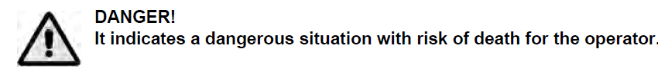

**IMPORTANT SAFETY INSTRUCTIONS: READ AND UNDERSTAND ALL**

**INSTRUCTIONS BEFORE OPERATING OR SERVICING MACHINE**

**Failure to Observe These Instructions Can Cause Personal Injury to Machine Operator,   
By-standers or Possible Machine Damage.**

* Disconnect the batteries before performing any maintenance/repair procedure.
* This machine must be used by properly trained and authorized personnel only.
* Keep the battery far from sparks, flames and incandescent material. During the normal operation explosive gases are released.
* Do not wear jewelry when working near electrical components (battery).
* Do not work under the lifted machine without supporting it with safety stands.
* Do not operate the machine near toxic, dangerous, flammable and/or explosive powders, liquids or vapors.
* Battery charging produces highly explosive hydrogen gas. Keep the tanks open during battery charging and perform this procedure in well-ventilated areas and away from bare flames.
* **NEVER** attempt to operate this machine unless you have been trained in its operation.
* **NEVER** allow an untrained person to operate this machine.
* **NEVER** attempt to operate this machine if it is not working properly or has been damaged in any manner.
* **NEVER** disconnect or modify any switch or safety device (circuit breaker) on this machine.
* **ALWAYS** operate this machine from the rear control panel, not from the side.
* **NEVER** operate this machine with any air opening blocked. Keep all air openings free of dust, lint, hair, etc.
* **NEVER** allow the vacuum motor or battery charging plug to get wet. The vacuum motor and battery charging plug will short out if wet.
* **NEVER** operate this machine when battery charger is plugged in.
* **NEVER** operate this machine in an explosive atmosphere (grain dust, flammable liquids or fumes).
* **NEVER** use flammable liquids (gas, kerosene, solvents or thinners) to clean floor.
* **ALWAYS** turn the brush switch OFF when attaching pads or brushes.
* **ALWAYS** store this machine indoors in a dry, cool area.

**Operating Auto Scrubbers**

* Make sure the batteries are sufficiently charged
* Check pad driver that pad is properly installed per operator’s manual
* Turn power on the machine via button or key
* Set controls to the limits you require, as per operators manual
* Maintain a neutral spine position
* Grip machine with neutral wrist posture
* Use in area as required per operating procedures

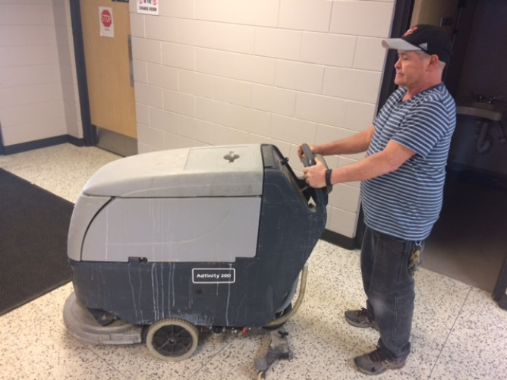 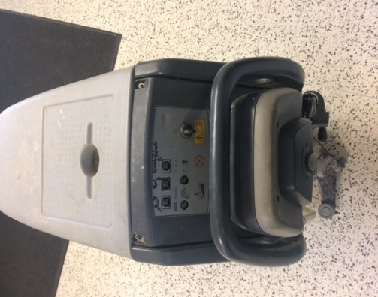

**Maintain a neutral spine with neutral wrist position.**

**Make sure controls are set in proper place for use.**

**Changing the Pads**

1. With pad driver up, manually remove by following operator’s manual instructions. Some units will have a release button on machine to drop pad driver.
2. Release center lock and remove old pad.
3. Replace with new pad and replace center lock.

©WorkSafeBC. Used with permission from *A Clean Sweep.*

**Be Accountable: Choose safety - work safe - and go home injury free!**



**Safety Memo**

***Safety is everyone’s responsibility!***

**Broken Glass**

Inside schools/facilities or outside/playgrounds broken glass can be a common occurrence. Inside or outside, whatever the broken glass is it needs to be cleaned up quickly and safely and disposed of properly.

**All schools/facilities will have a designated container with lid, dustpan and broom.**

**Procedure (Refer to CP-110)**

Secure the area so that no one cannot approach the broken glass. Then, while wearing appropriate shoes, gloves and safety glasses, if applicable:

* Pick up large pieces of glass and place them in a box, bin or on several sheets of newspaper.
* Sweep the smaller pieces of glass in towards the center of the area.
* Once you have gathered all the glass shards, use a dust pan or other suitable object to sweep the glass onto and place it with the large pieces already collected.
* Small glass fragments can be very effectively cleaned off smooth surfaces by using some wet paper towel.
* Vacuuming the area, if appropriate, is also very effective.
* Once cleanup is complete the collected glass needs to be sealed in a container; box for larger pieces of glass.
* Clearly label the box as containing broken glass and place it in a caretaker room or directly into the school dumpster.

**Issues to Note**

* Examine the area closely so that you are sure just how far the broken glass has scattered.
* Broken glass tends to stick/embed into sheet flooring and can be difficult to clean up. Be very thorough.
* Carpets can be particularly difficult to clean glass out of as it can get tangled in the carpet pile.
* If the broken glass was a container with material or residue in it then you should determine the need to consult an SDS prior to attempting cleanup. It may be a hazardous material.

©WorkSafeBC. Used with permission from *A Clean Sweep.*

**Be Accountable: Choose safety - work safe - and go home injury free!**

**Safety Memo**

***Safety is everyone’s responsibility!***

**Burnisher**

Operating a burnisher requires skill and experience. It operates at high speeds to maintain floors.

**Operating a Burnisher (Refer to Caretaking Procedure: CP-103)**

* Visual pre inspection of equipment, initial & date on equipment sheet (form)
* Maintain a neutral spine position
* High starting torque. Hold machine firmly with both hands. Feet planted shoulder width apart
* **Do not** pull/run machine over cord. **Keep** cord away from heated surfaces
* Operational hazard may occur when running the machine over the supply cord
* Let the machine do the movement by moving with it as a unit back and forth over desired area
* The burnisher has been designed for use with pads specified by the manufacturer. The fitting of other pads may affect safe operating
* Ensure centre lock is secure, unplug to check and tighten centre lock
* Dry mop area when complete

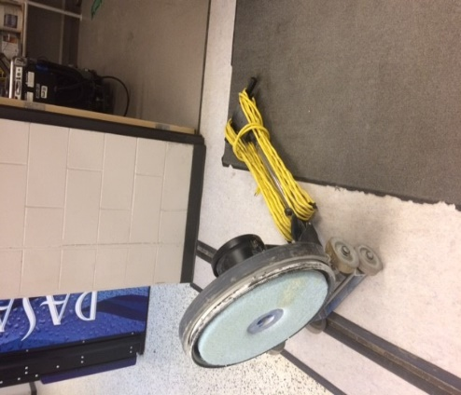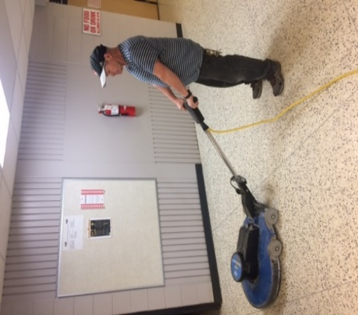

**Remove the center lock to replace the pads**

**Maintain a neutral spine position**

**Changing the Pads**

1. Unplug the burnisher
2. Lay machine back, exposing the underside
3. Remove center lock as per operator’s manual
4. Ensure pad is centered on pad driver. Pull pad to edge of pad to edge of pad driver in several directions to check for proper engagement
5. Replace center lock by as per operator’s manual.

©WorkSafeBC. Used with permission from *A Clean Sweep*

**Be Accountable: Choose safety - work safe - and go home injury free!**



**Safety Memo**

***Safety is everyone’s responsibility!***

**Cleaning Walls**

* Stand upright and use a lightweight long-handled mop or squeegee
* Adjust the length of a telescopic handle to minimize awkward bending and overreaching
* Alternate lead hands to avoid fatigue
* Use your legs, not just your arms, to generate force

**Using Telescopic Wall Washing Tools**

* Keep your hands in front of you and between your shoulders
* Work in a small area of the wall and try to keep your elbows below shoulder level
* Face the wall and move the tool up and down while:
  + Using a combination of small arm movements while walking sideways

***or***

* + Holding the tool across your body while walking forward to minimize arm movements
* Extend your washing range by walking forward to wash higher and walking back to wash lower

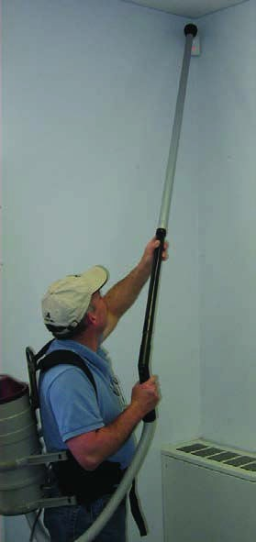

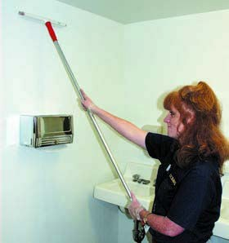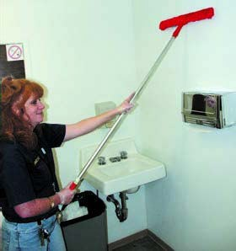

**Attach a long handled pole to mop or squeegee**

**Use lightweight plastic extension when vacuuming** **walls**

©WorkSafeBC. Used with permission from *A Clean Sweep.*

**Be Accountable: Choose safety - work safe - and go home injury free!**



**Safety Memo**

***Safety is everyone’s responsibility!***

**Garbage – Managing Containers and Bags**

Don't assume that garbage cans weigh the same each time Injuries can occur when lifting an unexpectedly heavy can.

**The risks of injury are related to:**

* Size of the garbage can
* Trying to predict the weight
* Suction holding the bag in place (see *Safety Talk: Garbage - Pulling Bags*)
* Ability to replace lifting with pulling
* Controlling the weight of bag
* Method of transporting bag to dumpster (see Safety Talk: Garbage - Transporting-Lifting- Dumpsters)
* Mechanics of lifting bag into dumpster (see Safety Talk: Garbage - Transporting-Lifting- Dumpsters)

**Container Size**

The right capacity for the container is based on the size and weight of the items placed in it.

When collecting heavy articles (wet paper, books, food waste):

* Use a smaller container
* Put in a false bottom to reduce the available space

**Controlling Bag Size**

Ensure the garbage bags are not overfilled

* Place a false bottom (styrofoam blocks or cardboard box) in the container to "use up some of the capacity"
* Tie off the bag when it's 1/2 (one-half) full and start a new bag on top of the first
* Tie off the second bag when it reaches the top of the container at 1/2 (one-half) full

**Predicting the Weight**

Often the person filling the container is not the person emptying it, so the containers may be overfilled.

* Test the load before lifting it, especially when a heavy load would be unusual

**Times when garbage bags may be heavier than usual:**

* Room set-up time
* Room clean-up time
* Special events

**Garbage – Transporting, Lifting and Dumpsters**

The dumping of garbage bags requires repeated high force and high shoulder lifts to toss in bags.

|  |  |
| --- | --- |
| **Common problems** | **Possible solutions** |
| * Heavy lids with stiff hinges * Overhead push of lids for shorter workers * Need to hold lid open with one arm while throwing bag in with the other | * Step stool - for better working height to throw in bags * Locking hinge lid - to allow two-handed handling of bags |

**Transporting to Dumpster**

* Always transport garbage bags to the dumpster with a cart
* Keep bags compact and light if no carts are available

**Lifting to Dumpster**

* Always wear gloves
* Roll barrels and other equipment containing trash bags as close to the dumpster as possible
* If the bag is too heavy, get help
* Use a step up platform next to the dumpster
* Avoid twisting and tossing side ways

**Garbage – Pulling Bags**

Repeated heavy lifting is more difficult when the contents of the bag have been pushed down to avoid extra trips to the dumpster. A strong suction is generated and extra force is needed to pull the bag out.

**Suction Effect**

Garbage bags fit tightly against the walls of the container and create a suction effect. This makes it difficult to remove the bags by increasing the force required. In order to remove the bag, air must enter the space between the bag and container.

**To reduce the suction**

Place a loosely fitting false bottom in the container (i.e., a light piece of foam, empty box placed upside down)

**Maintaining Garbage Cans**

* Empty cans before they are half full
* Do not overfill or compact trash in the barrel
* Ask for help when the bag is overfilled and too heavy

**Tilt and Pull**

Put the container on its side and use a pulling motion to get the bag out to avoid awkward lifts above your shoulder.

**Garbage – Emptying Cans**

Always wear gloves.

Check the weight of the can by tilting or pushing it.

Look over the contents of the can for sharp points or protrusions

Grasp the lip around the rim of the can; use two hands if the can is heavy and avoid bending your wrists.

Change hands to pick up and lower trash cans.

Empty trash cans frequently to avoid accumulating heavy loads.

©WorkSafeBC. Used with permission from *A Clean Sweep.*

**Be Accountable: Choose safety - work safe - and go home injury free!**



**Safety Memo**

***Safety is everyone’s responsibility!***

**Wiping and Dusting**

A wet mop can weigh up to 25 pounds when fully saturated. Wet mopping can cause significant contact stress over the hand and wrist. It also adds strain to the low back.

**Wringing a mop**

* Bend your knees and keep your back straight as you push the mop wringer down
* Face the wringer lever with a straight elbow
* Use your body weight to press down on the lever
* Use a mop bucket raised off the floor to reduce the bending force required to wring out the water
* While squeezing the mop, place your foot in front of the wheel to prevent the bucket from moving

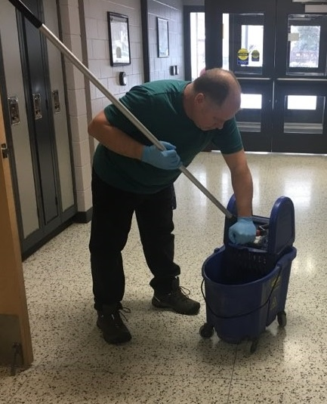

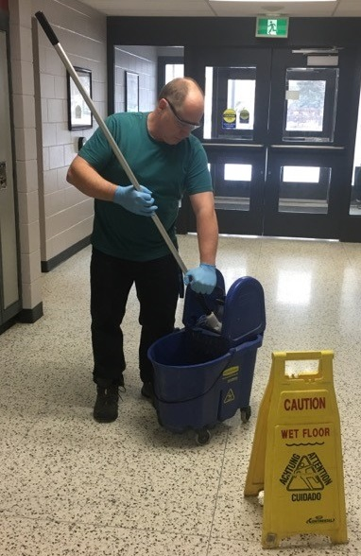

**Wear applicable PPE**

**Do not bend your back to squeeze out water**

©WorkSafeBC. Used with permission from *A Clean Sweep.*

**Be Accountable: Choose safety - work safe - and go home injury free!**



**Safety Memo**

***Safety is everyone’s responsibility!***

**Personal Protective Products – (PPE)**

The school division will ensure that in any circumstance requiring PPE that they are readily available, up to standard and appropriately used.

1. **Gloves**
2. Glove use is NOT a substitution for proper hand hygiene.

* Remove gloves after each procedure has been completed.
* Discard gloves and then perform hand hygiene.
* Never use the same gloves for more than one individual or procedure.

1. Gloves shall be used:

* To provide a protective barrier and prevent contamination of hand.
* Where there is potential to be exposed to blood, body fluids, secretions, excretions, mucous membranes, and non-intact skin.
* Selection of gloves should be based on:
* proper fit for the worker;
* the type of procedure being done; and
* the likelihood of exposure to body fluid.

**Note: The employer will ensure that latex-free options are made available for employees   
with latex allergies.**

1. Gloves shall be changed:

* When task or procedure is complete.
* If a leak is suspected or a glove tears.

1. Gloves shall be worn:

* When exposure to potentially infectious material such as blood, body fluids, secretions, excretions, mucous membranes, and non-intact skin is anticipated.
* For handling cleaning products that require them per the Safety Data Sheet (SDS)
* By caretakers who have cuts, scratches, or other breaks in the skin.

1. Single-use Disposable Gloves:

* Single-use disposable gloves must not be washed or reused.

1. Procedure for Removing Soiled Gloves:

* The outside of gloves is considered contaminated.
* Grasp outside of glove with opposite gloved hand and peel off.
* Hold removed glove in gloved hand.
* Slide fingers of un-gloved hand under remaining glove at wrist.
* Peel glove off over first glove.
* Discard gloves in appropriate waste container.

1. **Eye Protection**
2. Eye protection includes such items as:

* eyegoggles
* face shield
* safety glasses

1. Eye protection must be worn during procedures in which it is required per the Safety Data Sheet (SDS) of the chemical.
2. **Respiratory Protection/ High Efficiency (95%) Particulate Respirators - N95 Masks**
3. Where a worker is likely to be exposed to dust, fumes, gas, mist, aerosol, vapours, or any contaminant that may be present in amounts that are harmful or offensive to the worker, the employer will provide the worker with suitable, approved, and adequate respiratory protection.
4. The worker must use the respiratory protective equipment provided.
5. The use of a respiratory mask is recommended to prevent the worker from being infected by micro-organisms that are transmitted through the air. Masks protect the wearer from inhaling both large particle aerosols (droplets) that are transmitted by close contact and generally travel short distances (1 meter or 3 feet) or small particle aerosols (droplet nuclei) that remain suspended in the air and thus travel longer distances.
6. In general:

* Masks are for single use only.
* Masks must completely cover the nose and mouth.
* Do not touch the mask when in use.
* Change the mask when wet.
* Discard all used masks into the wastebasket immediately after proper removal.
* Masks must not dangle around the neck.
* Wash hands after proper removal.
* Masks should be worn with nose piece on top, pleats open downward with the nose piece being formed around the nose to provide thorough protection.

1. N95 masks:

* Have the ability to filter particles 1 micron in size and are required for protection against diseases transmitted through the air.
* Must be worn by employees attending to an infectious participant as determined by infection control standards.
* To be effective, the N95 mask must be fitted to the wearer to determine which respirator provides the most amount of protection for each worker.

1. Removal of Disposable Mask/Respirator

* Front of mask/respirator is considered contaminated.
* Grasp bottom, then top ties or elastics and remove.
* Discard in waste container.
* Wash hands.

©WorkSafeBC. Used with permission from *A Clean Sweep.*

**Be Accountable: Choose safety - work safe - and go home injury free!**



**Safety Memo**

***Safety is everyone’s responsibility!***

**Swing Machines**

Operating swing machines requires skill and experience. Very small motions can produce sudden, extreme direction changes.

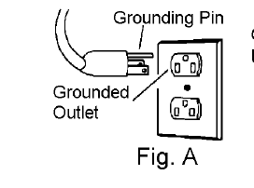

**Grounding Instructions:**

**This appliance must be grounded. See figure A.** If it should malfunction or break down, grounding provides a path of least resistance for electric current to reduce the risk of electric shock. This appliance is equipped with a cord having an equipment-grounding conductor and grounding plug. The plug must be inserted into an appropriate outlet that is properly installed and grounded in accordance with all local codes and ordinances.

**Daily Maintenance**

* Inspect power cord for wear. To prevent electrical shock replace cords with frayed or cracked insulation immediately.
* Place machine in the storage position.
* Check pad condition. Change if soiled or torn.

**Operating Floor Machines**

* Visual pre inspection of equipment, initial & date on equipment sheet (form).
* Maintain a neutral spine position.
* High starting torque. Hold machine firmly with both hands. Feet planted shoulder width apart.
* **Do not** pull/run machine over cord. **Keep** cord away from heated surfaces.
* Operational hazard may occur when running the machine over the supply cord.
* Ensure that handle is locked in position before starting machine.
* Let the machine do the movement by moving with it as a unit.
* Grip machine with neutral wrist posture.
* Control direction by raising and lowering the handles.
* Do not let machine rest on pad. When finished with the machine, return handle to the storage position.

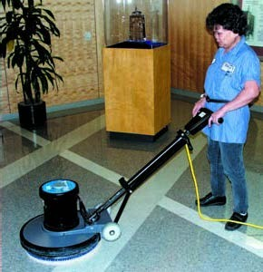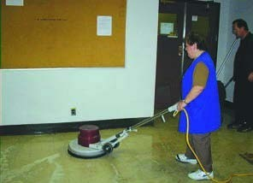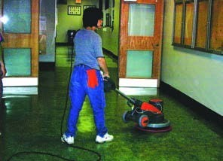

**Maintain a neutral spine position**

**Train workers in safe work procedures**

**Spread feet apart to maintain wide base & stability**

**Changing the Pads**

* 1. Unplug swing machine.
  2. Lock the handle in an upright position.
  3. Tilt the machine to place it on the floor.
  4. Place the pad on the floor near the machine and lower the machine onto the pad.

**Storage:**

**Pad Driver/ Brush Installation and Removal**

1. Unplug swing machine.
2. Lock the handle in an upright position.
3. Lay machine back, exposing the underside.
4. Place pad driver on the motor lug and rotate counter-clockwise until engaged. To remove, turn clockwise.

©WorkSafeBC. Used with permission from *A Clean Sweep.*

**Be Accountable: Choose safety - work safe - and go home injury free!**

**Safety Memo**

***Safety is everyone’s Responsibility!***

**Vacuum Cleaner**

**Procedure for Vacuum Cleaners (Refer to Caretaking Procedure: CP-111)**

**IMPORTANT SAFETY INSTRUCTIONS**

When using an electrical appliance, basic precautions must always be followed, including the following. READ ALL INSTRUCTIONS BEFORE USING THIS MACHINE WARNING: To reduce the risk of fire, electric shock, or injury:

* Do not leave appliance when plugged in. Unplug from outlet when not in use and before servicing.
* Do not use outdoors or on wet surfaces.
* Use only as described in this manual. Use only manufacturer’s recommended attachments.
* Do not use with damaged cord or plug. If appliance is not working as it should or has been dropped, damaged, left outdoors, or dropped into water, notify your supervisor.
* Do not pull or carry by cord, use cord as a handle, close a door on cord, or pull cord around sharp edges or corners. Do not run appliance over cord. Keep cord away from heated surfaces.
* To unplug, grasp the plug, not the cord. Do not unplug by pulling on cord.
* Do not handle plug or appliance with wet hands.
* Do not put any object into openings. Do not use with any opening blocked; keep free of dust, lint, hair, and anything that may reduce air flow.
* Keep hair, loose clothing, fingers, and all parts of body away from openings and moving parts. Do not place fingers or other body parts under vacuum unless unplugged.
* Do not pick up anything that is burning or smoking, such as cigarettes, matches, or hot ashes.
* Do not use without dust bag and/or filters in place.
* Turn off all controls before unplugging.
* Do not use to pick up flammable or combustible liquids such as gasoline or use in areas where they may be present.
* Machines can cause a fire when operated near flammable vapors or materials. Do not operate this machine near flammable fluids, dust or vapors.
* Maintenance and repairs must be done by qualified personnel.
* Use only identical replacement parts. See instructions for Servicing of Appliances.
* If used on plush carpet or carpet with thick padding, do not leave machine in one place with machine turned on.
* Do not use the handle in the dust bag housing cover to carry the machine.
* Always turn off this appliance before connecting or disconnecting motorized nozzle.
* Brush may unexpectedly restart. To reduce the risk of injury from moving parts – unplug before servicing. (Refer to Lock Out/Tag Out Procedure)
* The vacuum has a manual reset thermal protector. The protector is reset by switching off the vacuum. The thermal protector needs some time to cool down after switching off! Check the vacuum for air blockages or mechanical failures before switching on.
* Store the vacuum in a dry place at room temperature. When the vacuum is not in use, you should wrap the cord on the cable hooks.
* Any other servicing should be put in as a service request.

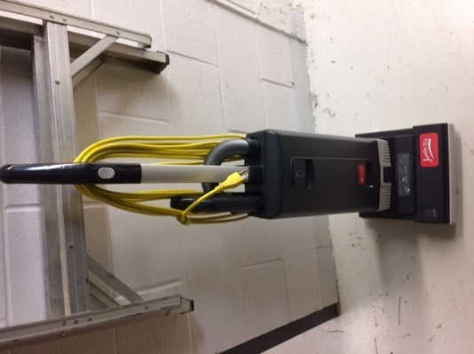

**Store vacuum with cords wrapped around cable hooks**

©WorkSafeBC. Used with permission from *A Clean Sweep.*

**Be Accountable: Choose safety - work safe - and go home injury free!**



**Safety Memo**

***Safety is everyone’s responsibility!***

**Wiping and Dusting**

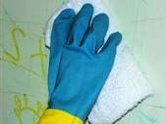Extending the shoulder and arm to wipe forcefully with the whole hand for long periods of time is tiring. Wringing wet wash cloths produces forceful and repetitious twisting and bending of the wrist.

**Cloth selection-size**

Cloths should be large enough to be efficient, but small enough to squeeze out excess water with no more than two squeezing motions.

**Wringing**

The twisting force of the wringing action gets out more water than a simple squeeze, but this can cause wrist injury when done repetitively.

* To avoid injury, hold one hand above the other to produce a squeeze action – this allows both wrist joints to be in a straight neutral position.

**Wiping Horizontal/ Vertical Surfaces**

* Use effective cleaning products and let the cleaning products do the work.
* Divide work into sections to allow task rotation.
* Alternate arms to reduce muscle fatigue.
* Use well designed tools that match your height, strength and endurance.

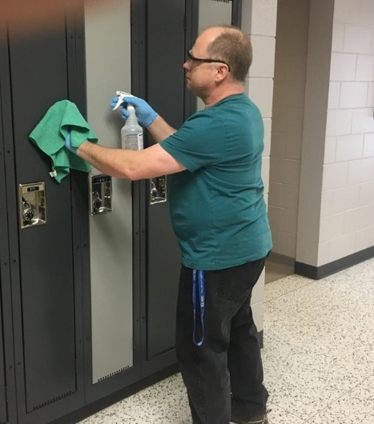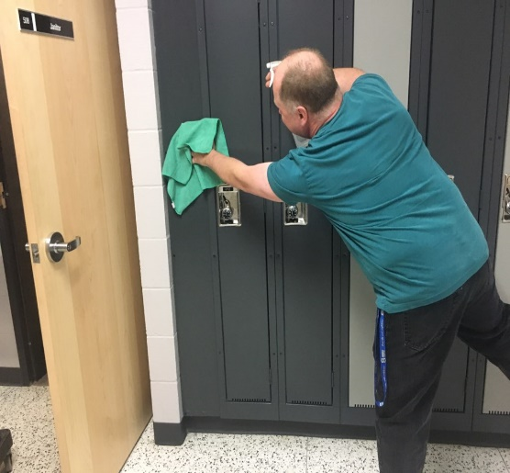

**Do not over reach to avoid injury**

**Wear applicable PPE**

©WorkSafeBC. Used with permission from *A Clean Sweep.*

**Be Accountable: Choose safety - work safe - and go home injury free!**



**4**

# Chapter 4: Security and Emergency Preparedness

**[ENTER DIVISION NAME]**

## Section 4.1: Security

1. Keys
2. Keys are obtained from your supervisor/school administration.
3. Any lost, missing, or stolen keys must be reported to the supervisor/school administration immediately.
4. Keys are your personal responsibility
5. Security of Buildings
6. It is the caretaker’s responsibility to know and follow the school administration’s direction for opening/locking all doors of the school.
7. Security Systems
8. Security systems will be run per school administration’s direction

## Section 4.2: Emergency Preparedness

Every school in the school division will have an emergency procedure for various items. Please read and follow the site specific emergency plans for your school, including: fire, tornado, lockdown, etc.



**5**

# Chapter 5: Training, Communication & Ordering for Caretakers

**[ENTER DIVISION NAME]**

## Section 5.1: Training

1. **Mandatory Training**
2. WHMIS 2015 – Education & Training
3. TLR –Object Moving (Transfer/Lift/Reposition) Training – Every 3 Year Review
4. Fit Testing for Respirator(s) – Every 2 Year Review
5. Orientation
6. Powered Mobile Equipment (where applicable)

## Section 5.2: Department In-Service

1. **Department In-Service**
2. Caretakers are required to attend and participate in the Department In-Service as scheduled.
3. Attendance is compulsory[1]14.
4. At the meetings, caretakers are updated on new regulations and requirements, and review existing procedures and practices that must be followed.

## Section 5.3: Communication

* 1. **Communication**

Whether you have an issue/concern, suggestion or observation you are free to contact your supervisor or designate at any time.

Most issues/concerns can and should be resolved beginning with your immediate supervisor. This is encouraged as your first effort to solve an issue/concern, if an issue/concern cannot be resolved, an employee may discuss the issues with the next level of management and/or Human Resources. Take the following steps:

1. Immediate Supervisor
2. Caretaking Supervisor
3. Facilities & Transportation Manager
4. Human Resources Manager
   1. **Communication Processes**

The Caretaking Sector will establish and maintain communication processes to ensure information regarding health and safety in the workplace is fully communicated in a timely manner (and ensures a two-way flow of information).

1. Caretakers – Must check email 3 times per week for compliance
2. Working Alone Policy & Procedure (Division specific)
3. Knowledge of resetting password (Division specific procedure)

## Section 5.4: Ordering Supplies & Keeping Inventory

**Ordering Supplies & Keeping Inventory**

* All orders must be made with the approved suppliers who have been awarded contracts with the Facilities & Transportation Department.
* Caretakers will place orders on or before the following dates:

1. September 1
2. December 1
3. March 1
4. June 1

* It is suggested that when you are planning and ordering your supplies you should allow two weeks for delivery in case of problems and situations beyond your control.
* Be sure to fill out and send into your supervisor your Chemical List that is required to be put in before your above order dates.
* Check your supply order for errors before you send to your supervisor to avoid delays.
* Items such as tools and equipment must be requested through your supervisor who will assess the need and issue Purchase Orders.
* All new chemicals ordered will need to have Safety Data Sheets (SDS) printed and placed in SDS binder where that chemical will be stored. (Contact your supervisor if SDS cannot be located)
* When delivered, supplies should be stored in their proper place.
* Decanted products MUST have a Workplace Label on bottle or container. Workplace label must be properly filled out to include name of product, pictograms, precautionary statements, PPE, signal word and any further information on Safety Data Sheet.

Example of Workplace Label:

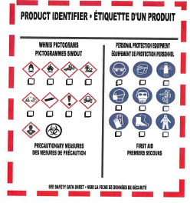

## Section 5.5: Orientation Checklist

|  |  |  |  |
| --- | --- | --- | --- |
| **Department/Site Orientation Checklist** | | | |
| **Employee Name: ___________________________________________** | | **New ______** | **Transferred ____ Annual _____** | |
| **Dept./Facility/Area: _________________________________________** | | **Date of Hire: _____________________________** | | |
|  |  |  |  |  |
| **Topic** | **Initials** | | **Comments** |  |
|  | Supervisor or designate | Employee |  |  |
| Review of Health & Safety Policy |  |  |  |  |
| Privacy and Confidentiality expectations for the Department/Area. (Reference applicable policy) |  |  |  |  |
| How to do service requests as applicable (i.e., Maintenance, IT) and find relevant forms |  |  |  |  |
| Dress Code – Closed toe shoe or boot, general neat in appearance |  |  |  |  |
| Security: Responsibility of keys, securing of building |  |  |  |  |
| Parking – designated |  |  |  |  |
| Other forms – Request for Leaves, etc. |  |  |  |  |
| Use of Work phones, computers and printers |  |  |  |  |
| Personal Cell Phone Use |  |  |  |  |
| Smoking – contractors, visitors, staff |  |  |  |  |
|  |  |  |  |  |
| **Safety Orientation Checklist:** |  |  |  |  |
| Workers’ Rights: |  |  |  |  |
| -Right to Know |  |  |  |  |
| -Right to Participate |  |  |  |  |
| -Right to Refuse |  |  |  |  |
| Scent Awareness, if applicable site specific |  |  |  |  |
| Review of employee roles and responsibilities |  |  |  |  |
| What areas are restricted/prohibited |  |  |  |  |
| Asbestos locations and training/PPE if applicable |  |  |  |  |
| Supervisor – Name and process to communicate to their supervisor at all times |  |  |  |  |
| Location of the OH&S Bulletin Board – minutes, membership, names/introduction of OHC Co-Chairs |  |  |  |  |
| Location of the OH&S Policy & Procedure Manual |  |  |  |  |
| Location of The Saskatchewan Employment Act and The Occupational Health and Safety Regulations, 1996 |  |  |  |  |
| Safe and Respectful Workplace |  |  |  |  |
| ▪         Harassment Policy (Reference applicable policy) |  |  |  |  |
| ▪         Violence Policy (Reference applicable policy) |  |  |  |  |
| **Topic** | **Initials** | | **Comments** |  |
| Supervisor or designate | Employee |  |  |
| WHMIS 2015 education and site specific training, |  |  |  |  |
| •         Location of the SDS binder |  |  |  |  |
| Review of Job Specific Hazards and JSA for Job Position |  |  |  |  |
| •         Dangerous tools, equipment |  |  |  |  |
| •         Working Alone Policy, Process |  |  |  |  |
| •         Confined Space |  |  |  |  |
| •         Personal Protective Equipment (PPE) |  |  |  |  |
| * Location, selection, storage, disposal |  |  |  |  |
| Location of emergency exits and equipment |  |  |  |  |
| Location of first aid station |  |  |  |  |
| Location of eye flushing equipment, if applicable |  |  |  |  |
| Relevant safe work practices and procedures |  |  |  |  |
| General safety rules |  |  |  |  |
| Sharps disposal |  |  |  |  |
| Review Management of Exposure to Blood & Body Fluids (Reference applicable policy) |  |  |  |  |
| Incident Reporting: Review **Workplace Incident Report** Policy, Process and form (Reference applicable policy) |  |  |  |  |
|  |  |  |  |  |
| Emergency Preparedness Plan |  |  |  |  |
| Fire Plan, Fire Drill, Fire Extinguisher/Alarm |  |  |  |  |
| * Evacuation |  |  |  |  |
| * Bomb Threat |  |  |  |  |
| * Hostage Taking |  |  |  |  |
| * Lock Down |  |  |  |  |
| * Hold & Secure |  |  |  |  |
| * Hazardous Material Spill |  |  |  |  |
| * Severe Weather |  |  |  |  |

|  |  |  |  |  |  |
| --- | --- | --- | --- | --- | --- |
|  |  |  |  |  | |
| Required mandatory job specific training |  |  |  |  | |
| (check applicable and add additional) |  |  |  |  | |
| Confined Space, if applicable |  |  |  |  | |
| WHMIS 2015 Education/Training |  |  |  |  | |
| Fit Testing (N95, respirator’s, storage, use) |  |  |  |  | |
| TLR Training –object moving |  |  |  |  | |
| Communication- email must check 3x a week |  |  |  |  | |
|  |  |  |  |  | |
| **Signature of completion:** |  |  |  |  | |
|  |  |  |  |  | |
| Employee___________________ Manager/Supervisor_____________________ | | | | |
|  |  |  |  |  | |
| Date Completed: _________________________ | **Distribution:**  Original copy – HR Department – Personnel File Copy – Manager/supervisor  Copy – Employee | | |  | |
| **Note:** |  | |
| Manager/supervisors are to verify that the new/transferred employee |  | |
| is competent in department policies, procedures, practices and rules |  | |

## Section 5.6: Online Leave Entry

**ENTER DIVISION SPECIFIC INFORMATION**



**6**

# Chapter 6: Appendices

**[ENTER DIVISION NAME]**

## Appendix A: Quick Reference Guide

**Phone Contacts**

* Caretaking Supervisor:
* Assistant Caretaking Supervisors:
* Manager of Facilities & Transportation:
* Facilities & Transportation Administrative Assistant:
* Human Resources:
* Payroll:

### **Appendix B: Administrative Procedures** (listed but not limited to)

**Introduction**

Administrative Procedures refer to the caretaking role of staff in several places. The titles below provide a brief description of these administrative procedures and reference to where related material may be accessed through this manual.

**Titles** (Division specific if applicable)

### Responsible use of Technology and the Internet

-outlines the proper use of technology and internet use in the division.

### Exposure Control Plan (Blood, Body Fluids)

-outlines safe work practices when contact with blood or body fluids.

### Tobacco Free Environment

-outlines the use of tobacco products.

### Video Surveillance

-outlines protocols and procedures for using electronic surveillance on school premises.

### Confidentiality

-outlines protection of personal information of staff and students.

### Emergency Water Situations

-outlines the response of schools in the case of emergency water situations.

### Social Media Guidelines

-outlines the acceptable use of Social Media

### Student Welfare

-outlines the safety and well-being of children is a responsibility shared by every member of the community. As all citizens have a duty to report child abuse in accordance with provincial legislation, all employees of the Division have a duty to report suspected child abuse to an appropriate authority.

### Student Discipline

-outlines protocols and procedures for ensuring positive learning environment.

### Damage to Property by Students

-outlines protocols and procedures for a student who willfully or unknowingly destroys or damages school property will be held financially responsible for their actions.

### Service Dogs in Schools

-outlines the guidelines and recognizes the diverse/intensive needs of some students may require unique accommodations.

### Criminal Record and Vulnerable Sector Checks

-outlines the procedure before commencing employment

### Reporting of Criminal Charges

-outlines responsibilities for any employee charged with a criminal offense.

### Harassment

-outlines ensuring work environment is free of harassment.

* + Harassment Complaint Form

### Violence

-outlines the employer is committed to minimize or eliminate the risk of violence in the workplace.

### Injury/ Incident Reporting

-outlines the procedures and responsibilities of reporting an injury/ incident.

### Caretaker Supervision

-outlines the procedures and responsibilities of caretaker supervision.

### Employee Use of Drugs and Alcohol

-outlines drug and alcohol use.

### Mobile Devices

-outlines division mobile communication devices.

### Hazard Identification and Control- Workplace Hazardous Materials Information System WHMIS 2015

-outlines the practices and procedures for the safe use, storage, handling and disposal of hazardous products.

### Buildings and Grounds Security

-outlines the procedures for division buildings and grounds security.

### Use of Division Vehicles

-outlines the proper use of vehicles owned by the (enter division name)

## 

## Appendix C: Key References

* *The Saskatchewan Employment Act*
* *The Occupational Health and Safety Regulations, 2020*



**7**

# Chapter 7: Forms

**[ENTER DIVISION NAME]**

## Section 7.1: Caretaking Sector Forms (listed but not limited to)

**Introduction**

This Chapter lists and includes forms required by caretakers.

These forms are: (Division specific if applicable)

### Incident Report Form

* This form is used for reporting all accidents, near misses or property damage.

### Expense Reimbursement Form

* This form is to be used in situations where caretakers incur expenses that are eligible for reimbursement through the school division. This must be approved and signed by your supervisor.

### Equipment Inventory - Yearly

* This form is used to collect information from all equipment at school.
* This form will be filled at yearly when required by Caretaking Supervisor.

### Chemicals on Hand – Quarterly Inventory

* Before quarterly orders are submitted this form must be filled out and submitted to your supervisor.

### Caretaker Performance Review Form

* This evaluation will be done a minimum of once every 3 years.

### Snow/Ice Removal Log

* Every instance of snow removal is to be logged on daily sheet.

### Playground Inspection

* Visual inspection of playground equipment to be done weekly.
* Any deficiencies.

### Tri-Annual Reports

* Reports to be completed and sent in October/February/May of each school year.
* Reports to be filled out and sent in to Area Facilities Foreperson

### Yearly Inventory List

* List to be completed by August 31 of each school year.
* Reports to be filled out and sent in to your supervisor also by August 31.

### Working Alone



**Caretaking**

**Performance Review Form**

Name: ________________________________ Date of Review: __________________________

School/Location: __________________________________ Position: __________________________

How long has this employee worked in his/her assignment? ________________________________

Type of Evaluation (check one)

Interim Probationary  Final Probationary  Trial Period

1 Year Following Probationary  Review (3 years)  Other____________________

Evaluator (print name): _________________________ Position: _____________________________

Mark (X) the box that most accurately reflects your evaluation of the employee.

***3. Meets Expectations:*** *A person who consistently meets requirements and expectations; one who excels in one or more areas of performance.*

***2. Needs Improvement:*** *A person who inconsistently meets the requirements and expectations; one who has areas of performance that require improvement.*

***1. Unacceptable:*** *A person whose performance is notably below job requirements and expectations; significant improvement to performance is required.*

| Criteria for Evaluation (Note: Space for general comments provided at the end) | **3** | **2** | **1** | **N/A** |
| --- | --- | --- | --- | --- |
| **Quality of Work**   1. Completes work with the expected degree of quality 2. Is attentive to detail, and actively seeks out and corrects issues 3. Able to arrive at sound solutions, even in unusual circumstances 4. Work is consistently complete and accurate |  |  |  |  |
| **Organization of Work**   1. Organizes day well   6. Plans work in advance  7. Manages time and conflicting priorities  8. Completes assignments within expected timeframe |  |  |  |  |
| **Adaptability and Flexibility**  9. Learns new tasks easily  10. Responds well to changing needs and procedures  11. Accepts new ideas with relative ease  12. Suggests new methods and approaches to work |  |  |  |  |
| **Job Knowledge**  13. Understands how to work with school and/or division staff  14. Has necessary skills to do the required job  15. Seeks further knowledge and professional development opportunities |  |  |  |  |
| **Communication Skills**  16. Conveys detailed information well  17. Communicates clearly and effectively within assigned role  18. Is clear and concise, both orally and in writing  19. Clarifies instructions when necessary  20. Shares knowledge and ideas  21. Listens well and responds appropriately |  |  |  |  |
| **Cooperation**  22. Agreeable and pleasant  23. Works well as part of a team  24. Agreeable to supervision  25. Eager to be helpful  26. Quick to offer assistance and support |  |  |  |  |
| **Attitude**  27. Demonstrates a positive attitude towards others, work and organization |  |  |  |  |
| **Reliability**  28. Follows through on commitments and job duties consistently  29. Accepts accountability for his/her work  30. Follows instructions, directives and procedures |  |  |  |  |
| **Initiative**  31. Actively seeks out additional responsibilities, without being asked  32. Demonstrates an ability to encourage and/or inspire others |  |  |  |  |
| **Attendance and Punctuality/ Other**  33. Regularly in attendance and is punctual  34. Uses time constructively  35. Wears clothing consistent with a professional work environment |  |  |  |  |
| **Safety**  36. Reports all incidents / accidents to supervisor immediately  37. Follows established policies & safe work procedures  38. Knows the 3 worker rights & what they mean  39. Demonstrates proper use of personal protective equipment (PPE), donning, doffing, selection, storage  40. Worker ensures all applicable training is current |  |  |  |  |
| **Work Habits/Skills**   1. Stores all supplies in an orderly fashion 2. Maintains caretaking and maintenance equipment accordingly 3. Completes minor repairs/painting as required 4. Maintains inventory of supplies and places orders in a timely and efficient manner 5. Efficiently sweeps, mops, strips, waxes and polishes floors 6. Maintains all storage areas in clean orderly condition 7. Classroom and lab fixtures 8. Washrooms and bathroom fixtures 9. Whiteboards 10. Collects wastepaper and other waste materials regularly 11. Ensures all entrances and windows are closed and secure at the end of the day 12. Dusts all furniture, fixtures, walls and other areas regularly 13. Cleans/maintains an attractive entrance through the school/work day 14. Washes walls and ceilings (other than tiled areas) annually or as requested 15. Promptly replaces burned out light bulbs and reports ballast issues 16. Demonstrates an understanding of the operation and maintenance of HVAC systems 17. Completes minor repairs to the HVAC system 18. Maintains all fixtures, entrances and windows in good condition 19. Controls weeds and cuts grass regularly 20. Performs playground inspections and logs results weekly and reports deficiencies to Administrators or submits service requests 21. Removes snow/ice from entrances and sidewalks and logs results |  |  |  |  |

Goals and Objectives

Summarize goals and objectives and how they have been met:

____________________________________________________________________________________________________________________________________________________________________________________________________________________________________________________________________________________________________________________________________

Objectives for the Next Review Period

List goals and objectives to be attained in the upcoming review period:

____________________________________________________________________________________________________________________________________________________________________________________________________________________________________________________________________________________________________________________________________

Overall Review

Outline areas of major strength(s):

_____________________________________________________________________________________________________________________________________________________________________________________________________________________________________________________________________________________________________________________________________________________________________________________________________________________

Areas which could be improved:

_____________________________________________________________________________________________________________________________________________________________________________________________________________________________________________________________________________________________________________________________________________________________________________________________________________________

Professional Development goals:

_____________________________________________________________________________________________________________________________________________________________________________________________________________________________________________________________________________________________________________________________________________________________________________________________________________________

General comments and recommendations:

_____________________________________________________________________________________________________________________________________________________________________________________________________________________________________________________________________________________________________________________________________________________________________________________________________________________

______________________________________________ ___________________________

Supervisor’s Signature Date

______________________________________________ ____________________________

Employee’s Signature Date



**Working Alone Form**

**Supervisor to document all steps taken to reduce and eliminate the identified risks:**

**Caretaker: _______________________________________________**

**School/Facility: ____________________________________________**

**Working Hours: ___________________________________________**

1. The communication system for the alone worker includes:

* phone or cellular communication
* maintain regular call in/call out contact with:

Contact name/position: ____________________

Contact phone number: _____________________

* The contact person will activate emergency procedures if have not heard from the individual working alone by a specific time or if alerted to an emergency.

Emergency step process:

1. Wait 10 mins
2. Call work contact number (number listed above)
3. Wait 10 mins
4. Call personal phone number
5. Wait 10 mins
6. Call immediate supervisor
7. Wait 10 mins
8. Call emergency contact number
9. Wait 10 mins
10. Call local emergency service request a welfare check

2. If working alone, the worker will not perform the following tasks (list):

* Do not enter any confined spaces
* Do not move a heavy object alone; assess and arrange for assistance
* Caretaker to complete self-assessment to determine level of risk as specific to location
  + Considerations should be given to weather conditions, working environment/surroundings

3. Specific training and instructions for safe work practices when working alone include:   
(identify for the specific facility/school)

* + Call in/call out procedures (Communication plan)
  + WHIMIS 2015 education and training
  + TLR Object Moving/Safe Body Mechanics
  + Fire safety and evacuation

**\*\* This manual may be changed or updated/revised at any time \*\***

1. 14 Caretakers not able to attend in-service meetings must have permission from supervisor