Communicable Disease Handbook

Infection Prevention & Control Basics - Reportable Diseases - Outbreaks - Fact Sheets

Table of Contents
Introduction 4
Infection Prevention & Control Basics 5
What Causes Infections? 5
How Do Infections Spread? 6
The Chain of Infection 7
Preventing Infections 8
Routine / Universal Practices 8
Hand Hygiene 9
Immunization 12
Personal Protective Equipment-PPE 12
Cleaning & Disinfection 15
Mixing Bleach and COLD Water 16
Blood and Body Fluids Spills 17
Enhanced Environmental Cleaning & Disinfection 18
Bug Bite Prevention – Vector Borne Diseases 19
Role of the School (if applicable to Division) 21
Student Illness 21
Common Reportable Diseases in Schools 23
Exclusion - Quick Reference Chart 24
Student Absenteeism 25
Outbreaks 25
What is an Outbreak? 25
Identify the Source 26
Outbreak Control Measures 26
Declaring an Outbreak Over 27
MRSA 28
Norovirus 28
Pinworm 30
Head Lice 32
Conjunctivitis- Pink Eye 33
Appendix A - Sample Outbreak Control Measures Checklist 35
References 36

Introduction
Infectious diseases are a major cause of illness among school-aged children. There are numerous opportunities for infections to be passed from child to child within the school setting. Children have a higher risk of developing and spreading infections because they play closely together, spend a lot of time together, readily share their possessions, food and germs, and they are not always careful about their hygiene and may lack immunity to various diseases.
Preventing the spread of infectious diseases in schools is most likely to be successful when the following are implemented:

- Effective and frequent hand hygiene - teaching children the skills of hand hygiene and cough etiquette is essential in breaking the chain of infection;
- Appropriate vaccination of staff and students, in line with the https://www.saskatchewan.ca/residents/health/accessing-health-care-services/immunization-services has resulted in fewer childhood illnesses;
- Appropriate use of infection prevention and control measures in schools will minimize transmission of infection both within the school, but also to the wider community.
This manual is intended to provide information to school staff about common infections and to assist in preventing transmission of infections within the school setting. This guide will provide information about:
- The role of schools in reporting reportable diseases and outbreaks;
- The role of [enter division name] in following up reportable diseases and outbreaks;
- When to exclude students with infectious diseases;
- Preventing the spread of infections;
- Common childhood disease information sheets that can be copied and shared as needed.

Infection Prevention & Control Basics

What Causes Infections?

Germs, such as viruses, bacteria, parasites or fungi, may produce an infection. Each germ has different characteristics that attack the body’s defenses in different ways. Children are vulnerable to many of them because their immune systems are not well-developed.
Some germs can survive outside the body for hours or even days under the right conditions. For example, the influenza virus can survive for 5 minutes on the skin and up to 2 days on a hard surface such as a desk, computer keyboard or toy.

Not all infectious diseases are contagious. For example, ear infections are caused by germs that are not usually passed from person to person. Chickenpox on the other hand, rapidly spreads from person to person and is an example of a highly contagious infectious disease.

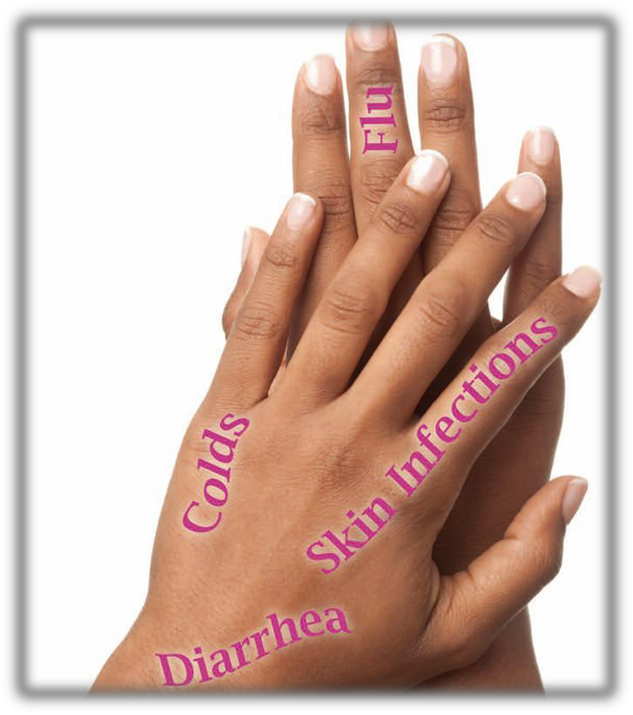

Key Point: Prevent the Spread of Infection

An infected person may not get sick or feel sick while they spread their germs. Stop the spread of infection by cleaning your hands often; frequently cleaning and disinfecting commonly touched surfaces and items in the school environment; ensuring your immunizations are up-to-date; staying home when you are sick; seeking medical care when needed.

How Do Infections Spread?

Type of Contact | How Germs Spread | Where the Germs are Found | Examples of Infections
Direct | - When a person is touched, coughed on, or kissed by an infected person.  - When the blood from an infected person enters the blood stream of another person through a small cut, bite, or break in the skin. | Body fluids, skin, and hair. Body fluids include:  - Saliva  - Eye discharge  - Nose and mouth secretions  - Blood  - Oozing sores | Pink eye, impetigo, ringworm, pinworms, HIV/AIDS, hepatitis B and C.
In-Direct | - When a person touches a surface or objects that has germs on it and then touches their eyes/nose/mouth. | Toys, tables, doorknobs, light switches. | Cold viruses, influenza, ringworm, pinworms (through bed linens).
Fecal-Oral | - When the germs in the stool of an infected person are ingested by another person. | Toilet handles, toys, doorknobs, swimming pools, water parks. | Rotavirus, norovirus, salmonella, giardia, hepatitis A, shigella.
Route | How Germs Spread | Where the Germs are Found | Examples of Infections
Droplet | - When a person comes into contact with droplets from the nose or mouth of an infected person.  - Droplets spread when the infected person talks, coughs, or sneezes.  - Droplets can travel up to 2 metres and enter another person’s eyes, mouth, and nose.  - Droplets can land on surfaces and live for hours. If someone touches the surface and then their face, they may become sick. | Tables, desks, toys, computer keyboards, phones etc. | Cold virus, influenza, fifth disease, meningitis, mumps, whooping cough, strep throat.
Airborne | - When a person inhales the airborne particles from the cough or sneeze of an infected person they may become sick.  - Airborne particles can remain in the air for several hours. | In the air. | Chickenpox, measles, tuberculosis.
Vector | - When a person is bitten by an animal or insect that carries an infection. | Bats, mosquitoes, ticks. | Rabies, West Nile virus, Lyme disease.
(Wellington, Dufferin, Guelph Public Health, 2010)

The Chain of Infection
Infectious Agent
(Bacteria, Virus, Parasite)

Break the Chain:
Diagnosis/Treatment

Break the Chain: Immunize; recognize high risk staff/students
Reservoir (Where the germs live e.g., animals, humans, food, water, frequently touched surfaces and items such as door knobs & computer keyboards)

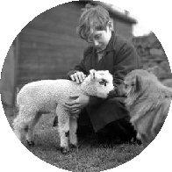
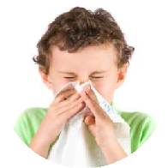
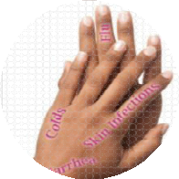
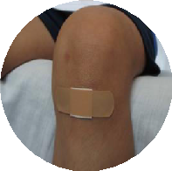
Susceptible Host (Someone who is vulnerable to infection i.e., babies, seniors, people with weak immune systems)

Breaking
the Chain Involves
You

Break the Chain: Clean your hands; don’t touch your face; cover skin lesions; wear appropriate personal protective equipment (i.e., gloves, masks)

Portal of Exit (How the germs leave the host i.e., through the respiratory tract by sneezing and coughing, through the gastrointestinal tract – stool; through skin, blood, and urine)
Break the Chain:
Educate/develop policies; environmental cleaning and disinfection

Break the Chain: Clean your hands; use insect repellent; clean and disinfect environmental surfaces & items; ensure adequate ventilation; proper food handling, exclusion

Portal of Entry (How germs get into a new host e.g., through broken skin; through mucous membranes such as the eyes, nose, or mouth)
Mode of Transmission (How the germs are spread e.g., through direct contact with contaminated hands; by breathing in germs in respiratory droplets; through the bite of an insect)
Break the Chain: Clean your hands: cover your coughs and sneezes; control excretions; properly dispose of waste

Preventing Infections

Routine / Universal Practices

Routine practices/universal practices refers to a combination of actions and infection prevention and control practices that should be used when providing direct care (i.e., first aid) to anyone. Routine practices are based on the idea that every person should be treated as if they may have an infection that could be spread to others.

Routine practices include:

- Hand hygiene
- Cough and sneeze etiquette
- Immunization
- Use of personal protective equipment such as gloves/masks
- Environmental cleaning and disinfection

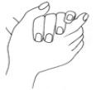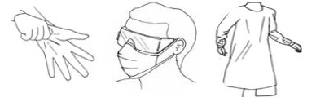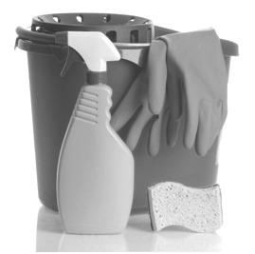

Ensuring your school has an adequate stock of the following supplies and products will help support infection control practices in the school setting:

- Soap
- Alcohol-based hand sanitizer
- Toilet paper
- Paper towels
- Tissues
- Garbage bags
- Cleaning supplies
- Personal Protective Equipment (PPE)

The following section provides information about the practical steps that anyone can take in a school setting to reduce the risk or acquiring or transmitting germs.

Hand Hygiene

Hand hygiene is the number one way to prevent the spread of infections.

Did you know…? Hands spread about 80% of infections like the common cold and influenza.

Make hand hygiene a part of your daily routine:

- Teach students how to effectively clean their hands with soap and water or an alcohol-based hand sanitizer.
- Ensure that students and staff always clean their hands:
Key Point: Choosing Soap

A mild liquid soap in a dispenser works best. Antimicrobial or germicidal soaps are not necessary or recommended for use in schools as they kill both helpful and harmful bacteria. Bar soap is also not recommended for use in schools as it is shared by too many hands and may spread germs. Germs can also grow on the bar and in the dish.

Best Practice Recommendation:

Discard or replace your soap dispenser when it is empty or clean and refill it. Don’t top it up with fresh soap – this practice has been shown to spread germs.
(Canadian Paediatric Society, 2008)

  - Before eating or handling food
  - After using the washroom
  - After coughing, sneezing or blowing your nose or helping a student to do the same
  - After shaking hands
  - After touching animals or animal waste
  - Before touching your face
  - After handling garbage
  - Before and after caring for a sick person
- Place hand sanitizers in easily accessible locations (i.e., outside of each classroom, near tissue boxes, above garbage cans).
- Supervise students when they wash their hands or use hand sanitizer.
- Hand hygiene posters are available upon request (specific to division).

Using Soap and Water
- Remove jewelry. Wet hands with warm water. Use liquid soap if possible. Apply a small amount about the size of a nickel or quarter. Antibacterial soap isn't necessary.
- Rub your hands together until the soap forms a lather and then rub all over your hands, between your fingers and under the finger nails.
- Continue rubbing for 15-20 seconds. Encourage students to wash their hands for as long as it takes to sing the ABCs or Happy Birthday.
- Rinse your hands well under running water.
- Dry your hands using paper towel. Use the paper towel to turn off the faucet and open the door.

Important points:
Always use soap and water:
- When your hands look dirty.
- Before you eat or prepare food.
- After using the washroom or changing a diaper.

Using Alcohol-Based Hand Sanitizer
- Remove jewelry. Apply a small amount, about the size of a quarter, to your hands.
- Use a rubbing motion to spread the sanitizer all over your hands, between the fingers, the finger tips, back of hands and under the fingernails.
- Rub until your hands feel dry, about 15 seconds.
- Do not wipe hands dry.

Important points:
- Use alcohol-based hand sanitizer when hands aren't visibly dirty.
- Alcohol-hand sanitizer should contain at least 70% alcohol or isopropanol.
- Alcohol-based hand sanitizer is safe to use with children, as directed, but ingestion could be dangerous. Use only with supervision.
- Keep products in a secure location, away from open flame and high temperatures.

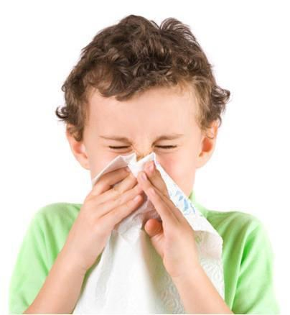
Cough and Sneeze Etiquette

Teach students to cover their mouth and nose with a tissue when they cough or sneeze. If a tissue isn’t available, encourage students to cough or sneeze into their upper sleeve or elbow, not in their hands.
  - Have plenty of tissues available for runny noses, coughs and sneezes.
  - Tissues should be available in all classrooms.
  - All soiled tissues should be disposed of in covered wastebaskets.
  - Remind students to clean their hands after using tissues.
Did you know…? Respiratory droplets forcibly expelled from a cough or sneeze travel for up to two metres.

Stay Home When You Are Sick
Staff and students should not be at school when they are sick.

- For common colds and other typical illnesses, staff and students should be advised to stay home until they feel well for one full day.
- If you are aware that a reportable disease has been diagnosed (e.g., someone has a Salmonella infection), contact length of time to exclude ill students and staff. (if applicable to division).

See page?? for specific exclusion requirements for common childhood infections.

Immunization

PART VII
General
Conscientious objection to immunization
64(1) A person who conscientiously believes that immunization or prophylaxis would be prejudicial to his or her health or to the health of his or her child or ward, or who for conscientious reasons objects to immunization or prophylaxis, may swear or affirm an affidavit to that effect before a justice of the peace, commissioner for oaths or notary public.
(2) A person described in subsection (1) is excused from compliance with any regulation, bylaw or order pursuant to this Act that makes immunization mandatory if the person delivers personally or by registered mail to the local authority for the area in which the person resides a duly attested affidavit described in that subsection.
1994, c.P-37.1, s.64; 2003, c.29, s.70.

Personal Protective Equipment-PPE
See Expose Control Plan for detailed information regarding PPE

Applying Universal Precautions require correct donning (putting on) and doffing (taking off) all personal protective equipment PPE
*Posters available
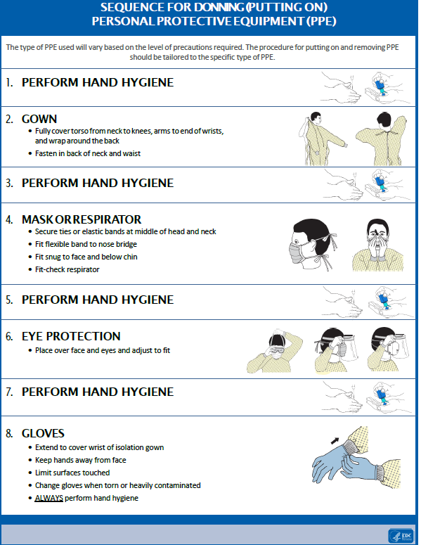
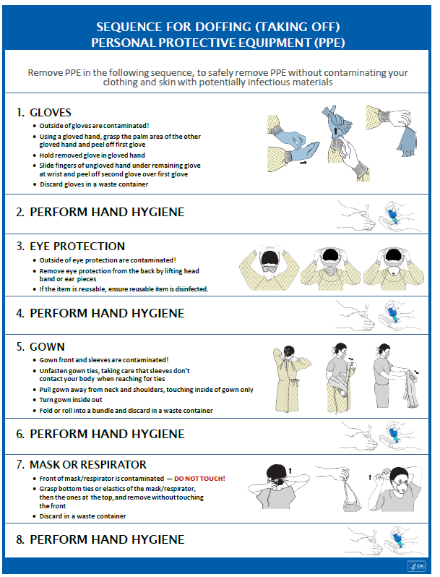

Cleaning & Disinfection

Proper cleaning and disinfection will help stop germs from spreading and making people sick. Cleaning is just as important as disinfecting.
Clean
To remove dirt and germs from a surface by using friction, soap or detergent, and water.

Disinfect
To kill germs by using a chemical solution such as chlorine bleach, quaternary ammonium compounds (QUATs), or accelerated hydrogen peroxide.

Steps to Cleaning and Disinfecting Environmental Surfaces and Items
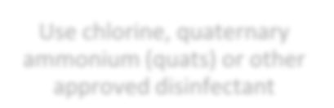
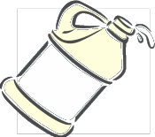
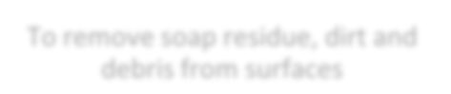
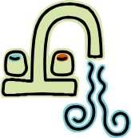
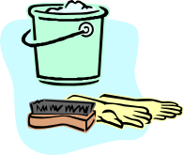
Step 3
DISINFECT
Use chlorine, quaternary
ammonium (quats) or other approved disinfectant
To kill most harmful germs
Step 2
RINSE
Use clean, warm water
To remove soap residue, dirt and
debris from surfaces

Step 4
AIR DRY or wipe dry with a disposable towel
Step 1
CLEAN/WASH
Scrub using detergent and clean
water
To loosen dirt and debris on
surfaces

How to disinfect?

After cleaning the surface, choose one of these four methods:

- Apply an approved disinfectant; or
- Immerse the object in a container of disinfecting solution. Remove the object and allow it to air dry; or
- Wash and disinfect objects in a commercial dishwasher; or
- Wipe the surface of large toys or objects that may be harmed by saturation (i.e., book covers, puzzles) with a clean cloth moistened with disinfectant.

What areas to focus on?
  - Washrooms
  - Toys, crafts and sensory play tables
  - Common areas
  - Areas where there is food

Mixing Bleach and COLD Water

High Level Disinfectant (1:10)
5000 parts per million
For cleaning up blood or body fluid spills.

- Slowly add 250 ml (1 cup) of bleach to 2250 ml (9 cups) of COLD water when preparing solution
- Leave on surface for 10 minutes

Intermediate-High Level Disinfectant (1:50)
1000 parts per million
For use in washrooms during outbreaks of vomiting & diarrhea.

- Slowly add 20 ml (4 teaspoons) of bleach to 1000 ml (4 cups) of COLD water when preparing solution
- Leave on surface for 10 minutes
- Intermediate-Level Disinfectant (1:100)
- 500 parts per million
- For routine use on floors, walls, washrooms, countertops, tables, and toys.

- Slowly add 10 ml (2 teaspoons) of bleach to 1000 ml (4 cups) of COLD water when preparing solution
- Leave on surface for 2 minutes

For a more precise calculation of how to mix bleach and water to achieve the desired concentration, calculated in parts per million (PPM), use the bleach dilution tool at:
www.publichealthontario.ca/en/ServicesAndTools/Tools/Pages/Dilution-Calculator.aspx

Blood and Body Fluids Spills

Cleaning blood and body fluids may require the use of personal protective equipment. Follow the recommendations in the chart below to properly clean and disinfect surfaces and laundry soiled by blood and body fluids.

Body Fluid | Mask | Gloves | Surface Cleaning and Disinfecting
Blood  - Hepatitis B  - Hepatitis C  - HIV  (Note: Blood-borne infections are very rare in children and the risk of transmission in the school setting remains extremely low). | No | Yes  Discard single use disposable gloves in a plastic lines garbage container.  Clean hands immediately after removing gloves. | Use disposable paper towels to soak up excess blood or body fluids before cleaning. Discard in a plastic lined garbage container.  Wash area with hot water and detergent, then rinse.  Disinfect the area with a fresh chlorine bleach solution (use 1:10 dilution with 1 cup bleach to 9 cups COLD water and leave on surface for 10 minutes).
Vomit/Stool  - Hepatitis A  - Norovirus  - Salmonella  - E. coli | Yes  (vomit only-masks should be used because some germs can go into the air during cleaning and be swallowed) | Yes  Discard single use disposable gloves in a plastic lines garbage container.  Clean hands immediately after removing gloves.

Enhanced Environmental Cleaning & Disinfection

[Enter division name] recommends the following enhanced environmental cleaning and disinfection practices to minimize the spread of infection due to vomiting and diarrhea. These enhanced practices are in addition to general, routine cleaning practices:
- To clean a surface means to remove all material first and then wash visible dirt away with soap and water. To disinfect means to kill invisible germs on a surface (with bleach or substitute product). A surface must be cleaned before it can be disinfected.
- Bleach is the best product to use to disinfect. Use unscented bleach when possible. Household bleach typically comes in 5.25% concentration. Dilute this concentration with COLD water to a 1:50 bleach to COLD water ratio. For example, put 20 ml (4 teaspoons) of household bleach into 1000ml (4 cups) of COLD water. This is equivalent to 200 ml bleach in 10 L of water (i.e., for the purpose of a mop bucket). Make sure to let the bleach solution sit on the surface for at least 1 minute before wiping up.
- If bleach cannot be used, choose a product that kills Norwalk and Norwalk-like viruses. Accelerated hydrogen peroxide products are an example of an effective bleach substitute. Follow the manufacturer’s guidelines, and Safety Data Sheet with respect to safe usage and for required contact time.
- Do not ‘double-dip’ cleaning cloths. A cloth should not go into the disinfectant solution more than once and should be used on only one surface.
- Do not re-use a dirty cloth. Keep dirty cloths away from clean ones. It is best to keep all dirty cloths together in a hard bucket or plastic bag until they can be laundered.
- Bathrooms must be cleaned and disinfected at least once per day and more often if possible.
- Frequently touched items/surfaces (e.g., doorknobs, stair rails) must be cleaned and disinfected. These areas need to be disinfected at least once per day and more often if possible.
- To prevent spreading germs, clean surfaces from low-touch to high-tough areas and from top to bottom.
- Vomiting and/or diarrhea should be cleaned up immediately.
To clean, do the following:
  - Perform hand hygiene.
  - Put on gloves.
  - Soak up vomit/diarrhea. It is best to use disposable products. If disposable products are not available, use clean cloths or a mop. Place dirty linen in a container until it can be laundered.
  - Soak area with disinfectant solution. Avoid splattering dirt by not spraying solution.
  - Let solution sit for 10 minutes to ensure area is thoroughly disinfected.
  - Soak up area with a clean mop. Place dirty mop in a container until it can be laundered.
  - Remove gloves.
  - Perform hand hygiene (wash hands with soap and water or alcohol-based hand sanitizer)

Bug Bite Prevention – Vector Borne Diseases

Vector-borne diseases are illnesses that are spread through the bite of an infected tick or mosquito.

Two major vector-borne diseases of public health importance in Saskatchewan are West Nile virus and Lyme disease.

Lyme Disease
Lyme disease is caused by a bacterium that spreads through the bite of an infected deer (blacklegged) tick. Not all ticks can carry Lyme disease, and the tick has to be attached for at least 24 hours to be able to transmit the bacteria. It is important to quickly and properly remove the tick and have it identified to know the risk of getting Lyme disease.

Symptoms of Lyme disease usually begin between three days and one month after being bitten by an infected tick. Prompt antibiotic treatment is usually effective. Early symptoms of Lyme disease may include; fever, headache, muscle and joint pain, fatigue and an expanding red rash.

Ticks like areas with tall grass, marshlands and bushes, and they get on people who walk through these areas. Ticks cannot jump or fly.

How to avoid tick bites
- Make sure students are properly dressed (light colored clothes, long sleeves, pants tucked into socks and close-toed shoes)
- If walking in woodsy areas have students stick to paths
- Use insect repellent as appropriate

How to properly remove a tick on yourself or a student
- Use fine-tipped tweezers to grab the tick close to the skin and pull the tick straight out
- Do not squeeze the tick or put anything on it
- Clean the bite with rubbing alcohol and/or soap and water
- Place the tick in a hard container (e.g., food container, specimen jar)

If your school has a naturalized areas
- Provide education to kids to stick to pathways
- Encourage reporting of tick bites
- Teach students not to pick them off and throw them away
- Have the parents/guardians complete a ‘tick check’

Information for parents
- After being in an area that may have ticks, have the child shower and towel off to remove loose ticks
- Complete a ‘tick check’: check underarms, neck and groin area for ticks
- Watch for symptoms such as fever, chills, headache or the bull’s eye rash (but not everyone will get this rash)
- Talk with your doctor

West Nile virus (WNV) is a mosquito-borne virus that can be transmitted to humans through the bite of an infected mosquito.
West Nile Virus (WNV)
The main species that carries WNV in Saskatchewan is Culex tarsalis. The risk of becoming infected varies from year to year, depending on weather conditions and the number of infected Culex tarsalis mosquitoes.

When you are most at risk?

You are most at risk in July, August and early September when Culex tarsalis mosquitoes are most active and present in higher numbers. If you spend a lot of time outside on the farm or worksite, at the cottage, camping, hiking, gardening or golfing, you are at higher risk of being bitten by mosquitoes.
Prevention is the first line of defence.

How to avoid mosquito bites
- Make sure students are properly dressed (light colored clothes, long sleeves and pants)
- Use insect repellent as appropriate
- Get rid of standing water around the school. This is especially important to do after heavy rainfall has occurred or during hot humid weather
- Adult mosquitoes like dense shrubbery. Keep bushes and shrubs clear of overgrowth and debris More information on mosquitoes and West Nile Virus can be found at:
https://www.saskatchewan.ca/residents/health/diseases-and-conditions/west-nile-virus/about-west-nile-virus

Role of the School (if applicable to Division)

Student Illness

School personnel are legally required to report infectious diseases on the reportable disease list that may have been diagnosed in students at the school (see page ?? for a list of reportable diseases). The Saskatchewan Public Health Act, 1994. Section 32(1) states:
32(1) The following persons shall report to a medical health officer any cases of category I communicable diseases in the circumstances set out in this section:
(c) a teacher or principal of a school who becomes aware that a pupil is infected with or is a carrier of a category I communicable disease;
A report submitted shall include:
- Name and address
- Age
- Telephone number
- Sex

Exclusion from school (from The Public Health Act, 1994)
44(1) A teacher or principal of a school:
(a) may exclude from school any pupil who is infected with or is suspected to
be infected with a communicable disease; and
(b) shall inform a medical health officer of any action taken pursuant to clause (a).
(2) The medical health officer shall determine the length of the pupil’s exclusion from school.
1994, c.P-37.1, s.44; 2003, c.29, s.62.

Category I Communicable Diseases
1. acute flaccid paralysis
2. amoebiasis
3. anthrax
4. botulism
5. brucellosis
6. campylobacteriosis
7. chickenpox
8. cholera
9. Clostridium difficile infection
10. congenital rubella syndrome
11. coronavirus infections associated with severe acute respiratory syndrome
12. Creutzfeldt-Jakob disease, all forms and other transmissible spongiformencephalopathies (TSE)
13. cryptosporidiosis
14. cyclosporiasis
15. diphtheria
16. encephalitis - vector borne
17. food poisoning of animal, bacterial, viral or chemical origin, not including diseases otherwise listed
18. giardiasis
19. Haemophilus influenzae invasive disease - all typeable and non-typeable strains
20. haemorrhagic fevers - viral
21. hantavirus infections
22. hepatitis A
23. Human parvovirus infection
24. infections associated with antimicrobial resistant organisms
25. influenza - lab confirmed
26. legionellosis
27. leprosy
28. leptospirosis
29. listeriosis
30. Lyme disease
31. malaria
32. measles
33. meningococcal invasive disease
34. mumps
35. paratyphoid fever
36. pertussis
37. plague
38. pneumococcal invasive disease
39. poliomyelitis
40. psittacosis
41. rabies
42. rickettsial diseases
43. rubella
44. salmonellosis, excluding typhoid and paratyphoid fevers
45. severe acute respiratory illness
46. shigellosis
47. smallpox
48. streptococcal A - invasive disease
49. streptococcal B - neonatal disease
50. tetanus
51. toxoplasmosis
52. trichinosis
53. tularemia
54. typhoid fever
55. verotoxigenic Escherichia coli infections
56. West Nile virus infections
57. yellow fever
58. Yersiniosis
As listed in the Saskatchewan Disease Control Regulations

Common Reportable Diseases in Schools

School staff will most commonly encounter only a few of these diseases in students or staff in the school setting. The majority of illnesses in students and staff are non-reportable. Physicians, hospitals and labs are also required to report all reportable diseases. The more serious diseases, such as meningitis, are most often reported directly from the hospital. The most commonly reported illnesses from schools include:

Type of Infection Comments
Gastroenteritis  (Diarrhea, Vomiting) | High student absenteeism rates may be due to norovirus. Gastroenteritis is common in the winter. Report clusters of cases.
Respiratory Infections (Influenza-fever, cough, headache, body aches; colds) | High student absenteeism rates are often due to influenza. Influenza season is between Oct – Apr. Report clusters of cases.  Note: Schools are not required to report cases in individual students.
Chickenpox | Report the total cases.

Symptoms that May Indicate a Communicable Disease
Fever | Elevated body temperature especially if other symptoms such as vomiting, sore throat, diarrhea, headache, stiff neck or undiagnosed rash are present. Note: The child may have a communicable disease without having a fever.
Gastroenteritis | Unexplained diarrhea; nausea; vomiting; stomach cramps (child may curl up).
Respiratory Symptoms | Coughing; wheezing; sneezing; runny nose and eyes; earache (child may pull on or rub ear).
Eye/nose drainage | Mucus or pus draining from an eye or nose.
Sore throat | Sore throat, especially when other symptoms such as fever, decreased appetite, or difficulty swallowing are present.
Skin problems | Undiagnosed rashes, itchiness; tiny white bumps on shafts of hair. Sores with crusty, yellow or green drainage.
Appearance/behaviour | Poor appetite; unusual behavior (child may want to be left alone or may be clingy); sleepiness/lethargy; irritability.
Unusual colour | Eyes or skin - yellow (jaundice) Stool - grey or white  Urine - dark, tea coloured

Exclusion - Quick Reference Chart

Refer to the following chart when determining whether to exclude staff/students:

Disease Exclusion Requirements
Diarrhea (e.g., Norovirus, Rotavirus) | Exclude symptomatic food handlers, staff and students until symptom free for at least 24 hours or until a physician determines the diarrhea is not infectious.
E. coli | Exclude symptomatic food handlers, staff and students until two consecutive stool specimens or rectal swabs taken at least 24 hours apart are negative.
Hepatitis A | Exclude symptomatic food handlers, staff and students for one week after the start of jaundice or for 2 weeks after the start of illness if no jaundice present.
Impetigo | Exclude until 24 hours after the start of appropriate antibiotic treatment and are feeling well enough to take part in activities.
Influenza | Exclude until fever free for 24 hours and well enough to take part in activities.
Measles | Exclude until at least 4 days after the onset of rash. Non-immune children and staff must also be excluded from 5 days after the first exposure and up to 21 days after the last exposure, unless they: 1) can be immunized within 72 hours from the first exposure; 2) show lab confirmation of immunity or, 3) have received immune globulin.
Meningitis, bacterial | Exclude until 24 hours after the start of antibiotic treatment and well enough to take part in activities.
Mumps | Exclude until 5 days after the onset of swelling of the glands at the jaw line on one or both sides of the face.
Pink eye, bacterial and viral (Conjunctivitis) | Exclude until seen by a healthcare provider.  Bacterial pinkeye: Exclude until 24 hours after the start of treatment.  Viral pinkeye: Return to school with the approval of a healthcare provider.
Ringworm | Exclude until appropriate treatment has started.
Rubella (German Measles) | Exclude for 7 days from the onset of rash.
Scabies | Exclude until 24 hours after appropriate treatment is first applied.
Strep Throat/Scarlett Fever | Exclude until 24 hours after the start of appropriate antibiotic treatment and are feeling well enough to take part in activities.
Whooping Cough (Pertussis) | Exclude until 5 days after the start of treatment or three weeks from onset of  “whooping” cough if no treatment is given.

The following illnesses do NOT require exclusion, unless the child is not well enough to participate in regular activities:
- Chickenpox  Cold sores
- Ear infections  Fifth Disease
- HIV  Roseola
- Colds
- Hand, Foot, Mouth Disease
- Shingles
- Cytomegalovirus
- Hepatitis B

Student Absenteeism
Influenza is a common infection in schools during the influenza season (Oct – Apr) each year and may cause a sudden increase in student absenteeism. Schools are not required to report individual cases of influenza in students or staff members, but are requested to report when absenteeism rates rise significantly.

Possible Flags for Concern:

- >10% absenteeism – common flag used in public health to determine if an outbreak is occurring
- >2 times the all school average – if a school has more than double the average of students absent than all schools put together, it should be investigated further
- >2 times the school average from the previous year – if the weekly absenteeism rate is higher than twice the typical school average from the previous year, it should be investigated further
- >2 times the school’s average of that month from the previous year – if for example the student absenteeism in the first week of April is more than twice the absenteeism of that month in the previous year, it should be investigated further
Increased absenteeism rates in school children are often a first indication that influenza (or occasionally norovirus) has appeared in the community. Reporting this type of absenteeism from schools assists the health units in surveillance for this disease and in alerting health care facilities in the area to increase their preparation.
Schools may also report clusters of illness within a classroom or area (e.g., several students are away with diarrhea, nausea or vomiting). The health unit will investigate as appropriate to determine the possible cause of the illness and ensure there is no food or water-related issues.

Outbreaks

What is an Outbreak?

An outbreak is an increase in the number of children or staff absent due to infectious illness above what you would normally expect over a defined period of time. Often in the school setting it is difficult to determine if an outbreak exists.
The following are examples of confirmed or suspected outbreaks that should be reported by the school to public health. If your school has a situation that does not fit the criteria below but you think an outbreak might be occurring, it is a good idea to consult with Public Health.

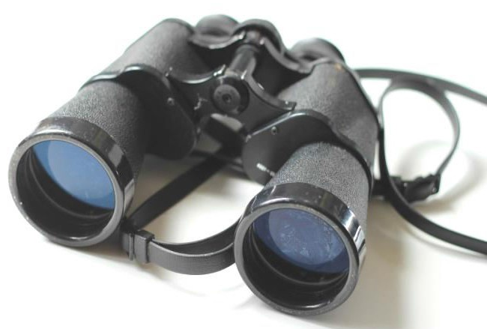
Surveillance
Look for new cases among students and staff. Be alert for illness among
exposed persons. Keep track of cases on a line list.
When a student is absent, ask parents to provide the reason for the
student’s absence in order to determine if the student is a part of the outbreak and in need of further follow-up.

Identify the Source

The school and public health should work together to determine the source of the outbreak. The outbreak source is the person or item responsible for transmission of illness to others. It can be a:

- Single sick child
- Contaminated surface or product in the school
- Contaminated water supply
- Classroom pet

Occasionally, even with thorough investigation, the source might not be identified.

Outbreak Control Measures

- Increase Frequency of Handwashing (see hand hygiene poster page?)
  - Clean hands with liquid soap and warm water. Hands should be cleaned after using the washroom, sharing objects, shaking hands and before preparing and eating food. Ensure students are given the opportunity to wash their hands before eating.
  - If hand sanitizer stations are available, ensure they are stocked.

- Exclude ill Students and Staff (see page ? for quick reference for exclusion)
  - Ill students and staff should be sent home as soon as they become ill.
  - Those with respiratory symptoms should not return until they are well enough to take part in activities.
  - Those with diarrhea or vomiting should not return until at least 24 to 48 hours after symptoms have resolved.

- Increase Frequency of Environmental Cleaning (see page ? for enhanced environmental cleaning information)
  - Ensure all commonly touched surfaces such as door knobs, stair rails, phones, desks, hand dryers, etc. are cleaned and disinfected daily.
  - Ensure washrooms are cleaned and disinfected daily and when soiled.
  - Ensure washrooms are stocked with liquid soap, paper towels and toilet paper at all times.
  - Ensure the disinfectant product used is capable of killing a wide spectrum of germs such as bleach or Accelerated Hydrogen Peroxide products especially when vomiting and diarrhea is circulating
  - Follow the manufacturer’s directions and recommended contact time for the disinfectant.

Group Activities and Toys
  - Discontinue any activity where groups of students touch a common item including play dough, sensory play materials (sand, macaroni, etc.) and water play until the number of people ill is under control. Discard any recently used play dough and food based sensory items.
  - Remove any soft toys (stuffed animals, cloth dolls) because they are difficult to clean when compared to materials/surfaces that are smooth and non-absorbent.

Declaring an Outbreak Over

Generally, an outbreak will be declared over as follows:

  - A respiratory outbreak will be declared over 8 days after symptom onset date of the last case.
  - An enteric outbreak will be declared over 48 hours after symptom resolution of the last case.
  - Till fever free for 24 hours and feeling well enough to take part in activities.
  - Consult your health care provider if you develop flu-like symptoms and you have a condition that puts you at higher risk of complications such as lung or heart diseases or a weak immune system.
  - You should also call your health care provider if your symptoms get worse, such as shortness of breath or difficulty breathing, chest pain, or signs of dehydration (such as dizziness when standing or low urine output).

MRSA

What is MRSA?
  - MRSA is a type of staphylococcus (bacterium) that is resistant to many antibiotics.

What are the symptoms?
  - MRSA can cause wound infections, pimples, boils, and sometimes blood infections and pneumonia.
  - People can carry MRSA and not show any symptoms, this is called colonization.

How is MRSA spread?
  - Touching someone’s MRSA infected skin
  - Touching surfaces that have MRSA on them, like doorknobs, light switches and keyboards
  - Sharing sports equipment
  - Sharing personal hygiene items such as bar soap, towels
  - Not having the resources to keep clean
  - Overusing antibiotics, also stopping them early, or missing doses

How can I prevent MRSA?
  - Clean your hands often.
  - Avoid activities such as contact sports that involve skin-to-skin contact until the infection is treated and healed.
  - Clean and disinfect anything that has come into contact with the drainage from an infected person’s wound. Dispose of materials and items that cannot be cleaned and disinfected.
  - Avoid sharing towels and clothing.
  - Launder linens and clothing in hot water and dry with heat.

What should I do if I have symptoms of MRSA?
  - You should see your healthcare provider. Your health care provider may:
    - Drain the infection and/or
    - Give an antibiotic and/or
    - Help reduce the amount of bacteria on the skin.

Norovirus

What is norovirus?
  - Noroviruses are a group of viruses that cause acute gastrointestinal illness
  - Noroviruses were previously known as Norwalk virus, Norwalk-like virus and Calicivirus

What are the symptoms of norovirus?
  - Symptoms often include any combination of:
    - Nausea
    - Vomiting
    - Stomach cramps
    - Diarrhea
  - In general, children experience more vomiting than adults do.
  - Severe illness and hospitalization is uncommon.

How long after infection does it take for symptoms to appear?
  - It can take 1-2 days from the time you are exposed to the virus for symptoms to develop.

How long do symptoms last?
  - Symptoms usually last 12 to 60 hours.
  - Infected people usually recover in 2 to 3 days without serious or long-term health effects.

How does Norovirus spread?
  - Noroviruses are found in the stool or vomit of infected people. People can become infected with the virus in several ways:
  - Direct contact with another person who is infected and showing symptoms (e.g., caring for an ill family member, sharing foods or eating utensils)
  - Touching surfaces or objects contaminated with Norovirus, and then placing contaminated hands to mouth.
  - Eating food prepared by an infected person who has not washed their hands.
  - Eating food that might be fecally contaminated with Norovirus before harvesting (e.g., shellfish harvested from fecally contaminated water).
  - Drinking liquids that are contaminated with Norovirus (e.g., drinking water or ice cubes coming from a contaminated water source).
  - Infected people can spread the infection from the time symptoms start and for up to two days after the symptoms (usually diarrhea) stop but people can carry the virus for up to two weeks longer.

What should I do to prevent the spread Norovirus infection?
  - Clean your hands often. Washing hands is especially important after using the washroom, changing diapers and before, during and after preparing food.
  - Carefully wash fruits and vegetables, and steam oysters before eating them.
  - DO NOT PREPARE FOOD for others if you are ill with diarrhea or vomiting for at least 48 to 72 hours after your symptoms have stopped.
  - Dispose of feces, vomit and contaminated material, such as sheets and towels carefully, with as little agitation as possible. WASH HANDS thoroughly after handling soiled items such as laundry and diapers.
  - Immediately remove and wash clothing or linens that may be contaminated with virus after an episode of illness (use hot water and soap).
  - Flush or discard any vomit or stool in the toilet and make sure the surrounding area is kept clean.
  - Clean and sanitize washrooms and surfaces such as countertops and doorknobs at least once daily or as needed using an appropriate product according to the manufacturer’s instructions or by using a bleach/water solution of 1 tsp. household bleach in 2 cups of water.

What should I do if I think I might be infected with norovirus?
- See your health care provider.

How is norovirus diagnosed?
- Diagnosis is often based on the combination of symptoms and the length of illness.
- The symptoms of norovirus infection are similar to other gastrointestinal illnesses, so laboratory testing is the only way to obtain a definitive diagnosis.

How is norovirus treated?
- No specific treatment is available.
- Fluid replacement is important to prevent dehydration. Dehydration is usually seen among the very young, the elderly and persons with weakened immune systems.

Pinworm

What is pinworm?
  - A pinworm, also known as a “threadworm”, is a small thin white worm that sometimes lives in the colon (bowel) and rectum (bottom or bum) of humans.
  - Pinworms are small but visible to the naked eye, about the length of a staple.
  - Female worms crawl out of the rectum at night and lay their eggs on the surrounding skin.
  - Pinworms are unpleasant and uncomfortable, but they do not cause disease.

What are the symptoms of pinworm infection?
  - The most common symptom is itching around the anus (opening of the bum) and vagina.
  - In severe cases, the itching can lead to difficulty sleeping, restlessness, grinding of teeth at night, loss of appetite and anxiety.
  - Many people do not have any symptoms.

Who is at risk for pinworm infection?
  - Pinworm infection occurs worldwide and affects people of all ages.
Pinworm infection occurs most commonly among:
- School-aged and preschool-aged children;
- Institutionalized people; and
- Household members and caretakers of people with pinworm infection.

How does pinworm infection spread?
  - When an infected person scratches the itchy area and gets the pinworm eggs on their fingers or under their finger nails and touches another person’s mouth.
  - When the eggs get onto objects, such as toys, toilet seats, bathtubs, clothes or bedding. By sharing these objects, other people can pick up the eggs on their hands and then put them in their mouth.
  - Pinworm eggs become infective within a few hours after falling off the skin and can survive for up to 3 weeks on clothing, bedding, or other objects.

What can I do to prevent pinworm infection?
To help prevent the spread of pinworm:
  - Wash your hands with soap and warm water after using the toilet, changing diapers and before handling food.
  - Teach children the importance of washing hands to prevent infection.
  - Decrease the number of eggs on your skin by bathing in the morning. This makes you less infective.
  - Change underclothes and bedding in the morning to prevent spreading the eggs in the environment. Eggs remain infective in the environment for 2-3 weeks. Do not shake out these items and place carefully in the washer and dryer to kill any eggs that may be there.
  - Cut fingernails frequently and try not to bite your nails.
  - In institutions, day care centres, and schools, control of pinworm can be difficult, but mass use of medication during an outbreak can be successful.

What should I do if I think I might be infected with pinworms?
  - Talk to your health care provider if you think you or a family member might have a pinworm infection.

How is pinworm diagnosed?
  - Diagnosis is usually made when adult worms are seen in the area around the bum. It is best to check the area with a flashlight 2-3 hours after the child is asleep.

  - Transparent tape can be applied to the skin around the bum to collect any eggs that may be present. The tape can then be placed in a baggie or sealed container and taken to the health care provider. The tape will be examined under a microscope for the presence of eggs. Three samples, collected first thing in the morning, for three days in a row are recommended.
  - Very few eggs are present in stool so stool samples are not recommended.

How is pinworm treated?
  - For information about treating pinworm infection, speak with your health care provider.

Head Lice

What is head lice?
  - Lice are small greyish, white or brown in color, wingless insects that live on the human scalp.
  - Lice is oval and about the size of a sesame seed.
  - They are common in classrooms and day cares, because of the close proximately.
  - Head lice are not dangerous and they do not spread disease.
  - Head lice is contagious.
  - Head lice cannot fly or jump.
  - While head lice can be found anywhere on the head, they prefer to live on the scalp along the neckline and behind the ears.
  - When lice bite the scalp, they cause itching.

What are the symptoms of head lice?
  - Children may say they have a tickling feeling on their head or may be very itchy on their scalp.
  - Lice are not easily seen and can be hard to find.
  - The only way to be sure a person has an active case of lice is to find live lice. (children usually have no more than 10-20 live lice)

Who is at risk for head lice?
  - Children are effected more than adults because of close proximity.
  - Anyone can have head lice.

How does head lice spread?
  - Having close head to head contact with another person who has head lice.
  - Sharing items used on the head or in contact with head (such as: combs, ribbons, hats, helmets, coats)

  - Head lice can spread when personal items come in close contact with another person’s personal items (coats hanging in a closet/cloakroom together)
What can I do to prevent head lice?
  - Teach children how head lice is spread and to avoid that activity.
  - It is a good idea to teach children not to share combs, brushes, hats, bandanas, etc.
  - Children may need to be checked frequently and daily during an outbreak.
  - It has been suggested that contact may be less if long hair is braided or tied back.

Procedure if lice is suspected or identified case:
  - Parents/Guardians to be notified
    - Send/share Saskatchewan Public Health information sheet
  - Child/Children to be treated immediately
  - Children with head lice should be treated and can attend school or child care as usual.
  - ‘No-nit’ policies that keep children with head lice away from school are not necessary because:
    - The presence of nits indicates a past infestation that may not be currently active;
    - Head lice are common among young children;
    - Head lice do not spread disease;
    - Cases of head lice are often misdiagnosed;
    - Children can have head lice for several weeks with no symptoms.

Conjunctivitis- Pink Eye

What is pink eye?
  - Pink Eye is inflammation of the membrane that covers the eyeball and inside of the eyelid.
  - The small blood vessels become inflamed causing the “whites” of the eyes to appear reddish/pink.
  - Pink eye is contagious.

What are the symptoms of a pink eye infection?
  - Painful red puffy eye(s)
  - Puffy eyelid(s).
  - May complain of a gritty feeling in the eye.
  - Discharge from eye; may be clear, yellow or green in color.
  - Discharge may form crust on eyelid.
  - Slight blurring of vision.

Who is at risk of a pink eye infection?
  - Contagious and spreads from person to person.
  - During the course of active infection, when drainage is present.
  - Anyone sharing towels, facecloths, tissues, make up, pillowcases, etc.
  - Note: no longer contagious 24 hours after antibiotics have been started.

What can I do to prevent a pink eye infection?
  - Infected person to seek medical.
  - Infected person to remain at home until 24 hours after antibiotic has been started.
  - Discourage rubbing of eyes.
  - Teach/encourage hand washing.
  - Disinfect any objects that may be contaminated. (toys)
  - Do not allow children to share towels, tissues, etc.
  - Observe others for signs 5 days following treatment/diagnosis.

Appendix A - Sample Outbreak Control Measures Checklist
Surveillance |  | Date Started
□ | Monitor and track cases daily using outbreak line list
□ | Provide daily updates?
Hand Hygiene |  | Date Started
□ | Students and staff should perform hand hygiene often  - after using the washroom/sharing objects/shaking hands/before preparing and eating food, etc.
□ | Distribute hand hygiene posters
□ | Ensure hand hygiene supplies are stocked  - soap, paper towels, hand sanitizer
Exclusion (Division specific) |  | Date Started
□ | Ill students and staff should be sent home as soon as soon as they become ill
□ | Those with respiratory symptoms should not return until they are well enough to take part in activities
□ | Those with diarrhea or vomiting should not return until 48 hours after symptoms have resolved
Environmental Cleaning |  | Date Started
□ | Ensure all commonly touched surfaces such as door knobs, stair rails, phones, desks, hand dryers, etc., are cleaned and disinfected daily
□ | Ensure washrooms are cleaned and disinfected daily and when soiled
□ | Ensure washrooms are stocked with liquid soap, paper towels and toilet paper at all times
□ | Ensure hand hygiene posters are posted
□ | Ensure the disinfectant product used is capable of killing a wide spectrum of germs such as bleach or Accelerated Hydrogen Peroxide products especially when vomiting and diarrhea is circulating
□ | Always follow the manufacturer’s directions/Safety Data Sheet and recommended contact time for the disinfectant
Group Activities and Toys |  | Date Started
□ | Discontinue any activity where groups of students touch a common item including play dough, sensory play materials (sand, macaroni, etc.,) and water play until the number of people ill is under control. Discard any recently used play dough and food based sensory items
□ | Remove any soft toys (stuffed animals, cloth dolls) because they are difficult to clean compared to materials/surfaces that are smooth and non-absorbent
Other |  | Date Started
□
□

References
The Saskatchewan Public Health Act, 1994

The Saskatchewan Disease Control Regulations

The Saskatchewan Employment Act
The Occupational Health and Safety Regulations, 1996

www.saskatchewan.ca/residents/health/diseases-and-conditions/west-nile-virus/about-west-nile-virus

Centers for Disease Control and Prevention

https://pubsaskdev.blob.core.windows.net/pubsask-prod/105320/105320-infection-control-manual-child-care-centres.pdf

Canadian Paediatric Society. (2008). Well Beings - A Guide to Health in Child Care, 3rd Edition. Ottawa: Canadian Paediatric Society.

Halton Region. (2015). Child Care Health Resource. Retrieved from Halton Region: www.halton.ca/common/pages/UserFile.aspx?fileId=72785 · PDF file

Heymann, D. L. (2015). Control of Communicable Diseases, 20th Edition. Washington: APHA Press.

Ontario Ministry of Health and Long Term Care. (2009). Infectious Disease Protocol. Retrieved from Ontario Ministry of Health and Long Term Care: www.health.gov.on.ca/en/pro/programs/publichealth/oph_standards/infdispro.aspx

Region of Waterloo. (2014). Guidelines for Prevention and Management of Infectious Diseases in Schools. Retrieved from Region of Waterloo: http://chd.region.waterloo.on.ca/en/healthyLivingHealthProtection/resources/IDPreventionManagement_SchoolGuidelines.pdf

Wellington, Dufferin, Guelph Public Hh. (2010). Healthy faces, healthy places: Volume 2. Retrieve

