Inspection Checklist

School Name

Date: Area Inspected:

Team:

Key:
Verification: D=documentation O=observation I=interview/informal chat with employee

General
Item/Standard/Expected Findings | Risk  Level | Verification |  |  | - Reference (e.g., standard/Act/regulations, etc.)  - Recommendation for corrective action (short and/or long term) based on that reference | Person(s) Responsible | Follow-up/ Completion Date
 |  | D | O | I
The Saskatchewan Employment Act, Part III, and The Occupational Health and Safety Regulations, 2020, are readily available for reference by all employees? |  |  | x | x
Is the OHS safety book utilized by all employees, and reviewed during staff meetings? |  |  | x | x

OH&S Bulletin Board
Item | Risk  Level | Verification |  |  | - Reference (e.g., standard/Act/regulations, etc.)  - Recommendation for corrective action (short and/or long term) based on that reference | Person(s) Responsible | Follow-up/ Completion Date
 |  | D | O | I
Does the safety bulletin board display current OHC minutes? |  |  | x
Does the safety bulletin board display information from the LRWS? (e.g., General OHS information, notices of contravention, officer’s reports, etc.) |  |  | x
Does the safety bulletin board display inspection and investigation results? |  |  | x
Does the safety bulletin board display (site specific) injury statistics? |  |  | x

Posted Items
Item | Risk  Level | Verification |  |  | - Reference (e.g., standard/Act/regulations, etc.)  - Recommendation for correction action (short and/or long term) based on that reference | Person(s) Responsible | Follow-up/ Completion Date
 |  | D | O | I
Is the corporate policy posted at the worksite? |  |  | x
Are the 3 OH&S legislated workers’ rights posted at the worksite? |  |  | x
Are the organization’s general safety rules posted at the worksite? |  |  | x
Is the Harassment Policy posted? |  |  | x

Emergency Preparedness
Item | Risk  Level | Verification |  |  | - Reference (e.g., standard/Act/regulations, etc.)  - Recommendation for correction action (short and/or long term) based on that reference | Person(s) Responsible | Follow-up/ Completion Date
 |  | D | O | I
Emergency evacuation plans clearly identify the evacuation route, location of fire extinguishers and smoke detectors? |  |  | x
Emergency numbers and building location (address) is displayed next to the phone? |  |  | x

Fire
Item | Risk  Level | Verification |  |  | - Reference (e.g., standard/Act/regulations, etc.)  - Recommendation for correction action (short and/or long term) based on that reference | Person(s) Responsible | Follow-up/ Completion Date
 |  | D | O | I
Fire extinguishers maintained and tested annually? |  |  | x | x
All fire extinguishers full and in their proper place? |  |  | x
Fire doors are clear, are in working condition and are not inappropriately propped open? |  |  | x
Location of extinguishers, alarm panels are accessible and all employees know their location? |  |  | x | x
Fire instructions are posted?  (steps to be taken) |  |  | x

First Aid
Item | Risk  Level | Verification |  |  | - Reference (e.g., standard/Act/regulations, etc.)  - Recommendation for correction action (short and/or long term) based on that reference | Person(s) Responsible | Follow-up/ Completion Date
 |  | D | O | I
Are the first aid kits clearly marked and checked monthly to ensure supplies are fully stocked? |  |  | x | x
First aid log in place and used by employees? |  |  | x | x
OH&S incident report forms are available? |  |  | x | x

Exits/Entrances
Item | Risk  Level | Verification |  |  | - Reference (e.g., standard/Act/regulations, etc.)  - Recommendation for correction action (short and/or long term) based on that reference | Person(s) Responsible | Follow-up/ Completion Date
 |  | D | O | I
Exit is highly visible and light bulbs are working? |  |  | x
Exits/Entrances are unblocked and clear at all times? |  |  | x | x
Exits/Entrances are well lit? |  |  | x
Exits/Entrances free of ice? |  |  | x | x

Grounds
Item | Risk  Level | Verification |  |  | - Reference (e.g., standard/Act/regulations, etc.)  - Recommendation for correction action (short and/or long term) based on that reference | Person(s) Responsible | Follow-up/ Completion Date
 |  | D | O | I
Outside lighting is in good working order? |  |  | x
Pathways are free from clutter and ice? |  |  | x | x
Ramps and outside stairways are in good condition? |  |  | x
Is the BBQ in good working condition? |  |  | x
Are employees are trained in the safe operation of the BBQ? |  | x |  | X

Workplace Hazardous Materials Information System (WHMIS)/Consumer Products
Item | Risk  Level | Verification |  |  | - Reference (e.g., standard/Act/regulations, etc.)  - Recommendation for correction action (short and/or long term) based on that reference | Person(s) Responsible | Follow-up/ Completion Date
 |  | D | O | I
Current Safety Data Sheets are available for hazardous products used? |  |  | x | x
All chemicals are stored and labelled in accordance with WHMIS legislation? |  |  | x
All workers have received WHMIS education? |  |  | x
All workers trained in the handling and safe use of hazardous products and consumer products? |  | x |  | x

Personal Protective Equipment (PPE)
Item | Risk  Level | Verification |  |  | - Reference (e.g., standard/Act/regulations, etc.)  - Recommendation for correction action (short and/or long term) based on that reference | Person(s) Responsible | Follow-up/ Completion Date
 |  | D | O | I
Appropriate PPE is available to all employees? |  |  | x | x
Employees know where to obtain PPE? (Goggles, gloves, masks, etc.) |  |  |  | x

Housekeeping
Item | Risk  Level | Verification |  |  | - Reference (e.g., standard/Act/regulations, etc.)  - Recommendation for correction action (short and/or long term) based on that reference | Person(s) Responsible | Follow-up/ Completion Date
 |  | D | O | I
There are no cracked window panes? |  |  | x
Are walls clean and in good repair? |  |  | x
Floors are free from breaks, loose tiles, or other tripping hazards? |  |  | x
Floors are washed in small areas and/or at uncrowded times? |  |  | x | x
Wet floor signs are used on wet or hazardous floors? |  |  | x | x
Containers for broken glass/china are available and used? |  |  |  | x

Garbage
Item | Risk  Level | Verification |  |  | - Reference (e.g., standard/Act/regulations, etc.)  - Recommendation for correction action (short and/or long term) based on that reference | Person(s) Responsible | Follow-up/ Completion Date
 |  | D | O | I
Flammables kept in and disposed of in proper bins? |  |  | x | x

Storage
Item | Risk  Level | Verification |  |  | - Reference (e.g., standard/Act/regulations, etc.)  - Recommendation for correction action (short and/or long term) based on that reference | Person(s) Responsible | Follow-up/ Completion Date
 |  | D | O | I
Storerooms are well lighted and orderly? |  |  | x
Are floors around the shelves clear? |  |  | x
Are racks and shelves secured and maintained? |  |  | x
Materials are stored so they cannot fall? |  |  | x
Storage of heavy items are kept below waist level on the lower shelves? |  |  | x
Spillable items are stored below eye level? |  |  | x
Objects that might roll are blocked? |  |  | x
Materials are stored 24” clear of sprinkler heads and light fixtures? |  |  | x

Ergonomics/Manual Handling of Objects
Item | Risk  Level | Verification |  |  | - Reference (e.g., standard/Act/regulations, etc.)  - Recommendation for correction action (short and/or long term) based on that reference | Person(s) Responsible | Follow-up/ Completion Date
 |  | D | O | I
Step ladders or step stools are available where required? |  |  | x | x
Step ladders or step stools in good condition? |  |  | x
Employees have been trained in safe lifting techniques and safe body mechanics? |  | x |  | x

Safe Student/Client Handling
Item | Risk  Level | Verification |  |  | - Reference (e.g., standard/Act/regulations, etc.)  - Recommendation for correction action (short and/or long term) based on that reference | Person(s) Responsible | Follow-up/ Completion Date
 |  | D | O | I
Employees are trained in a safe student/client handling program? |  | x |  | x
The equipment is maintained according to the manufacturer’s recommendations? |  | x | x
A preventative maintenance program that meets the manufacturer’s recommendations is in place for each piece of equipment? |  | x | x

Equipment
Item | Risk  level | Verification |  |  | - Reference (e.g., standard/Act/regulations, etc.)  - Recommendation for correction action (short and/or long term) based on that reference | Person(s) Responsible | Follow-up/ Completion Date
 |  | D | O | I
Equipment is inspected and cleaned as required (just prior to using it)? |  |  | x | x
Power is switched off, unplugged, or locked-out before being cleaned or serviced? |  |  | x | x
All furniture and chairs are in safe condition? |  |  | x | x

Electrical
Item | Risk  Level | Verification |  |  | - Reference (e.g., standard/Act/regulations, etc.)  - Recommendation for correction action (short and/or long term) based on that reference | Person(s) Responsible | Follow-up/ Completion Date
 |  | D | O | I
Electrical cords, plugs and sockets in good condition? |  |  | x
All electrical equipment is properly grounded? |  |  | x
Electrical appliances are unplugged when not in use? |  |  | x | x
Electrical cords are secured away from traffic/work areas? |  |  | x
There is minimal use of extension cords? |  |  | x
Are cords secured? |  |  | x

Lighting
Item | Risk  Level | Verification |  |  | - Reference (e.g., standard/Act/regulations, etc.)  - Recommendation for correction action (short and/or long term) based on that reference | Person(s) Responsible | Follow-up/ Completion Date
 |  | D | O | I
Is emergency lighting in place and is it adequate? |  |  | x | x
Is emergency lighting working and maintained? |  |  | x | x
All overhead lighting units are adequate and in working condition? |  |  | x | x

Environment
Item | Risk  Level | Verification |  |  | - Reference (e.g., standard/Act/regulations, etc.)  - Recommendation for correction action (short and/or long term) based on that reference | Person(s) Responsible | Follow-up/ Completion Date
 |  | D | O | I
Is there is adequate ventilation to the work area? |  |  | x | x
Temperature is adequately controlled? |  |  | x | x

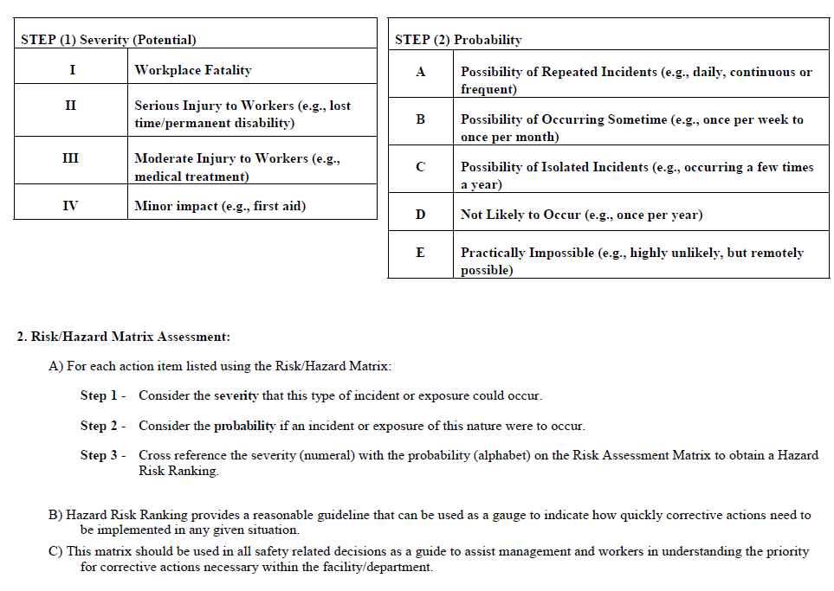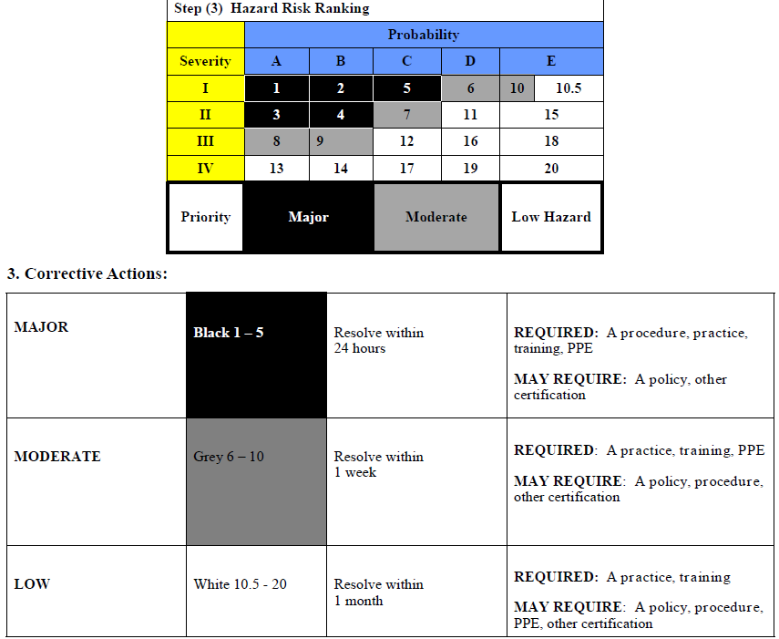

Occupational Health and Safety Regulations, 2020 (frequently used)
General Duties | Part 2 & 3
General duties of an employer | Regulation 3-1
General duties of an employer | Regulation 3-1(d)
General duties of a worker | Regulation 3-2
Supervision of a worker | Regulation 3-6
Duty to inform workers | Regulation 3-7
Training of a worker | Regulation 3-8
Occupational Health & safety program | Regulation 3-11
Maintenance and repair of equipment | Regulation 3-14
Working Alone | Regulation 3-24
Harassment | Regulation 3-25
Harassment | Regulation 3-25 (2) (b)
Violence | Regulation 3-26
Accidents causing serious bodily harm | Regulation 2-2
Dangerous occurrence | Regulation 2-3
General Health Requirements | Part 6
Sanitation | Regulation 6-1
Ventilation and air supply | Regulation 6-2
Mechanical ventilation | Regulation 6-3
Mechanical ventilation (Carbon Monoxide detectors) | Regulation 6-3(3)(b)
Lighting | Regulation 6-6
Thermal condition | Regulation 6-7
Clothing | Regulation 6-10
Change and shower facilities | Regulation 6-11
Lifting and handling loads | Regulation 6-15
Musculoskeletal injuries | Regulation 6-18
Exposure Control Plan | Regulation 6-22(3)(d)(f,”v”), Reg 7-13,
PPE | Part 7
Use of equipment | Regulation 7-1 and 7-2
Respiratory devices | Regulation 7-3 and 7-4
Eye and face protection | Regulation 7-8
Skin protection | Regulation 7-9
Lower body protection | Regulation 7-10
Foot wear | Regulation 7-11
Safeguards, Storage, Warning Signs & Signals | Part 9
Protection against Falling | Regulation 9-8
Machine Safety | Part 10
Safeguards | Regulation 10-4
Locking out | Regulation 10-6
Power Mobile Equipment | Part 11
Trained operators for power mobile equipment | Regulation 11-2 and Table 11
Visual inspection | Regulation 11-3
Inspection and maintenance | Regulation 11-4
Entrance, Exit, and Ladders | Part 16
Ladders | Regulation 16-2
Portable ladders | Regulation 16-6
Use of portable ladders | Regulation 16-7
Chemical and Biological Substances | Part 21
Eye flushing equipment | Regulation 21-12
Flammable, unstable, highly reactive and corrosive substances | Regulation 21-13
WHMIS | Part 22
Worker education and training | Regulation 22-4
Supplier label | Regulation 22-5
Workplace label for decanted products | Regulation 22-7
Availability of Safety Data Sheet | Regulation 22-13
Asbestos | Part 23
Inspection | Regulation 23-7
Asbestos processes | Regulation 23-8
Asbestos surface | Regulation 23-9
Fire and Explosion Hazard | Part 25
Fire safety plan | Regulation 25-2
Fire extinguishers | Regulation 25-3
Garbage as a fire hazard | Regulation 25-4

