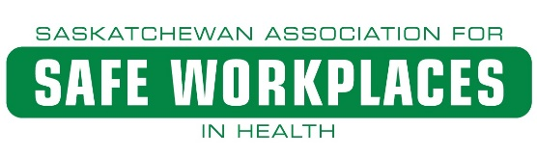

Appendix 160 – Respiratory Protection – Procedure/Information for Usage
With respirators, one size doesn’t fit all. Even with three different sizes of face pieces, for instance, no one size from one manufacturer may fit you. A different brand may be necessary. If a respirator doesn’t fit right, it can’t protect you. Even when a respirator fits properly, it may get nudged or bumped out of position while you’re working, causing leaks that can be dangerous. Respirators and cartridges must be appropriate for the hazardous substances in the air. Particulate respirators, for example, don’t work for acids, solvents, ammonia, or other gaseous mixtures.
Since filters capture particles, caution must be exercised to always check that these filters are not clogged as it makes it harder for air to pass through. Cartridges can also become "full" or saturated. It will stop working and "breakthrough" will occur – this term means that the gases or vapours will leak through the cartridge. Both cartridges and filters must be replaced on a regular basis by using the manufacturer's recommendations (usually determined by using warning properties or end-of-service indicators).
There are different classes of particulate filters, depending on the particulate material. They are also classified based on levels of oil resistance and filter efficiency. Oil can break down certain types of filters which means it is important to know the materials you are working with at all times and always select the right cartridge for your respirator.
The main categories are:
- N series (Not resistant to oil) - May be used in any atmosphere where there is no oil particulate.
- R series (Resistant to oil) - May be used in any atmosphere where there is no oil particulate, or up to one shift where there is oil particulate present. "One shift" means eight hours of continuous or intermittent use.
- P series (Oil-Proof) - May be used in any atmosphere, including those with oil particulates, for more than one shift. If the filter is used in atmospheres with oil particulates, contact the manufacturer to find out the service life of the filter.

Color Coding of Cartridges are:
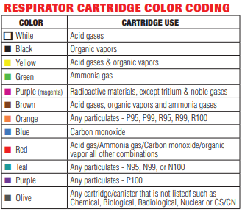
Identify controls:
You should be clean-shaven to get the best possible seal with your respirator. Facial hair can cause leakage and reduce protection. Test for fit every time you put the respirator on and throughout your shift. Two easy tests can show whether most reusable respirators fit right and don’t leak:
1. Negative-pressure seal check
2. Positive-pressure seal check.

What should I do before wearing a respirator?
- Report to your supervisor if there is any reason why you cannot wear your respirator safely (e.g., a change in medical condition, facial hair that may interfere with the seal, etc.)
- Use the respirator and filters/cartridges as assigned. They will have been selected to provide protection from the hazards that are present for that task. e.g., fit testing
- Check that the respirator is clean and in good condition before each use. Inspect for:
  - Condition of the parts (e.g., face piece, harness, valves, filters, cartridges, etc.) for cracks, tears, holes, distortion or warping
  - Tightness of the connections
  - End-of-service life indicator (if present) or shelf-life dates
- Proper functioning of any alarms or other warning systems (if present). Know how to determine if the filters have reached their end-of-service ability
- Do not wear any respirator that may be defective. Report concerns immediately to your supervisor.

How do I put on an elastomeric half-face piece respirator?
- Elastomeric face pieces are made of silicone, thermoplastic, or rubber material. One or more filters or cartridges are attached to the face piece.
- Always follow the directions provided by the manufacture and your employer. These instructions describe how to put on a reusable elastomeric half-face piece. Full face respirators would follow a similar process.
- Adjust the straps so that the respirator fits tightly, but does not dig into your face or leave red marks on your skin.
- The respirator should feel snug but comfortable. Straps should be placed under a hard hat or hood. Position the straps correctly – one strap should go above the ears and over the crown of your head, and the other below the ears and around the neck.

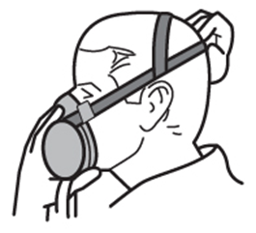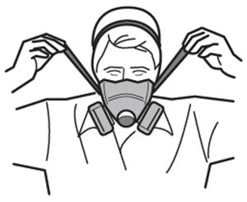

- If the respirator has adjustable straps, tighten or loosen them without removing the respirator.
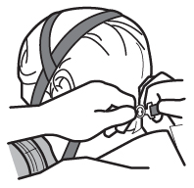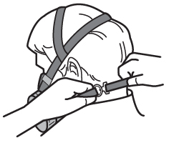

How do I put on a disposable respirator?
- Filtering face piece respirators are those respirators in which the entire face piece acts as the filter. These respirators usually cover half of your face, and are sometimes called "disposable" respirators.
- Hold the respirator in your hand with the nosepiece near your fingertips.
- Place the mask over your nose and mouth, and hold with one hand. Using your other hand, pull the top strap over your ears.
- Pull the bottom strap behind your head and below your ears. If there is a clip, clip it behind your neck.

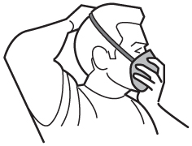

- If there is a metal nosepiece, mould it around your nose to create a proper seal.

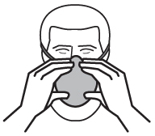

How do I perform seal checks to make sure the mask is adjusted correctly?
Each time and every time a respirator is worn, you must check that the respirator is sealing properly to the face. Not all respirators will allow the wearer to temporarily block the inlet openings or valves, but these checks should be done whenever possible. Do not wear a respirator that does not seal properly.

Negative pressure seal check: Negative-pressure checks can be done on air-purifying respirators and other respirators with a tight fitting face piece.
- Put on the respirator.
- Close or block the inlet opening(s) of the respirator so that when you inhale (breath in), no air enters the face piece.
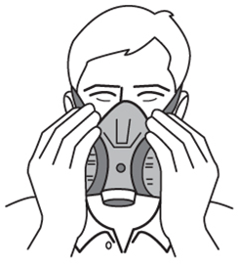
- Gently inhale, and hold your breath for at least 5 seconds.
- The face piece should collapse (“squish in”) slightly on your face.
- If the face piece remains collapsed while you hold your breath, the seal check is successful.
- If the face piece does not remain collapsed, check that nothing is obstructing (blocking) the sealing surface, adjust the face piece and harness, and repeat the user seal check.

Positive pressure seal check: Positive-pressure seal checks can be done with respirators equipped with tight-fitting face pieces that have both inhalation and exhalation valves.
- Put on the respirator.
- Close or block the exhalation valve or breathing tube, or both.
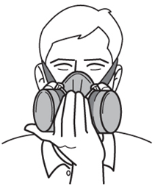
- Exhale (breath out) gently.
- The respirator should expand (“puff out”) slightly.
- If a slight positive pressure can be maintained inside the face piece without noticing any air leaking for 5 seconds, the seal check is successful.
- If a slight positive pressure does not occur, check that nothing is obstructing (blocking) the sealing surface, adjust the face piece and harness, and repeat the user seal check.

Seal checks for disposable respirators: A seal check can be done by placing both hands over the respirator itself, or by using a device provided by the manufacturer.
- Put on the respirator.
- Place both hands over the respirator. If there is a valve, block the valve with your hand.
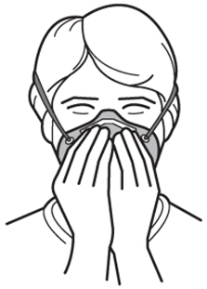
- Breathe in and out.
- If you have a good seal, the face piece should collapse slightly when you inhale.
- As you exhale, you should not feel air leaking out.
- If you have air leaks, check that nothing is obstructing (blocking) the sealing surface, adjust the noise piece or straps, and repeat the user seal check.
Again, do not wear a respirator that cannot pass the seal checks successfully.
Respirator Care and Maintenance

Respirator users shall use and care for respirators in accordance with the written instructions and training received and shall:
- Report to their supervisor or other responsible person when there is any condition that can impair their ability to safely use a respirator;
- In the case of a tight-fitting respirator, maintain their respirator seal interference free, that is, refrain from having any object or material on their person that would interfere with the seal or operation of the respirator;
- Check that the respirator is clean and in good operating condition prior to each use and at intervals that will ensure that it continues to operate effectively;
- Perform user seal checks after each donning of a tight-fitting respirator;
- Remove from service any respirator that they determine to be defective and report it to their supervisor or other responsible person; and
- Report to their supervisor or other responsible person when there is any condition or change that could impact their ability to safely use the selected respirator.

Cleaning and Disinfecting Respirators
- Remove filters, cartridges, or canisters. Disassemble face piece. Discard or repair any defective parts.
- Wash components in warm water with mild detergent or with a cleaner recommended by the manufacturer. A stiff bristle brush may be used to remove any dirt.
- Rinse components thoroughly in clean, warm, preferably running water. Drain.
- When the cleaner used to clean the respirator does not contain a disinfecting agent, respirator components should be fully immersed for 2 minutes in one of the following:
  - sodium hypochlorite solution – 1mL of bleach to 1L of water
  - aqueous solution of iodine – 0.8mL of tincture of iodine to 1L of water
  - other commercially available cleaners of equivalent disinfectant quality when used as directed, if their use is recommended or approved by the respirator manufacturer.
- Rinse components thoroughly in clean, warm, preferably running water. Drain.
- Components should be allowed to air dry or be hand dried with a clean, lint free cloth.
- Reassemble the face piece, replacing filters, cartridges, and canisters where necessary. Disinfection (steps 4 &5) is not required for a respirator used by only one worker. For multiple users, however, the respirator must be cleaned and sanitized before it is transferred to another person for use. The disinfecting solution must not damage the respirator and must not cause skin irritation to the respirator wearer. Proper rinsing of the respirator is important to ensure that this does not happen.
Inspecting Respirators (both elastomeric and disposable respirators)
- Check the condition of component parts:
  - Check condition of the face piece, looking for cracks, cuts, tears, holes and distortion of face piece.
  - Check head straps to ensure they are properly attached and have elasticity.
  - Check head straps for broken buckles and breaks and tears.
  - Check inhalation and exhalation valves to ensure that they are in place and are not damaged.
  - Check all rubber or flexible parts for cracks and pliability.
  - Check cartridges, canisters, and filters to ensure that they are not spent.
  - Check for cracks or damage to cartridge, filter, or canister.
  - Check the breathing tube (if present) for cracks, holes, missing or loose clamps, and broken or missing end connectors.
  - Check the hood, helmet or, suit (if present) for ripped or torn seams, and for cracks or breaks in the face shield.
- Check the tightness of connections between cartridges, filters and the respirator face piece.
- Check the end-of-service-life indicator (if present).
- Check the expiration date on the side of the cartridge, filter, or canister.
Always store cartridges separate from respirator.

