Transportation Sector Manual

[ENTER DIVISION NAME]

Sept, 2020

Table of Contents

Preface 5
Chapter 1A: Duties, Roles and Responsibilities of Bus Drivers 6
Job Description of Bus Driver 7
Section 1A.1: Role of Bus Drivers 9
Section 1A.2: General Duties of Bus Drivers 9
Section 1A.3: General Bus Maintenance 13
Section 1A.4: Student Conduct 13
Section 1A.5: Reporting Accidents, Incidents, Near Misses or Property Damage 15
Chapter 1B: Employment: Conditions & Compensation 18
Section 1B.1: Conditions of Employment 19
Section 1B.2: Driver Abstract Review Process 26
Section 1B.3: Bus Driver Status 27
Section 1B.4: Charters 27
Chapter 2A: Job Safety Analysis Safety Procedures Safety Memos 28
Section 2A.1: Job Safety Analysis (JSA) 29
Section 2A.2: Safety Procedures 31
Article 2A.2.1: Ergonomics & Proper Body Mechanics 32
Article 2A.2.2: Self Check Assessment 33
Article 2A.2.3: Hantavirus 34
Article 2A.2.4: WHMIS 2015/Safety Data Sheets (SDS) 37
Article 2A.2.5: Working Alone 41
Chapter 2B: Roadside Emergency & Road/Weather Conditions 44
Section 2B.1: Assessing an Emergency Situation 45
Section 2B.2: Securing and Protecting a Collision Scene 45
Section 2B.3: Bus Evacuation 46
Article 2B.3.1: Front Door Evacuation 47
Article 2B.3.2: Rear Door Evacuation 47
Article 2B.3.3: Emergency Window/Roof Hatch Evacuation 48
Section 2B.4: Fire or Danger of Fire 48
Section 2B.5: Unsafe Position 49
Section 2B.6 Mechanical Breakdown 50
Section 2B.7: Emergency Equipment 51
Section 2B.8: Procedures for Inclement Weather 52
Chapter 2C: School Bus Regulations & Safety Standards 56
Section 2C.1: School Bus Regulations 57
Article 2C.1.1: National Safety Code (NSC) Standard 13 57
Article 2C.1.2: Schedule 2 59
Article 2C.1.3: Daily School Bus Deficiency/Inspection Report 62
Section 2C.2: Safety Standards 62
Article 2C.2.1: General Safety Standards 62
Article 2C.2.2: Winter Weather Safety Standards 65
Article 2C.2.3: Highway Safety Standards 65
Chapter 3: Training, Communication, Orientation and Recruitment of Bus Drivers & First Aid/CPR 68
Section 3.1: Recruitment (reference applicable policy) 69
Section 3.2: Training 69
Chapter 4: Maintaining an Effective Bus Route 73
Section 4.1: Bus Planner Route Mapping System 74
Section 4.2: Basic Route Management 74
Section 4.3: Scheduling 76
Section 4.4: Contacts 77
Section 4.5: Fuelling the School Bus 77
Section 4.6: Message Service, if applicable (division specific) 78
Section 4.7: Arranging for a Substitute Bus Driver (division specific) 78
Section 4.8: Servicing 78
Chapter 5: APPENDICES 80
Appendix A: Quick Reference Guide 81
Appendix B: Administrative Procedures (the list is including but not limited to) 82
• Bus Service Cancellation Due to Inclement Weather 83
Appendix C: Key References 84
Appendix D: Drug and Alcohol Use 85
Chapter 6: Forms 102
Section 6.1: Transportation Sector Forms (division specific) 103
Incident Report Form 103
Transportation (Bus Driver) Performance Review Form 103
Working Alone Form 103
Student Report Form 103
Charter Statement (Field Trip Form) 103
Expense Reimbursement Form 103
Online Leave Request Form 103
Driver Claim Form 103
Daily School Bus Deficiency/Inspection Report 103
Bus Driver Summary Sheet 104
Evacuation Drill Form 104
SGI Forms 104
Chapter 7: Assigned Route Information Package 109

Preface

[Enter division name] provides transportation for students requiring access to school in accordance with Board Policy and Administrative Procedures for Student Transportation, The Education Act, 1995, and The Traffic Safety Act. Provision is also made for special use of buses to enable students to participate in educational and extracurricular activities.

This manual provides bus drivers with information they require to provide the best possible service to our students, parents/guardians and staff.

The school division transports approximately _____students daily, traveling ______ kilometres on ___ bus routes. The safety of students and staff is of highest priority.

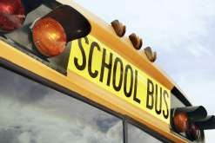

“Success and achievement for every student in every school”

Transportation Sector
[Enter division name]

1A

Chapter 1A: Duties, Roles and Responsibilities of Bus Drivers

[ENTER DIVISION NAME]

Job Description of Bus Driver

Position Profile: The bus driver is responsible for the safe, efficient and punctual transportation of students. Related responsibility includes the transportation of adults and students on approved extra-curricular and other Board approved excursions.

Directly Reports To: Transportation Foreman
Indirectly Reports To: Transportation Supervisor
Manager of Facilities & Transportation

Required Education, Knowledge, Qualifications and Experience:
- Hold and maintain a ‘Class 1 – 5’ Driver’s License with a School Bus “S” Endorsement.
- A clean driver’s abstract.
- Satisfactory results from a medical examination in accordance with Board Administrative Procedures and The Highway Traffic Act.
- Related training such as courses in first aid or defensive driving would be considered an asset.
- Previous experience in the operation of a school bus would be considered an asset.
- Knowledge of highway and school bus legislation and regulations would be considered an asset.

Required Skills and Abilities:
- Ability to work independently with minimal supervision.
- Ability to work in a team oriented, collaborative environment.
- Good communication skills required in order to interact with fellow drivers, children, parents and teachers in a respectful manner.
- Ability to work in varied climates.
- Employees must be physically fit and able to handle various tasks involving lifting, bending, twisting, turning, and climbing. Lifting up to 50 lbs. occasionally, and up to 20 lbs. frequently.
- Employees must demonstrate patience and maturity and must enjoy working with children.
- Ability to develop and maintain positive work environment.
- Ability to prioritize multiple demands and effectively manage time.
- Present a professional attitude and appearance.

Supervision of Staff:
This position does not involve the supervision of staff.

Duties and Responsibilities:
Without restricting the generality of this job description, the bus driver shall perform such duties and responsibilities as may be assigned including, but not restricted to, the following:

Student Related Duties:
- Advise students (families) of pick-up and drop-off times prior to the start of the year.
- Advise all students of bus rules at the start of the year.
- Advise substitute bus drivers of bus rules specific to the route. Substitute drivers are expected to uphold the regular driver’s rules.
- Provide supervision of students during transit and assist in supervision during boarding and unloading.
- Keep students on the bus until regular school supervision is provided.
- Manage passenger behavior by quickly and effectively solving discipline problems.
- Promptly advise the Principal and Transportation Foreman, Transportation Supervisor and Manager of Facilities & Transportation of any discipline problems on the bus or of any damage caused by a student to the bus.
- Comply with safety, traffic and bus regulations as well as Division & Transportation Admin Procedures in order to operate the bus in a safe and courteous manner.

Bus Care
- Minimum bus cleanliness requirements:
  - Sweep the floor and empty garbage cans daily.
  - Dust and wipe down the interior area of the bus as required.
  - Wash the exterior and interior of the bus as required and as weather and road conditions permit.
  - Ensure that all lights and windows are cleaned prior to the start of every run.
- During colder months, ensure the bus is plugged in for sufficient time to promote easy starting and longer engine life.
- Check and maintain all fluid levels.
- All buses must always maintain no less than ½ tank of fuel at all times.
- Report any bus malfunctions or needed repairs to the Transportation Foreman.
- Return spare buses cleaned in and out, full of fuel with fluids checked and ready for the next user.

General:
- Report all accidents immediately to the Transportation Foreman, Transportation Supervisor and Manager of Facilities & Transportation.
- Complete all applicable paperwork as required.

- Submit all required reports and documentation, including but not limited to:
  - Copy of renewed driver’s license
  - Annual SGI abstract
- Conduct oneself in a manner appropriate to an educational institution that provides services to children.
- Be willing to engage in lifelong learning with respect to professional development, training, in-service and courses of study.
- Perform other duties as may be required or assigned by the Transportation Foreman.
- Be knowledgeable about and supportive of Administrative Procedures and directives.
Judgement, Independence and Client/Peer Contact:

Confidentiality (Reference applicable policy)
At no time should a bus driver discuss in public information pertaining to anyone in the School Division. A Bus Driver is expected to respect the confidential nature of the position by avoiding discussion about any topics that are not formally communicated to the public by the administration of the school or the School Division. Breaching confidentiality is a serious violation of acceptable conduct.

Independence
A bus driver is expected to work independently and as a team member of the Transportation Sector, all Schools and the Division Office as required.

Working Jointly with Other Staff on Common Assignments or Tasks
This position can involve working jointly with other support staff, division office staff and school-based administration on a daily basis in support of the goals of the school division.

Responsibility for Quality of Assigned Work:
The employee is under supervision and is responsible for the quality of the work and is expected to seek clarification and direction on any matters of concern.

Section 1A.1: Role of Bus Drivers
1. The bus driver’s central role is to transport students safely and efficiently to and from school and school-related activities. In fulfilling this role, bus drivers shall:
- Perform duties as assigned by the Manager of Facilities & Transportation.
- Abide by directions outlined in this manual.
- Work under the direction of the Transportation Foreman.

Section 1A.2: General Duties of Bus Drivers

- Bus drivers shall:

- Be in possession of the School Bus Log supplied by the Saskatchewan Government Insurance Vehicle Standards & Inspection Agency.

- Be familiar with this manual and regulations contained within the School Bus Log.

- Follow the prescribed bus route unless you have notified the Transportation Foreman with a valid reason for not.

- Shall be courteous at all times to students, school staff, and the public. Personal neatness and cleanliness must always be kept in mind. Clothing should be in good repair. Clothing and hats with derogatory slogans (e.g., alcohol or drugs) are not permitted.

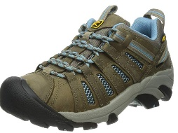
- Wear Personal Protective Equipment (PPE)

- Enclosed heel and toe footwear with flexible slip resistance soles. (See picture for approved footwear)
- Safety glasses, applicable gloves.

- Long pants/long sleeved shirts must be worn when performing the following tasks:

- Fueling and daily School Bus Deficiency/Inspection Reports

Always refer to the safety data sheet for hazardous products.

- Ensure that bus rules are posted in the school bus and enforced.

- Bus drivers shall render assistance to students entering or leaving the bus when age or other conditions make such assistance necessary or appropriate.

- Bus drivers shall not use tobacco products on school buses, school division vehicles or on any other school division property.

a. Tobacco Product Definition - is defined to include any lighted or unlighted cigarette, cigar, pipe, bidi, clove cigarette, e-cigarette, vapors, and any other smoking product, and spit tobacco, also known as smokeless, dip, chew and snuff, in any form.

- Cell phone use is prohibited while in motion. A cell phone can only be used to check voicemails or text messages that pertain to your route or to call your foreman when you are legally parked with the park brake applied.
- All use of any type of ear buds/headphones is prohibited.

“Eyes and Mind on Task”

- Daily Student Tracking- ( Division specific)

Insert example here if applicable

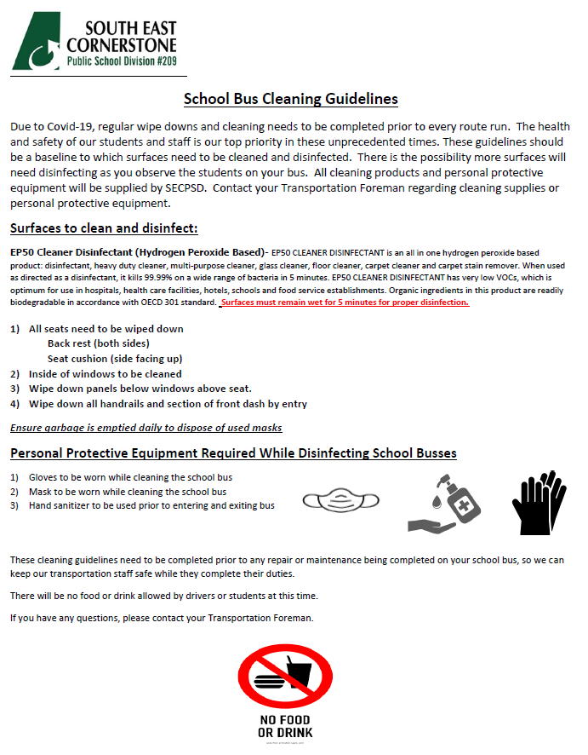
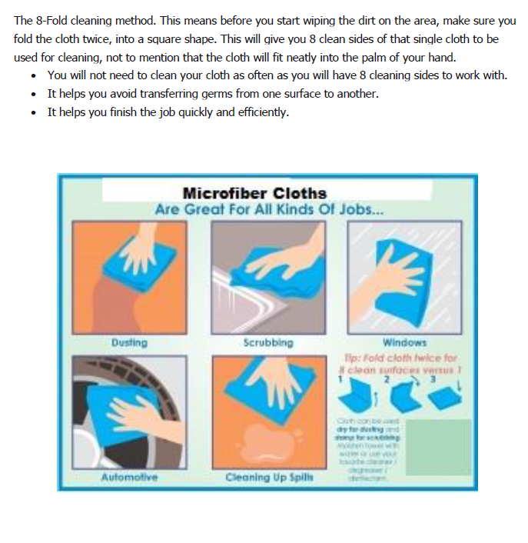

Section 1A.3: General Bus Maintenance

- Bus drivers shall, through the performance of general daily maintenance inspections, ensure that their bus is in clean and sanitary condition before transporting students.

- Before Annual Inspection/Maintenance appointments your bus must be clean including the under carriage (interior/exterior). Maximum 30 minutes wash time, if more time is needed approval from your Transportation Foreman is required.

- Bus drivers who fail to maintain a clean and sanitary bus will receive progressive discipline.

- Bus Drivers must notify Transportation Foreman if an oil change/service repair is required.

- Bus Drivers must bring their bus in on the scheduled day, unless other arrangements have been made with the Transportation Foreman.

Section 1A.4: Student Conduct

- In Charge of Discipline
Bus drivers shall follow the concept of “in-loco-parentis” (in place of the parent) and must exercise discipline in a manner that would be expected of a kind, firm and judicious parent.

- School Bus Rules
At the beginning of the school year, bus drivers shall communicate all posted rules of acceptable behaviour and personally communicate their expectations regarding student behaviour. The following general rules apply to all students traveling on a school bus:

Parental Responsibilities:
  - To inform the driver when their child or children will not require bus service.

  - To ensure their child or children are ready to board the bus at the appointed pick-up time.

  - To ensure their child or children are dressed appropriately for the weather conditions.

  - To arrange billets for their child or children in the event of severe weather, and ensure the school has this information.

  - To promote good conduct by their child or children on the bus.

Student Responsibilities:
- Show respect to the driver and to understand the driver is in charge at all times while they are on the bus.

- Abide by bus driver seating assignments.

- Observe the instructions and directions given by the driver when boarding or leaving the bus.

- No student is to attempt to board or leave the bus while it is in motion.

- Remain in their seats while the bus is in motion.

  - Be ready to board the bus at the appointed pick-up locations/times both before and after school.

  - The use of tobacco products, alcohol and non-medical drugs are prohibited on the bus.

  - Profanity is not permitted.

  - No part of the body is to protrude out of an open window on the school bus.

  - School conduct on the bus is to be consistent with the good conduct that is expected in the classroom.

  - Eating and drinking only allowed at the driver’s discretion.

- Dealing with Discipline Concerns (Division specific)
Bus drivers shall maintain discipline and use a progression of disciplinary actions when behavioural concerns arise. The following measures are provided by way of example:

  - Initially, bus drivers should discuss discipline concerns with student individually.

  - If, after discussion, student conduct does not improve, bus drivers must follow the procedures below:

- Contact the Transportation Foreman, seeking suggestions for alternative solutions.
- Fill out a Student Report Form and submit to your Transportation Foreman (form to be filled out at the time of the incident, as soon as it is safe to do so).
- Contact parents for additional support and reinforcement of required behaviours.
- Contact Principal for additional support and reinforcement of required behaviours.

- Consequences for Failing to Display Good Conduct on the School Bus
If efforts to maintain discipline do not achieve required results, bus drivers shall report their concerns to the Principal and the Transportation Foreman as follows:

  - If a student continues to misbehave, despite efforts of the bus driver to work with that student, the bus driver shall submit a written report (Student Report Form) to the Principal and Transportation Foreman. The driver can recommend to the Principal that bus service be refused to any student who misbehaves or fails to abide by the rules established for the bus.

  - The Principal has the authority to decide on the consequence(s) that is to be applied to a student for failing to abide by the rules.

  - Should a student be suspended from bus riding privileges, the Principal shall inform the following persons: (Reference applicable policy)

- The parent or guardian of the student
- The Transportation Foreman
- Transportation Supervisor
- Manager of Facilities & Transportation
- Superintendent of Schools or designate

  - Should the Principal recommend a suspension of longer than (3) days for failing to display good conduct on a school bus, the Superintendent of Schools or designate will follow a course of action in accordance with Reference (Division specific policy)

Section 1A.5: Reporting Accidents, Incidents, Near Misses or Property Damage

- Reference: (Specific Division Policy)– Injury Reporting System

- Definitions:

  - Accidents
An unwanted, unplanned event that results in a loss (production, property or human).

  - Incidents
An unwanted, unplanned event that results in or could have resulted in a loss (production, property or human).

  - Near Miss
An unwanted, unplanned event that didn’t but could have resulted in a loss (production, property or human).

- Reporting Accidents/Incidents/Near Misses or Property Damage

General Reporting:
  - Complete Incident Report Form and submit to the Foreman or designate.

  - Participate in the follow up investigation of incident, near miss, accident or property damage.

  - Obtain the name and plate number of any other person involved in the motor vehicle accident.

  - Consult the Transportation Foreman before the bus is moved from the accident scene.

  - Complete a Student Report Form, if applicable and ensure a copy is given directly to the Principal/Vice Principal by the driver and a scanned copy is sent to the Foreman from the school scanner.

  - Report any damages to the Transportation Foreman or designate. Complete and submit incident report form to the Foreman.

  - When able to do so, contact the Principal particularly if the accident, incident or student behavior results in an alteration to the regular schedule or other circumstances that might impact school operations.

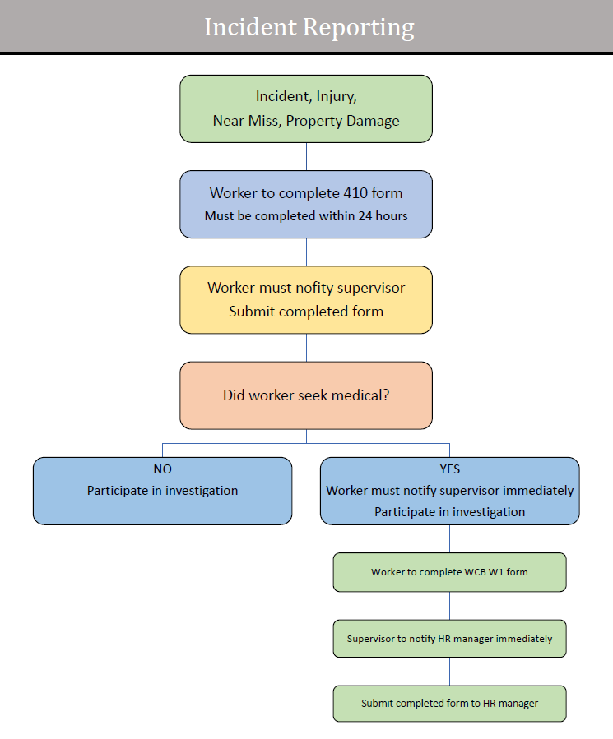

- Traffic/Criminal Code Violations
Under The Traffic Safety Act, bus drivers must report the following situations to the Manager of Facilities & Transportation or designate:

  - Any ticket violations received while driving any type of [enter division name] vehicle.
  - Any type of Criminal Code Violations received whether it be in a [enter division name] or personal vehicle must be reported to the Director of Education of the charges. Reference (Specific Division Policy)

  - Drug or alcohol related incidents.

- Fines
The following applies to situations where a traffic violation summons, or a ticket has been issued to a bus driver:

  - Bus drivers who are cited for any type of violation must pay fines with their own funds.

  - Traffic violations become part of the National Safety Code (This document is for internal use by the Transportation Sector staff only). In this document, the driving record of all employees is summarized, and demerits are assigned.

1B

Chapter 1B: Employment: Conditions & Compensation

[ENTER DIVISION NAME]

Section 1B.1: Conditions of Employment

- General Terms of Employment
Bus drivers are employed under the conditions of their applicable collective agreement.

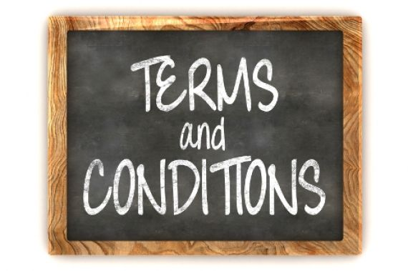
- Required Documentation
All drivers are required to produce the following documentation:

  - A valid Class 5 Driver’s License. This includes every renewal.

  - A Criminal Record Check of good standing, which includes a Vulnerable Sector Check.

  - A current driver’s abstract.

  - “S” Endorsement. Must provide SGI Driver Examination Certificate.

  - Completed WHMIS 2015 education.

- Criminal Record Check
Transportation will review the prospective bus driver’s criminal record check.
Regarding this review:

  - A positive result allows the hiring process to continue.

  - Criminal Record Checks that cite a conviction will be assessed by the Director or designate.

- Driver’s Abstract
The driver’s abstract is reviewed to see if there are any convictions showing. This process is continued each succeeding year in August (in the case of continued employment).

- Ongoing Evaluation
Bus drivers are evaluated a minimum of once every 3 years through an on-bus evaluation carried out by the Transportation Foreman.

- Complaints Regarding Bus Drivers
Complaints against bus drivers are handled as follows:

  - Complaints against bus drivers are kept on file in the Transportation Shop and/or personnel file.

  - Documents on file can become part of the permanent file of a driver.

  - Drivers will receive written notification when a letter has been put in their permanent file.

- Changing Routes
The following conditions apply to changing bus routes:

  - Bus drivers may apply for another bus route if posted on the website.

  - All routes are posted for competition.

  - It is the driver’s responsibility to review the website and keep current on driving positions across the school division.

  - Drivers may be changed from routes for efficiency purposes.

- Roles & Responsibilities

Employer

The Act, section 3-1(1)(j), defines an “employer” as:

“a person, firm, association, or body that has, in connection with the operation of a place of employment, one or more workers in the service of the person, firm, association or body.”

An employer has responsibilities under the legislation to:

- Provide and maintain a safe and healthy workplace;
- Ensure that legal health and safety requirements are met by complying with the Saskatchewan Employment Act and the Occupational Health and Safety Regulations (2020);
- Define responsibility and accountability for health and safety in the workplace;
- Inform workers of their rights and responsibilities for a safe workplace;
- Establish and maintain an effective occupational health committee (OHC) and ensure it functions effectively and efficiently;
- Consult and cooperate with the OHC and/or representative(s) and resolve concerns in a timely manner;
- Assist OHC members to obtain appropriate training that will enable them to fulfill their duties;
- Establish and maintain an effective Safety Management System;
- Ensure personal information is protected and only disclosed as allowed in legislation (e.g. The Saskatchewan Health Information Protection Act)
- Identify all hazards and risks to the workers, and establish safe work practices and procedures to eliminate, reduce or control those hazards;
- Conduct workplace inspections and correct sub-standard conditions of the workplace;
- Allocate sufficient resources (money, time, equipment, and people, including competent managers and supervisors) to implement the Safety Management System;
- Ensure managers and supervisors are trained, supported, and held accountable for fulfilling their workplace health and safety requirements;
- Provide workers with legislated health and safety information and training;
- Ensure workers are trained in all matters that are necessary to protect their health, safety and wellness;
- Ensure that all work is sufficiently and competently supervised;
- Ensure workers are not exposed to harassment;
- Ensure there is a plan to limit or prevent the exposure to violence (verbal, physical, psychological);
- Provide for the safe handling, use, storage, and transport of hazardous materials;
- Ensure personal protective equipment (PPE) is available to workers;
- Ensure incidents and occupational diseases are reported to the appropriate authority;
- Ensure medical/first aid resources are provided as necessary;
- Provide a safe means of entrance to, and exit from, the work site; and
- Inform and train volunteers regarding safety policies and procedures related to their duties so as to enable them to work and act safely.

In addition, the employer should ensure that basic human resource functions promote a safety focus (e.g., safety expectations are written into job advertisements, position descriptions and performance expectations).

Supervisor

The Act section 3-1(1)(dd) defines a “supervisor” as:

“an individual who is authorized by an employer to oversee or direct the work of the employer’s workers.”

A supervisor has responsibilities under the legislation to:

- Ensure the health and safety at work of all workers who work under their direct supervision and direction;
- Ensure that workers under their direction comply with the legislation;
- Ensure workers under their direct oversight and direction are not exposed to harassment;
- Understand and ensure his or her compliance with workplace health and safety requirements;
- Co-operate with the OHC, helping it to do its job properly, and ensure all workers support committee members in their health and safety activities;
- Ensure hazards are identified and proper measures are taken to control the risks associated with those hazards;
- Inspect work areas and correct unsafe acts and conditions;
- Instruct and coach workers to follow safe work procedures;
- Ensure that workers comply with legislation;
- Ensure only authorized, trained, and competent workers operate equipment;
- Ensure the necessary PPE is provided to workers and used properly;
- Ensure equipment is properly maintained;
- Know how to safely handle, store, and dispose of chemical and biological substances at the workplace;
- Develop and implement emergency workplace procedures;
- Ensure workers are trained in emergency workplace procedures and know what to do in the event of an emergency;
- Report and investigate all incidents and dangerous occurrences;
- Promote health and safety awareness in the workplace; and
- Co-operate with other parties in dealing with health and safety issues.

Worker

The Act, section 3-1(1)(gg), defines a “worker” as:

“an individual, including a supervisor, who is engaged in the service of an employer.”
A worker has three rights under the OH&S legislation; namely to:

Know about hazards in the workplace.
Participate in OH&S activities.
Refuse work if the work is unusually dangerous.

A worker has responsibilities under the legislation to:

- Take reasonable care to protect his or her health and safety and that of others in the workplace;
- Refrain from causing or participating in harassment;
- Co-operate with any person exercising a duty under the legislation;
- Understand and follow legislative requirements;
- Use safety equipment, machine guards, safety devices, and PPE as required by the legislation, and as required and provided by the employer;
- Report all unsafe acts and workplace hazards to his or her supervisor;
- Take initiative to resolve unsafe situations within the scope of his or her responsibility;
- Follow safe work practices and procedures;
- Report all work related incidents, dangerous occurrences, injuries, or illnesses to his or her immediate supervisor;
- Participate in OHC activities; and
- Co-operate with the OHC and others on health and safety issues.
*** Failure to comply may result in discipline and/or termination***

Contractor

The Act, section 3-1(1)(g), defines a “contractor” as:

“A person who, or a partnership or group of persons that, pursuant to one or more contracts, directs the activities of one or more employers or self-employed persons involved in work at a place of employment.”

A written agreement or contract will be developed between the (agency) and the contractor to do work for the agency. The employer must designate a site manager in charge of the operations to ensure that the contractor policy is followed and there is compliance with safety policies and procedures.

A contractor has responsibilities under the legislation to:

- Ensure a safe worksite that is without risk to the health of employers, workers, self-employed persons, patients, clients or residents at the place of employment;
- Address safety matters that he or she has control over;
- Provide the employer/self-employed person with any information which may affect the health and safety of his or her workers, patients, clients or residents;
- Post any prescribed notice in a conspicuous location in the workplace where the contractor is working; and
- Comply with legislation.

Supplier

The Act, section 3-1(1)(ee), defines a “supplier” as:

“A person who supplies, sells, offers or exposes for sale, leases, distributes or installs any biological substance, chemical substance or any plant to be used at a place of employment.”

A supplier has responsibilities under the legislation to:

- Take reasonable precautions to ensure that any biological or chemical substance or any products supplied to a workplace are safe when used according to instructions provided by the supplier;
- Provide written instructions for safe use of product(s) supplied to the employer; and
- Ensure that product(s) comply with legislation.

Volunteer

As volunteers are not technically employed in the service of an employer, the legislation does not apply to them. However, in the best interest of safety and risk management, volunteers should be expected to:

- Act safely; and
- Abide by all safety policies and procedures of the employer.
- Please see Administrative Procedure 490 – Volunteers

Reference: The Saskatchewan Employment Act
The Occupational Health and Safety Regulations, 2020

Safety Rules

We are all accountable for our actions and are expected to comply with the provisions of the [enter division name], Transportation Sector policies, procedures and code of conduct.
  - Accidents, injuries, property damage, unsafe conditions and near misses must be reported promptly to your supervisor and complete an incident report form.
  - Always be aware of your surroundings at all times.
- Bus drivers anytime you have parked your bus, walk around prior to moving.
  - Always hang on to hand rails entering and exiting bus.
  - Ensure you are wearing appropriate winter clothing for winter conditions. Be a role model.
  - Always follow WHMIS 2015 education and training, read the Safety Data Sheets.
  - Use proper body mechanics when washing, cleaning bus or checking fluids.
  - Wear enclosed toe and heal footwear with slip resistant soles.
  - Use the Personal Protective Equipment (PPE) identified for the task being performed to protect your health and safety.
  - Do not use a cell phone until safely parked at a stop, off the road way. Apply parking brake and turn on hazard lights.
  - Keep your bus clean, all lights must be visible at all times.
  - Practice proper hand hygiene (wash your hands).

Health & Safety Policy
______

STATEMENT OF COMMITMENT TO HEALTH & SAFETY

Background

In Saskatchewan the employer is required by law to promote and protect the safety of workers in the workplace. This document provides the [enter school division] public declaration of its commitment to safety.

Statement of Commitment to Health and Safety will be posted in a location visible to all employees, such as the OHC bulletin board.

Commitment

The [enter school division] is committed to providing a safe and healthy work environment for all individuals (employees, students, visitors, contractors and volunteers).

The [enter school division] recognizes the duties, rights and responsibilities of all workers and will ensure that all workers are aware of these and other conditions embodied in provincial legislation. The [enter school division] declaration does not preclude all employees’ responsibilities and accountabilities in achieving a safe work environment for all.

The [enter school division] will establish and maintain an occupational health and safety program as part of its Safety Management System to ensure the goals of this policy and the right of participation of all workers. The [enter school division] will support safe work procedures through the funding of adequate equipment, programs, training and through the establishment of standards for safe work practices.

The [school division] will adopt and preserve the following safety philosophy statements:

- The safety of workers is as important as the safety of students, visitors and contractors.
- Workers have a right to work in a safe and healthy workplace.
- Health and safety is everyone’s responsibility based on the workplace responsibility system (WRS).
- Working in a healthy and safe way is a condition of employment.
- All hazards will be identified and controlled through regular formal and information workplace inspections.
- Health and safety education and training will be consistent and ongoing.
- Health and safety meetings will be held regularly, with worker input encouraged.
- All incidents and dangerous occurrences will be reported and investigated.
- Safety applies to all employers, supervisors, workers, volunteers, students, contractors, self-employed resources and suppliers in their dealings with the [enter school division].
This policy shall be reviewed every three years by the [enter school division] as part of the safety program review and/or whenever there is a change of circumstances that may affect the health and safety of workers, or a change in OHS legislation.
References
The Saskatchewan Employment Act, Part III, Section 3-20.
The Occupational Health and Safety Regulations (2020), Section 3-11.

Section 1B.2: Driver Abstract Review Process

- Establishment of Abstract Review Committee
This committee shall be comprised of the Manager of Facilities and Transportation, Transportation Foreman, and Administrative Assistant. This committee operates as follows:

  - In August of each year, the Administrative Assistant shall prepare a summary report that includes the identification of individual abstracts to be reviewed by the committee.

  - In August of each year, the Manager of Facilities & Transportation will set a meeting date for the committee to review identified abstracts.

  - The committee will review the summary report compiled by the Administrative Assistant and any individual abstracts flagged for review.

- Outcome of Abstract Reviews
Upon evaluation of the summary report, individual abstracts, and documentation using established criteria the committee may direct the following

  - Driver evaluation;

  - Professional development and training, e.g. defensive driving course;

  - Letter of reprimand;

  - Letter of commendation;

  - Suspension;

  - Termination of employment.

Note:
The Manager of Facilities & Transportation is responsible for ensuring committee decisions are implemented.

- Appeal Process for Bus Drivers (Specific Division Policy)

  - First Step: (If applicable)

  - Second Step:

Section 1B.3: Bus Driver Status

- The following items are required for maintaining ongoing status for bus drivers:

  - “S Endorsement” is required every 5 years.

  - Any changes to the bus driver’s medical or license status shall be reported to the Transportation Foreman immediately.

  - If any bus driver, including casual drivers are on medical leave for any reason must be reported to your Transportation Foreman immediately. If you are off for over 3 consecutive school days a doctor’s note is required.

- The school division will compensate for only successful “S” Endorsement tests passed (including medicals) with receipts and a completed and signed expense form.

- Expense Reimbursement Forms

- All drivers’ claiming for reimbursement of expenses must complete the Expense Reimbursement Form.

- Common expense claim items include:
- “S” Endorsement renewal costs, written and driven. You must include a copy of your SGI Driver Examination Certificate.
- Driver’s commercial medical costs.
- Fuel costs (when credit cards are not available and previously approved by your Transportation Foreman).

Section 1B.4: Charters

- General Conditions for Charter Service - (Specific Division Policy)
(Insert steps if applicable)

- Charter Employment Process (Specific Division Policy)
(Insert steps if applicable)

- Charter Bus Driver Responsibilities (Specific Division Policy)
(Insert steps if applicable)

- Compensation for Charter Service (Specific Division Policy)
(Insert steps if applicable)

2A

Chapter 2A: Job Safety Analysis Safety Procedures Safety Memos

[ENTER DIVISION NAME]

Section 2A.1: Job Safety Analysis (JSA)

Job Safety Analysis (JSA)
Job/position/work type: Bus Diver |  |  |  |  |  | Date Completed:
Assessment Team: |  |  |  |  |  | Reviewed/revised:
Tasks  (List all tasks/activities of the job/position) | Hazards  (List all existing and potential health and safety hazards) | Severity | Probability | Risk | Controls  (List the controls for each hazard:  Elimination, Engineering, Administrative, Personal Protective Equipment) | Comments
 |  | S x P = R
Pre-Trip Inspection:  - Open / close hood  - Check fluids  - Bleeding air lines  - Walk around  - Entering bus | Slips, trips, falls  Pinch fingers  Shoulder strain  Back strain  Getting down on hands & knees |  |  |  | Wear appropriate footwear(identified in driver handbook)  Hold hand rails when entering/ exiting bus  Wear gloves  Follow bus driver ergonomic and safe body mechanics | Requires orientation to:  -Transportation Manual  - Bus driver self-assessment  - Bus driver safe body mechanics
Working alone | Potential harm, entrapment/ no assistance, medical emergency |  |  |  | Follow working alone process/communication plan
Pick up/drop off students (Route)  - Driving  - Parking at school  - Leaving school  - Placing/removing “empty” sign at back of bus  - Students on bus  - Scents | Road/weather conditions  Other drivers  Watching students, foot traffic  Distracted driving (student behavior, noise)  Reaction to scents |  |  |  | Practice defensive driving skills  Communicate rules to ride the bus  Be aware of your surroundings at all times  Proper clothing for winter weather | Transportation Manual -Student responsibilities (rules)
Fueling the bus | Spilling fuel |  |  |  | Attention to task/monitor fuel | Follow WHMIS 2015 education and training
Washing the bus | Slip, trip  Back strain  Shoulder strain |  |  |  | Wear appropriate footwear(identified in driver handbook)  Practice proper body mechanics  Wear safety glasses  Read Safety Data Sheet | Follow WHMIS 2015 education and training
Biological exposure (mouse droppings, insect bites, blood, body fluids) | Mouse droppings on bus  Blood & body fluids (vomit, blood, urine) |  |  |  | Wear PPE (gloves, masks) as identified in safe work procedure. Clean rodent droppings up following safe work procedure for Hantavirus.  Refer to Exposure Control Plan and Communicable Disease Handbook.
Rural driving | Passing/meeting farm equipment  Wildlife |  |  |  | Practice defensive driving  Aware of surroundings at all times
Handling hazardous products, chemical exposure (WHMIS 2015).  -fuelling  -checking fluids | Chemical burns, respiratory problems, infections, illness, serious condition, death. |  |  |  | WHMIS training/education and current SDS sheets for hazardous products. Wear PPE (gloves, masks) as identified in SDS/safe work procedure. | Handling hazardous products, chemical exposure (WHMIS 2015).
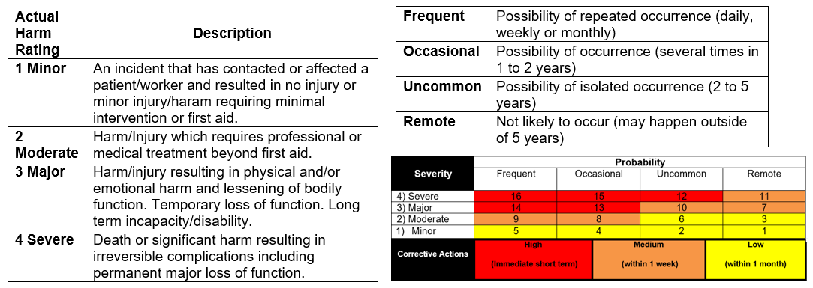
Risk Matrix

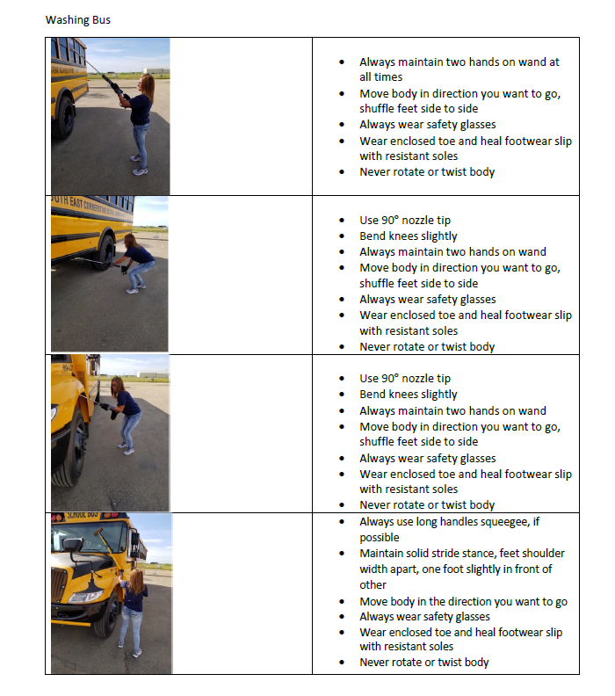
Section 2A.2: Safety Procedures

Article 2A.2.1: Ergonomics & Proper Body Mechanics

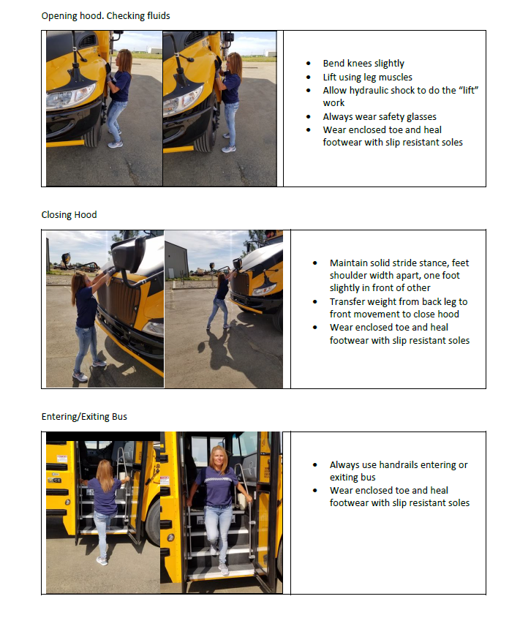

Article 2A.2.2: Self Check Assessment
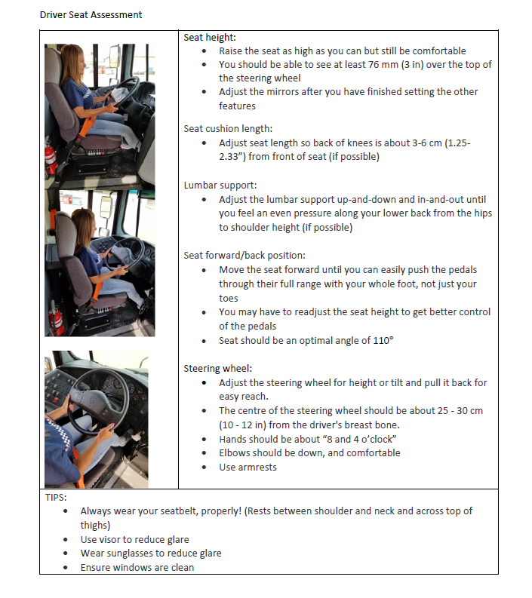

Article 2A.2.3: Hantavirus

- Hantavirus (rodent droppings)

What is Hantavirus?
Hantavirus infection is caused by a virus that is found in some field rodents, especially deer mice in Canada and the United States. The virus is rarely transmitted to people; when it is, the virus can cause severe illness-even death.
People can contract the disease when they breathe the virus that is found in the urine, saliva, or droppings of infected rodents. Hantavirus infections usually occur in rural or semirural areas where workers are more likely to contact infected rodents or their droppings. Those infected with the virus have shown flu-like symptoms that turn to dangerous, pneumonia-like condition after two or three days.

How is Hantavirus transmitted?
Hantavirus is not transmitted from person to person, only from deer mice to humans.
The virus is found in the droppings, urine, or saliva of the mouse and can spread to humans when particles of the infected saliva, urine or droppings are inhaled. Inhalation may occur through direct contact with the rodent, or from breathing airborne dust particles that are generated when rodent droppings or urine are disturbed. The virus can also be spread if an infected rodent bites you or if infected materials contact broken skin or the membrane of the eyes.
Hantaviruses do not survive for long outside of their hosts-usually less than a week indoors, and only a few hours when exposed to direct sunlight. The viruses can also be killed by most household disinfectants (e.g., 10% bleach).

What are the symptoms of Hantavirus?
Hantavirus is rarely transmitted to humans, but when it is it can cause severe illness including death. Early symptoms include fatigue, fever, and muscle aches (especially the large muscles, hips, back, thighs, shoulders). Some people will also experience, headaches, dizziness, chills, vomiting and abdominal pain. Later symptoms may include coughing and trouble breathing. If you experience any of these symptoms see your doctor as soon as possible and make sure the doctor is aware of any possible exposure you may have had to rodents or their droppings.
How can it be prevented?
There are no vaccines against Hantavirus. The only protection is to keep your home or workplace as free of deer mice as possible, and to safely clean up any mouse droppings or urine that you see. Regular inspections for rodents should be conducted to determine if active rodent control is necessary. Make sure your building is rodent proof by closing openings where rodents can gain entry. Ensure proper sanitation and elimination of food sources by storage in rodent proof containers.

General Clean-up Procedure:
- Clear all unnecessary persons from the area.
- Ventilate area, open doors and windows, if possible.
- Disinfectant solution:
  - Diluted bleach (100ml/1litre water) to be used on rodent carcasses, nesting materials, droppings, surfaces, and materials contaminated with droppings or urine; or to decontaminate rubber gloves and boots.
- Cover any broken skin that may be exposed to infection prior to beginning clean-up of rodent contamination.
- Wear disposable gloves (nitrile, latex, etc.).
- Put on protective eyewear before starting clean-up of contaminated area.
- Wear a NIOSH approved respirator with a high efficiency P-100 filter (Note: All caretaking staff has been fit tested and issued ½ mask respirators equipped with these filters). If the area is heavily infested, workers should also wear disposable coveralls, rubber boots or disposable shoe covers.

Respirator Selection:
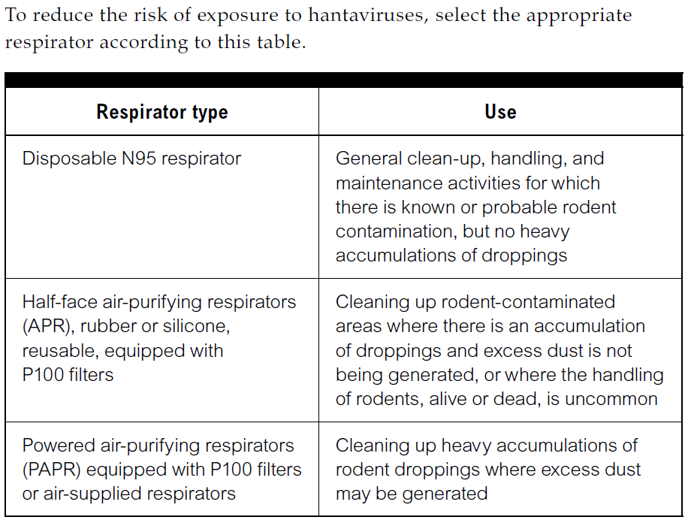

- Do not stir up dust by sweeping up or vacuuming up dry droppings, urine or nesting materials. Note: A high efficiency vacuum equipped with a HEPA filter would be acceptable in hard to reach areas.
- To kill the virus lightly wet down the droppings or dead mouse with a solution of bleach. This should be mixed fresh daily because the quality of the bleach solution deteriorates after 24 hours.
- Clean up the contaminated materials with a damp towel. Put the droppings and towels in double plastic bags, label the bag contents, seal the bag and place in the outdoor garbage bin (out of reach of children).
- Dispose of any food or liquid that mice may have come into contact with. If you encounter a dead mouse, wet the mouse down with the disinfectant solution. Wearing rubber gloves, put your hand inside a plastic bag, pick up the mouse, then turn the bag inside out so that the mouse is inside the bag and you haven’t touched it.
- Wipe or mop the surfaces and any equipment used with a solution of the disinfectant.
- Prior to removing your eye, hand and respiratory protection, remove coveralls, if applicable, (preferably outdoors) and disposable booties and place in a double plastic bag.
- Wet-wipe outer surface of the eyewear, respirator and footwear with a disposable towel.
- Rinse gloves in the disinfectant solution and place along with other disposable items in the double plastic bag.
- Wash your hands and any exposed skin areas well after the clean-up.

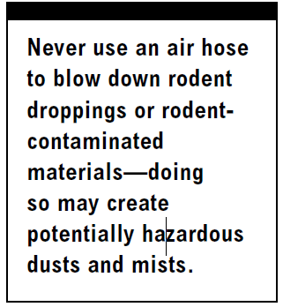

Clean carpets, clothing, upholstery or hard surfaces
Remove droppings and contaminated materials following similar procedures as above, but do not use the bleach solution. Wet the area first with hot water; remove the mouse or droppings, then shampoo (do not use bleach on carpets or upholstery). Make sure you use a commercial rug shampoo to which you have added a disinfectant. It should not stain the carpet or upholstery. For small spot cleaning, spray the area with a disinfectant solution (not bleach), and wipe the droppings as above. Use the disinfectant on hardwood floors, and the bleach solution on linoleum floors, counters and appliances. Take bedding or clothing outside and either gently roll the droppings off or pick them off with rubber gloves - do not shake them off! Then wash them as regular laundry and dry them in a dryer or hang them outside in the bright sunlight.

Article 2A.2.4: WHMIS 2015/Safety Data Sheets (SDS)

Transportation Sector WHMIS 2015 Process
Worker must have completed WHMIS 2015 Education and Training.
All hazardous products in or on the worksite must have a Safety Data Sheet (SDS).
NOTE: Consumer Products (which are materials intended for consumer use, and provided in volume, such as cleaners, adhesives, lubricants, etc.) are not subject to WHMIS 2015 requirements. However, if product is brought into the workplace a SDS must accompany the product. In many cases, SDSs are available from the product supplier.
Only Safety Data Sheets SDS are acceptable. Material Safety Data Sheets MSDS are not acceptable.
Transportation Bus Garages:
Worker purchases a hazardous product that is new to the WHMIS 2015 inventory, worker must:
- Provide SDS (this can be provided by supplier)
- SDS to be added to inventory database (internal facility drive), binder in the shop, binder in work truck, binder in buses; communicate with supervisor
- If unable to locate/acquire SDS notify shop foreman immediately

Hazardous Products used in Buses:
- No products are to be left in buses unless the product is required for the operation of the bus (ex: fuel, washer fluid, fuel additive, etc.)
  - The above mentioned products must have a SDS in the bus, SDSs are provided to bus driver to include in Transportation Manual

Hazardous Product no longer used or available or supplier change
- SDS must be removed from database, binder(s) shop, truck, buses

Supervisor:
- To support worker locating SDS, maintain index, database, binder(s)
- Any identified change in SDS information must be communicated to worker
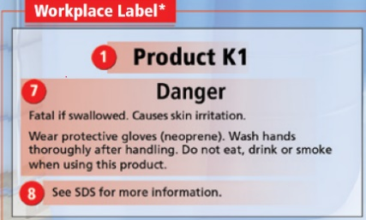
- Provide new SDS if applicable

Availability of Safety Data Sheets:
- To workers who may be exposed to the hazardous product
- To the Occupational Health Committee

Workplace Label required:
- A hazardous product is decanted into another container (ex: transferred or poured)
- A supplier label is lost or no longer illegible (unable to read)
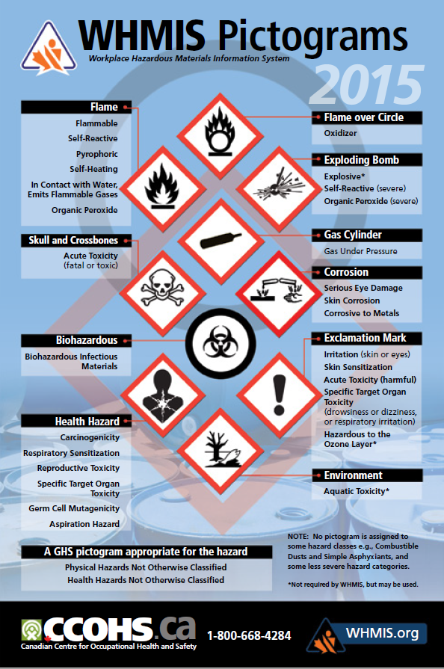
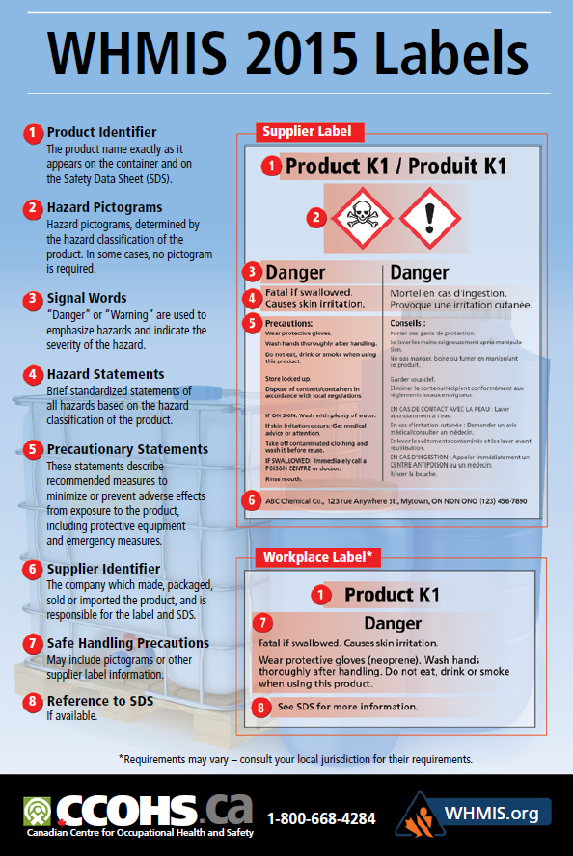
INSERT SAFETY DATA SHEETS HERE FOR BUS DRIVERS

Article 2A.2.5: Working Alone

WORKING ALONE PROCEDURE
Working Alone
This standard establishes the requirements for managing the risks associated for workers when working alone. The school division is committed to taking preventative measures to protect workers who work alone.
This standard outlines the minimum requirements that shall be met or exceeded by school division workers. Failure to comply may result in injuries, damage to equipment, environmental harm, or performance management.
Control Measures
- Where practical, working alone hazards shall be removed. Where hazards cannot be removed, controls shall be used to reduce the probability of an incident occurring.
- The steps to be taken to eliminate or reduce the risks must include the establishment of an effective two-way communication system that is documented.
- Examples of effective two-way communication systems include, but not limited to:
- Mobile Device
- Two-way radio
- Internal contact/buddy system
- Predetermined travel time and route notification

- Steps may include:
- Limitations on or prohibitions of specific activities
- Establishment of minimum training or experience, or any other standard of competency
- Provision and use of personal protective equipment
- Establishment of safe work practices or procedures
- Provision of emergency supplies for use in travelling in conditions of extreme temperatures or inclement weather conditions

- Allowable Operating Route Hours
- Regular scheduled route shall fall within 6:30 am – 6:30 pm
- Exceptions will be made as needed under the direction of your foreman
Working alone in certain circumstances, situations, or environments can increase the risk to health and safety of STATEMENT OF RESPONSIBILITIES:
Employer
- Ensures area/task specific Working Alone Procedures are developed, implemented, communicated, and enforced, in situations where workers are working alone.
- Assess tasks at hand to determine if safe while working alone.

Supervisors
- Review each worksite under his or her control to identify circumstances where individuals work alone in situations and where there is increased risk of injury or assistance that is not readily available.
- Ensure all reasonably practical steps are taken to protect the health and safety of workers.
Worker
- Must comply with the facility/school/task specific Working Alone Procedure.
- Adhere to the effective two-way communication protocol.
- Assess tasks at hand to determine if safe while working alone.

WORKING ALONE BUDDY SYSTEM PROCEDURE FOR DRIVERS:
To ensure the safety of all bus drivers as you fall under the working alone classification, (school division) Transportation Sector is implementing a buddy system ensure the safe return of each driver. Each driver is to contact their main contact for their area confirming they have arrived safely. Communication is the key to success in ensuring everyone’s safety. If you have a substitute driver covering your route you are to inform the school, parents and your main contact with the substitute drivers name, phone number, and dates of coverage. The main contact will activate emergency procedures if driver has not checked in by specific time or is alerted of an emergency.

Working Alone Form

Supervisor to document all steps taken to reduce and eliminate the identified risks:

Bus Driver: _______________________________________________

School/Area: ____________________________________________

Working Hours: ___________________________________________

Contact Number: _________________________________________

1. The communication system for the alone worker includes:
- phone or cellular communication
- maintain regular Call In/Call Out contact with:
Contact name/position: ____________________
Contact phone number: _____________________
- The Contact person will activate emergency procedures if have not heard from the individual working alone by a specific time or if alerted to an emergency.

Emergency step process:
- Wait 10 mins
- Call personal contact number (number listed above)
- Wait 10 mins
- Call personal phone number
- Wait 10 mins
- Call transportation foreman or designate
- Wait 10 mins
- Call personal contact number
- Wait 10 mins
- Call transportation foreman to inform no contact. The foreman will then do a physical check following the driver’s route to ensure the drivers safety. local emergency service request a welfare check

2. If working alone, the worker do not:
- alter route, without prior approval from foreman

3. Specific training and instructions for safe work practices when working alone include:

  - Call In/Call Out procedures (Communication plan)
  - WHMIS 2015 education and training
  - TLR Object Moving/Safe Body Mechanics
  - Fire safety and evacuation

FOREMAN CONTACTS FOR EACH AREA:
Insert specific contact information

2B

Chapter 2B: Roadside Emergency & Road/Weather Conditions

[ENTER DIVISION NAME]

Section 2B.1: Assessing an Emergency Situation

- In the event of an accident, a quick assessment must occur. Three things requiring immediate attention are:

  - Condition of the scene.
  - Types of injuries.
  - Need for medical treatment.

Report:

Situation

Location

Needs

Actions/Intentions

- If passengers are in danger, immediately direct them away from harm.

  - Note:
For more information on student evacuation procedures, see Section 2B.3: Bus Evacuation.

- Immediately after an initial assessment and ensuring that passengers are safe from harm, call the Transportation Foreman and/or Manager of Facilities & Transportation. If you have an emergency, be sure to state clearly (repeat if necessary) that you have an “EMERGENCY SITUATION” to ensure that the supervisor notifies emergency personnel.

- Shortly after the emergency situation is under control and while details are still fresh in your mind, complete and submit an Incident Report.

Section 2B.2: Securing and Protecting a Collision Scene

- First Actions
As a first action, direct passengers from further danger and monitor your personal condition.

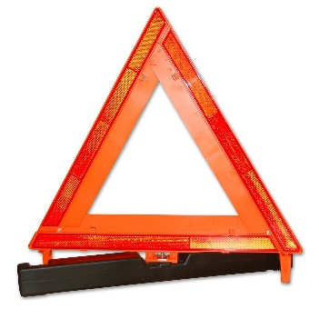
- Factors for Determining Appropriate Action
There are several factors dictating what the bus driver should do:

  - Condition of the Bus
- Is the bus operational?
- Is the bus on fire?

  - Position of the Bus
- Is the bus upright?
- Is the bus on the road, in the ditch or some other location?

  - Position of Other Vehicles
Assess the position of other vehicles, including the potential for moving vehicles entering the collision scene.

  - Dangerous Materials
Assess the scene for presence of dangerous materials such as gasoline, flammable liquids, or gases.

  - Moving the Bus
- As a general rule do not move the school bus until directed by a police officer or supervisory personnel.
- If the safety of others is at risk if you do not move the bus, then do so. In such cases, the extreme right portion of the roadway is usually the safest position.

  - Securing the Bus
Once the bus is in a safe final location, do the following:

    - Stop the bus and turn off the engine.
    - Activate the 4-way flashers.
    - Set the parking brake.
    - Reassure and/or direct passengers.
    - Set out hazard markers
(Section 2B.7 Article 2B.7.2 Flares and Reflectors)

Section 2B.3: Bus Evacuation

- Situations Requiring Evacuation
In most instances students remain on the bus during an emergency however, two situations require bus evacuation. These situations are:

  - Fire or potential for fire
  - Unsafe position

- Standard Means of Evacuation
There are several standard ways to conduct a school bus evacuation. While evacuation procedures vary depending on bus layout and the situation at hand, available means of exiting the bus may be as follows:

  - Front Entrance/Exit
  - Rear Door Exit
  - Side Emergency Door Exit
  - Emergency Window Exit
  - Roof Hatch

- Evacuation Objectives
There are three objectives for any bus evacuation. A successful evacuation is one where students:

  - Move in a safe and orderly fashion, as directed.
  - Move in the shortest possible time without compromising safety.
  - Evacuate to assigned area.

- Practicing Bus Evacuation
It is important that evacuation procedures are practiced. Bus drivers shall:

  - Communicate procedures students are expected to follow in the event of an evacuation.
  - Conduct practice drills throughout the year (October, January and April).
It is mandatory that 3 drills be conducted through the school year
  - Submit your completed Evacuation Drill form to your Transportation Foreman within 48 hours of completion. Must be scanned from a school scanner or handed directly to your Foreman.

Article 2B.3.1: Front Door Evacuation

    - The following steps should be followed when conducting a front door evacuation drill:

  - Stop the bus, set the parking brake, turn off the ignition and remove the key.
  - Stand, open the front door, face students, and get their attention.
  - Give the command, “Emergency Drill – Remain Seated – Front Door Evacuation”.
  - Choose designated students to assist guiding passengers as follows:

- Assign a student to lead students to a designated safe location at least 35 paces from the school bus.
- Assign a student to stand outside the front door to count and assist students as they leave the bus.

    - Stand between the first occupied seats and turn toward the front of the bus. From this position:

  - Beginning with the right-hand seat, tap the shoulder of the student nearest the aisle, indicating that they should leave the bus. Remind all students to walk and use hand rails.

  - Hold hands up to students in the left-hand seat to prevent them from departing at the same time.

  - Now alternate to the left-hand seat and continue this pattern moving toward the back of the bus or the last occupied seats. (see Figure 1)

  - When the last seat is empty, walk to the front of the bus while checking that all students have left the bus.

  - In the case of a drill, assess how students have done and advise accordingly.

Article 2B.3.2: Rear Door Evacuation

1. In a “Rear Door Evacuation” or drill, follow the same steps as Article 2.3.1 in reverse order.(see Figure 1)
Figure 1

Rear Door
Evacuation

Alternate Right/Left for Adjacent Seats |  | Front Door Evacuation

Article 2B.3.3: Emergency Window/Roof Hatch Evacuation

- These types of evacuations should only be attempted in actual situations where the standard front or rear doors are not available for evacuation. This type of evacuation should only be considered in actual emergency situations. This is not to be done during the practice evacuation – EMERGENCY ONLY

Section 2B.4: Fire or Danger of Fire

- Background Considerations
The following considerations must be taken into account in the event of fire or danger of fire:

  - A bus shall be stopped and evacuated immediately if the engine or any portion of the bus is on fire.
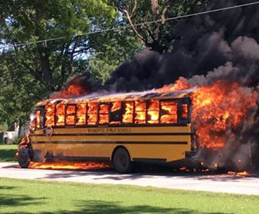
  - Passengers should move a distance of 35 metres (115 feet) or more in the safest direction from the bus and remain there until it is determined that no danger exists.

  - Where an existing fire, gasoline or other combustible material spill is in close proximity to the school bus and the bus is unable to move away from the threat, this situation should be treated as a “danger of fire” scenario and passengers should be evacuated to a safe location.

  - If you suspect there is an engine fire, DO NOT open the internal engine cover or the external engine hood.

- Steps to Follow for Fire or Danger of Fire
The following steps should be conducted in sequence:

  - Secure the bus.

  - Unload passengers using standard bus evacuation procedures.
Note:
For more information on emergency evacuation procedures, see Section 2B.3: Bus Evacuation.

  - Before leaving the bus, make a final check for any passengers left on board. If the bus is smoke filled, crawl along the floor to do this check.

  - Remove the fire extinguisher after the final check for passengers. Only if possible.

  - Direct passengers to a safe location.

  - Call for emergency help.

- Fire Fighting Tips
Consider the following fire-fighting tips:

  - Be aware that the bus may move forward if the transmission is left in forward gear. This happens when the insulation is burned off the starter solenoid and the starter engages.

  - Tire fires cannot normally be extinguished by a small fire extinguisher. Water must be used to cool the tire.

  - Be aware of exploding tires when fighting fires. Pressure build up can be tremendous when tires are exposed to extreme heat. This may cause an explosion and potential for personal injury.

Section 2B.5: Unsafe Position

- Assessing an Unsafe Position
In the event that a bus is stopped due to collision, mechanical failure, road conditions, human failure, or any other reason beyond the control of the bus driver, the driver must immediately assess whether it is safest for passengers to remain in the bus or evacuate.

- Evacuation in an Unsafe Position
The bus driver shall evacuate passengers when:

  - The final stopping point is in the path of any train or adjacent to any railroad tracks.

  - The stopping position of the bus might increase the level of danger – for example in a situation where the bus is resting on unstable ground near water or a steep incline.

  - The stopping point of the bus is such that there is danger of a collision. In normal traffic conditions, the bus should be visible for a distance of 100 metres (330 feet) or greater. (A stopped position over a hill or around a curve where such visibility does not exist, is reason for evacuation)

- Assign a student to lead students to a designated safe location at least 35 paces from the school bus.

- Assign a student to stand outside the front door to count and assist students as they leave the bus.

Section 2B.6 Mechanical Breakdown

- Background Considerations
The following considerations must be taken into account in the event of a mechanical breakdown:

  - Despite good preventative maintenance, buses may experience mechanical failure. In such situations bus drivers must know what measure to take.

  - Although the breakdown may appear relatively harmless, the lives of your passengers could be endangered in the process. Knowing how to handle an emergency situation of this nature quickly and effectively is essential.

  - Even though you cannot possibly know when a mechanical breakdown is going to occur, you can be prepared to handle the situation by knowing your route for the best pull-off positions, location of public telephones, key landmarks, and appropriate contact persons.

- Steps to Follow for Mechanical Breakdowns
The following steps should be conducted in sequence:
  - If able to do so, stop the bus as far to the right of the road as possible, or on the shoulder of the road and engage the parking brake.

  - Secure the bus and activate four-way hazard lights.

  - If the location of the bus is safe, keep children on the bus.

  - If the location of the bus is unsafe, move children to a safer location.

  - Call the Transportation Foreman, giving location of the bus, description of the breakdown, and an indication of who is on the bus. After direction from the Supervisor, call the parents if necessary.

  - Place reflectors or flares in accordance with provincial law.

Note:
For information regarding the placement of reflectors and the use of flares see Section 2B.7: Emergency Equipment.

Section 2B.7: Emergency Equipment

- Basic Safety Equipment
All school buses must be equipped with the following safety equipment items:

  - Flares or reflectors.
  - Fire extinguisher.
  - Four-way hazard flashers.
  - First-Aid kit.

Note:
If your bus does not have these items, speak with the Transportation Foreman, requesting required items.

- Flares and Reflectors
Proper use of these warning devices is critical for adequately signalling motorists. General rules of use are as follows:

  - Place one device on the roadway side of the bus, ensuring it is a safe distance from both the bus and oncoming traffic.

  - Put a second device approximately 35 metres (115 feet) behind the bus. On hills or curves, increase the distance but do not go beyond 90 metres (300 feet).

  - Put a third device the same distance as in 2(b) in front of the bus.

- Four-Way Hazard Flashers
When involved in a crash or other emergency situations, you can use the four-way flashers on your bus as a further warning device to alert motorists. Do not use your alternative flashing lights. They are only to be used when loading and unloading passengers.

- Calling in Emergency Situations
If you are in an emergency situation, keep the following points in mind:

  - If you have an emergency, when you call your Transportation Foreman be sure to state that you have an “EMERGENCY”, as this alerts and immediately increases the priority level of your call.

  - When giving a message, speak clearly and slowly, giving the Transportation Foreman time to write down your message.
  - Transportation Foreman should repeat your message to confirm the information as being correct.

  - If your emergency is of a medical nature try to provide as much information as possible. Be prepared to comment on:

- Patient condition (conscious, unconscious, etc.)
- Approximate age of patient
- Type of injury present
- Number of patients

Section 2B.8: Procedures for Inclement Weather
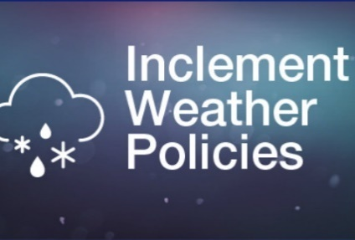
- Monitoring Inclement Weather
The school division uses The Weather Network (www.weathernetwork.com) weather towers to track weather conditions for each school.

- Cancellation of Bus Service
Cancellation of bus service proceeds as follows:

  - Principals will ensure that billet information is supplied for each of its students that live outside of the urban centre where the school is located.

  - Principals will develop procedures to contact billets and/or ensure student safety in the event of route cancellations after students are at school.

  - Factors that impact the decision for a cancellation of bus service include, but are not limited to:

- Severe cold weather temperatures of -40 Celsius ambient temperature or
-45 Celsius or greater wind chill.
- Consideration of the weather forecast for the day.
- Severely limited visibility, blizzard or “white-out conditions”.
- Unsafe or extremely adverse road conditions.
No single factor automatically requires the cancellation of routes.

Conditions reported on www.weathernetwork.com at 6:30 a.m. will be the criteria used throughout the Division.

  - When the decision to cancel routes is made, the Manager of Facilities & Transportation or designate shall:

  - Provide information on the cancellation to local radio stations and schools.
[________________________________________________]
  - Post information on the Division website and social media.

  - If a bus route is cancelled in the morning due to severe weather conditions, it will schedule to operate in the afternoon. If the route is cancelled for the afternoon, bus drivers will notify parents and school. Cancellation of afternoon routes shall occur no later than 1:00 p.m.

  - If the decision to cancel is made after students are in school, students transported to school by bus shall be required to stay at school until they are taken home or other appropriate arrangements for their care have been made.

  - Authority to cancel bus routes is delegated as described in this procedure.

  - Urban Buses Only
8.1 Urban bussing will normally occur even if rural pickups are cancelled.
8.2 The Manager of Facilities & Transportation may cancel urban only bus routes. When the Manager of Facilities & Transportation makes a decision to cancel urban routes in an urban centre, all urban routes in that urban centre are cancelled.
8.3 During severe weather conditions, children are to be accompanied to the bus stop or have very clear instructions on what to do if the bus does not arrive. Children are never to be left at the stop without an alternative arrangement in the event of an emergency.
8.4 The Manager of Facilities & Transportation’s decision to cancel urban routes will, where possible, be made in cooperation with the transportation department of other divisions in the same urban centre.
8.5 When the Manager of Facilities & Transportation makes a decision to cancel urban routes, the Manager of Facilities & Transportation or designate shall inform the affected bus drivers and schools.
8.6 Principals may arrange for additional communication with parents in the case of Urban Route Cancellation.

  - Rural Bus Routes
9.1 A driver may recommend cancelling his/her bus route according to the criteria in this procedure and guidance from the Transportation Foreman. When a driver is granted approval to cancel the driver’s bus route, the driver will, one half hour (1/2 hour) prior to first pickup, contact the parent or guardian of each child who would ordinarily ride on the bus, the Principals of school(s) affected by the cancellation and the Manager of Facilities & Transportation or designate.
9.2 The Manager of Facilities & Transportation may cancel any one route, combination of routes or all routes. The Manager of Facilities & Transportation or designate will notify affected drivers of the cancellation.

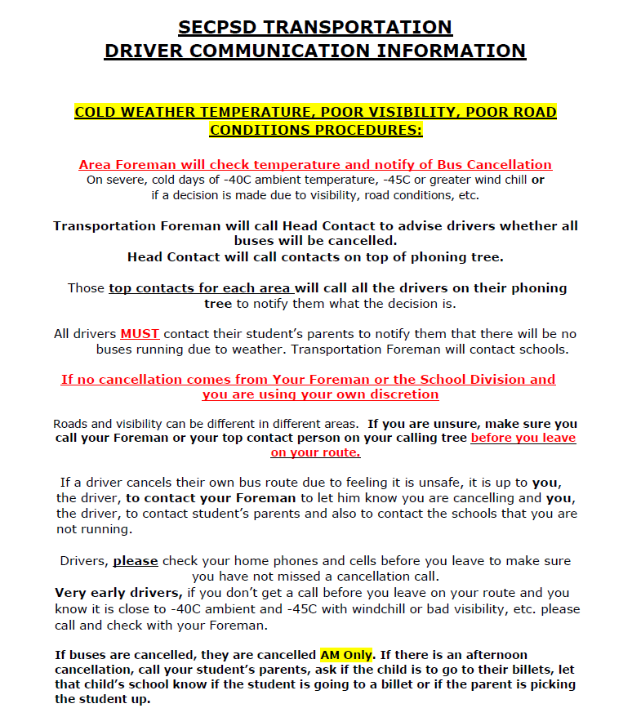

INSERT DIVISION CONTACTS HERE

2C

Chapter 2C: School Bus Regulations & Safety Standards

[ENTER DIVISION NAME]

Section 2C.1: School Bus Regulations

Article 2C.1.1: National Safety Code (NSC) Standard 13
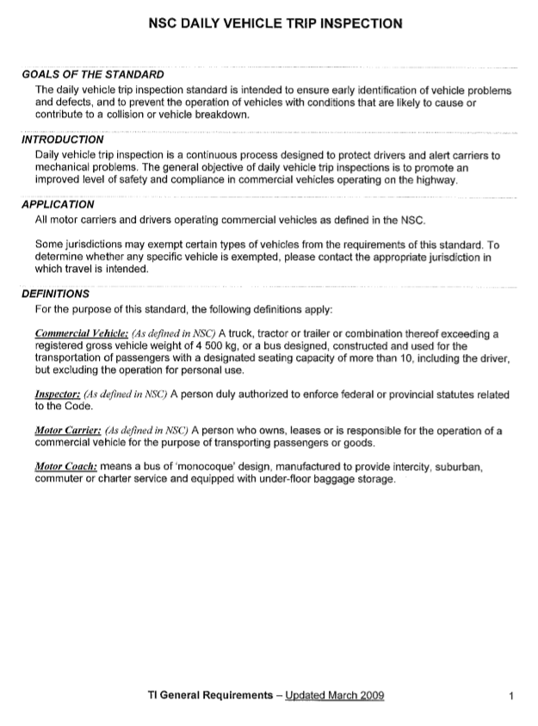

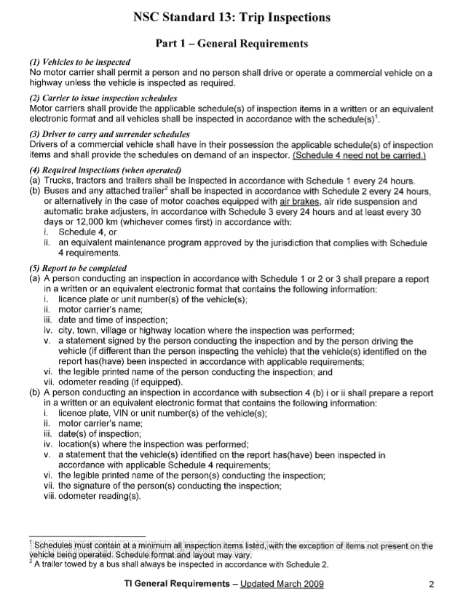
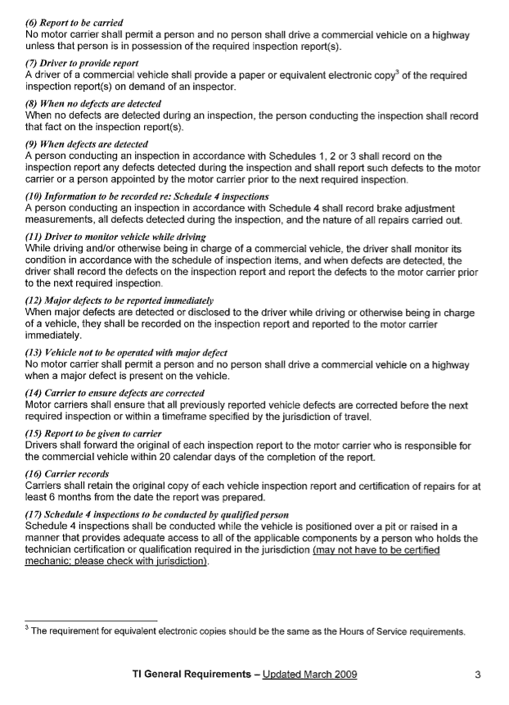

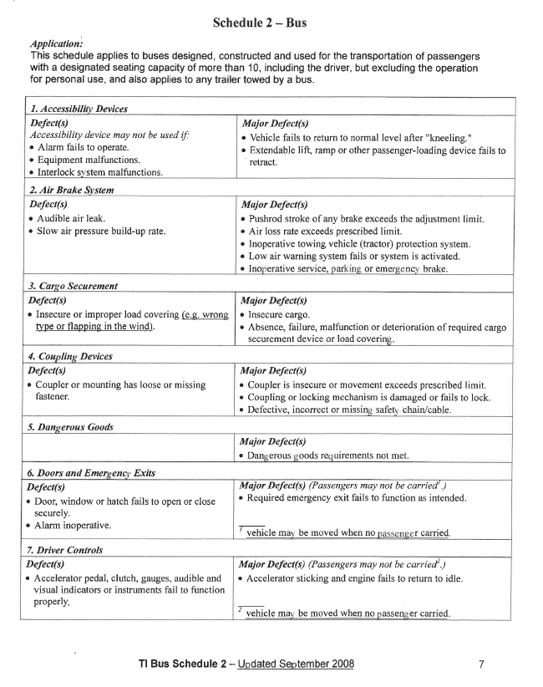
Article 2C.1.2: Schedule 2

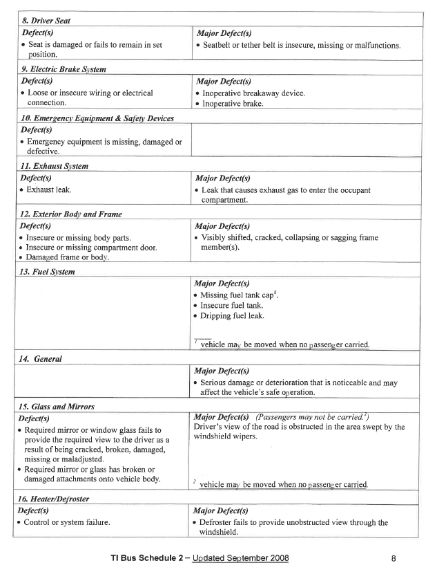

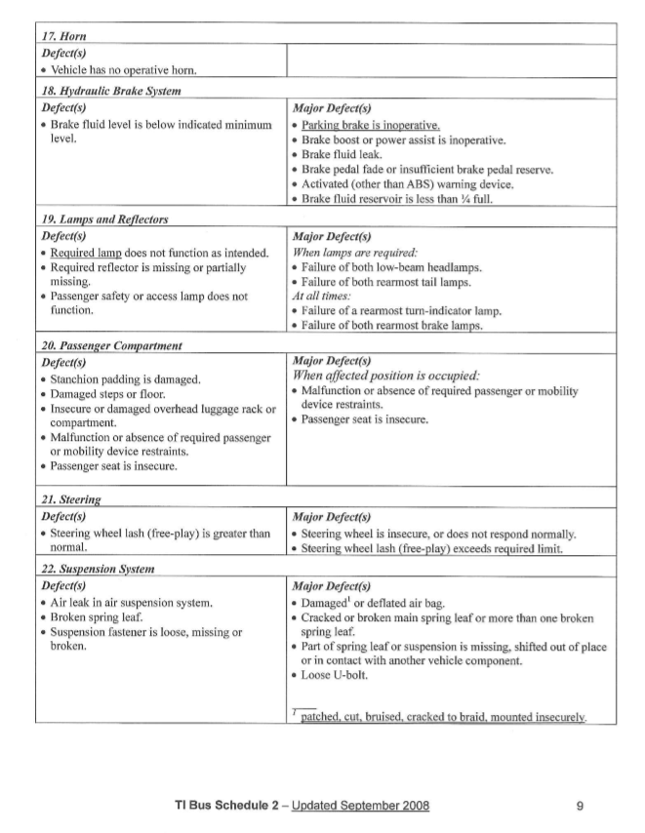

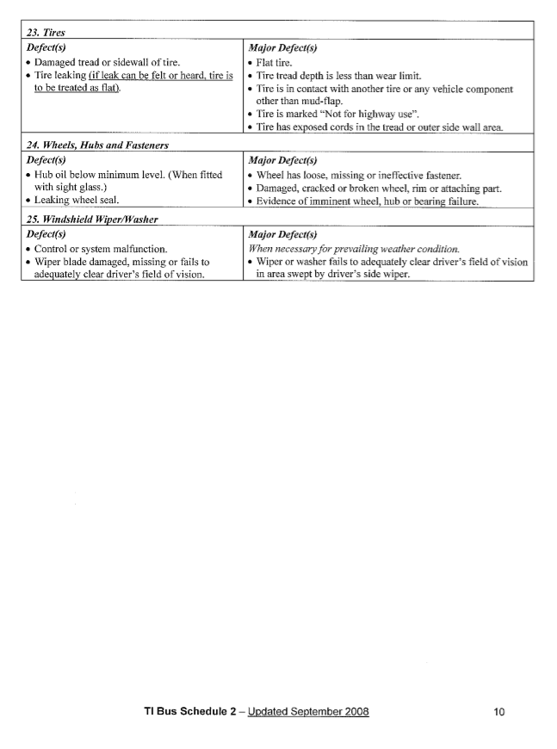

Article 2C.1.3: Daily School Bus Deficiency/Inspection Report

- Daily Deficiency/Inspection Report Process

- All drivers must follow NSC 13 (Article 2C.1) requirements for Trip Inspection (Daily School Bus Deficiency/Inspection Report).
- If defect(s) are detected driver must refer to Schedule 2 (Article 2C.2) to see if it falls under a Major or Minor defect. (If a defect is found you MUST contact your Transportation Foreman immediately before operating the bus).
- Submit after 2 full days are completed on the following report.
- Reports must be scanned and emailed from the school to your Transportation Foreman or the original handed in directly once the 2 full days are completed on the following report.
- If the report is scanned in, the driver must keep the original copy with them until your next scheduled service and hand it into your Transportation Foreman.
These are a legal document and the originals cannot be discarded or left at the school.

Section 2C.2: Safety Standards

Article 2C.2.1: General Safety Standards

- Bus drivers shall exercise extreme caution in operating their bus.

- Bus drivers shall exercise correct judgment in the use of the loading/unloading warning lights.

- Bus drivers shall cooperate with all officials in efforts to promote safety.

- Bus drivers shall ensure that any object carried onto the bus that cannot be held by the passenger is stored as close to the front barrier as is practical (such objects shall not exceed the height of the front barrier).

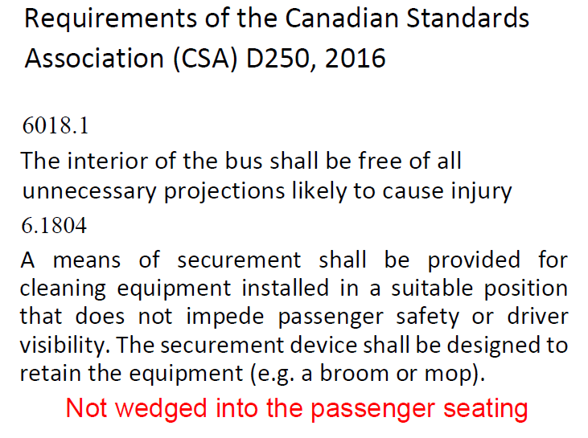
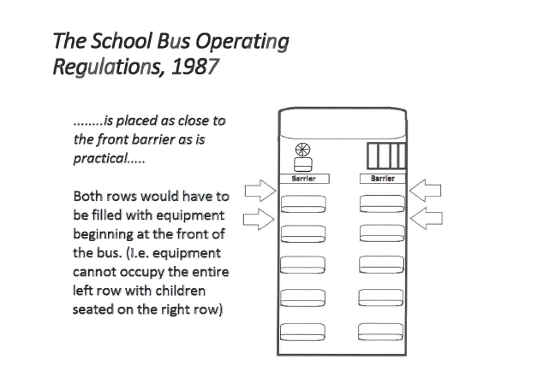
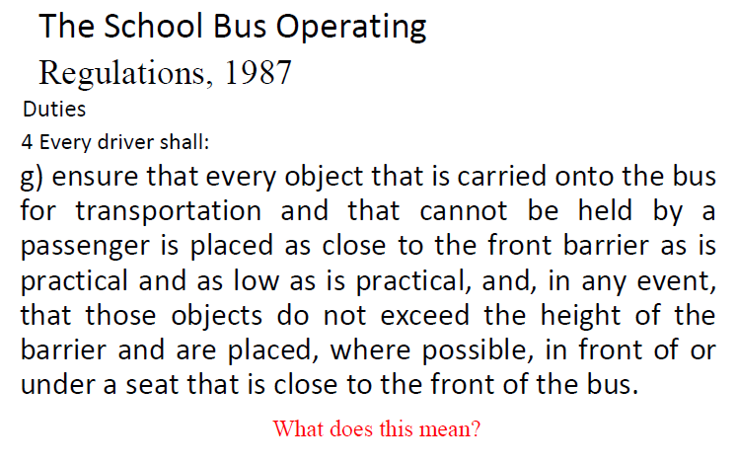
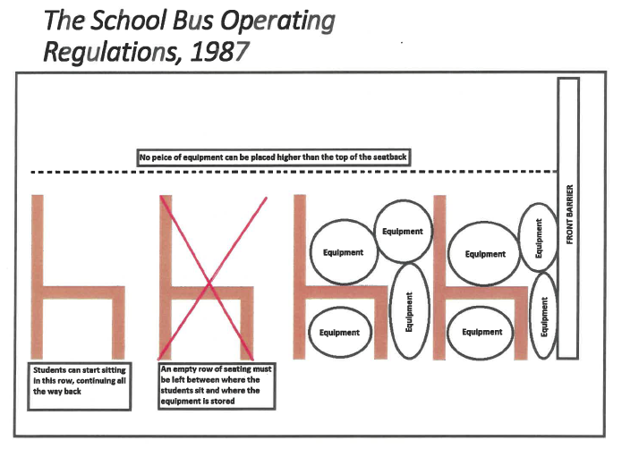

Article 2C.2.2: Winter Weather Safety Standards
- In accordance with (Reference applicable policy)

- To ensure their child or children wear warm clothing during winter months. A school bus driver shall notify the Principal and Transportation Foreman on the first occurrence where a student is inadequately clothed (Adequate clothing is defined as clothing that is capable of preventing frostbite/frozen flesh during a one kilometre walk in prevailing weather conditions or as forecasted).

- Upon such notification as indicated above, the Principal will advise the parent by phone call that the student will not be allowed on the bus when dressed inadequately unless denying access to the bus would place the student in greater danger.

- Once steps above have occurred, the bus driver should refuse to admit the student providing that in doing so, the student is not placed in greater danger.

Article 2C.2.3: Highway Safety Standards

- General Highway Safety Standards
Bus drivers shall:

  - Use directional signals when required.
  - Exercise extreme caution when passing other vehicles on the highway.
  - Operate on the established time schedule and route map without exceeding posted speed limits.
  - Report highway regulation offenders to the police.

- Safety Lights
Bus drivers shall, except where prohibited by municipal bylaw, activate safety lights as follows:

  - No less than 100 metres before stopping to load or unload passengers on a highway with a speed limit of 50 kilometres per hour, or more.

  - No less than 25 metres before stopping to load or unload passengers on a highway with a speed limit of less than 50 kilometres per hour.

- Strobe Light
Bus drivers shall, except where prohibited by municipal bylaw, activate the bus strobe light only when you have any passengers on the bus and are outside of a city, town, or village.

- Uncontrolled Railway Crossing
When approaching an uncontrolled railway crossing, bus drivers shall:

  - Move the bus as far to the right as possible.

  - Activate the hazard warning lamps not less than 100 metres before the crossing when on a highway with a speed limit greater than 50 kilometres per hour.

  - Activate the hazard warning lamps not less than 25 metres before the crossing when on a highway with a speed limit of 50 kilometres per hour or less.

  - Stop the bus not less than four (4) and not more than ten (10) metres from the railroad crossing.

  - Open the front door of the bus and look in both directions.

  - Proceed across the tracks when it is safe and, in the case of standard transmission buses, remain in first gear until the bus is completely clear of the tracks.

  - Move back into the travelled portion of the highway when it is safe and deactivate the hazard warning lamps.

- Loading and Unloading Passengers
When loading or unloading passengers, bus drivers shall:
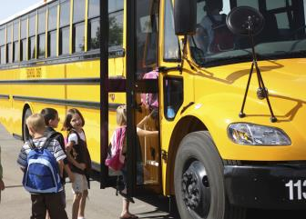
  - Exercise due caution.

  - Move the bus as far to the right as possible when on a highway.

  - Stop the bus on the side of the street nearest the school when on a street that allows traffic in both directions.

  - The emergency brake must be applied every time you are loading and unloading passengers.

- Added Conditions for Operating a School Bus
Bus drivers shall not:

a. Enter a provincial highway without:

- Stopping the bus not less than four and not more than ten (10) metres from the travelled portion of the provincial highway.
- Ensuring that it is safe to proceed.

    - Operate a bus unless the head lamps and tail lamps of the bus are activated.

    - Operate a bus unless all passengers are seated in a seat designed for the purpose of transporting passengers.

    - Activate the safety lights unless the bus is stopped or in the process of stopping for the purpose of loading or unloading passengers.

    - Activate the stop arm unless the bus is stopped for the purpose of loading or unloading passengers.

    - Consumption of alcohol or drugs is zero tolerance – (Reference applicable policy) and refer to SGI information in Appendix D

    - Transport firearms, explosives, or other dangerous commodities on a bus.

    - Back up the bus on school grounds except while under the direction of a responsible person who is positioned in such a manner to see that the bus is safely backed up.

    - Leave a bus that contains passengers unless:

- The bus has an interlock ignition system or a device that prevents the bus from being moved or operated by anyone other than the driver.
- The interlock ignition system or similar device has been activated.
- The driver has turned off the engine of the bus and removed the ignition key.
- The parking brake is engaged.

3

Chapter 3: Training, Communication, Orientation and Recruitment of Bus Drivers & First Aid/CPR

[ENTER DIVISION NAME]

Section 3.1: Recruitment (reference applicable policy)

Section 3.2: Training

- Driver Training
All applicant must receive training from the school division Transportation Foreman and/or designate. Once an applicant has been accepted into a training position, the following steps shall occur:

  - The applicant is required to make an appointment for a commercial medical (completion of this form will require a medical that must be arranged by the driver).

  - The applicant is required to provide a Criminal Record Check/Vulnerable Sector Check, Driver’s Abstract and a copy of their commercial medical to the Transportation Foreman.

  - The applicant is provided with the Saskatchewan Professional Driver’s Handbook for further study by SGI (This handbook is produced by SGI and covers a number of professional driving situations).

  - SGI will administer a written exam.

  - Road training can begin at any time, but the applicant is expected to complete the training prior to taking the road test.

  - A maximum of 6 hours in house training will be provided.

  - The Division will only reimburse the successful road test by the applicant.

  - After the driver successfully passes the road test and receives the “S” Endorsement, a copy of their driver’s licence showing the endorsement, the trainer’s evaluation and any additional related information will be placed in the bus driver’s personnel file.

  - The bus driver is provided with a copy of the [enter division name] Transportation Manual/Bus Package for further study.

  - In most cases bus drivers start out as substitutes.

- Training Expense
Upon completion of training, the bus driver shall submit original receipts for the successful completion of their medical test, written test and the road test to the Transportation Foreman within 30 days of having incurred the expense.

- First Aid

  - First Aid & CPR Training is provided; however, this is not mandatory.

  - The school division will arrange training.

- Mandatory Training

  - WHMIS 2015 – Education & Training

  - Ergonomics/Proper Body Mechanics – Annual Review

- Training Assignments
Training assignments leading to the position of “spare driver” will operate as follows:

- [enter division name] will provide a maximum of 6 hrs of training new bus drivers.

- Once initial training is complete, and a new driver has successfully attained their license, the driver shall contact all other drivers in their area to schedule a ride-along training assignment.

- The new bus driver will drive routes with regular drivers to become familiar with the route map and to meet students.

  - The driver-in-training will be paid during ride-along training as per the collective agreement. You must complete a Substitute Driver Claim form the day that you train.

  - Newly appointed spare bus drivers shall keep in contact with regular route drivers in their area to remain up to date on any route changes.

  - The area that spare bus drivers cover will vary depending on situational and individual circumstances.

  - Spare bus drivers shall call the Transportation Foreman if there are any other questions in regard to their assignment.

- Workshops/Biennial Department In-Service

a. Bus driver workshops occur annually. The following topics may be included in the workshop agenda: (listed but not limited to)

- Bus Driver Start-Up Meeting (annually late August)
- Defensive driving – as required
- Orientation
- Bus driving skills
- Emergency procedures (including First Aid) – optional
- Student management/conduct/discipline – as required
- Transportation of students with diverse and intensive needs
- Online Leaves

  - Attendance is compulsory.

  - At the meetings, bus drivers are updated on new regulations and requirements, and review existing procedures and practices that must be followed.

  - Drivers unable to attend the Annual Workshops must get written approval from the Transportation Foreman.

- Communication

The Transportation Sector will establish and maintain communication processes to ensure information regarding health and safety in the workplace is fully communicated in a timely manner (and ensures a two-way flow of information).
- Bus Drivers – Email compliance 3 times per week check in.
- Knowledge of resetting password
INSERT STEPS TO CHANGE RESET PASSWORD (Division specific)

- Orientation Checklist
The process of familiarizing an individual to a work process, workplace, work site or environment.
Transportation Orientation Checklist
Employee Name: ___________________________ | New ______ Transferred ______ Annual _______
Dept./Facility/Area: ________________________ | Date of Hire: ___________________________

Topic | Initials |  | Comments
 | Supervisor or designate | Employee
Review of Health & Safety Policy
Privacy and Confidentiality expectations (Reference applicable policy)
Dress Code – Closed toe shoe or boot, generally neat in appearance
Other forms – Leave Requests, Daily Inspections, Evacuation Drill, etc.
Mobile Devices (Reference applicable policy)
Tobacco Free Environment (Reference applicable policy)
Sick Leave or other absence call in process
Workers’ Rights:
-Right to Know
-Right to Participate
-Right to Refuse
Review of employee roles and responsibilities
What areas are restricted/prohibited
Supervisor – Name and process to communicate to their supervisor at all times
Location of the OH&S Bulletin Board – minutes, membership, names/introduction of OHC Co-Chairs
Location of the OH&S Policy & Procedure Manual
Location of The Saskatchewan Employment Act and The Occupational Health and Safety Regulations, 2020
Safe and Respectful Workplace
▪ Harassment Policy (Reference applicable policy)
▪ Violence Policy (Reference applicable policy)
WHMIS 2015 education and site specific training,
- Location of the SDS binder
Review of Job Specific Hazards and JSA for Job Position
Personal Protective Equipment (PPE)
- Location, selection, storage, disposal
Relevant safe work practices and procedures
- Hantavirus
- WHMIS 2015
- Working Alone
Incident Reporting: Review Workplace Incident Report Policy, Process and form (Reference applicable policy)
General safety rules
Review Management of Exposure to Blood & Body Fluids (Reference applicable policy)
Emergency Preparedness Plan:
- Fire Plan, Fire Drill, Fire Extinguisher
- Bus Evacuation
- Severe Weather Inclement Weather
Communication, site specific
Mandatory Training:
- Ergonomics/Proper Body Mechanics
- WHMIS 2015

Signature of completion:
Employee___________________ Manager/Supervisor_____________________
Distribution:
Original copy – HR Department – Personnel File Copy – Manager/supervisor
Copy – Employee
Note:
Manager/supervisors are to verify that the new/transferred employee is competent in department policies, procedures, practices and rules.

4

Chapter 4: Maintaining an Effective Bus Route

[ENTER DIVISION NAME]

Section 4.1: Bus Planner Route Mapping System

- Mapping System
The school division uses Bus Planner software to generate route maps.

- Establishing Annual Bus Routes
At the beginning of each year, bus drivers will receive a route map and a student list based on the student information generated into Bus Planner.

- Changes to Route Maps and Lists
- New students must register for transportation with the school, the school will submit a Student Bussing Form to Transportation Bus Requests email to be reviewed.

- Once reviewed/approved the driver will be notified by the Transportation Foreman and given updated route map and student list, driver will notify the family.

- Transportation will not be provided until the driver has been notified by the Transportation Foreman.

- Drivers will be provided with updated routes as needed.

- Schools need to complete a Student Bussing Form for all deletions to routes.

Section 4.2: Basic Route Management

- Route Revisions
The Transportation Foreman is responsible for making changes that will enhance the efficiency and effectiveness of routes. Routes are reviewed near the end of each year and bus drivers are usually consulted before routes are changed. Bus drivers are not to deviate from the established route without prior approval from your Transportation Foreman.

- New Students
All students must be registered through the school. Bus drivers are not to pick-up students without the approval of the Transportation Foreman.

- Guest Riders
On school days, the only passengers to ride on a scheduled school bus are K-12 and early entrant students who attend a school in the Division, and who ordinarily ride that bus to reach their school.

On certain occasions, up to (4) other students from the same school may ride on a bus:

- If there are sufficient seats on the bus;

- If the drop-off or pick-up point is a regularly scheduled stop;

- The guest rider follows the rules of the bus (violation of bus rules may result in denial of future requests), and

- If the school administration, in consultation with the bus driver and parents, has provided written approval in accordance with the Guest Rider Consent Form (see Appendix). Requests for approval should be submitted with as much notice as possible. School administration reserves the right to deny requests if adequate notice is not provided.

- Turn Around Policy
Yard service may be approved if the residence is:

  - At least (200) meters from the road allowance (fence line);

  - The access road is of all-weather construction; and

  - There is a clear area so the bus can exit the yard without having to reverse.

Yard service outside these guidelines maybe provided on recommendation of the driver and approval of the Manager of Facilities and Transportation.

- School Bus Driver Generated Reports
Daily School Bus Deficiency/Inspection Report are kept in each bus. They are completed daily, submitting a copy on the 15th and last driving day of the month, as you should have up to 2-days’ worth of log information in your bus at all times. These are not transferable between buses. A summary of daily log reports follows:

  - Daily School Bus Deficiency/Inspection Form
This report logs deficiencies, daily mileage and fuel.

- School Division Generated Reports
Bus planner student lists and route maps are provided to bus drivers at start-up. Any change to the route must be generated by the Transportation Foreman.

  - Route Maps
Any changes required to route maps due to construction or other road restrictions must be reported to the Transportation Foreman.

  - Student Lists
Any changes to student lists shall be submitted as directed by the Transportation Foreman. (Any deletions to student lists that you are aware of should be submitted immediately to your Transportation Foreman)
- School Calendar
Bus drivers must keep the following points in mind with regards to school-year calendars:

  - The school division calendar applies to all school division bus routes.

  - School bus driver calendars operate on the basis of the school division they serve.

- Additional Bus Driver Resources
Depending on the situation, bus drivers may have access to the following:

  - Fuel & Compound Keys
Bus compound gate keys and fuel tank keys are provided by your Transportation Foreman.

  - Fuel Cards
Each bus has a specific fuel card for that bus, if you have issues with your fuel card or you are sent to take a bus to be serviced and a different fuel card is required you will get this from your Transportation Foreman.

Section 4.3: Scheduling

1. Scheduling
School bus drivers shall:

- Set their schedule such that their bus arrives at school approximately fifteen minutes before school starts.

- Set their schedule such that their bus leaves school no sooner than five minutes after school is dismissed to allow time for students to board the bus.

- Communicate their bus route schedule to parents. (This schedule is based on normal driving conditions)

- Wait no longer than two minutes at any scheduled pick-up location except in situations where the student is in sight and approaching the bus. (Students are required to be ready to board and at the stop five minutes before their scheduled pick-up time)

- Remain at all pick-up locations until scheduled time has passed except in cases where all students have been accounted for.

- Only pick-up or drop-off students at pre-approved bus stops or in accordance with provisions for guest riders (see above).

- Contact families to advise them of any changes to pick-up or drop-off times.

Section 4.4: Contacts

1. Contacts
The following contact persons are available to assist bus drivers:

- Mechanical Problems
Transportation Foreman will assist bus drivers with mechanical problems.

[ ____________________________________________________________ ]

- Discipline
The Transportation Foreman, Transportation Supervisor and Manager of Facilities & Transportation must be notified of any student incidents that occur on the bus, a student report form must be completed within 48 hours, and the school Principal will be responsible for any disciplinary consequences related to the student conduct.

- Safety Issues
The Transportation Foreman shall be contacted where safety issues arise.

- Passenger Eligibility
The Transportation Foreman manages passenger eligibility.

Section 4.5: Fuelling the School Bus

- Fuelling

  - Each fuelling station has a different fuelling process.
  - The school division has vehicles that operate on gas and diesel.

  - Bus drivers must ensure that they have instructions for proper fuelling processes for their bus.

  - All buses must always maintain no less than ½ tank of fuel; at all times.

  - Bus drivers must record the amount of fuel and the date that the fuelling took place in the bus log and ensure that the reports are completed at the time of the fuelling operation.

  - Bus driver shall sign and put bus # on ALL receipts.

- Safety Considerations for Fuelling the School Bus

  - No student or passenger is allowed on the bus during fuelling.

  - Bus drivers must check with the Transportation Foreman or designate if requiring information on proper fuelling of the bus.

  - Must refer to Safety Data Sheet (SDS) and wear Personal Protective Equipment (PPE) as directed by SDS.

Section 4.6: Message Service, if applicable (division specific)

Section 4.7: Arranging for a Substitute Bus Driver (division specific)

Section 4.8: Servicing
- Service and Repairs
Service and repairs to buses operates as follows:

    - All buses are serviced at your designated shop.

    - All buses are to be thoroughly cleaned and sanitized before your appointment.

    - Each bus has a scheduled maintenance date that indicates when the next service is due.

    - Drivers are to make ensure they take their bus in to be serviced on their scheduled date, unless other arrangements have been previously made with your Transportation Foreman.

    - Notify Transportation Foreman of any repairs needed including oil changes. Do not leave these until scheduled maintenance date.

    - Each bus undergoes a thorough annual inspection. A spare bus will be made available during this time if required.

    - An SGI sticker is applied to the bus so the driver can track required service updates.

- Vehicle Licensing and Inspections

  - The driver is to check and verify the following:
- the current valid SGI registration paper located in the yellow SGI booklet
- the expiration date on the SGI Inspection decal
- the green copy of the SGI Inspection Certificate (located in the yellow SGI booklet) matches the decal number on the inspection decal
- complete the Daily School Bus Deficiency/Inspection Report

  - Any deficiencies must be immediately reported to your transportation foreman.

Bus Driver Online Leave Entry (division specific)
Insert sample here

5

Chapter 5: APPENDICES

[ENTER DIVISION NAME]

Appendix A: Quick Reference Guide

Phone Contacts
- Transportation Foreman:
- Transportation Supervisor:
- Manager of Facilities & Transportation:
- Transportation Administrative Assistant:
- Payroll:

Daily Routines
- Complete Daily School Bus Deficiency/Inspection Report (circle check).
- Check safety inspection decal when it is due for re-inspection (circle check).
- Inspect bus for cleanliness.
- Ensure fuel tank is above ½ tank.

Bi-Monthly/Monthly Routines
- Submit a copy of your Daily School Bus Deficiency/Inspection Report on the 15th and last driving day of the month, as you should have up to 2-days’ worth of log information in your bus at all times. These are not transferable between buses.
- Submit monthly gas receipts at the end of each month.

Annual Routines
- Attend the annual Bus Driver Start-Up Workshop.
- Establish and post school bus rules at the beginning of the school year before the first route.
- Submit a current validated copy of your driver’s license to your Transportation Foreman to submit to the Transportation Office when you renew your licence.

Ongoing Routines
- Have your bus serviced on the day you are booked for your scheduled maintenance.
- Ensure that you have completed any Leave Requests and submitted to your Transportation Foreman for prior approval for any days you are needing to request off.

Appendix B: Administrative Procedures (the list is including but not limited to)

Introduction
Administrative Procedures refer to the role of the Transportation staff in several places. The titles below provide a brief description of these administrative procedures.

Titles (Division specific if applicable)

- Responsible use of Technology and the Internet
-outlines the proper use of technology and internet use in the division.

- Exposure Control Plan (Blood, Body Fluids)
-outlines safe work practices when contact with blood or body fluids

- Tobacco Free Environment
-outlines the use of tobacco products.

- Video Surveillance
-outlines protocols and procedures for using electronic surveillance on school premises.

- Confidentiality
-outlines protection of personal information of staff and students.

- Social Media Guidelines
-outlines the acceptable use of Social Media

- Student Welfare
-outlines the safety and well-being of children is a responsibility shared by every member of the community. As all citizens have a duty to report child abuse in accordance with provincial legislation, all employees of the Division have a duty to report suspected child abuse to an appropriate authority.

- Student Discipline
-outlines protocols and procedures for ensuring positive learning environment.

- Damage to Property by Students
-outlines protocols and procedures for a student who willfully or unknowingly destroys or damages school property will be held financially responsible for their actions.

- Service Dogs in Schools
-outlines the guidelines and recognizes the diverse/intensive needs of some students may require unique accommodations.

- Reporting of Criminal Charges
-outlines responsibilities for any employee charged with a criminal offense.

- Harassment
-outlines ensuring work environment is free of harassment.
- Harassment Complaint Form

- Violence
-outlines the employer is committed to minimize or eliminate the risk of violence in the workplace.

- Injury/Incident Reporting
-outlines the procedures and responsibilities of reporting an injury/incident.

- Employee Use of Drugs and Alcohol
-outlines drug and alcohol use.

- Mobile Devices
-outlines division mobile communication devices.

- Hazard Identification and Control- Workplace Hazardous Materials Information System WHMIS 2015
-outlines the practices and procedures for the safe use, storage, handling and disposal of hazardous products.

- Buildings and Grounds Security
-outlines the procedures for division buildings and grounds security.

- Use of Division Vehicles
-outlines the proper use of vehicles owned by the [enter division name].

Bus Service Cancellation Due to Inclement Weather
-outlines roles and responsibilities related to bus service cancellation in the event of inclement weather.

- Student Conduct on School Buses
-outlines expectations for student conduct on school buses.

Appendix C: Key References

The following key reference documents provide statutory, policy, or procedure related information regarding school bus transportation in the school division.
- The Education Act, 1995,

  - Sec. 85(1)(k); Duties of the Board
  - Sec. 85(cc)(iii); Duties of the Board
  - Sec. 87(2)(z); Powers of the Board
  - Sec. 149(3);(4); Right to Attend at Cost to the Division
  - Sec. 178(15); Pupils with Intensive Needs
  - Sec. 194; Transportation to Certain Pupils
  - Sec. 196; Administration and Supervision of Transportation
  - Sec. 197; Reports Respecting Student Transportation
o Sec. 354; Acquisition of Vehicles or Transportation Services
o Sec. 356; Specification of Vehicles
  - Sec. 370; Regulations

- The Traffic Safety Act

  - Division IV: Safety Lights and School Buses
  - Part XX: Regulations, Sec. 287(1)(ii)

- The Saskatchewan Employment Act

- The Occupational Health and Safety Regulations, 2020

Appendix D: Drug and Alcohol Use

The following documents provide SGI guideline information regarding impaired driving laws for drug and alcohol use.
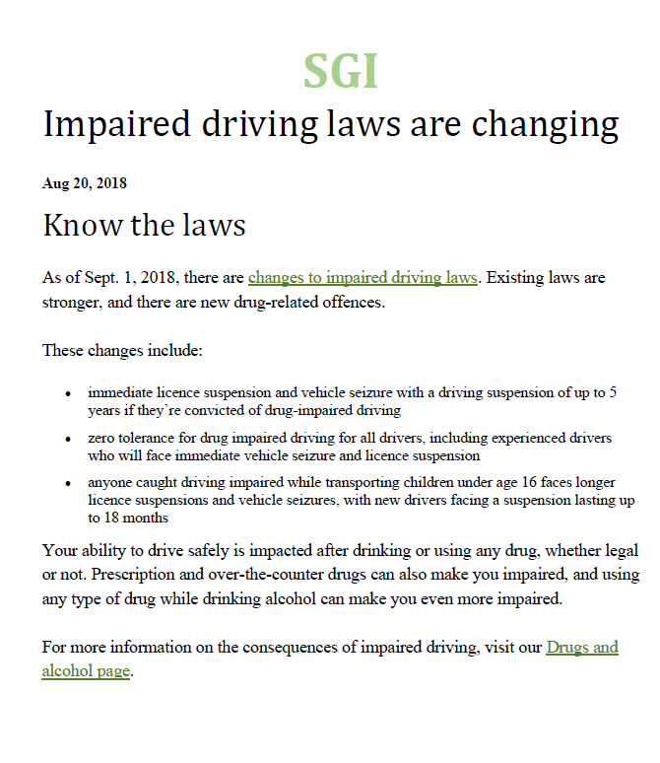
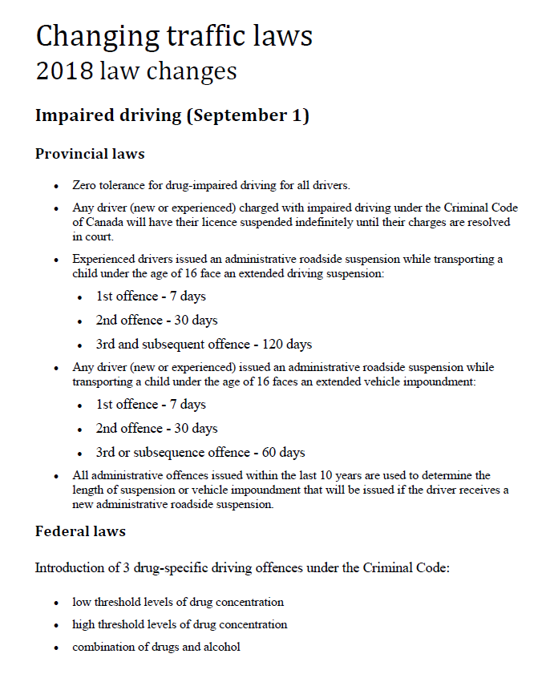
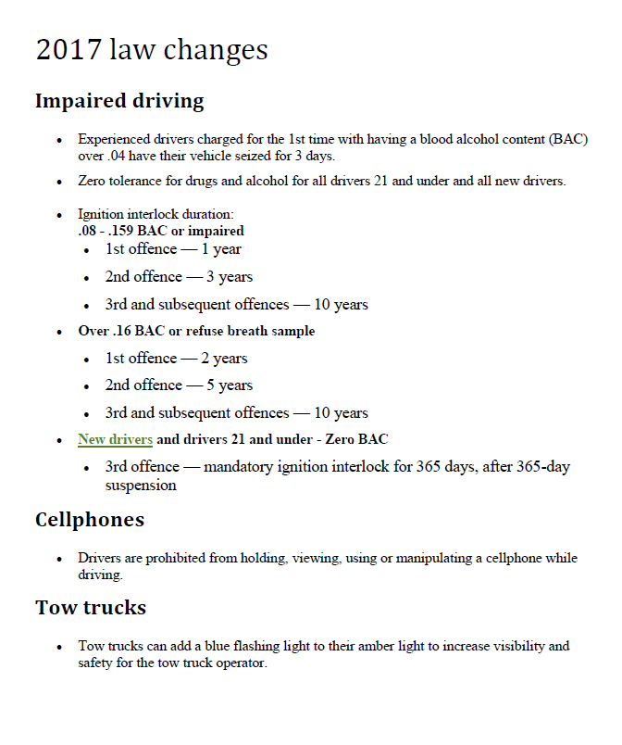
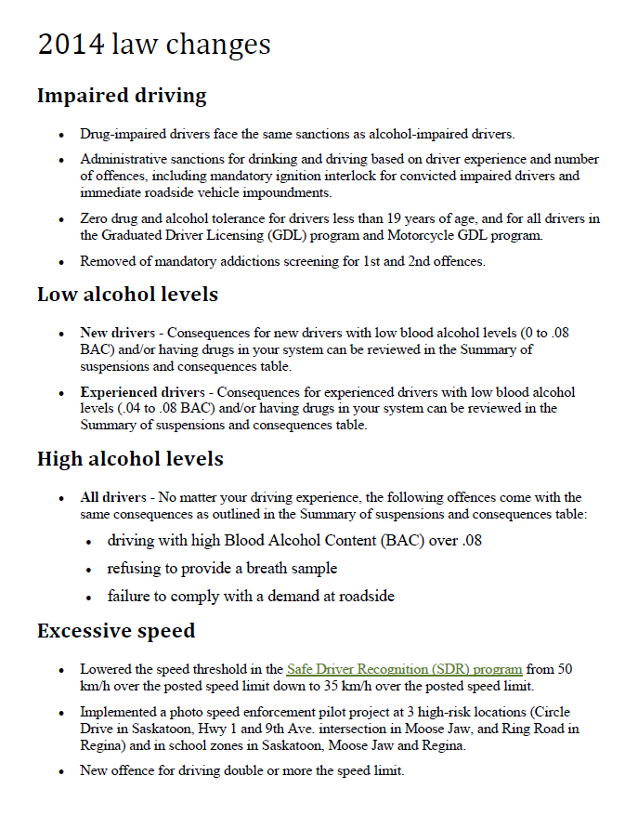
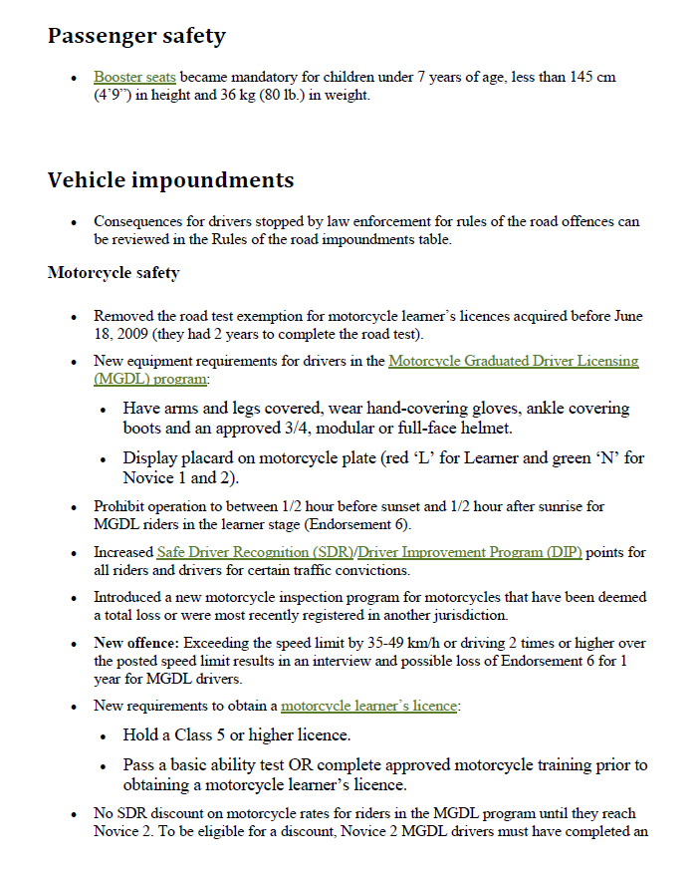
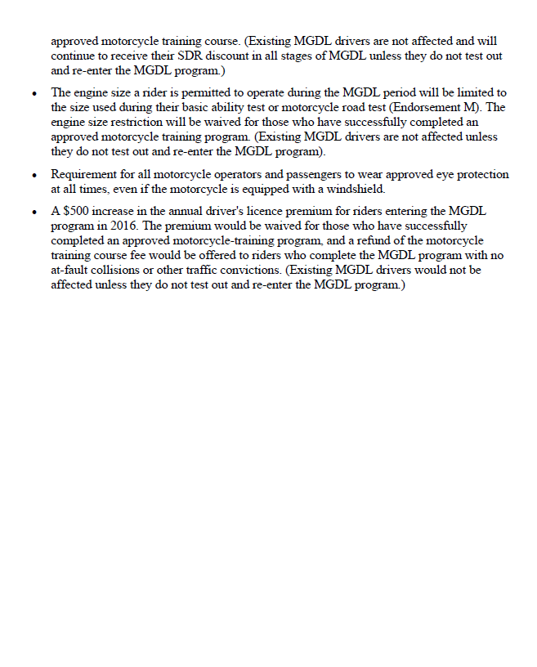
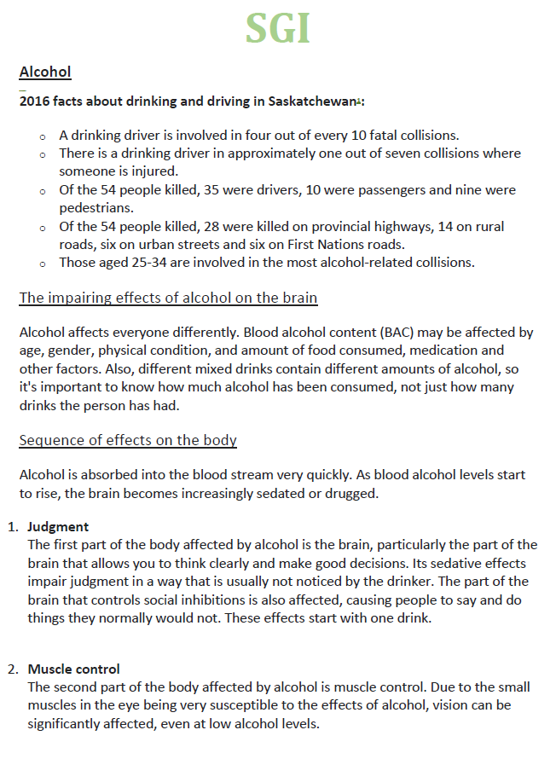
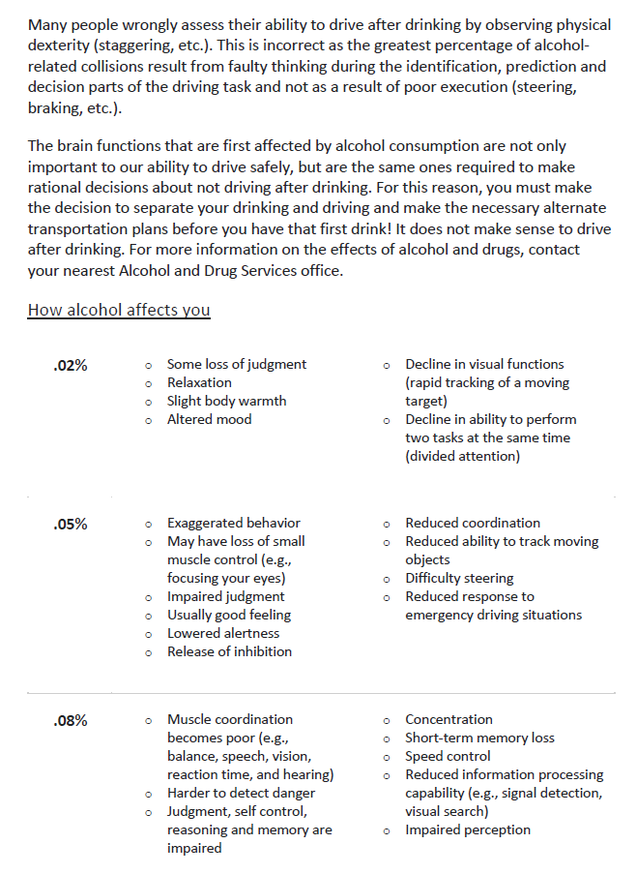
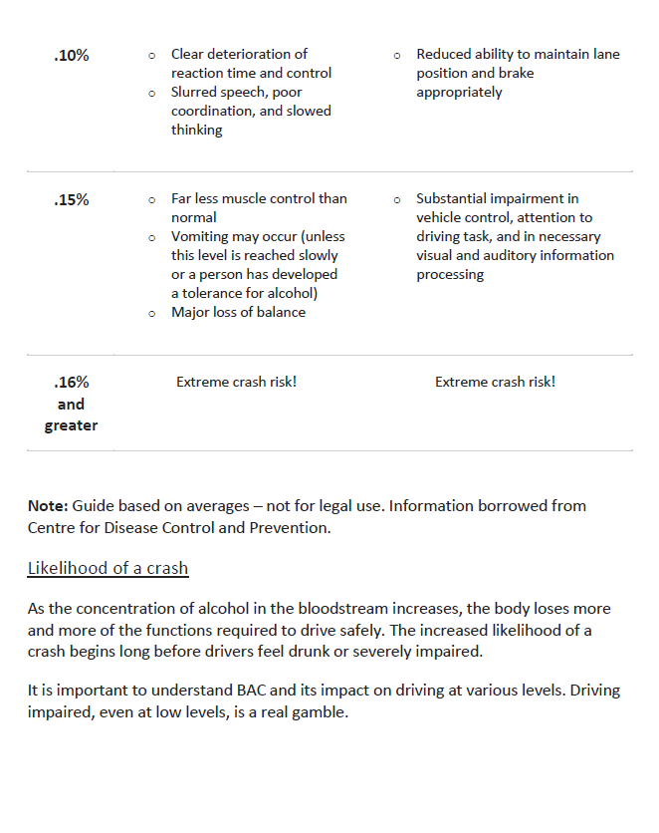
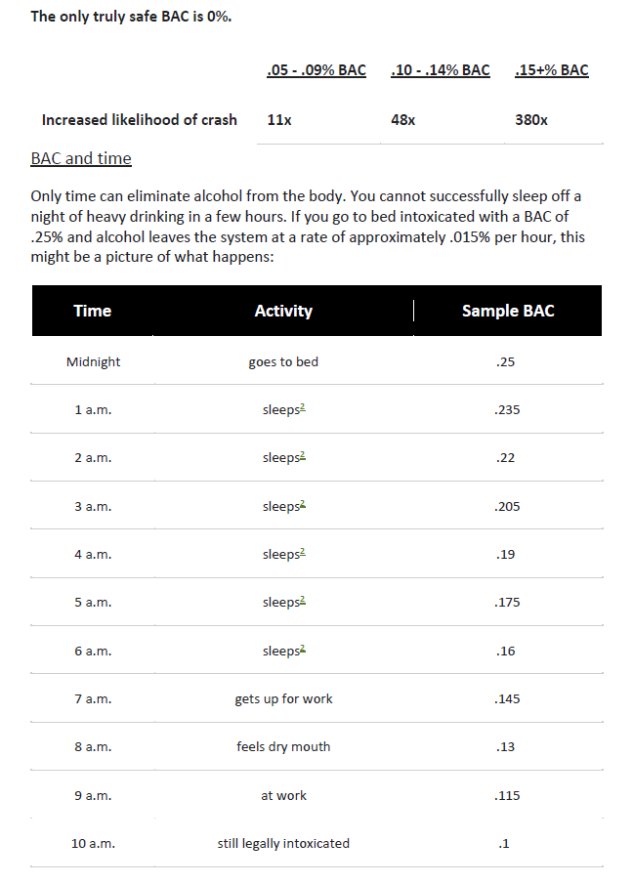
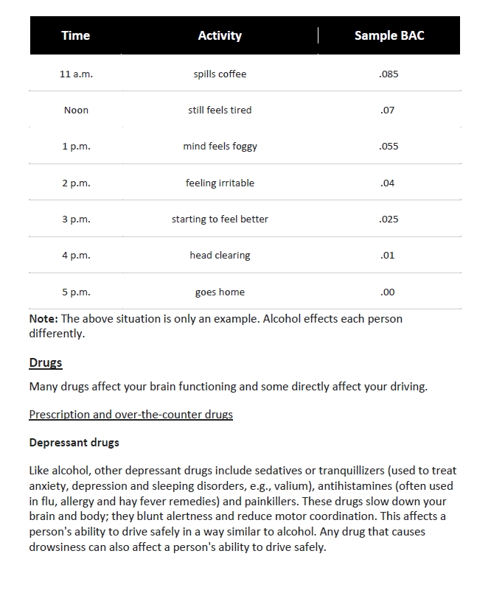
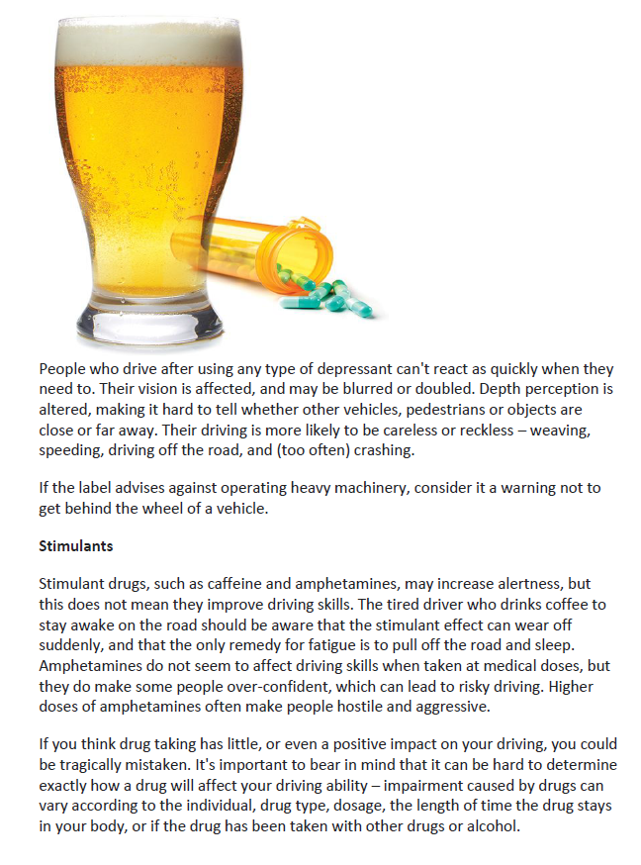
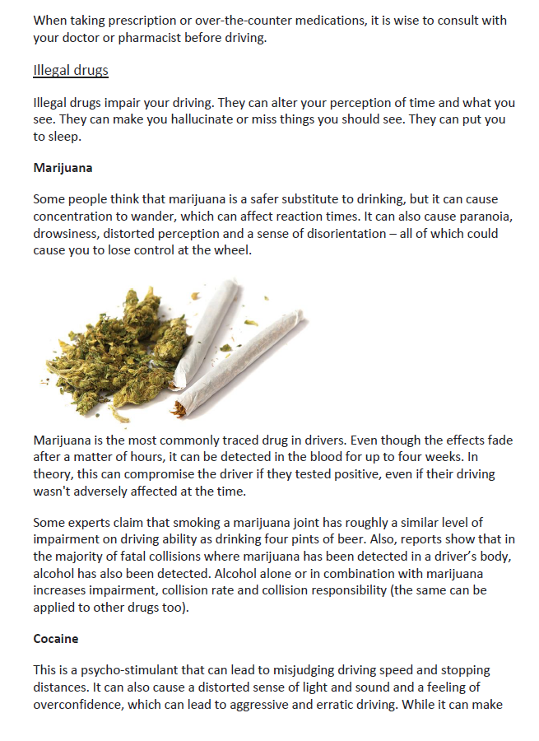
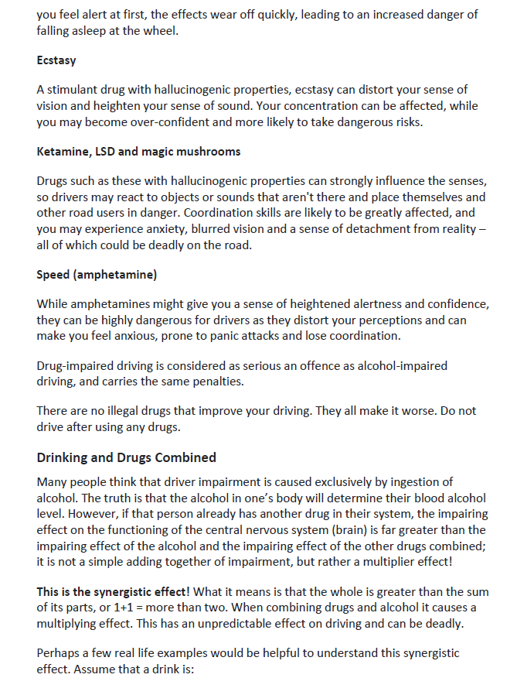
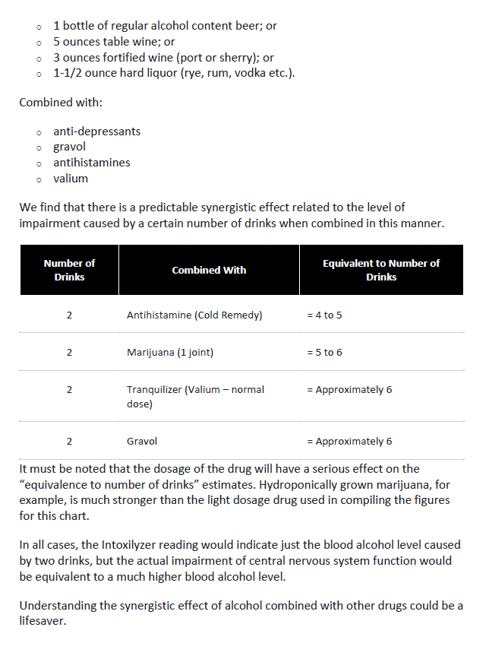
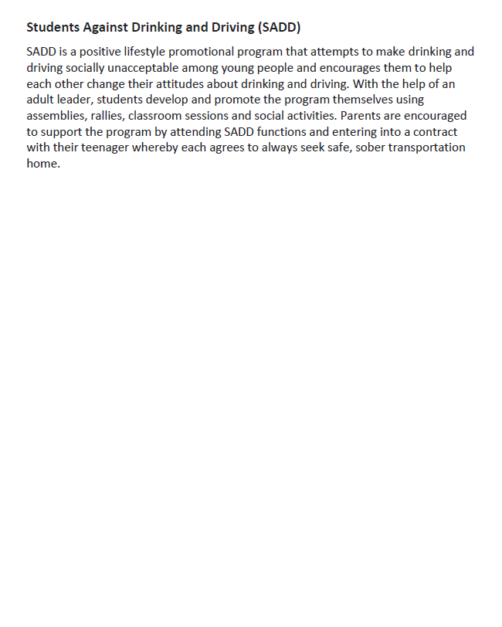

6

Chapter 6: Forms

[ENTER DIVISION NAME]

Section 6.1: Transportation Sector Forms (division specific)

Introduction
This Chapter lists and includes forms required by the transportation staff. These forms are: (Division specific if applicable)

Incident Report Form
- This form is used for reporting all accidents, near misses or property damage.

Transportation (Bus Driver) Performance Review Form
- This evaluation will be done a minimum of once every 3 years.

Working Alone Form

Student Report Form
- This form is to be used for student behavior/conduct on the bus.

Charter Statement (Field Trip Form)

Expense Reimbursement Form

- This form is to be used in situations where bus drivers incur expenses that are eligible for reimbursement through the school division. This must be approved and signed by the Transportation Foreman.

Online Leave Request Form

- An Online Leave Request must be completed and submitted as soon as you know you will be off duty for approval both by your Transportation Foreman and the Manager of Human Resource.

Driver Claim Form

- This form is used by substitute bus drivers to record and report any extra travel while covering a bus route.
- This form can be used by regular bus drivers to record and report extra travel for repairs other than regular scheduled maintenances.

Daily School Bus Deficiency/Inspection Report

- This needs to be filled out daily. Must be complete and accurate.
- Submit a copy of the completed form to your Transportation Foreman after the 15th and last day of the month.

Bus Driver Summary Sheet

- It is important that the Bus Driver Summary Form be fully completed and accurate.

Evacuation Drill Form
- The evacuation drill must be done, and the form completed for each bus route by the regular bus driver in October, January and April of each school year. Submit your completed Evacuation Drill form to your Transportation Foreman within 7 days of completion.

SGI Forms
- Samples of specific SGI forms are shown in the Driver Information section.

Insert samples below

Bus Driver
Performance Review Form

Name: ________________________________ Date of Review: __________________________

School/Location: __________________________________ Position: __________________________

How long has this employee worked in his/her assignment? ________________________________

Type of Evaluation (check one)

Interim Probationary Final Probationary Trial Period

1 Year Following Probationary Annual Review (3 years) Other____________________

Evaluator (print name): __________________________ Position: ______________________________

Mark (X) the box that most accurately reflects your evaluation of the employee.

3. Meets Expectations: A person who consistently meets requirements and expectations; one who excels in one or more areas of performance.

2. Needs Improvement: A person who inconsistently meets the requirements and expectations; one who has areas of performance that require improvement.

1. Unacceptable: A person whose performance is notably below job requirements and expectations; significant improvement to performance is required.

Criteria for Evaluation (Note: Space for general comments provided at the end) |  |  |  |  |  | 3 | 2 |  | 1 |  | N/A
Criteria for Evaluation (Note: Space for general comments provided at the end) | 3 | 2 | 1 | N/A
Student Related Duties
 | 1. | Communicates pickup/drop off times to families in a timely manner
 | 2. | Advises and enforces school bus rules effectively
 | 3. | Advises sub driver of any route specific rules/  changes or student concerns
 | 4. | Properly supervises students during transit, loading  & unloading
 | 5. | Supervision of students until regular supervision is provided
 | 6. | Ability to manage student behavior quickly and effectively
 | 7. | Communicates any bus issues to supervisor
 | 8. | Complies to all safety, traffic and bus regulations
 | 9. | Knowledgeable with Transportation Manual
 | Bus Care & Maintenance
 | 10. | Meets bus cleanliness standards as established by supervisor
 | 11. | Ensures bus is plugged when temperature below 0ċ
 | 12. | Properly checks and maintains all fluid levels
 | 13. | Reports any bus malfunctions to supervisor
 | 14. | Maintains fuel level above half a tank
 | 15. | Returns spare buses clean and full of fuel
 | 16. | Properly performs & documents pre-trip inspections
 | General Duties
 | 17. | Completes & submits all applicable paperwork in a timely manner
 | 18. | Conducts oneself in an appropriate manner within an educational environment
 | 19. | Willingness to engage in all professional development
 | 20. | Notifies supervisor of any changes to route
 | 21. | Maintains a neat personal appearance
 | Attitude
 | 22. | Demonstrates a positive attitude towards others,  co-workers, and school/division
 | 23. | Willing to listen/learn & provide valuable feedback
 | 24. | Accepts accountability for his/her work
 | 25. | Properly follows instructions, directives, and procedures
 | Initiative
 | 26. | Comes forward with concerns or new ideas
 | 27. | Willing to assist co-workers/team player
 | Punctuality
 | 28. | Maintains consistent route pickup/drop-off times at stops and school
 | 29. | Ability to show up on time for any job related duty
 | 30. | Communicates any delays to any affected families or schools
 | Safety
 | 31. | Reports all incidents / accidents to supervisor immediately
 | 32. | Follows established policies & safe work procedures
 | 33. | Knows the 3 worker rights & what they mean
 | 34. | Demonstrates proper use of personal protective equipment (PPE), donning, doffing, selection, storage
 | 35. | Worker ensures all applicable training is current

Objectives for the Next Review Period

List goals and objectives to be attained in the upcoming review period:
____________________________________________________________________________________________________________________________________________________________________________________________________________________________________________________________________________________________________________________________________________________________________________________________________________________________________

Overall Review

Outline areas of major strength(s):
____________________________________________________________________________________________________________________________________________________________________________________________________________________________________________________________________________________________________________________________________________________________________________________________________________________________________

Areas which could be improved:
____________________________________________________________________________________________________________________________________________________________________________________________________________________________________________________________________________________________________________________________________________________________________________________________________________________________________

Professional development goals:
____________________________________________________________________________________________________________________________________________________________________________________________________________________________________________________________________________________________________________________________________________________________________________________________________________________________________

General comments and recommendations:
____________________________________________________________________________________________________________________________________________________________________________________________________________________________________________________________________________________________________________________________________________________________________________________________________________________________________

____________________________________ __________________________
Supervisor’s Signature Date

___________________________________ __________________________
Employee’s Signature Date

7

Chapter 7: Assigned Route Information Package

[ENTER DIVISION NAME]

** This manual may be changed or updated/revised at any time **

