WHMIS 2015
Worker must complete WHMIS 2015 Education and Training.
All Hazardous Products in or on the worksite must have a Safety Data Sheet (SDS).
NOTE: Consumer products (which are materials intended for consumer use, and provided in volume, such as cleaners, adhesives, lubricants, etc.) are not subject to WHMIS 2015 requirements. However, if product is brought into the workplace an SDS must accompany the product. In many cases, SDSs are available from the product supplier.
Only Safety Data Sheets are acceptable. Material Safety Data Sheets MSDS are not acceptable.
Worker purchases a hazardous product that is new to the WHMIS 2015 inventory, worker must:
- Provide SDS (this can be provided by supplier).
- SDS to be added to inventory database, binder in shop (if applicable), binder in work truck (if applicable).
- Communicate with supervisor.
- If unable to locate/acquire SDS notify supervisor immediately.

Hazardous products used at schools:
- No products are to be left at schools unless the product is required for operations (e.g., Glycol, etc.)
  - The above-mentioned products must have a SDS at the school, provide SDS to school administrator

Hazardous product no longer used or available or supplier change:
- SDS must be removed from database, binder(s) school, truck, shop (if applicable)

Supervisor:
- To support worker locating SDS, maintain index, database, binder(s)
- Any identified change in SDS information must be communicated to worker
- Provide new SDS if applicable

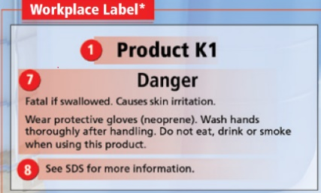
Availability of Safety Data Sheets:
- To workers who may be exposed to the hazardous product
- To the Occupational Health Committee

Workplace label required:
- A hazardous product is decanted into another container
(e.g., transferred or poured)
- A supplier label is lost or no longer illegible (unable to read)

