Occupational Health Committee Agenda Template

- Approval of Agenda
- Approval of Minutes
- Old Business
  - Contraventions
  - Recommendations c.
d.
- New Business
  - Review WHMIS training – review how WHMIS training is provided and if any deficiencies are identified, recommend improvements.
  - Incident/injury reports
  - Inspections d.
- Review OH&S regulation sections
a. 7-4; 7-5; 9-22; 12-2 – 12-17; 12-21; 12-24; 12-25; 21-9; 21-10
- Complete the:
  - Chemical and Biological Substance Analysis
  - Fire Safety Survey – Worker Survey

Note all deficiencies must be accompanied by recommended actions.
- Plan staff awareness
  - Chemicals and Biological Substances
- Adjournment

Year Two: October - December

Saskatchewan Employment Act and OH&S Regulations Review

Section | Title | Applies to | Requires/States | Further Definitions | Questions to Answer
Occupational Health and Safety regulations
7-4 | Inspection of Respiratory Devices | All committees | An employer or contractor shall ensure that:  (a) any respiratory protective device for emergency use is thoroughly inspected by a competent person at least once a month and after each use;  (b) the date of every inspection made pursuant to clause (a) and the name of the person who made the inspection are recorded and conspicuously displayed at the location where the respiratory protective device is stored; and  (c) any defects identified during the inspection carried out pursuant to clause (a) are corrected immediately by a competent person. |  | Does your worksite use respirators for emergencies?  If yes, are they inspected monthly? After each use?  Is every inspection and inspector noted by the respirator?  Are inspections/repairs completed by a competent person?
7-5 | Working in dangerous atmospheres | All committees | (1) Where a worker is required to enter an atmosphere that is immediately dangerous to the life or health of the worker, an employer or contractor shall ensure that the worker is provided with and uses an approved atmosphere-supplying respirator that is:  (a) an open-circuit SCBA that:  (i) operates in a pressure demand or other positive pressure mode;  (ii) has a minimum rated capacity of 30 minutes;  (iii) is sufficiently charged to enable the worker to perform the work  safely; and  (iv) is equipped with a low-pressure warning device or an escape  respirator;  (b) an airline respirator equipped with a full facepiece that:  (i) operates in a pressure demand or other positive pressure mode; and  (ii) has an auxiliary supply of air sufficient to allow the worker to escape in case of failure of the primary air supply equipment; or  (c) a closed-circuit SCBA.  (2) Where a worker is required to enter an atmosphere that is immediately dangerous to life or health, an employer or contractor shall ensure that:  (a) a second worker, suitably equipped and trained, is present and in communication with the worker at all times; and  (b) suitably equipped personnel who are trained in rescue procedures and are fully informed of the hazards are readily available to rescue the endangered worker immediately if the worker’s atmosphere-supplying respirator fails or the worker becomes incapacitated for any other reason.  (3) An employer or contractor shall ensure that compressed air in an atmosphere‑supplying respirator used by a worker in an atmosphere that is immediately dangerous to the worker’s life or health meets the purity requirements set out in Table 2 of the Canadian Standards Association standard CAN3-Z180.1-M85 Compressed Breathing Air and Systems. |  | Are there situations in your workplace that may require staff to enter an atmosphere that is immediately dangerous to life and health?  If so, do they have atmosphere supplying respirators that meet these requirements?  Do they have a second worker trained to be a “watch person”?  Do they have the rescue team and equipment?
9-22 | Risk from vehicular traffic | All committees | (1) An employer or contractor shall ensure that a worker who is at risk from vehicular traffic, whether on a public highway or at any other place of employment, is provided with and required to use a high visibility vest, armlets or other high visibility clothing.  (2) Where there is a danger to a worker from vehicular traffic on a public highway, an employer or contractor shall develop and implement a traffic control plan, in writing, to protect the worker from traffic hazards by the use of one or more of the following:  (a) warning signs;  (b) barriers;  (c) lane control devices;  (d) flashing lights;  (e) flares;  (f) conspicuously identified pilot vehicles;  (g) automatic or remote-controlled traffic control systems;  (h) designated signallers directing traffic.  (3) An employer or contractor shall ensure that:  (a) workers are trained in the traffic control plan developed pursuant to subsection (2); and  (b) the traffic control plan developed pursuant to subsection (2) is made readily available for reference by workers at the place of employment.  (4) An employer or contractor shall use designated signallers to control traffic on a public highway only where other methods of traffic control are not adequate or suitable.  (5) Where designated signallers are used to control traffic on a public highway, an employer or contractor shall provide:  (a) at least one designated signaller if:  (i) traffic approaches from one direction only; or  (ii) traffic approaches from both directions and the designated signaller and the operator of an approaching vehicle would be clearly visible to one another; and  (b) at least two designated signallers if traffic approaches from both directions and the designated signaller and the operator of an approaching vehicle would not be clearly visible to one another.  (6) Where there is or may be a hazard to a worker from traffic at a place of employment other than a public highway, an employer or contractor shall develop and implement a traffic control plan to protect the worker from traffic hazards.  (7) A traffic control plan required by subsection (6) must:  (a) be in writing;  (b) be made readily available for reference by workers at the place of employment; and  (c) set out, where appropriate:  (i) the maximum allowable speed of any vehicle or class of vehicles, including powered mobile equipment, in use at the place of employment;  (ii) the maximum operating grades;  (iii) the location and type of control signs;  (iv) the route to be taken by vehicles or powered mobile equipment;  (v) the priority to be established for classes of vehicle;  (vi) the location and type of barriers or restricted areas; and  (vii) the duties of workers and the employer or contractor.  (8) A worker who operates a vehicle or unit of powered mobile equipment at a place of employment and who does not have a clear view of the path to be travelled shall not proceed until a person who has a clear view of the path to be travelled by the vehicle or unit of powered mobile equipment signals to the worker that it is safe to proceed.  (9) Where a provision of this section conflicts with a provision of The Highway Traffic Act, The Highways and Transportation Act, The Vehicle Administration Act, a regulation made pursuant to any of those Acts or a bylaw of a municipality made pursuant to The Urban Municipality Act, 1984, The Rural Municipality Act, 1989 or The Northern Municipalities Act, the provision of the other statute, regulation or bylaw prevails.  (10) Nothing in this section applies to a peace officer in the performance of the peace officer’s duties. |  | Does your site have a traffic control plan that meets the requirements of this section?  Do workers have and wear high visibility clothing if they are at risk from vehicular traffic?
12-2 | Scaffold Required | Committees at sites where scaffolding is used. | Where work cannot be safely done from the ground or from a permanent structure, an employer or contractor shall provide a scaffold or other safe working platform or a ladder that meets the requirements of Part XVI for the use of workers. | “scaffold” means a temporary elevated platform and the platform’s supporting structure that are designed to support workers and hand tools, or workers, equipment and materials | Are scaffolds used at the worksite?
12-3 | Prohibition | Committees at sites where scaffolding is used. | No employer or contractor shall require or permit a worker to use a needle‑beam scaffold or a suspended outrigger scaffold as a work platform. | “needle-beam scaffold” means a platform that is supported by parallel horizontal beams suspended by ropes attached to overhead anchors  “suspended outrigger scaffold” means a scaffold with a working platform that is suspended by wooden vertical members from rigid horizontal members that are cantilevered out from the structure | Does your site use needle-beam or suspended outrigger scaffolding as a work platform?
12-4 | Limited use of certain scaffolds | Committees at sites where scaffolding is used. | (1) An employer or contractor shall ensure that the following types of scaffolds are used only as light-duty scaffolds:  (a) half-horse scaffolds;  (b) ladderjack scaffolds;  (c) single-pole scaffolds.  (2) An employer or contractor shall ensure that the following types of scaffolds are used only as light-duty scaffolds unless the scaffold is designed by a professional engineer and constructed, erected, used, maintained and dismantled in accordance with that design:  (a) bracket scaffolds;  (b) outrigger scaffolds;  (c) suspended scaffolds;  (d) suspended powered scaffolds. | “half-horse scaffold” means a platform that is supported by two or more braced, splayed supports resting in or on the structure  “ladderjack scaffold” means a platform that is supported by brackets attached to ladders  “single-pole scaffold” means a platform that is supported by bearers attached at the outer end to a single row of braced uprights and at the inner end to the structure  “bracket scaffold” means a platform that is supported by two or more triangular brackets projecting out from a structure to which the brackets are securely fastened  “outrigger scaffold” means a platform that is supported by rigid members that are cantilevered out from the structure or vertical supports  “suspended outrigger scaffold” means a scaffold with a working platform that is suspended by wooden vertical members from rigid horizontal members that are cantilevered out from the structure  “suspended powered scaffold” means a platform that is suspended from overhead supports by ropes or cables and equipped with winches or pulley blocks so that the scaffold can be moved, and includes a boatswain’s chair, work basket, work cage, swingstage or other similar scaffold
12-5 | Scaffolds, Aerial Devices, Elevating Work Platforms and Temporary Supporting Structures- General requirements | Committees at sites where scaffolding is used. | (1) An employer or contractor shall ensure that:  (a) every light-duty scaffold is designed and constructed to support:  (i) a minimum working load of 3.63 kN per lineal metre of platform width applied vertically and uniformly across an independent platform section along an imaginary line drawn perpendicular to the platform edge anywhere along the length of the section; and  (ii) a minimum uniformly distributed working load of 1.20 kN/m2, acting simultaneously with the concentrated load specified in subclause (i); and  (b) every heavy-duty scaffold is designed and constructed to support:  (i) a minimum working load of  3.88 kN per lineal metre of platform width applied vertically and uniformly across an independent platform section along an imaginary line drawn perpendicular to the platform edge anywhere along the length of the section; and  (ii) a minimum uniformly distributed working load of 3.60 kN/m2, acting simultaneously with the concentrated load specified in subclause (i).  (2) An employer or contractor shall ensure that every scaffold is:  (a) designed, constructed, erected, used and maintained so as to perform safely any task that the scaffold is required to perform;  (b) designed, constructed and erected to support or resist:  (i) in the case of a wooden scaffold, at least four times the load that may be imposed on the scaffold;  (ii) in the case of a metal scaffold, at least 2.2 times the load that may be imposed on the scaffold;  (iii) in the case of any components suspending any part of a scaffold supporting workers, at least 10 times the load that may be imposed on those components; and  (iv) four times the maximum load or force to which the scaffold is likely to be subjected without overturning;  (c) erected, maintained and dismantled by a competent worker.  (3) An employer or contractor shall ensure that a freestanding scaffold is restrained from overturning by guying or other suitable means.  (4) An employer or contractor shall ensure that a scaffold that is built from the ground or other surface:  (a) is supported by a foundation that is of sufficient area, stability and strength to ensure the stability of the scaffold;  (b) is set level on a stable sill that is at least 38 x 240 millimetres and continuous under at least two consecutive supports;  (c) where an upright could penetrate the sill, a base plate is installed in the upright;  (d) is supported against lateral movement by adequate, secure bracing;  (e) is anchored:  (i) vertically at not less than four-metre intervals and horizontally at not less than six-metre intervals;  (ii) where designed by a professional engineer, at intervals recommended by a professional engineer; or  (iii) where commercially manufactured, at intervals recommended by the manufacturer;  (f) is provided with internal stairways or ladders if the scaffold is nine metres or more in height; and  (g) is checked to ensure that the scaffold is plumb and level after each tier is added.  (5) Where a scaffold is partially or fully enclosed, an employer or contractor shall ensure that all scaffold components and tie-ins are adequate to support the added load that may be placed on the scaffold as a result of wind or other adverse weather conditions.  (6) An employer or contractor shall ensure that all workers who are required to work on a scaffold are provided with the following information:  (a) the maximum working load of the scaffold;  (b) any other information, restriction or condition that is necessary to ensure the safe use of the scaffold.  (7) Where a scaffold is more than six metres high, an employer or contractor shall install a gin wheel and hoist arm or other suitable lifting device to hoist materials from the ground. |  | Is scaffolding used in your workplace?  Is it assembled and used in compliance with these regulation requirements?  Do workers know the safe working load of the scaffolding?
12-6 | Ropes in scaffolds | Committees at sites where scaffolding is used. | (1) An employer or contractor shall ensure that a rope or wire rope that forms an integral part of a scaffold is protected against abrasion or other physical damage.  (2) Where damage to a rope that forms an integral part of a scaffold from heat or chemicals is possible, an employer or contractor shall ensure that rope of heat or chemical resistant material is used. |  | Are ropes/wires protected?
12-7 | Scaffold planks and platforms | Committees at sites where scaffolding is used. | (1) An employer or contractor shall ensure that scaffold planks:  (a) are inspected by a competent worker to ensure that the scaffold planks are free of defects before the planks are incorporated in a scaffold;  (b) subject to subsections (2) and (4), are of 38 x 240 millimetre, number 1 structural grade spruce lumber or material of equivalent or greater strength;  (c) are the same thickness as adjoining planks;  (d) are laid tightly side by side with adjoining planks to cover the full width of the platform;  (e) are secured to prevent accidental or inadvertent movement in any direction;  (f) where wooden, do not span more than three metres between vertical supports on a light-duty scaffold or 2.1 metres between vertical supports on a heavy-duty scaffold;  (g) where metal or manufactured laminate, do not have a span between vertical supports greater than the span recommended by the manufacturer; and  (h) do not extend less than 150 millimetres or more than 300 millimetres beyond the bearers.  (2) An employer, contractor or supplier may use a manufactured scaffold plank if the plank is used according to the manufacturer’s recommendations and the manufactured scaffold plank is clearly marked with its maximum working load or the load specifications are readily available at the worksite.  (3) Subject to subsection (4), an employer or contractor shall ensure that a scaffold platform:  (a) is at least one-half metre wide in the case of a light-duty scaffold;  (b) is at least one metre wide in the case of a heavy-duty scaffold; and  (c) is level or, where used as a ramp, has a slope at an angle not steeper than five horizontal to one vertical.  (4) A single manufactured extending painter’s plank, or a plank that is 51 x 305 millimetre, number 1 structural grade spruce lumber or material of equivalent or greater strength, may be used in a ladderjack scaffold. | “ladderjack scaffold” means a platform that is supported by brackets attached to ladders | Do planks used in your scaffolding meet the requirements of this section?
12-8 | Wooden scaffolds | Committees at sites where scaffolding is used. | (1) An employer or contractor shall ensure that the dimensions of members of a light-duty wooden scaffold that is less than six metres in height are not less than the dimensions specified in Table 15 of the Appendix.  (2) An employer or contractor shall ensure that a wooden scaffold is constructed of unpainted number 1 structural grade spruce lumber or material of equivalent or greater strength. | TABLE 15  [Subsection 175(3)]  Minimum Dimensions of Members of Light Duty Wooden1 Scaffolds  (Height Less Than 6 Metres) | Do you have wooden scaffold that is less than 6m tall?  Does it meet the requirements of table 15?
12-9 | Metal scaffold | Committees at sites where scaffolding is used. | (1) Where a metal scaffold is used, an employer or contractor shall ensure that the metal scaffold is:  (a) erected, used, maintained and dismantled in accordance with the manufacturer’s or professional engineer’s specifications and recommendations;  and  (b) inspected, by a competent person, prior to use and daily when in use for any damage, deterioration or weakening of the scaffold or the scaffold’s components.  (2) If a metal scaffold or a component of a metal scaffold is damaged, deteriorated or weakened so that the strength or stability of the scaffold is affected, an employer or contractor shall ensure that the scaffold is not used until the scaffold or component is repaired or replaced by a competent person in accordance with the manufacturer’s or a professional engineer’s specifications and recommendations.  (3) Where a metal scaffold is a tube and clamp scaffold, an employer or contractor shall ensure that:  (a) joints in adjacent uprights are staggered and do not occur in the same tier;  (b) joints in uprights are located not more than one-third of a tier away from the connection of a ledger;  (c) ledgers are erected horizontally along the length of the scaffold and coupled to each upright at regular intervals of one tier;  (d) all ledgers are joined to form a continuous length;  (e) individual tube lengths of a ledger are the lesser of:  (i) two or more bays in length; or  (ii) the horizontal length of the scaffold;  (f) tubes of different metals or gauges are not joined together; and  (g) where base plates are required, they are securely installed in the uprights and securely attached to the sills.  (4) Where a metal scaffold is a standard tubular frame scaffold, an employer or contractor shall ensure that:  (a) where base plates, shore heads, extension devices or screwjacks are necessary, they are securely installed and securely attached to the sills and the legs of the frame; and  (b) there are no gaps between the lower end of one frame and the upper end of the frame below on stacked frames.  (5) Where a metal scaffold is a modular scaffold, an employer or contractor shall ensure that:  (a) where extension devices or screwjack bases and base collars are necessary, they are securely installed and securely attached to the sills;  (b) joints in adjacent uprights are staggered and do not occur in the same tier;  (c) there are no gaps between the lower end of one upright and the upper end of the upright below it;  (d) ledgers, bearers and braces are properly secured; and  (e) components from different modular scaffold systems are not used in the same scaffold. | “tube and clamp scaffold” means a platform that is supported by steel or aluminum tubes with wedge or bolt clamp connectors and accessories  “tubular frame scaffold” means a platform that is supported by welded tubular frames, cross-races and accessories | Does your site use metal scaffolding? If so, what type?  Does it meet the requirements of this section?
12-10 | Heavy-duty scaffolds, scaffolds used at certain heights | Committees at sites where scaffolding is used. | (1) This section applies to a scaffold that:  (a) is to be used as a heavy-duty scaffold;  (b) in the case of a wooden scaffold, has a platform at a height that is six metres or more above either ground level or a permanent working surface; or  (c) in the case of a metal scaffold, has a platform at a height that is greater than 15 metres above either ground level or a permanent working surface.  (2) An employer, contractor or owner shall ensure that a scaffold mentioned in subsection (1) is:  (a) designed by a professional engineer and erected, used, maintained and dismantled in accordance with that design; or  (b) commercially manufactured to meet the requirements of an approved standard and erected, used, maintained and dismantled in accordance with the manufacturer’s specifications and recommendations.  (3) While a scaffold mentioned in subsection (1) is being constructed, erected, used, maintained or dismantled, an employer, contractor or owner shall keep at the worksite all drawings and supplementary information regarding the scaffold, including:  (a) the dimensions, specifications, type and grade of all components of the scaffold; and  (b) the maximum load and the maximum working load that the scaffold is designed or manufactured to support.  (4) An employer, contractor or owner shall make readily available to the workers a copy of the drawings and supplementary information mentioned in subsection (3). | “heavy-duty scaffold” means a scaffold that is intended to support workers, equipment and stored or stacked materials and that is designed to support the minimum load identified in clause 172(1)(b)  172(1) An employer or contractor shall ensure that:  (b) every heavy-duty scaffold is designed and constructed to support:  (i) a minimum working load of  3.88 kN per lineal metre of platform width applied vertically and uniformly across an independent platform section along an imaginary line drawn perpendicular to the platform edge anywhere along the length of the section; and  (ii) a minimum uniformly distributed working load of 3.60 kN/m2, acting simultaneously with the concentrated load specified in subclause (i). | Do you have scaffold that is  - Heavy duty?  - Wooden with a platform 6m above the ground?  - Metal with a platform 15m above the ground?  If so, does it meet the requirements of this section?
12-11 | Half horse scaffolds | Committees at sites where scaffolding is used. | (1) An employer or contractor shall ensure that the legs of a half-horse scaffold are not spliced, are less than three metres high and have an angle of repose and an angle of splay that are 15° from the vertical.  (2) An employer or contractor shall ensure that a ladder is used to provide access to and exit from a half-horse scaffold. | “half-horse scaffold” means a platform that is supported by two or more braced, splayed supports resting in or on the structure | Does your site have half-horse scaffold?  If so, does it meet the requirements of this section?
12-12 | Bracket scaffolds | Committees at sites where scaffolding is  used. | An employer or contractor shall ensure that the brackets of a bracket scaffold are securely attached to prevent the brackets from dislodging and are not more than three metres apart. | “bracket scaffold” means a platform that is supported by two or more triangular brackets projecting out from a structure to which the brackets are securely fastened | Does your site have bracket scaffolds? Are the brackets securely attached? Are the lass than 3m apart?
12-13 | Ladderjack scaffolds | Committees at sites where scaffolding is used. | An employer or contractor shall ensure that:  (a) brackets and ladders used for a ladderjack scaffold are:  (i) designed and constructed to support the anticipated load safely; and  (ii) used according to the manufacturer’s specifications and recommendations; and  (b) ladders used for a ladderjack scaffold are not more than three metres apart. | “ladderjack scaffold” means a platform that is supported by brackets attached to ladders | Does your site have ladderjack scaffold?  If so, does it meet the requirements of this section?
12-14 | Single-pole scaffolds | Committees at sites where scaffolding is used. | An employer or contractor shall ensure that:  (a) a single-pole scaffold is adequately supported in two directions by a system of diagonal braces that are:  (i) not more than six metres long; and  (ii) connected to the uprights as close to the ledgers as possible; and  (b) every ledger on a single-pole scaffold is supported by a bearer that is of substantial construction and that is securely fastened to the structure. | “single-pole scaffold” means a platform that is supported by bearers attached at the outer end to a single row of braced uprights and at the inner end to the structure | Does your site use single-pole scaffold?  If yes, does it meet the requirements of this section?
12-15 | Outrigger scaffolds | Committees at sites where scaffolding is used. | Where an outrigger scaffold is used, an employer or contractor shall ensure that the scaffold is:  (a) designed by a professional engineer and erected, used, maintained and dismantled in accordance with that design; or  (b) commercially manufactured to meet the requirements of an approved standard and erected, used, maintained and dismantled in accordance with the manufacturer’s specifications and recommendations. | “outrigger scaffold” means a platform that is supported by rigid members that are cantilevered out from the structure or vertical supports | Does your site use outrigger scaffolds?  If so, does it meet the requirements of this section?
12-16 | Suspended scaffolds | Committees at sites where scaffolding is used. | 183(1) Where a suspended scaffold is used, an employer, contractor or supplier shall ensure that the scaffold is:  (a) designed by a professional engineer and erected, used, maintained and dismantled in accordance with that design; or  (b) commercially manufactured to meet the requirements of an approved standard and erected, used, maintained and dismantled in accordance with the manufacturer’s specifications and recommendations.  (2) An employer or contractor shall ensure that the working parts of the hoisting mechanism of a suspended scaffold are left exposed so that defective parts or irregular working of the mechanism can be easily detected.  (3) An employer or contractor shall ensure that no worker is required or permitted to operate the hoisting mechanism of a suspended scaffold unless the worker is competent and has been designated by the employer or contractor to perform that work.  (4) An employer or contractor shall ensure that all parts of a suspended scaffold are inspected prior to use and daily when in use. | “suspended scaffold” means a platform that is supported by four wire ropes suspended from members that are cantilevered out from the structure | Does your site uses suspended scaffolds?  If so, does it meet the requirements of this section?
12-17 | Suspended powered scaffolds | Committees at sites where scaffolding is used. | (1) Where a suspended powered scaffold is used, an employer, contractor, supplier or owner shall ensure that the scaffold and its suspension system is:  (a) designed by a professional engineer and erected, used, maintained and dismantled in accordance with that design; or  (b) commercially manufactured to meet the requirements of an approved standard and erected, used, maintained and dismantled in accordance with the manufacturer’s specifications and recommendations.  (2) An employer, contractor or owner shall ensure that:  (a) where a parapet is part of the support structure of a suspended powered scaffold, the parapet can withstand the force of the load; and  (b) the anchor points for the suspension system are secure and can safely withstand the load.  (3) An employer, contractor, owner or supplier shall ensure that a power unit of a suspended powered scaffold is equipped with positive pressure controls and positive drives for raising and lowering the scaffold.  (4) Where workers are required to use a manually-operated suspended powered scaffold, an employer, contractor, supplier or owner shall ensure that:  (a) the scaffold is equipped with spring-actuated locking pawls;  (b) the hoisting mechanism is locked in a positive drive position by means of a spring-steel locking pin; and  (c) the locking pin is permanently attached to the hoisting mechanism by a light chain.  (5) Where a suspended powered scaffold is used, an employer, contractor or owner shall ensure that:  (a) the suspension rope consists of wire rope that is at least eight millimetres in diameter or meets the specifications recommended by the manufacturer of the scaffold or the professional engineer who designed the scaffold;  (b) either:  (i) the suspension rope is long enough to reach the next working surface below the scaffold;  (ii) the end of the suspension rope is doubled back and held securely by a cable clamp to prevent the hoisting machine from running off the end of the rope; or  (iii) directional limiting devices that prevent travel of the working  platform beyond the safe limit of travel are installed; and  (c) all rigging hardware has a safety factor of at least 10.  (6) An employer, contractor or owner shall ensure that a suspended powered scaffold is equipped with a secondary safety device that will activate if the suspension rope connection or primary hoisting system fails.  (7) An employer, contractor or owner shall ensure that a lifeline used with a suspended powered scaffold is:  (a) suspended independently from the scaffold; and  (b) securely attached to a fixed anchor point so that the failure of the scaffold will not cause the lifeline to fail.  (8) An employer, contractor or owner shall ensure that the working platform of a suspended powered scaffold:  (a) is at least 500 millimetres wide and fastened to the stirrups; and  (b) is designed to prevent the scaffold from swinging or swaying away from the structure from which the scaffold is suspended.  (9) An employer, contractor or owner shall ensure that:  (a) there is no covering or hoarding around or over a suspended powered scaffold; and  (b) two or more suspended powered scaffolds are not linked together by bridging the distance between the scaffolds with planks or any similar form of connection.  (10) Where a suspended powered scaffold is permanently installed on a structure, an employer, contractor or owner shall ensure that a professional engineer has certified that the scaffold, its suspension system and all components and anchor points are safe before the scaffold is used. | “suspended powered scaffold” means a platform that is suspended from overhead supports by ropes or cables and equipped with winches or pulley  blocks so that the scaffold can be moved, and includes a boatswain’s chair, work basket, work cage, swingstage or other similar scaffold | Does your site use suspended powered scaffolding?  If so, does it meet the requirements of this section?

Section | Title | Applies to | Requires/States | Further Definitions | Questions to Answer
12-24 | Prohibition | All committees at sites where aerial devices/elevating work platforms are used. | Except as provided in sections 192 and 194, an employer or contractor shall ensure that no worker is raised or lowered by, or works on, a platform or load suspended from powered mobile equipment. |  | Are workers ever raised/lowered by powered mobile equipment?  Do they ever work from a platform on powered mobile equipment?
12-25 | Aerial devices and elevating work platforms | All committees at sites where aerial devices/elevating work platforms are used. | (1) An employer or contractor shall ensure that:  (a) an aerial device, elevating work platform or personnel lifting unit is designed, constructed, erected, operated and maintained in accordance with an approved standard; or  (b) a professional engineer has certified that:  (i) an aerial device, elevating work platform or personnel lifting unit and its elevating system and mountings are safe for the purpose of raising workers and loads; and  (ii) the components of an aerial device, elevating work platform or personnel lifting unit and its elevating system and mountings are designed in accordance with an approved standard.  (2) An employer or contractor shall not require or permit a worker to be raised or lowered by any aerial device or elevating work platform or to work from a device or platform held in an elevated position unless:  (a) there is an adequate and suitable means of communication between the worker operating the controls and the worker raised on the platform, if they are not the same person;  (b) the elevating mechanism is designed so that, if any failure of the mechanism occurs, the platform will descend in a controlled manner so that no worker on the platform will be endangered;  (c) the controls are designed so that the platform will be moved only when direct pressure is applied to the controls;  (d) the drive mechanism of any operation for moving the platform is positive and does not rely on gravity;  (e) road traffic conditions, environmental conditions, overhead wires, cables and other obstructions do not create a danger to the worker;  (f) the brakes of the aerial device or elevating work platform are engaged, except when operated in accordance with manufacturer’s recommendations;  (g) if the aerial device or elevating work platform is equipped with outriggers, the outriggers are set;  (h) pursuant to clause (i), the worker is provided with and is required to use a personal fall arrest system that meets the requirements of Part VII; and  (i) the aerial device or elevating work platform is equipped with a lanyard attachment point that is:  (i) designed and constructed to an approved standard; or  (ii) certified as safe by a professional engineer and installed and used in accordance with that design.  (3) Notwithstanding any other provision in this section but subject to section 465, an employer or contractor shall not require or permit a worker working on an exposed energized high voltage electrical conductor to work from an aerial device or elevating work platform unless the controls are operated by the worker on the device or platform.  (4) Where a worker leaves an aerial device or elevating work platform parked or unattended, an employer or contractor shall ensure that the device or platform:  (a) is locked or rendered inoperative; or  (b) is fully lowered and retracted with all hydraulic systems in the neutral position or incapable of operating by moving the controls.  (5) An employer or contractor shall ensure that:  (a) a worker who operates an aerial device or elevating work platform is trained to operate the device or platform safely; and  (b) the training includes the manufacturer’s instructions and recommendations, the load limitations, the proper use of all controls and any limitations on the surfaces on which the device or platform is designed to be used.  (5.1) An employer or contractor shall ensure that, while a worker is on a work platform mounted on a forklift and the forklift is in the raised position, the operator:  (a) remains at the controls; and  (b) does not drive the forklift.  (6) An employer or contractor shall ensure that the manufacturer’s operating manual for the aerial device or elevating work platform is kept with the device or platform at all times. | “aerial device” means a vehicle-mounted telescoping or articulating unit that is used to position a worker at an elevated worksite, and includes a work basket or bucket, an aerial ladder, an extendable and articulating boom platform, a vertical tower and any combination of those devices  “elevating work platform” means a work platform that can be self-elevated to overhead worksites, and includes an elevating rolling work platform, a self-propelled elevating work platform and a boom-type elevating work platform  “personnel lifting unit” means a work platform suspended by rigging from a crane or hoist that is used to position a worker at an elevated worksite, and includes a man basket and work basket | Does your site raise/lower workers with aerial devices or elevating work platforms?  If so, are all the requirements of this section being met?
21-9 | Accumulations, spills and leaks | All committees | Where there is a possibility of an accumulation, spill or leak of a chemical substance or biological substance that may be hazardous to the health or safety of a worker at a place of employment, an employer:  (a) in consultation with the committee, shall develop written emergency procedures to be implemented in the event of an accumulation, spill or leak;  (b) shall make readily available for reference by workers a copy of the emergency procedures developed pursuant to clause (a);  (c) shall ensure that each worker is trained in and implements any of the emergency procedures developed pursuant to clause (a) that:  (i) require the involvement of the worker; or  (ii) are necessary to protect the health or safety of the worker;  (d) shall ensure that competent persons, equipment, supplies and personal protective equipment are available for the prompt, safe and effective containment, neutralizing and decontamination of any accumulation, spill or leak; and  (e) shall ensure that the emergency procedures developed pursuant to clause (a) are implemented in the event of an accumulation, spill or leak. |  | Does your site have written procedures for spills/accumulations and leaks?  Have they been implemented? Are staff trained in them?  Do they have the equipment, supplies and PPE to perform the work?  Was the OHC consulted when they were developed?
21-10 | Report of Worker’s exposures | All committees | (1) Where an accumulation, spill or leak of a chemical substance or biological substance listed in Table 19 or 20 of the Appendix occurs and results in the exposure of a worker to the chemical substance or biological substance to an extent that may affect the health or safety of the worker, an employer, in consultation with the committee, shall investigate the incident as soon as is reasonably possible and prepare a written report that includes:  (a) a description of the incident, including the date and all affected worksites;  (b) the names of the substances released and the characteristics of the substances;  (c) for each substance released, the estimated duration and the extent of each worker’s exposure;  (d) the name of each worker exposed and the manner in which the substance entered the worker’s body;  (e) the causes of the incident; and  (f) any corrective actions taken to prevent occurrence of a similar incident.  (2) An employer shall provide a copy of a report prepared pursuant to subsection (1) to any worker who was exposed to the chemical substance or biological substance that was released. | TABLE 19  [Sections 305 and 311]  Notifiable Chemical and Biological Substances  TABLE 20  [Sections 306 and 311]  Designated Chemical Substances | Are processes in place to ensure the OHC are consulted during the investigation of an incident in 311(1)?

Scaffolding and Lifting Devices Terminology

Term | Definition | Picture
Bearer | Is a horizontal portion of scaffolding on which the platform rests. It joins the uprights, posts, poles, etc. | 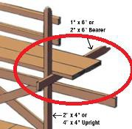
Bracket Scaffold | Scaffolding supported by brackets that are temporarily attached to the side of a building or column. | 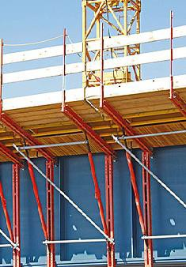
Directional Limiting  Device | A device which prevents movement. | No Picture
Gin Wheel | A device used to lift items using ropes. | 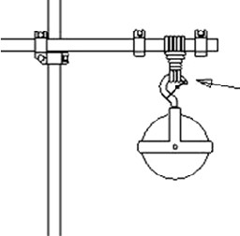
Guying | A rope, cord or cable used to steady, guide or secure something | 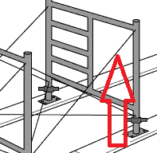
Half-Horse Scaffold | Scaffold that is kept upright by tilting it toward and resting it against a structure – as known as lean to scaffold | 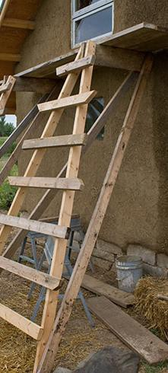
Ladderjack Scaffold | Consists of a platform resting on brackets attached to a ladder. | 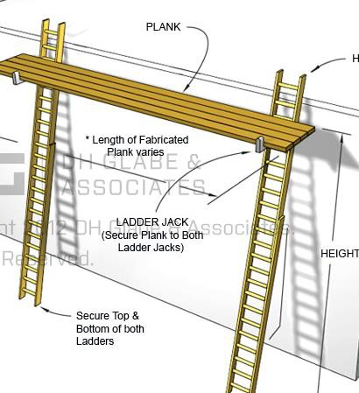
Ledgers | A horizontal brace in scaffolding | 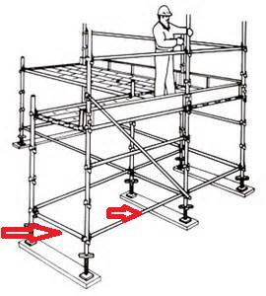
Metal Tube and Clamp Scaffold | Scaffolding consisting of steel tubes and clamps. Vertical tubes are connected to horizontal tubes by clamps. Diagonal tubes are connected to stabilize to scaffold.  Two options are available – standard tubular and modular. Modular consists of prefabricated components. | 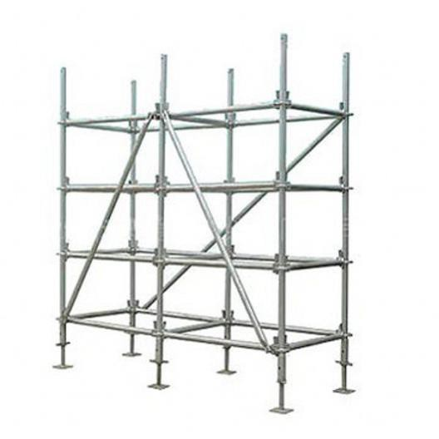
Needle Beam Scaffold | Consists of a plank platform resting on two horizontal beams (needle beams) which are supported by lines from overhead. | 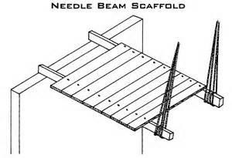
Outrigger Scaffold | Scaffold suspended from outrigger beams or brackets fixed to the outer wall of a building | 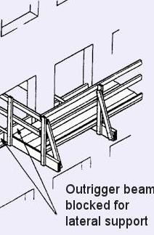
Parapets | Part of the wall that extends above the roof level | 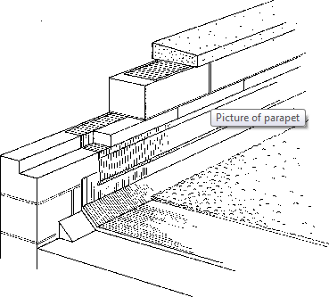
Plumb | Vertical | No Picture
Positive Pressure Controls | Deliberate sustained application of force to operate the device | No Picture
Positive Drive | Means it must be driven in both the up and down directions, it is not allowed to descend freely | No Picture
Sill | Wood, concrete or metal footing used to distribute the load from the vertical posts or base plate to the ground. Also known as mudsill | 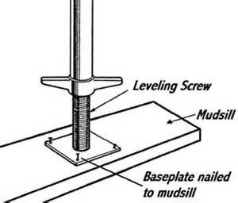
Single Pole Scaffold | A platform that rests on crossbeams.  The outer side is supported by ledgers and posts, while the inner side is supported by the wall. | 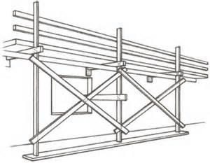
Spring Actuated Locking Pawls | A pawl hinged device that fits into a notch of a ratchet wheel to create forward motion or prevent backward motion. The pawl must be activated by a spring. | 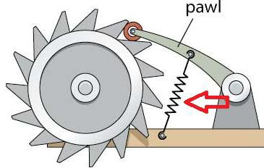
Stirrups | Hangers for platforms. | 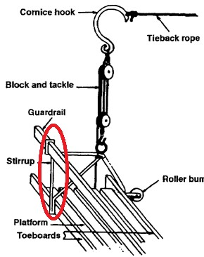
Suspended Outrigger Scaffold | Scaffolding platform suspended from outrigger beams or brackets which are fixed to the outer wall of a building | 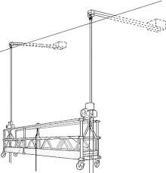
Suspended Powered Scaffold | A work platform that is raised and lowered by powered hoisting equipment. | 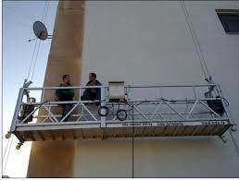
Suspended Scaffold | Platforms suspended by ropes or other non-rigid means from overhead structures. | 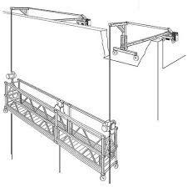

Chemical and Biological Substances

- Has the employer substituted/chosen the least harmful chemical substance? | Yes | No
2. Do you have policies/procedures that ensure safe handling, use,
storage, production and disposal of:
a. Chemical substances | Yes | No
b. Biological substances | Yes | No
3. Are workers educated on all chemicals? | Yes | No
4. Do you have a list of controlled products at your worksite? | Yes | No
5. Do you have a list of biological substances at your worksite? | Yes | No
6. Do lists identify which products are controlled products? | Yes | No
7. Are the lists available to workers? | Yes | No
8. Do you have written emergency procedures for spills, leaks, etc? | Yes | No
9. Are workers trained in the procedures? | Yes | No

Worker Survey – Fire Safety

1. Do you know where the closest fire pull station is? | Yes | No | N/A
2. Do you know what your responsibility is in the event of a fire? | Yes | No | N/A
3. Have you recently had fire safety training? | Yes | No | N/A
4. Do you know how to operate
- A fire extinguisher? | Yes | No | N/A
- Other fire suppression devices? | Yes | No | N/A
5. Are fire/emergency exits clearly marked? | Yes | No | N/A
6. Are fire/emergency exits illuminated? | Yes | No | N/A
7. Are fire extinguishers readily available? | Yes | No | N/A
8. Are fire extinguishers maintained? | Yes | No | N/A

