Inspection Report
Template

Employer Name/Logo | OHC Inspection Report - template  purpose:  the report will assist the occupational health committee (OHC) and the employer to assess the hazards identified during an inspection and guide them to an action to meet a standard  guidelines:  - enhance this template to suit the OHC’s needs so that it will provide a clear picture of the hazard and that the desired controls are well communicated  - the report captures the information obtained from the inspection checklist  - ensure the hazard to the employee is clearly identified and explained  - all recommended actions are to be based on the referenced standards (e.g., Canadian Standard Agency, Universal Precautions and infection control, fire code, policy/procedure, legislation, manufacturer guidelines, etc.)  - OHC co-chairpersons should discuss the recommendations with the employer/manager  distribution and retention:  - a copy of the report would be provided to the manager responsible for the inspected area, posted on the OHC bulletin board  - the report is retained and used for various purposes including tracking progress, an injury claim, investigation, by occupational health officers  additional:  - assign an OHC member to ongoing follow-up of a concern and to report back to the OHC until the concern is resolved  - attach copy of the inspection checklist, thank you letter and other relevant documentation
Elements of the Safety Management System | 1. Management and Leadership  2. Hazard Identification and Control  3. Training and Communication  4. Inspections  5. Incident Reporting and Investigation  6. Emergency Response

Inspection Report

Date: |  | Site: |  | Department: |  | Manager:

Date of Inspection:
Date Inspection Report provided to manager:

Key for Verification: D=documentation O=observation I=interview/informal chat with employee

Risk Matrix:
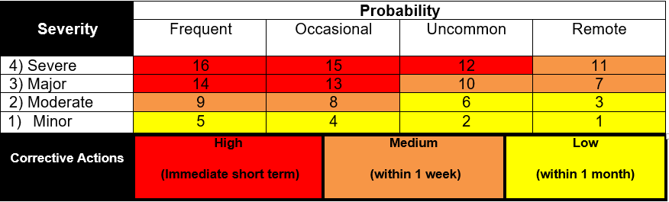
Actual Harm Rating | Description
1 Minor | An incident that has contacted or affected a patient/worker and resulted in no injury or minor injury/haram requiring minimal intervention or first aid.
2 Moderate | Harm/Injury which requires professional or medical treatment beyond first aid.
3 Major | Harm/injury resulting in physical and/or emotional harm and lessening of bodily function. Temporary loss of function. Long term incapacity/disability.
4 Severe | Death or significant harm resulting in irreversible complications including permanent major loss of function.
Frequent | Possibility of repeated occurrence (daily, weekly or monthly)
Occasional | Possibility of occurrence (several times in 1 to 2 years)
Uncommon | Possibility of isolated occurrence (2 to 5 years)
Remote | Not likely to occur (may happen outside of 5 years)

 |  |  |  |  |  |  |  | For Future Follow-up
Hazard(s) Identified | Risk  matrix  score | Verification |  |  | - Reference (e.g., standard/Act/ regulations, etc.)  - Recommendation for correction action (short and/or long term) based on that reference | Person(s) responsible | Completion Target Date | OHC member responsible | Date | Comments
 |  | D | O | I

 |  |  |  |  |  |  |  | For Future Follow-up
Hazard(s) Identified | Risk  matrix  score | Verification |  |  | - Reference (e.g., standard/Act/ regulations, etc.)  - Recommendation for correction action (short and/or long term) based on that reference | Person(s) responsible | Completion Target Date | OHC member responsible | Date | Comments
 |  | D | O | I

