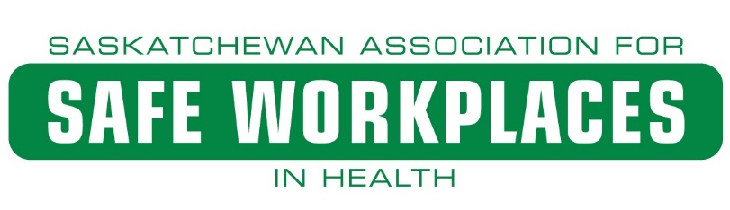
Effective
Occupational Health and Safety
Committee Guide

PURPOSE: This guide provides information on how to conduct effective committee meetings, establishing quorum, templates for meeting minutes, committee draft agendas, and details on co-chair and member responsibilities. Included in this guide is the three-year master plan which provides a critical path to ensure legislative compliance for effective committee work.

Table of Contents

1. Committee Meeting Information 3
2. Quorum 4
3. Minutes and Agenda 5
4. Three-Year Master Plan 6
5. Co-chair Responsibilities 7
6. Member Responsibilities 7
7. Tools and Resources 8

Committee Meeting Information

An occupational health and safety committee is a forum for bringing the internal responsibility system into practice. The committee consists of labour and management representatives who meet on a regular basis to deal with health and safety issues. The advantage of a joint committee is that the in-depth practical knowledge of specific tasks (labour) is brought together with the larger overview of company policies, and procedures (management). Another significant benefit is the enhancement of cooperation among all parts of the workforce toward solving health and safety problems. In smaller companies with fewer than a specified number of employees, a health and safety representative is generally required.
- Occupational Health and Safety Committees are required to meet quarterly. This is legislated, and every effort must be made to ensure this requirement is met.

- Occupational Health and Safety Committees must consist of a minimum of two members and no more than 12. No matter the size of the committee the function is still the same!

- Occupational Health and Safety Committees can meet outside of the quarterly requirement by hosting a special meeting called to order by either co-chair. These special meetings can discuss key hazards or safety issues that could possibly cause immediate injury or loss.

- Occupational Health and Safety Committees should not discuss matters outside the context of Occupational Health and Safety. Any attempt to use a committee for personal gain or to lay blame or implicate other staff of wrongdoing is strictly prohibited.

- Occupational Health and Safety Committees have a responsibility to review, investigate, inspect, and make recommendations on certain safety items. These items include, but are not limited to Dangerous Occurrence, Serious Injury or Incident, MSI (musculoskeletal injuries), time loss and medical aid incidents, injury statistics, policies, and procedures, refusal to work, all applicable legislation, all areas of the workplace, and any other component of the safety program. The agenda and minutes will help guide the OHC on these components. The 3-year master plan will ensure all reviews are completed. Workplace Inspections can be done during a meeting or scheduled for another day to help save time.

- Occupational Health and Safety Committees should meet with the intention of making the workplace safer for all staff. Minutes, agendas, and inspections are critical to ensure committees are on track and can meet their legislated duties.

- Occupational Health and Safety Committees should have access to an updated copy of The Saskatchewan Employment Act and The Occupational Health and Safety Regulations, 2020, as well as an updated copy of the Company Safety Program. These will be used during meetings for review and reference.

- Occupational Health and Safety Committees should be respectful of any worker union collective bargaining agreement and ensure they read and understand their role in the committee.

- Occupational Health and Safety Committee members must be given the time by the employer to ensure they can meet and fulfill their obligations. This may mean extra hours for meetings, inspections, or investigations to be completed.

Quorum

Half of all the OHC members must be present; half of all OHC members present must be workers; and at least one management member must be present.
- Committees must ensure they have a quorum at each meeting but should strive for full attendance and appoint alternates to the committee to help achieve this goal. Absenteeism leaves parts of the workforce without representation, creates discontinuity in committee activities, indicates a lack of commitment to workplace safety, and reduces the credibility of the committee.

- There can be more than one management member on a committee. In turn to meet quorum, management members may be asked to leave to establish quorum.

- If a meeting does not meet quorum, then it can not be transacted. Any discussion within will not be documented in the minutes. Having a set schedule for OHC meetings will help boost attendance. If a meeting falls on a day that cannot be used due to work related demands or on weekends, then try and schedule it for an earlier day. This will ensure that you meet the minimum requirement of quarterly. It is best to move a meeting ahead rather than push it back.

Minutes and Agenda

Under The Occupational Health and Safety Regulations, 2020, a committee is required to:
- record minutes of each meeting in a format provided by the division and keep minutes on file with the committee; and
- post a copy of the minutes at a location that is readily accessible to workers at the place of employment until all concerns recorded in the minutes are resolved.
The employer must maintain a copy of the minutes and have them readily available for inspection by a committee member or an occupational health officer.
- Minutes are important not only for the legislated requirements, but for the value they hold to all staff. These minutes show the committee is functioning and addressing concerns when required.

- Minutes and inspection reports need to be posted in a conspicuous spot (OHS BOARD) to ensure all staff can view them.

- Minutes should not be blank! There should be at minimum, incident stats as well as legislated and safety program reviews.

- Any items on the minutes that require attention should have a target date identified. This will ensure that items are dealt with according to risk and potential of injury or loss, as well it will show items that are past due. The higher the risk of injury or loss the sooner it needs to be addressed.

- Occupational Health and Safety Committees should ensure they table and discuss all safety concerns brought to them by other staff members. In turn these should be documented on the minutes, and a response given if required.

- Agendas will be developed for the occupational health and safety committees to follow. These agendas will lay out what needs to be discussed, investigated and/or reviewed. Agendas will keep committees aligned with a three-year master plan to ensure all components of the act, regulations, and the company safety program are reviewed.

Three-Year Master Plan
- This has been developed to guide the OHC through the full review of their safety program as well as The Saskatchewan Employment Act, and The Occupational Health and Safety Regulations, 2020.

- The Three-Year Master Plan will include the agenda and the material for review. It will be broken down in to four quarters. (Appendix A)

Co-chair Responsibilities

Co-chairs are essentially the link to management and staff. An employer co-chair (management) and worker co-chair (staff) are required for all OHCs. Co-chairs have shared responsibilities to ensure meetings are documented, quorum is met and agendas are completed.
In addition to Occupational Health and Safety Level 1 training, both co-chairs require Occupational Health and Safety Level 2 training. This training looks specifically at investigation and inspections and having this training is a requirement to hold a co-chair status.
Co-chairs are the go-to when an investigation of a certain safety concern is required or to lead facility inspections. Co-chairs are also required to be a part of any inspection that takes place from the Ministry of Labour Relations and Workplace Safety.
Co-chairs should have a good understanding of all required legislation and apply this knowledge during meetings. It is legislation that drives the committee and in turn someone needs to be steering! The co-chairs are at the wheel!

Member Responsibilities

OHC members are key to ensuring the meeting has representation from all departments. They are the subject matter experts in their field! Members make up the depth of committees. The more members a committee has the more that can be accomplished. Department representation is vey important for any OHC.

All members are typically appointed by their fellow workers. Other avenues such as collective bargaining agreements may hold some accountability on who is represented on the committee. Either way, building your committee strengthens its ability to perform at a high level!

All OHC members are required to take Level 1 Occupational Health and Safety training. This training focuses on the legislation and the responsibility as a OHC member.

OHC members can take part in all other aspects such as investigations, facility inspections, government led inspections, and must remember to be in the company of someone trained in Level 2 Occupational Health and Safety.

All members are encouraged to speak up! Table concerns brought to them by fellow staff members. These meetings have been developed for you with safety in mind. Make sure to use them to your advantage when discussing safety related matters.

Tools and Resources

There is a lot of information to take in! There are also many tools an OHC can use. Below is a list of things to consider using when developing and supporting your OHC!
  - The Saskatchewan Employment Act, PART III
- Sets the standard for what is required for a functioning safety program.

- The Occupational Health and Safety Regulations, 2020
- Is developed pursuant to PART III of the act and sets the standard on how to meet those requirements.

- Occupational Health and Safety Level 1 and 2 Training Books
- Hang on to them! These are full of excellent information. There should be a copy at each meeting.

- Three-Year Master Plan
- This will be available for all OHCs. Each agenda will guide the meeting and capture the reviews and components that are required.

- OHC Recommendation Form
- This form is important and will guide OHCs in developing formal recommendations. The form is user friendly and detailed for use.

- Saskatchewan Association for Safe Workplaces in Health
- The semi secure website will hold all components of the safety program for SECPSD. They also have all relevant training programs.

- Subject Matter Experts (Guests)
- OHCs should reach out to anyone that can help them with specific issues. Fire department, police services, managers, directors, etc. This is something that has worked well. Inviting guests to meetings is a great way to be confident to get the information you may need on a particular subject.

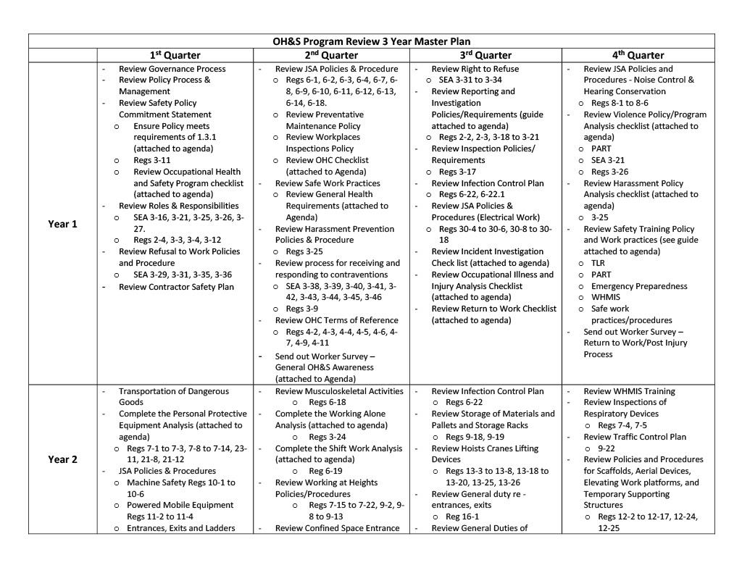
Appendix A

