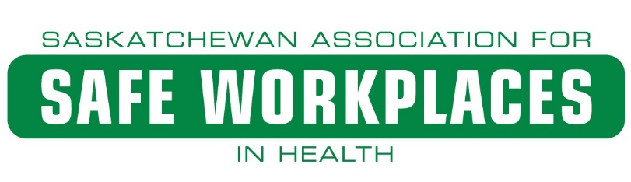
WHMIS 2015 Education and Training Guide

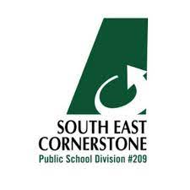

PURPOSE: This guide provides information on the WHMIS 2015 program. This includes both the education and training requirements.

Table of Contents

1. INTRODUCTION 3
2. WHMIS 2015 Education 5
3. WHMIS 2015 Site-Specific Training 6
4. Safety Data Sheet (SDS) Requirements 6
5. Hazardous Product Spill Cleanup 7
Appendix A - WHMIS 2015 Legislative Requirements 9
Appendix B - Exposure Control Plan – Hazardous Product Spill Cleanup 10
Resources: 11

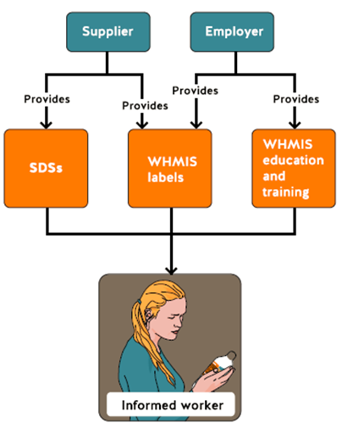

INTRODUCTION
Workplace Hazardous Materials Information System (WHMIS) helps the school division’s employees, managers, and supervisors know about the hazardous products that they use and store in the workplace. Hazardous products may lead to many serious health problems, such as kidney or lung damage, cancer, burns, or allergic reactions, while other hazardous products can cause fires or explosions.
WHMIS 2015 Education and Training Guide provides information regarding WHMIS to help staff work safely with and near hazardous products. Understanding WHMIS gives employees the knowledge to protect themselves and others from being exposed to hazardous chemicals and materials.
Overview of WHMIS
WHMIS provides Canadian workers with information about hazardous products in the workplace. It is a worker’s right to receive information about each hazardous product they use, handle, or store.

The purpose of WHMIS
The purpose of WHMIS is to reduce injury and disease by communicating specific health and safety information about hazardous products to workers.

WHMIS Involves:
- Classification of hazardous products into hazard classes and categories according to specific rules.
- Communication of hazard and precautionary information using labels and Safety Data Sheets (SDSs).
Through a series of complementary federal, provincial, and territorial laws and regulations, WHMIS first came into effect in 1988. WHMIS 1988 was updated in early 2015 to reflect a new initiative called Globally Harmonized System of Classification and Labelling of Chemicals (GHS). GHS does not replace WHMIS, but has aligned with WHMIS. GHS has introduced several important changes to WHMIS. Some changes include new pictograms, new requirements for labels, and safety data sheets (SDS). The changes to WHMIS will be hi-lighted throughout this guide.

The goal of GHS, as a worldwide system, is to have common rules for:
      - Classifying hazardous products
      - For supplier and workplace labels,
      - Standard format for SDS
Learning about the changes associated with the implantation of WHMIS 2015 is required as a manager/supervisor to educate and train employees to protect themselves and others from hazardous products. Both education and training remain required components of WHMIS 2015.

WHMIS IS THE LAW IN EVERY WORKPLACE

WHMIS is a coordinated system of federal, provincial, and territorial laws which applies to every workplace in Canada. Federal laws are the Hazardous Product Regulations (SOR/2015-17) and the Hazardous Products Act. (See Appendix A)

Under the federal law:
- Create WHMIS hazard classes and pictograms
- Describe rules for classifying products as hazardous products
- Require suppliers to attach labels to chemical products that are hazardous products
- Require suppliers to provide SDSs to customers

All Canadian jurisdictions have adopted similar WHMIS regulations for employers, based on laws built on consensus between businesses, labour, and government.

WHMIS requirements for Saskatchewan are found in The Saskatchewan Employment Act, The Occupational Health and Safety Regulations, 2020, and The Occupational Health and Safety (Workplace Hazardous Materials Information System) Regulations.

WHMIS laws determine if a workplace product is a hazard based on properties such as toxicity, flammability, and reactivity.

SUPPLIER RESPONSIBILITIES

- Classify products according to their hazards and the WHMIS criteria
- Provide labels for the product or container
- Provide a current SDS for WHMIS products sold to workplaces

WHMIS 2015 Education
- As stated earlier, WHMIS 2015 legislation has been enhanced. These changes brought many new components for the user to help identify hazardous products and be capable of working safely with and around them.

- With the enhancement, came an education component. This is the first step that all staff must go through in the process. The education component gives the user the relevant information on all the changes and what they will need to be aware of as the update continued.

- The education component is a requirement for all staff no matter the length or term of their employment.

- The education component can be taken online and is available through the Saskatchewan Association for Safe Workplaces in Health (SASWH). This link will be available to all staff.

- The online education only needs to be taken once. Upon successful completion you will receive a certificate.

- Using the SASWH online education is the best way to ensure you get the right information, certificate, and knowledge regarding WHMIS 2015.

- The SASWH education and training webpage is closely monitored and will keep record of your completion on WHMIS 2015 as well as any other education or training you take online.

WHMIS 2015 Site-Specific Training
School divisions must provide education and training for employees to ensure they can work safely with and near hazardous products. School division employees must know how WHMIS works, the hazards of hazardous products in their department, and the safe work procedures that must be followed.

- Upon successful completion of the WHMIS 2015 education the WHMIS 2015 site-specific training is the next step in the program. The site-specific training will consist of a competency checklist as well as a quiz.

- The site-specific training will be required by all staff working in the facility no matter the length or term of their employment.

- The site-specific training will be updated by all staff working in the facility on an annual basis.

- The WHMIS 2015 site-specific training should be delivered by someone in a supervisory role within the facility.

- Delivering this training in a group is best practice. This will help keep everyone on track and is easier when delivering it on an annual basis.

- The site-specific training documents should be kept on site. A sign in sheet can be sent to Human Resources for record keeping.

- With site-specific training the focus will be on the facility and the WHMIS 2015 components that you need to know. Emergency locations, SDS locations, and hazardous products that you may be working with or around.

Safety Data Sheet (SDS) Requirements
All staff within the school division must be familiar with the hazards of a product before they start working with the product. It is necessary to understand and be able to access the SDS of each hazardous product that is within the work environment. Spend some time to ensure that the SDS matches the hazardous product identified on the container. Your education in this area is to confirm that you know and understand the hazards of the product, understand the safe handling and storage instruction as indicated on the SDS. If for whatever reason you do not understand the product you are working with consult your manager/supervisor for advice and guidance. All workers must know exactly what to do in case of an emergency before starting to work with the hazardous product.

- All controlled products require a SDS. During the education it was stated that the supplier must include a SDS with any hazardous product. If it is not received from the supplier, then the employer must acquire it before the product is used.

- If you still have MSDS then these will need to be updated to SDS. The update has been received by all suppliers and we should not see any MSDS. However, there may be some that still exist in that format.

- All relevant facility SDSs must be kept either in paper or electronic form and must be readily available for all staff. This will need to be considered when deciding whether to keep a paper copy, electronic platform, or both.

- It is best practice to only manage the SDS you need to. The more products you have the more SDS you will require. Even some uncontrolled or store purchased products require SDS. This can start to have an impact on your WHMIS 2015 program. It can also lead to a higher risk of exposure or incident, and potential compliance undertakings or contraventions.

- SDSs are the critical link between staff and a hazardous product. Especially if the product has been misused and first aid treatment is required. The SDS houses all the relevant safety information for that product.

- SDSs should be reviewed and updated every 3 years. This in part is done through the workers as well as the OHC. Always ensure that your SDSs are up to date.

- SDSs can be found on the supplier website or a google search. When searching be sure to ensure you have the right SDS for the product. Always check the product identifier on the SDS and make sure it matches the product.

- It is best practice to check with your supervisor before bringing any product into the facility. Some scents, fragrances, and aerosols can affect people differently.

Hazardous Product Spill Cleanup (See Appendix B)
- Spills have the potential to be dangerous, especially if it is a hazardous product. Spills of any kind need to be cleaned up immediately.

- When hazardous products spill, the risk to staff and others is higher. Depending on what and how much can set the level of risk.

- The best practice is to have a well practiced spill cleanup process. This is very important to ensure safety of all involved.

- All hazardous products will have a process for cleaning up spills safely. This can be found on the SDS.

- All facilities should have a basic spill kit on hand. This kit should include:
- Absorbent material (enough for 3 litres of liquid)
- Chemical resistant gloves and goggles
- Yellow bags with label for cleanup waste
- Signage to indicate wet floor or another notifying marker

- Spills can be dangerous to staff if staff fail to protect themselves. Even small amounts of hazardous products can be dangerous.

- Do not attempt to cleanup hazardous product spills without first identifying the product, reading the SDS, and protecting yourself!

Appendix A - WHMIS 2015 Legislative Requirements
(Partial Excerpt only)
Legislation | Requirement
SEA 3-48 | Employer shall:  - Ensure concentrations of biological substances and chemical substances are controlled in accordance with prescribed standards  - Ensure all biological substances and chemical substances are stored, handled, and disposed of in the prescribed manner  - Ensure all biological and chemical substances in the place of employment and identified in the prescribed manner  - Ensure that all hazardous products are labelled with the prescribed information and pictograms
Sask. OHS Regs 22-4 | - Ensure all workers, working with or exposed to a hazardous product in the course of their work activities are informed about:  - All hazard information received by the employer from a supplier concerning that hazardous product  - Any further information that the employer is, or ought reasonably to be aware of concerning the use, storage, handling, disposal of that hazardous product  - Ensure all workers who work with a hazardous product or may be exposed to a hazardous product are educated and training respecting:  - The content that is required to appear on a supplier label and workplace label, and the purpose and significance of the information on the labels  - The content required to appear on a safety data sheet for a hazardous product and the purpose and significance of that information  - All necessary procedures for the safe use, storage, handling, and disposal of the hazardous product  - Emergency procedures to be followed in case of an emergency involving the hazardous product  - The knowledge of workers must be periodically evaluated using written tests, practical demonstrations or other suitable means  - An employer shall review at least annually the education and training programs provided to workers on the safe use, storage handling and disposal of hazardous products
Sask. OHS Regs 22-5 | - If a supplier label becomes damaged, or is accidentally removed, the employer shall replace the label with either a new supplier label or a workplace label
Sask. OHS Regs 22-7 | - If a hazardous product at a place of employment is in a container other than the container in which the hazardous product was received from a supplier, and employer shall ensure a workplace label is applied to the container
Sask. OHS Regs 22-11 | - An employer who acquires a hazardous product for use, storage, or handling at a workplace shall obtain a supplier safety data sheet  - If the hazardous product is more than 3 years old or if there is any significant new data, the employer shall obtain an up-to-date supplier safety data sheet
Sask. OHS Regs 22-13 | - An employer shall ensure that a copy of a safety data sheet is made readily available to any staff who may be working with the product or exposed to the product at work

Appendix B - Exposure Control Plan – Hazardous Product Spill Cleanup

Work Procedure: Hazardous Product Spill Cleanup

Sector: | Reviewed By: | Approved By: | Date Created: | Date of Last Revision:

Purpose: The purpose of this procedure is to explain the step-by-step instructions for safely cleaning and disposing of a spilled hazardous product.

PROCEDURE:
Personal Protective Equipment:
- Protective gloves
- Eye protection

Tools / Materials Required:
- Attack Pac spill kit
- Spilled product SDS
- Wet floor signs

Instructions:
- Do a pre-visual inspection of spill area
- Secure area using wet floor signs
- Identify product that was spilled (if unknown or unidentifiable treat it as hazardous)
- Retrieve spill kit and SDS for product (if identified)
- Review cleanup process for product using section 6 of SDS and review section 8 of SDS for required PPE
- Follow instructions on spill kit for safe and proper cleanup and disposal
- Remove wet floor signs once area is clean
- Report the spill and use of spill kit on an incident report form

Responsibilities, Completion and Review:
All staff members are required to adhere to Department policies & procedures at all times while employed with the (enter school division) as it relates to day-to-day operation of the Department. Supervisors are also required to ensure that staff members are following Department policies at all times and to take the necessary steps to inform staff who fail to follow policies and report all matters to management immediately. Employees who fail to follow Department policies will be subject to disciplinary action.

Resources:

- You can find on the Hazardous Products Regulations at:
http://laws-lois.justice.gc.ca/eng/regulations/SOR-2015-17/

- For further information or questions on OH&S legislation, you can contact the LRWS (Labour Relations and Workplace Safety) at 1-800-567-7233.

