Test: | Ladder Safety
Name (Print): |  |  | Date:
Name (Sign): |  |  | Employee #:
Examiner: |  |  | Mark:

1. Who is responsible for the pre-use inspection of a ladder?

2. List five (5) things you would check as part of your pre-use inspection.

3. What are 3 important considerations when choosing a ladder?

4. You can fix minor damage on a ladder yourself? ( True / False )

5. It is OK to use a ladder that was inspected the previous shift. (True / False )

6. What are 3 important rules when using an extension ladder?
a)
b)
c)

7. You find a defect in your ladder, what steps should you take?

8. What are 3 important rules when using a step ladder?
a)
b)
c)

9. The distribution of the load is not important if the capacity has not been exceeded.
( True / False )

10. How far do you need to stay away from electrical conductors?
 | a) | ten (10) feet
 | b) | five (5) meters
 | c) | it varies with the phase-to-phase voltage range
 | d) | Working around electrical conductors is not a safe practice

11. If you are using a 12-foot extension ladder, what distance for should the bottom be from the structure?
 | a) | 1 foot
 | b) | 6 inches
 | c) | 3 feet
 | d) | One half the working height of the ladder  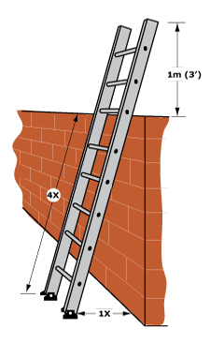

12. Step ladders pose a high risk due to improper use, name 3 things that would be considered improper use.
a)
b)
c)

13. Modification or alteration of any ladder can only be made with
 | a) | your supervisor’s permission
 | b) | the permission of the owner
 | c) | prior written permission of the manufacturer
 | d) | written permission from the dealer
e) none of the above

14. Circle the area of the step ladder that is considered “off limits” to the user.

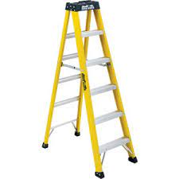

15. List three (3) things you would consider when planning a job that requires working at heights.

16. When working at height with a partner list 4 things to consider for the safety of everyone.
a)
b)
c)
d)

17. What are your 3 rights as a worker? (Give 1 example of each)

a)
b)
c)

18. Read policy # Preventing falls.

Signature:

Date:

