Slips, Trips, and Falls Safety Talk
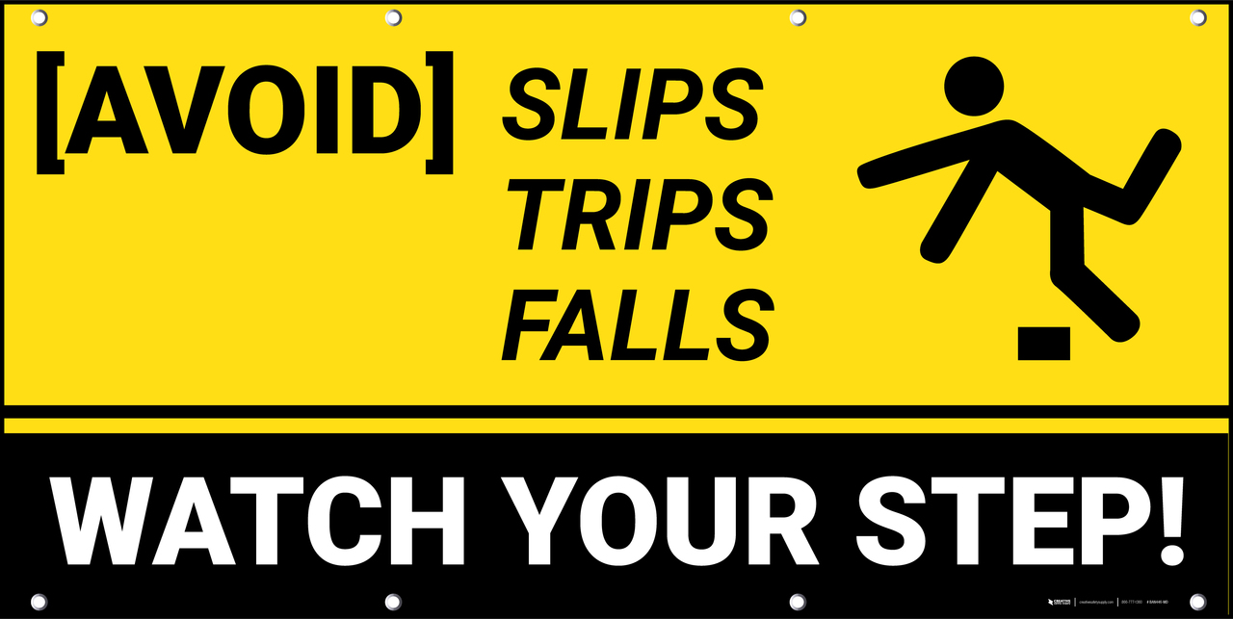
Wet Floors and Spills -Tips to Stay Safe

Outdoor conditions set the tone for slips and falls. However, inside our facilities there is still a high risk of slips, trips, and falls. Wet floors, spills, uneven floors, rolled matting and other hazards exist in any facility.
Tips to remember when inside any (insert name) facilities:
- We wouldn’t have clean facilities if it wasn’t for a dedicated cleaning staff! Slippery floors may not always be by accident. Keep an eye out for wet floor signs. All cleaning staff are required to use these anytime a floor has been recently mopped, this will help alert others to the potential for a slip, trip, or fall.

- Some hazards may be created by a spill. If you create or notice a spill, be sure to first identify what was spilled. Some chemical spills may require PPE to clean it up properly and safely. Always refer to any SDS for hazardous products that are spilled before attempting to clean it up. If a spill cannot be immediately cleaned up, then take action to minimize the risk to others. This may require signage or posting of someone to watch the area until proper cleanup can be done. Water and other consumable liquids can be easily and promptly cleaned up. Encourage others to be vigilant as well. This will ensure no spill goes unattended to.

- Entrance ways can become hazardous when outside conditions like snow and rain are present. These areas can become slippery with water, ice, and even things like sidewalk salt. Be cautious in these areas and be sure to watch where you step. If cleanup is required, please do your best to remedy it at the time. If not report it to your supervisor as soon as possible.

- Shops where equipment is repaired can become hazardous due to the nature of work. Oil, grease, water, all are a part of the job. Once an accumulation of these has started it is best to pause work and clean it up. This will ensure that hazards don’t go unnoticed. Squeegees, floor dry, and brooms should all be present in shop conditions.

