Slips, Trips, and Falls Safety Talk
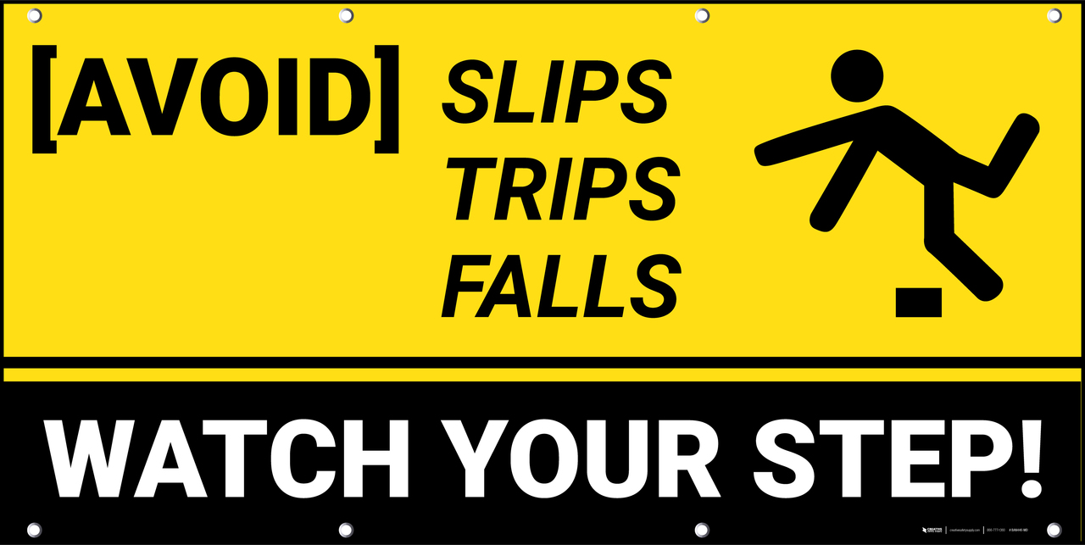
Winter Conditions -Tips to Stay Safe

Winter conditions are a major cause of slips, trips and falls. These conditions include ice, snow, drifting snow, and freezing temperatures. Awareness during winter conditions is critical to minimize slips, trips, and falls. Staff must take precautions during these conditions.

Tips to remember when winter conditions exist:
- Use a different walking technique
During winter conditions more cautious steps are important. Shorter and more controlled. Stability is important so the slower the better. Always expect there to be ice present. Controlling our steps and walking cautiously will help minimize the risk of injury due to slips, trips, and falls.

- Look at ground conditions constantly
A quick look down will help identify ice, snow, and drifts. Look for areas where snow has been removed, or areas with less snow. During winter conditions it is good to communicate consistently with the maintenance team who provide snow removal. This will ensure that areas are cleared of snow before heavy foot traffic is expected. Maintenance has a big job when winter conditions exist and may not cover all areas. It is important to communicate areas of concern that may have been missed. Entrances should be equipped with shovels and salt/sand for all staff to utilize.

- Utilize proper footwear for winter conditions
Proper footwear for all conditions is important. Wearing footwear that has sufficient grip and is fitted well to your foot will help minimize slips, trips, and falls during winter. Winter boots are built to adapt to the conditions. Grip and fit are important. Boots can be worn into the facility and changed for work footwear after. Cleats may also help during winter conditions. Talk with your supervisor before using cleats.

