Slips, Trips, and Falls Safety Talk
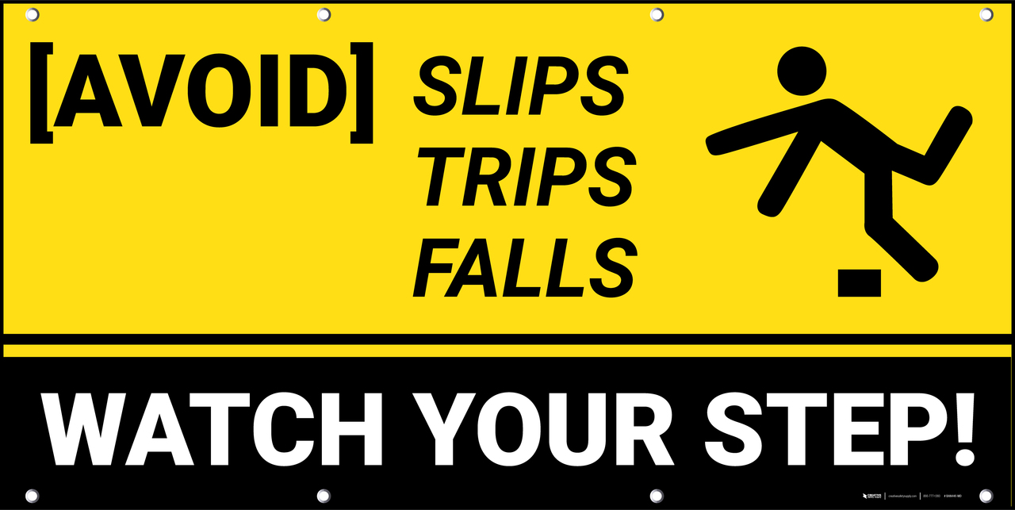
Entering and Exiting Vehicles -Tips to Stay Safe

If anyone has ever experienced a slip, trip and fall then you know what it is like to feel helpless as gravity takes over! Falls occur at home and at work. Identifying areas of concern is one way of spreading awareness.
Tips for safely entering and exiting a vehicle:
- Use 3-point contact when entering or exiting
3-point contact may seem like a technical term, and it is. However, if practiced regularly when entering and exiting a vehicle it can greatly reduce the chance of a fall or even a strain, sprain or overexertion causing injury.

- Look at ground conditions before exiting
A quick look down will help identify ice, snow, rocks, water, uneven surfaces, and anything else that could cause a fall. When exiting a vehicle sometimes we inadvertently look ahead.

- Retrieve personal items after safely exiting
Falling is not fun. Knowing your coffee is going with you is worse! Items like phones, coffee, book bags, purses, and any other personal items needed for the day should remain in the vehicle until you are safely out. Put small items in pockets, this will keep your hands free. Retrieve large items after exiting.

- Report hazardous conditions
If you notice areas that require attention due to a hazard, report promptly to your supervisor. Such hazards may include ice, snow, uneven ground, large cracks, loose gravel, or wet areas. All these should be reported.

